Identification of a novel autonomous role for Ecdysone Receptor during Drosophila ovarian germ cell differentiation.
By
Lauren Jung
July 2024

Director of Thesis: Dr. Elizabeth Ables
Major Department: Biology

ABSTRACT
A tightly regulated network of signals coordinates the division of Drosophila germline stem cells (GSCs) and differentiation of their daughter cells to produce viable oocytes. The steroid hormone, ecdysone, is known to promote GSC self-renewal; however, due to lack of compatible genetic tools, potential autonomous roles in the germline have not been fully evaluated. Ecdysone elicits a diverse array of transcriptional responses by binding to a heterodimeric complex composed of Ecdysone Receptor (EcR) and Ultraspiracle (Usp). To elucidate whether EcR facilitates autonomous reception of ecdysone in the germline, we built germline-compatible genetic tools to manipulate EcR levels or activity. Depleting EcR mRNA or loss of EcR ligand binding in the germline caused a loss of GSCs over time, demonstrating that it is necessary for GSC self-renewal. Further, over-expressing either EcR.A or EcR.B1 isoforms resulted in undifferentiated germ cell tumors and decreased numbers of GSCs. This is a ligand-dependent function of EcR, as over-expression of EcR that cannot bind ecdysone suppressed tumor development. By restricting over-expression to later stages of the germline, we found that EcR is sufficient to induce tumors only when over-expressed in the GSCs and early daughter cells. In tumorous ovaries, stem-like cells were also identified outside of their normal stem cell niche, suggesting that these cells remain competent to respond to BMP signals. Using single-cell RNA-sequencing to compare EcR over-expressing and Tkv over-expressing ovaries, we found remarkably similar transcriptomes in heterogenous populations of germ cells. These data suggest that EcR promotes differentiation of germ cells by directly regulating components of the BMP signaling pathway and that low levels of EcR expressed in wildtype GSCs are sufficient for ligand-dependent activation of an ecdysone-responsive transcriptional program. Altogether these data reveal a novel, autonomous role of EcR in GSC maintenance and regulation of differentiating daughter cells.

Identification of a novel autonomous role for Ecdysone Receptor during Drosophila ovarian germ cell differentiation.

A Thesis
Presented to the Faculty of the Department of Biology
East Carolina University

In Partial Fulfillment of the Requirements for the Degree
Master’s of Science in Molecular Biology and Biotechnology

By
Lauren Elizabeth Jung
July 2024

Director of Thesis: Elizabeth Ables, PhD
Thesis Committee Members:
Lauren Anllo, PhD
Michael Brewer, PhD
Daniel McKay, PhD

© Lauren Jung, 2024
ACKNOWLEDGEMENTS
I would love to thank past and present lab members of my lab not only for their contributions but their support and friendship. Specifically, I would like to acknowledge Danielle Finger and Daniel Phipps for their past data, this project would not have reached its potential without it. To the wonderful lab mates that also helped collect data, Lindsay Swain and Allison Simmons, I appreciate you! Lastly, deepest thanks to Amanda Powell for being a close friend and peer mentor. My utmost gratitude goes to my advisor, Dr. Ables, for culturing my passion for research and guidance on this project. I also want to thank my committee members for their encouragement and helpful feedback. Lastly, I want to thank my family for their unwavering support in my academic endeavors, even if all they understand is that I “play with fruit flies”.
Thank you to the Bloomington Drosophila Stock Center, the Developmental Studies Hybridoma Bank, the Drosophila Genomics Resource Center, and the Vienna Drosophila Resource Center for reagents. Thank you to colleagues, D. Drummond-Barbosa, T. Xie, M. Clemot, S. DeLuca, and R. Hughes for sharing fly lines and plasmids. I would like to acknowledge the incredible help from Dr. Weihua Huang and Dr. Changhong Yin at the Brody School of Medicine Genomics Core for their help with library preparation. This work is funded by the National Institutes of Health (R15-GM117502 to E.T. A.).
TABLE OF CONTENTS
Title page: i
Copyright page: ii
Acknowledgement page: iii
List of Figures: v
List of Abbreviations: vi
Chapter 1
Introduction pg.1
Chapter 2
Results pg.6
Chapter 3
Discussion pg.36
Chapter 4
Materials and Methods pg.40
References pg.49

LIST OF FIGURES

Figure 1: Drosophila ovary and germaria diagram 5
Figure 2: Generation of new genetic tools to manipulate EcR in the germline 8
Figure 3: Over-expression of EcR.B1 in germ cells causes tumors 9
Figure 4: Tagged EcR shows nuclear localization in germline tumors 11
Figure 5: EcR.B1 over-expression is sufficient to generate tumors only in the GSCs and cystoblast and at high levels 13
Figure 6: EcR.B1 dominant negatives reveal ligand binding facilitates tumor phenotype 15
Figure 7: Increasing ecdysone levels suppresses tumor formation 17
Figure 8: Over-expression of EcR.A phenocopies EcR.B1 19
Figure 9: EcR over-expression causes GSC loss and stem-like tumors 23
Figure 10: Germline tumors caused by EcR.B1 do not express differentiation markers 25
Figure 11: EcR.B1 and Tkv^{ACT} tumors reveal striking transcriptional similarity 28
Figure 12: Analysis of a germline tumor transcriptome 30
Figure 13: Loss of EcR mRNA causes GSC loss 32
Figure 14: EcR is necessary for cyst encapsulation 33
Figure 15: EcR is required in an ecdysone dependent manner in 16-cell cysts for their encapsulation 35

LIST OF ABBREVIATIONS
GSC | Germline stem cell
EcR | Ecdysone Receptor
usp | ultraspiracle
AF1 | Activation function 1
Ftz-f1 | Fushi tarazu transcription factor 1
DBD | DNA binding domain
LBD | Ligand binding domain
BMP | Bone morphogenetic protein
UAS | Upstream activating sequence
CyO | Curly of Oster
OE | Over-expression
DN | Dominant negative
Hts | Hu li tai shao
LamC | LaminC
LamB | LaminB
nos | nanos
dpp | decapentapalegic
gbb | Glass bottom boat
Tkv | Thick veins
Sax | saxophone
Mad | Mothers against decapentaplegic
pMad | Phosphorylated Mad
Bam | Bag of marbles
Dad | Daughters against dpp
PHH3 | Phospho-histone 3
bgcn | Benign gonial cell neoplasm
Mei-p26 | Meiotic protein 26
Fs(1)k10 | Female sterile (1) k10
side | sidestep
ple | pale
esg | escargot
scrt | scratch
Phm | phantom
sad | shadow
shd | Shade
Nvd | Neverland
Dib | Disembodied
Spo | Spooky
dae | Days after eclosion

Introduction
The steroid hormone ecdysone regulates diverse developmental processes across the lifespan, including tissue remodeling, tissue growth, developmental timing, and female fertility (Ables & Drummond-Barbosa, 2017). Ecdysone titers act as a temporal cue to initiate progression through larval stages, pupariation, and the final metamorphic transition to adulthood. Both the timing and level of ecdysone are critical for stage-appropriate events (Morrow & Mirth, 2024). Ecdysone levels are, in part, regulated by its synthesis. Dietary cholesterol is modified by a series of enzymes encoded by the Halloween gene family to produce ecdysone (Rewitz et al., 2006). In larval and pupal stages, the prothoracic gland is the primary source of ecdysone synthesis, where it is released into the hemolymph and circulated throughout the body. In the adult female, the ovary is the largest source of ecdysone production and loss of ecdysone biosynthesis prohibits progression of oogenesis (Swevers, 2018).
Developmental responses to ecdysone are initiated through an elaborate transcriptional response mediated by the Ecdysone Receptor (EcR). As a heterodimer composed of two nuclear receptors, encoded by the genes EcR and ultraspiracle (usp), the EcR complex regulates distinct temporal and spatial expression of genes through activation and repression (Uyehara and McKay et al., 2019). Context-dependent responses are, in part, due to the existence of three distinct EcR protein isoforms (EcR.A, EcR.B1, and EcR.B2), each with differential expression and transcriptional activity (Schubiger et al., 2003). The A and B1 isoforms share conserved DNA and ligand binding domains but have alternatively spliced N-termini (Talbot et al., 1993). The differing N-termini, also known as activation function 1 (AF1) region, suggests an isoform-specific role; however, to what extent the EcR isoforms regulate biological processes remains largely unknown (Schauer et al., 2011).
EcR-mediated signaling is critical for oogenesis in Drosophila melanogaster. Oogenesis begins in adults with a germline stem cell (GSC) population that resides in a specialized niche within the germarium at the anterior tip of each of ovarian subunit, called ovarioles (McLaughlin & Bratu, 2015; Hinnant et al., 2020). GSCs divide asymmetrically to produce a cystoblast, which continues to undergo four mitotic divisions with incomplete cytokinesis to produce a 16-cell cyst (de Cuevas et al., 1997). Within the interconnected cyst, one cell will commit to becoming the oocyte and the remaining 15 will become nurse cells. Follicle cells at the posterior end of the germarium envelop the cyst and bud it off from the germarium to form an egg chamber. In the egg chamber, nurse cells produce mRNA and proteins for the oocyte to uptake then undergo programmed cell death, producing a fully developed oocyte.
Analysis of EcR isoform specificity in the adult ovary has not been accomplished, largely because loss-of-function mutations specifically disrupting EcR.A, EcR.B1, or EcR.B2 result in larval lethality (Bender et al., 1997). However, loss-of-function experiments using a temperature- sensitive allele of EcR (EcR^{A483T}) permits temporal control over EcR knock-down and thus, allows flies to develop to adulthood before loss of gene function (Bender et al., 1997). Utilizing EcR^{A483T}, a global loss-of-function mutant that disrupts the common ligand binding domain, it was established that EcR is critical for egg chamber development and survival (Buszczak et al., 1999; Carney & Bender, 2000) and GSC self-renewal (Ables & Drummond-Barbosa, 2010; Morris & Spradling, 2012; Konig et al., 2011). However, these experiments could not distinguish whether EcR was autonomously required in the germline or the somatic cells for the observed effects on oogenesis.
To begin to address which ovarian cells require EcR, the Montell and Cherbas labs used the UAS/Gal4 system to over-express a dominant-negative EcR transgene in ovarian border cells, which form the anterior margin of the eggshell and the sperm entry point (Bai et al., 2000; Jang et al., 2000; Cherbas et al., 2003; Bhattacharya & Starz-Gaiano, 2024). These experiments demonstrated that EcR is necessary to provide a timing signal necessary for the proper migration of border cells, and thus, for female fertility. EcR is also necessary in ovarian follicle cells for several other processes including follicle cell migration and shape, oocyte lipid accumulation, and ovulation (Manning et al., 2017; Knapp & Sun, 2017; Romani et al., 2016; Sieber & Spradling, 2015). Using a similar experimental strategy, the Gilboa and Shcherbata labs found that EcR is also critical for primordial germ cell differentiation. Expression of the EcR dominant-negative transgenes in the somatic cells of the larval ovary caused precocious differentiation of primordial germ cells and subsequent abnormalities in GSC niche formation (Konig et al., 2011; Gancz et al., 2011; Yatsenko & Shcherbata, 2018).
A direct role for EcR in germ cells has not yet been established. The role of EcR within the germline has been largely presumed upon identification of a few EcR response genes expressed in the ovary (McDonald et al., 2019; Ables and Drummond-Barbosa, 2017). Canonical early targets E74, E75, and Broad are all expressed in germ cells, suggesting that EcR activates their expression (Buszczak et al., 1999). Moreover, E74 and EcR co-receptor Usp are both necessary in GSCs for their maintenance (Ables and Drummond- Barbosa, 2010). E78 is also essential in germ cells for cyst viability, and non-autonomously in somatic cap cells for stem cell niche establishment, GSC maintenance, and cyst viability (Ables et al., 2015). E74 and E75 are expressed at high levels beginning in 16 cell cysts and E75 null germline clones arrest during mid-oogenesis (Terashima & Bownes, 2006; Buszczak et al., 1999). Other ecdysone responsive nuclear receptors, such as Fushi tarazu transcription factor 1 (Ftz-f1) and HR3, show distinct and controlled expression throughout the ovary, although their role is largely undefined (McDonald et al., 2019). It has yet to be directly assessed whether these ecdysone responsive genes are regulated by EcR in the germline. Furthermore, although some roles of EcR in the germline can be implied by manipulations to canonical target genes, the direct and autonomous role EcR plays in the germline has not been evaluated. This is largely due to the lack of compatible germline genetic tools, since the core Hsp70 promoter used in the majority of UAS and transgenic constructs is silenced by piRNAs (DeLuca & Spradling, 2018).
Here, we present evidence that EcR is necessary and sufficient in ovarian GSCs for their self-renewal. Using novel genetic tools to over-express EcR, we find that it controls a stem cell transitional state. Utilizing single-cell RNA-sequencing, our data suggests that ecdysone signaling controls germ cell fate through the bone morphogenetic protein (BMP) signaling pathway. These data underscore previously unappreciated roles of steroid hormones in stem cell maintenance and differentiation in adult tissues.

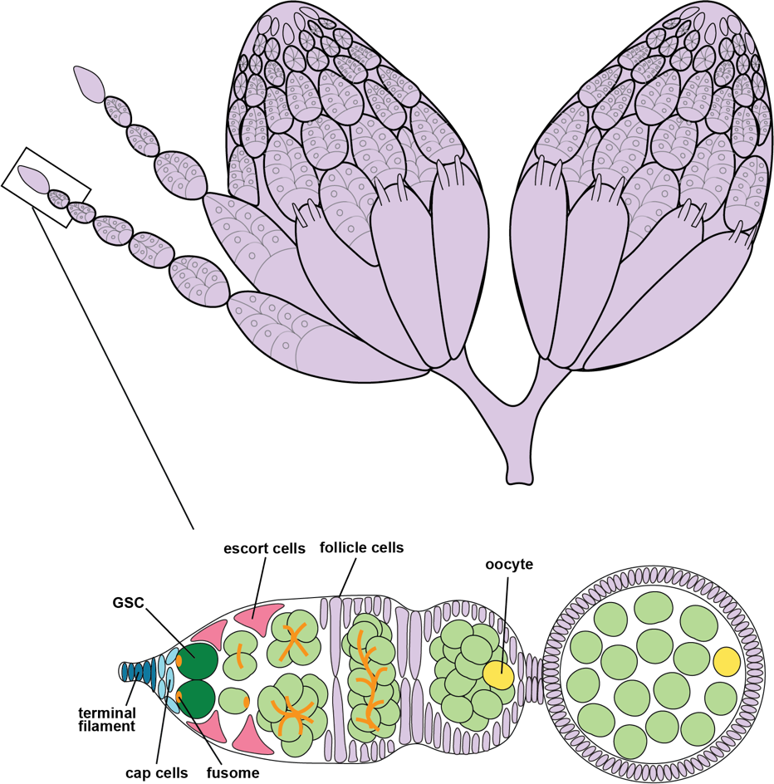

Figure 1: Drosophila ovary and germaria diagram. Each ovary is composed of ovarioles, connected chains of developing egg chambers arising from a single germarium. At the anterior tip, germline stem cells (GSCs, dark green) are attached to cap cells (pink) and have a specific organelle (the fusome, orange) that is useful for identification. GSCs divide to form the cystoblast (lime green), which undergoes four rounds of synchronous mitotic divisions. The resulting 16-cell cyst consisting of 15 nurse cells and one oocyte (yellow) becomes enveloped by a layer of follicle cells (light blue) to produce an egg chamber.

RESULTS

Generation of new genetic tools to manipulate EcR in the germline.
To unveil the potential germ cell autonomous role of EcR, we designed and built new genetic tools to manipulate EcR. The Gal4/UAS system allows for spatio-temporal controlled expression of transgenic constructs (Caygill & Brand, 2016). Gal4, a yeast transcription factor, can be expressed under cell or tissue specific enhancers. Gal4 can then bind Upstream Activating Sequence (UAS) elements to turn on transcription of those target genes. Many of the current tools to manipulate EcR under UAS control have a heat shock promoter that allows for expression in somatic cells but becomes suppressed in germ cells (DeLuca & Spradling, 2018). A new transgenic vector, UASz 1.0, has a different promoter and allows for effective expression in the germline.
In the UASz construct, we built an over-expression construct for an EcR protein that can bind ecdysone and is functionally undistinguishable from wildtype protein (UASz-EcR.B1^{ΔC655} = EcR.B1 and UASz EcR.A^{ΔC627} = EcR.A) (Figure 2B). We also created three additional transgenes of EcR dominant negatives that are unable to transactivate transcription due to mutations in their ligand binding domain (Cherbas et al., 2003) (Figure 2A-B). When these dominant negatives are over-expressed, they outcompete endogenous EcR protein for ligand binding.
Although these constructs have previously been described to effectively knockdown ecdysone signaling, we first confirmed that they function in the UASz background. To do this, the EcR.B1 over-expression and dominant negative constructs were expressed under Actin-Gal4. Actin expresses in all somatic cells throughout all stages of development. EcR is necessary for the progression through pupariation, so we expected flies expressing the dominant negatives would not survive into adulthood, while excess functional EcR protein should not inhibit fly development (Cherbas et al., 2003). We found that expressing the UASz dominant negatives under Actin-Gal4 was in fact lethal. Expression of EcR.B1 however was not, this showing these tools function similar to the original transgenes.

Over-expression of EcR.B1 in germ cells causes tumors.
EcR is expressed at apparently equal levels in GSCs, their dividing daughters, and in surrounding somatic cells of the germarium (Martin et al., 2022; Schwedes et al., 2011). We thus sought to test whether over-expression of EcR in germ cells impacted germline development. To confine expression to germ cells, we used nanos-Gal4∷VP16 (nos-Gal4), a strong driver that is maximally expressed in GSCs and their dividing daughters. Driving UASp-GFP allowed us to label germ cells with a fluorescent tag, while immunostaining with anti-Hts and anti-LaminC allowed for visualization of fusomes and nuclear membranes, and DAPI stained nuclei. As expected, expression of LacZ alone yielded ovarioles with 2-3 GSCs per germarium, mitotically dividing cysts, and egg chambers produced from the niche (Figure 3A). In contrast, over-expression of EcR.B1 in all germ cells under nanos-Gal4 resulted in germ cell tumors (Figure 3B). Instead of various stages of cyst development (2, 4, 8, and 16-cell) in the germarium, there is no identifiable post-mitotic, 16-cell cysts; rather, only cells with a round, dotted fusome indicative of cystoblasts. We identified egg chambers by larger nurse cell nuclei and approximate correct number of germ cells. As a result of the improper cyst development, egg chamber production was significantly reduced (Figure 3E).

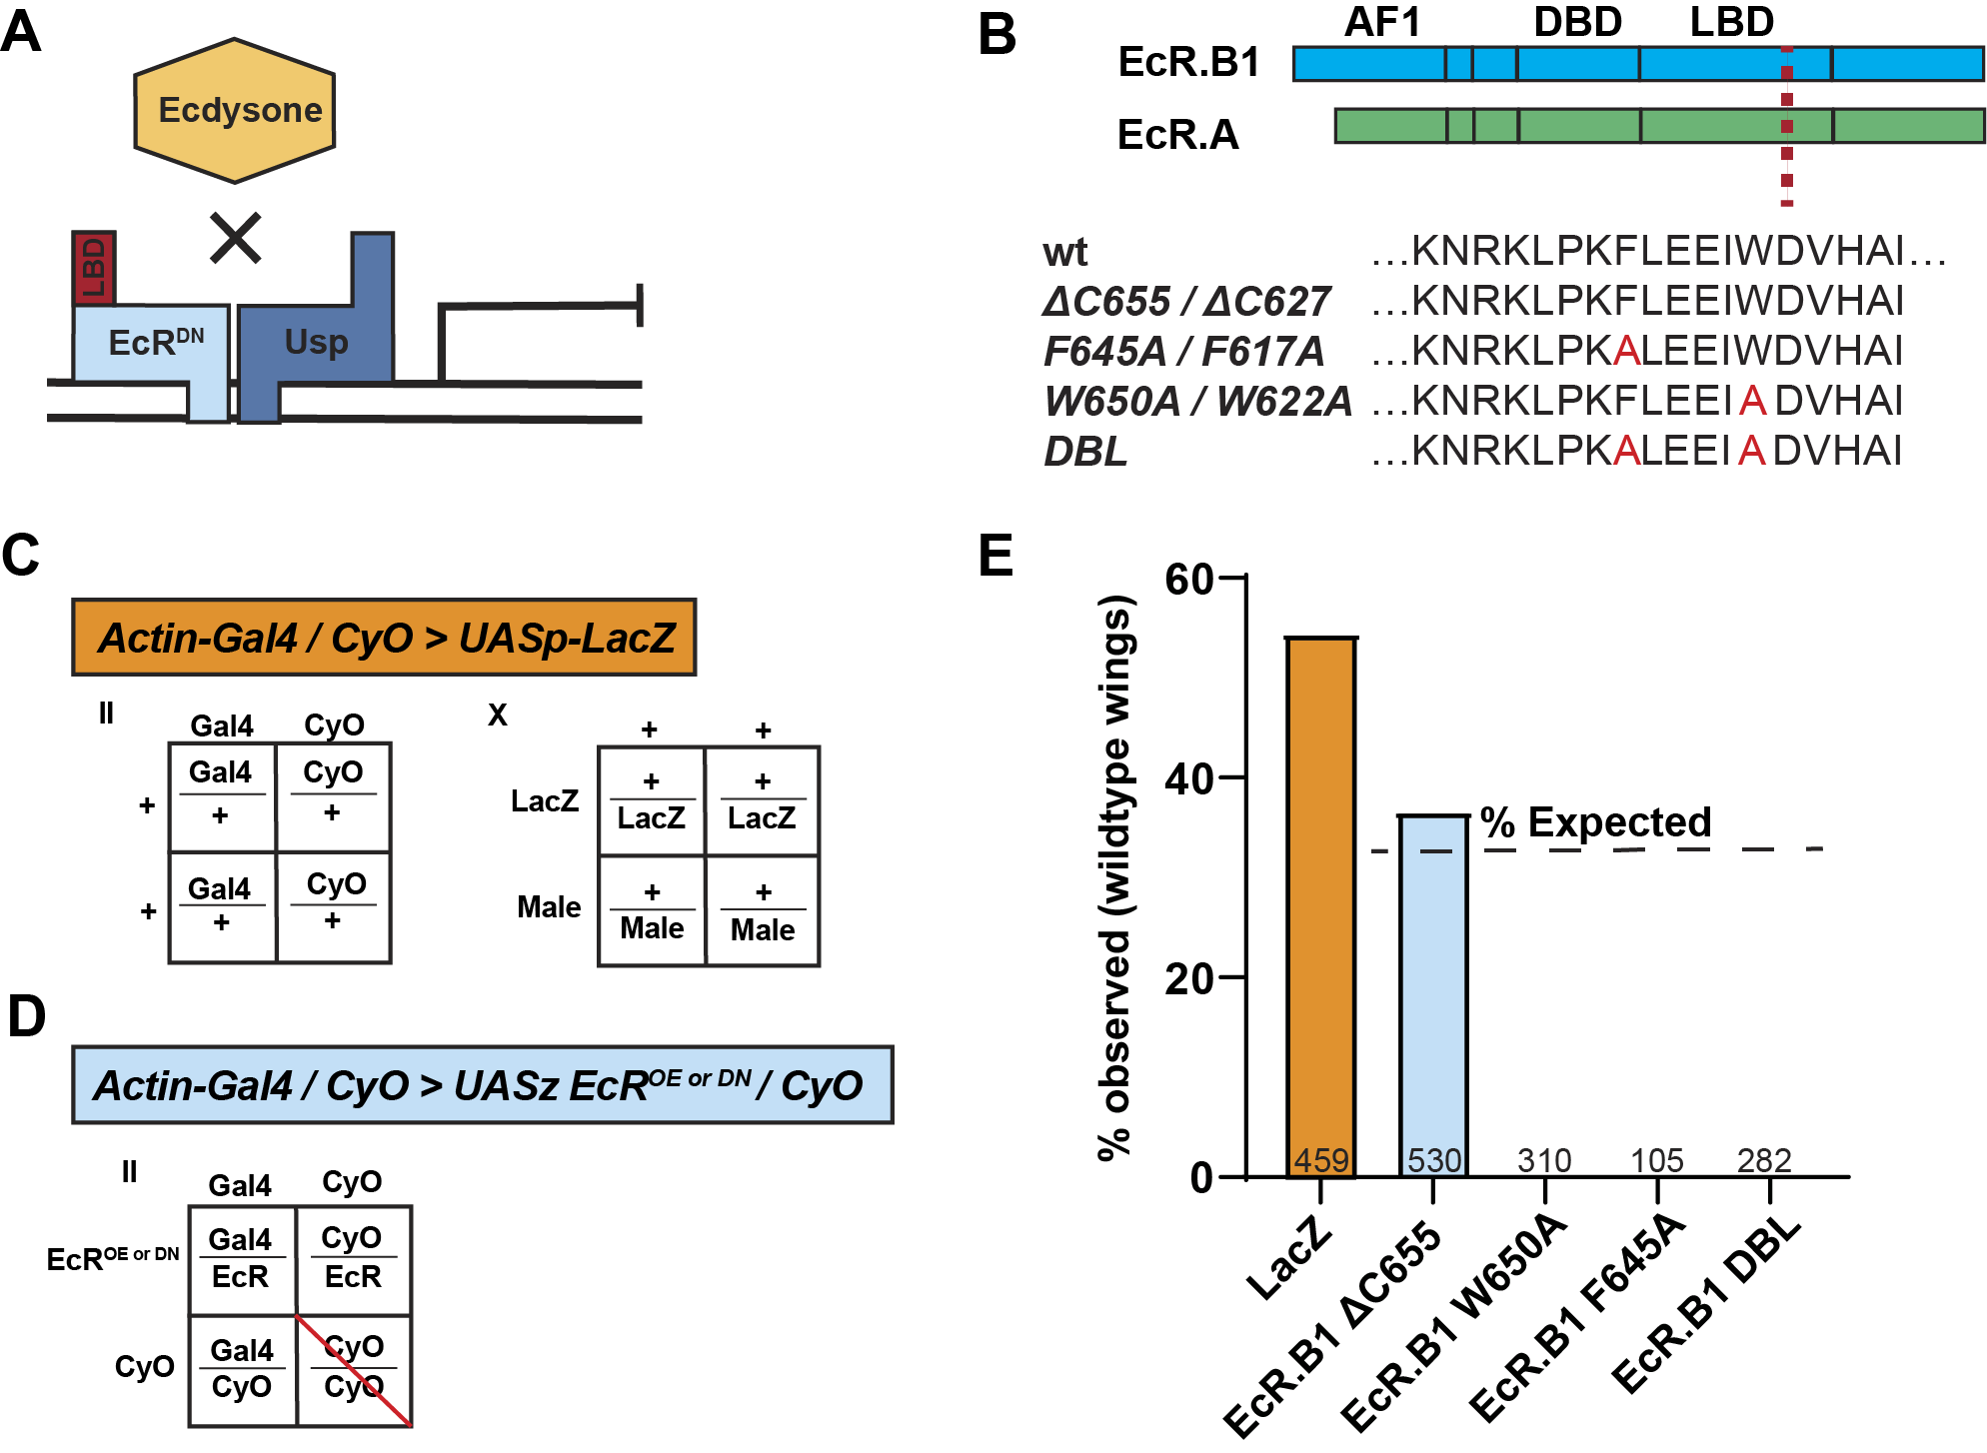Figure 2: Generation of new genetic tools to manipulate EcR in the germline. (A) Diagram of EcR dominant-negative function, where the the ligand binding domain inhibits ability of ecdysone binding. (B) EcR.B1 and EcR.A share a common DNA binding domain (DBD) and ligand binding domain (LBD) but have different activation function 1 (AF1) regions. Over-expression and dominant negative sequences have an early termination. In red are the amino acid substitutions made. (C-D) Punnett squares representing predicted genotypes of lethality screen progeny. Curly of Oster (CyO) is a wing trait used to identify flies that do not have the Gal4 gene. If EcR over-expression (OE) or dominant-negative (DN) expression is non-lethal, one third of progeny should have wildtype wings. (E) Bar graph of percent of progeny from each cross that have wildtype wings and thus the EcR transgene. Sample size is represented at the base of each bar.
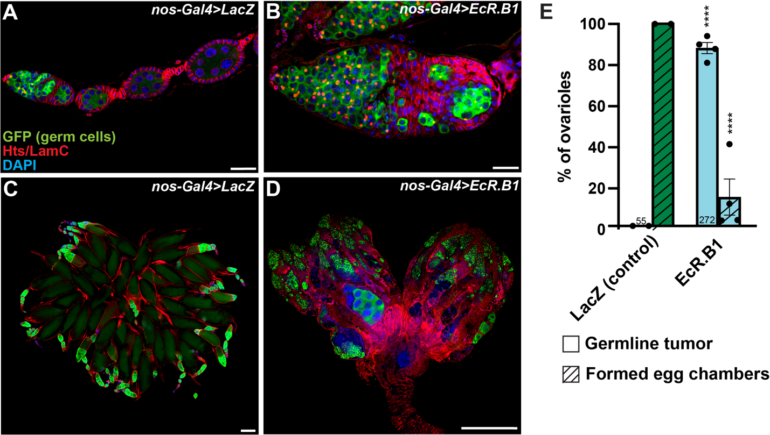

Figure 3: Over-expression of EcR.B1 in germ cells causes tumors. (A-D) nos-Gal4::VP16, UASp-GFP driving expression. GFP, (germ cells) is in green, Hts (stains fusomes) and LamC (stains nuclear lamina) in red, and DAPI (nuclei) in blue. A-B: scale bar = 20 μM, C-D: scale bar = 200 μM. (A) LacZ control germaria with progressive stages of cysts and egg chambers budded off from the niche. (B) EcR.B1 over-expression germaria where there is only cystoblast-like cells throughout the germaria. (C) Whole pairs of control ovaries with various stages off egg chambers and oocytes. (D) Whole pairs of ovaries over-expressing EcR.B1 where there is no egg chambers or oocytes. (E) Bar graph showing percentage of tumorous ovarioles and formed egg chambers. Dots represent percent from each sample group, bars represent standard error, and sample size is at the bottom of each bar. * p < 0.05, ** p <0.01, *** p < 0.001, and **** p < 0.0001.

Tagged EcR shows nuclear localization in germline tumors.
Nuclear localization of EcR is indicative of transcriptionally active protein (King-Jones & Thummel, 2005). To visualize EcR localization and spatial expression, we generated fluorescent tagged EcR proteins under UASz control (Figure 4). For EcR.B1 we added a mCherry protein to the N-termini and the C-termini. When overexpressing the N-terminal tagged EcR.B1 (mCherry::EcR.B1) proteins, germline tumors are generated at a frequency equivalent with the untagged protein (Figure 4A). We also see expression of the mCherry protein in all the germline tumors, localized predominately to the nucleus, and lesser amounts in the cytoplasm (Figure 4A). We suspect we see cytoplasmic localization due to the overabundance of the protein we expressed. The C-terminal mCherry (EcR.B1∷mCherry) partially allowed egg chamber development, yielding germaria of an intermediate phenotype with lower tumor frequency and more egg chambers produced (Figure 4C). This protein also localized to the nucleus in both tumorous and non-tumorous germ cells (Figure 4B). This data suggests that addition of the C-terminal mCherry may have partially blocked access of ligand to the EcR ligand binding domain or caused a conformational change in the protein, altering its function.

EcR.B1 over-expression is sufficient to generate tumors only in GSCs and cystoblasts and only at high levels.
The nos-Gal4∷VP16 driver is expressed in GSCs and their differentiating daughters. We therefore considered whether germ cells at different stages of differentiation were equally competent to respond to excess EcR. Unfortunately, a GSC-specific Gal4 driver (that is not expressed in cystoblasts) is not available. In the absence of this tool, we drove EcR.B1 over-expression in specific populations of undifferentiated cells and assay tumor frequency. (Figure
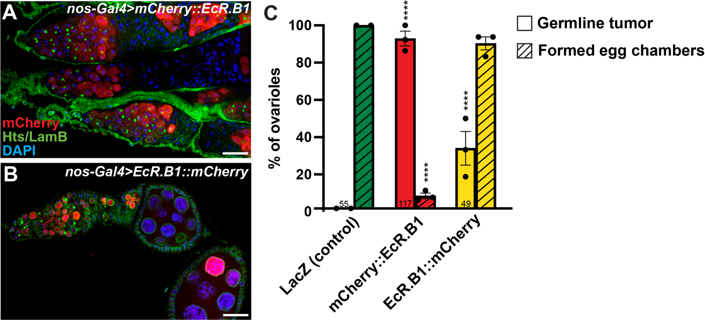
Figure 4: Tagged EcR shows nuclear localization in germline tumors. (A-B) nos-Gal4∷VP16 driving expression of mCherry tagged EcR.B1. Germaria stained for mCherry in red, Hts and Lamin B (LamB) in green, and DAPI in blue. Scale bar = 20 μM. (A) Over-expression of EcR.B1 with a N-terminal mCherry tag. mCherry signal is seen within and outside the nucleus. Cystoblast-like cells are present throughout the germaria. (B) Over-expression of EcR.B1 with a C-terminal mCherry tag. mCherry signal is detected within the nucleus. Cystoblast-like cells are present throughout the germaria, and egg chambers are produced from the niche. (C) Bar graph showing percentage of tumorous ovarioles and formed egg chambers. Dots represent percent from each sample group, bars represent standard error, and sample size is at the bottom of each bar. * p < 0.05, ** p < 0.01, *** p < 0.001, and **** p < 0.0001.

5). Using otu-Gal4::VP16, which drives expression in 16-cell cysts and developing egg chambers, we tested whether over-expression of EcR is sufficient to switch the fate of post-mitotic cells. However, over-expression of EcR.B1 under otu-Gal4::VP16 did not generate tumors or any noticeable issues with egg chamber development, likely since nurse cell and oocyte fates are already determined at these stages (Figure 5B).
Next, using Bam-Gal4, EcR.B1 was overexpressed in early, mitotic germ cells (primarily the 4, 8, and early 16-cell cysts). Under this Gal4 control, we again have no tumor formation (Figure 5C). We also over-expressed mCherry::EcR.B1 to confirm the spatial expression and see strong mCherry signal within the early germ cells (Figure 5D). To try expressing EcR in the earliest GSC daughter cells, we utilized aub-Gal4. This driver expresses in a mosaic pattern, occasionally weak GSC and cystoblasts expression and progressively stronger expression through the developing cysts. Over-expressing EcR.B1 under aub-gal4 there were no instances of germline tumors (Figure 5E). Altogether, restricting over-expression to the cysts and egg chambers is not able to generate germline tumors like overexpressing in all germ cells does. This indicates that over-expression is sufficient to alter cell fate only when expressed in the GSCs and cystoblast.
The level at which EcR is being over-expressed is also critical for the tumor phenotype. Using a germline driver that expresses EcR.B1 at lower levels in all germ cells, NGT-Gal4, there was no tumor formation (Figure 5F). Although we do not have a quantitative measure on the level at which EcR.B1 is over-expressed, we can conclude that the titer of protein is pertinent for the promotion of an undifferentiated fate.

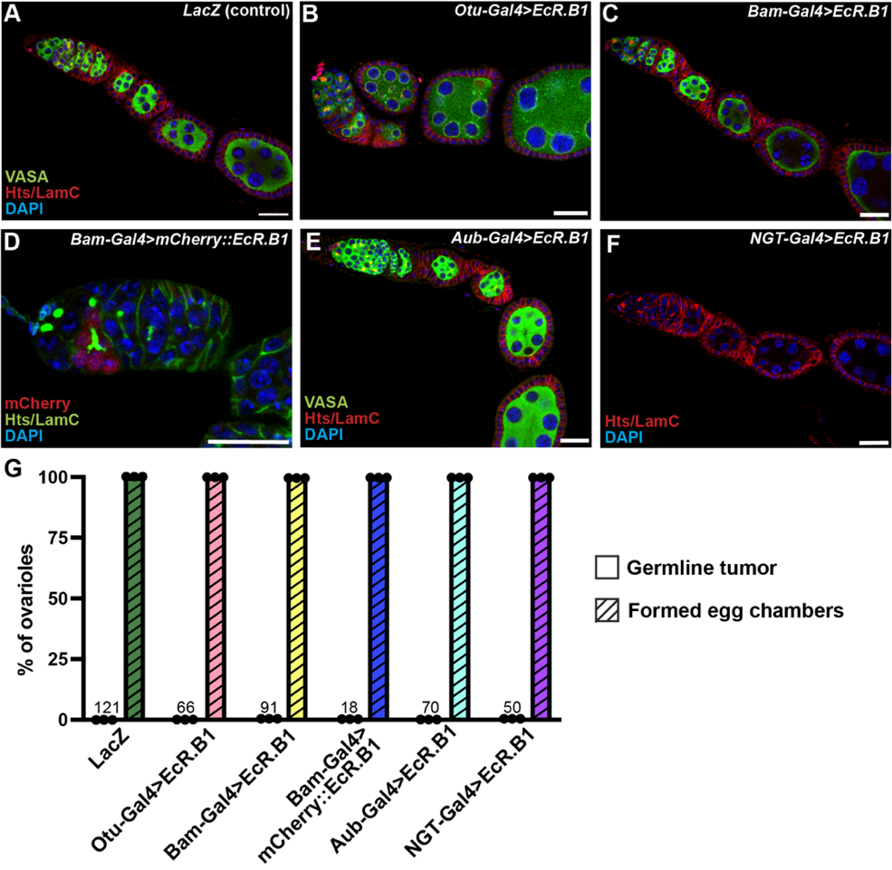
Figure 5: EcR.B1 over-expression is sufficient to generate tumors only in GSCs and cystoblasts and only at high levels. (A-F) Different germline Gal4 drivers expressing EcR.B1. Scale bar = 20 μM. (A-C, E-F) Vasa stained in green, Hts and LamC in red, and DAPI in blue. (A) Control germaria expressing LacZ under Bam-Gal4, no tumors formed. (B) Otu-Gal4 driving expression in post mitotic cells, no tumors formed. (C) Bam-Gal4 driving EcR.B1 expression in early mitotic cells, no tumors formed. (D) Bam-Gal4 driving expression of mCherry∷EcR.B1. mCherry stained in red, Hts and LamC in green, and DAPI in blue. No tumors formed. (E) Aub-Gal4 driving expression in a mosaic pattern, no tumors formed. (F) NGT-Gal4 driving low levels of EcR.B1 expression in all germ cells, no tumors formed. (G) Bar graph showing percentage of tumorous ovarioles and formed egg chambers. Dots represent percent from each sample group, bars represent standard error, and sample size is at the bottom of each bar. Significance was tested using Fisher’s exact test. * p < 0.05, ** p <0.01, *** p < 0.001, and **** p < 0.0001.
EcR.B1 dominant negatives reveal ligand binding facilitates tumor phenotype.
EcR can bind open chromatin in both the presence and absence of ecdysone (Uyehara et al., 2022). In the absence of ligand, in the model posited by Ashburner, EcR is thought to repress transcription, while ligand binding is thought to activate transcription. To test whether the tumor phenotype generated by over-expression of EcR reflected a ligand dependent function, we overexpressed forms of EcR that cannot activate transcription (Cherbas et al., 2003). Over-expression of EcR.B1^{F645A} , that can bind ligand but cannot activate transcription in vitro, did not generate germline tumors (Figure 6B). This indicates that the undifferentiated germline tumors caused by over-expression of EcR.B1 is in an ecdysone dependent manner. Over-expression of one of the dominant negatives, EcR.B1^{W650A}, which cannot bind ligand or activate transcription, did generate germline tumors (Figure 6C). However, the phenotype is milder, as they form tumors less frequently than wildtype EcR.B1 and similar to EcR.B1∷mCherry. We speculate that this phenotype is not a result of loss of ligand binding activity, since the EcR.B1^{DBL} that also contains the same amino acid substitution in addition to the F645A substitution, does not generate tumors (Figure 6D).

Increasing ecdysone levels suppresses tumor formation.
Given that EcR.B1^{F645A} and EcR.B1^{W650A} yielded different phenotypes, we asked whether levels of ecdysone influenced tumor formation in EcR.B1 over-expression females. To increase levels of ecdysone present, we fed adult females over-expressing EcR.B1 the active form of ecdysone, 20E, in their diet for five days (Figure 7). Supplemental ecdysone partially rescued the tumor phenotype, where we saw a decrease in frequency of tumors but did not see an increase in egg chambers formed (Figure 7 C and D).
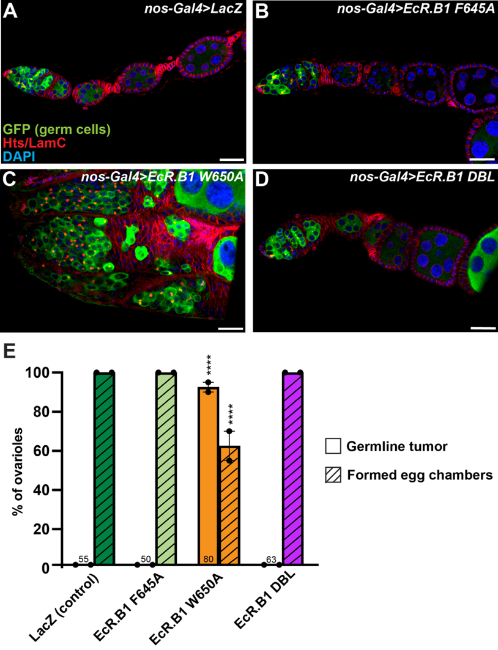
Figure 6: EcR.B1 dominant negatives reveal ligand binding facilitates tumor phenotype. (A-D) nos-Gal4∷VP16, UASp-GFP drove expression of EcR.B1 dominant negatives in all germ cells. GFP marks germ cells in green, Hts and LamC in red, and DAPI in blue. Scale bar = 20 μM. (A) Control germaria expressing LacZ. (B) Germaria over-expressing EcR.B1^{F645A} with typical cyst and egg chamber progression. (C) Tumorous germaria over-expressing EcR.B1^{W650A}. (D) Germaria over-expressing dominant-negative EcR.B1^{DBL} with typical cyst and egg chamber development. (E) Bar graph showing percentage of tumorous ovarioles and formed egg chambers. Dots represent percent from each sample group, bars represent standard error, and sample size is at the bottom of each bar. Significance was tested using Fisher’s exact test. * p < 0.05, ** p <0.01, *** p < 0.001, and **** p < 0.0001
Upon mating and deposition of sex peptide in the male seminal fluid, females increase ecdysone biosynthesis; thus, unmated females have low titer of ecdysone (Ameku & Niwa, 2016). We therefore tested whether mating influenced tumor production. Female flies were kept unmated for five days and in those ovaries, there was no significant change in tumor formation or egg chamber production (Figure 7 E and F). This suggests that early germ cells respond to very low levels of ecdysone.
Understanding that ecdysone levels is an important switch for EcR’s function in the germline, it became important to determine wildtype levels of ecdysone. Previous studies utilized EcR ligand sensors which act as ecdysone reporters (Kozlova & Thummel, 2002). These reporters, however, do not express in the germline, likely due to degradation by piRNAs (Ables, unpublished). We created a germline compatible EcR ligand sensor in which the constitutive germline promoter, nanos, should drive expression of a protein with the Gal4 DNA binding domain fused to the EcR hinge and ligand binding domain. When the protein binds ecdysone, it allows the Gal4 DBD to bind a UAS element and turn on expression of a reporter. Unfortunately, the reporter was not expressed in the germline and therefore could not be used as an evaluation of ligand availability.

Over-expression of EcR.A phenocopies EcR.B1.
It is plausible that the undifferentiated germ cell tumors caused by over-expression of EcR were a B1 isoform-specific phenotype. To over-express the A isoform, we also generated a UASz EcR.A transgene that had the equivalent early sequence termination in the ligand binding domain, EcR.A ^{ΔC627}. Over-expression of EcR.A phenocopied EcR.B1 and we see no difference

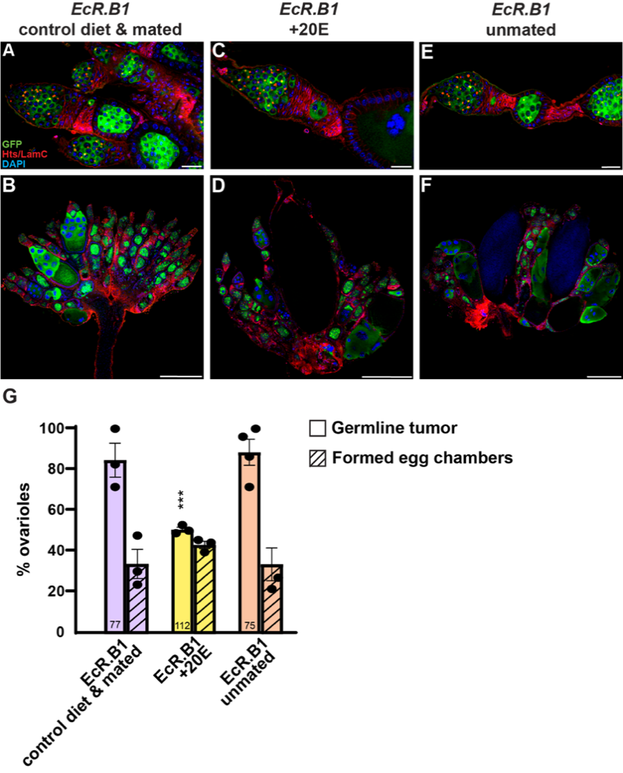
Figure 7: Increasing ecdysone levels suppresses tumor formation. (A-F) nos-Gal4, UASp-GFP driving over-expression of EcR.B1. GFP in green, Hts and LamC in red, and DAPI in blue. (A-B) Germaria and ovaries from flies that were maintained on a control wet yeast diet and mated. Germaria contain cystoblast-like cells throughout and egg chambers lack large nurse cell nuclei. (C-D) Germaria and ovaries from flies that were fed excess 20E in their diet and mated. Germaria contain later stages of cyst development and are less frequently tumorous. (E-F) Germaria and ovaries from flies that were fed a control diet and kept unmated. Germaria contain tumorous germ cells. (G) Bar graph showing percent of ovarioles with tumors and egg chambers. Dots represent percent from each sample group, bars represent standard error, and sample size is at the bottom of each bar. Significance was tested using Fisher’s exact test. * p < 0.05, ** p <0.01, *** p < 0.001, and **** p < 0.0001.
in tumor formation or egg chamber development (Figure 8A). We conclude that both isoforms are sufficient to promote an undifferentiated fate.

We also found that the over-expression of mCherry tagged EcR.A constructs in all germ cells generated germline tumors at similar frequencies to the B1 tagged constructs. We found that N-terminal tagged EcR.A (mCherry::EcR.A) formed tumors at similar frequency to the untagged construct, and the C-terminal (EcR.A::mCherry) generated tumors at a lower frequency (Figure 8C and D). Both proteins had nuclear mCherry localization, indicative of transcriptionally active EcR.A.
We also attempted to express both mCherry tagged proteins in germ cells at a lower level using a different Gal4 driver, NGT-Gal4::VP16, to visualize nuclear localization. Expressing under this Gal4 driver we could not see strong enough mCherry signal to distinguish nuclear localization in the early germ cells and egg chambers (Figure 8 E and F). With this weaker expression we also did not generate germline tumors, supporting that high levels of EcR protein is necessary to for the promotion of an undifferentiated fate.
Although over-expression of EcR-B1 or A had no difference in phenotype, loss of function could reveal an isoform specific role. To do so, equivalent EcR.A dominant negatives that cannot bind ecdysone were generated into the UASz construct. The EcR.B1^{F645A} equivalent, EcR.A^{F617A} did not generate tumors (Figure 8G). The EcR.B1^{W650A} equivalent, EcR.A^{W622A}, did however generate germline tumors (Figure 8H). Because all three dominant-negatives had no meaningful difference in phenotype from either isoform, we conclude that these genetic tools are not effective at discerning isoform-specific roles.

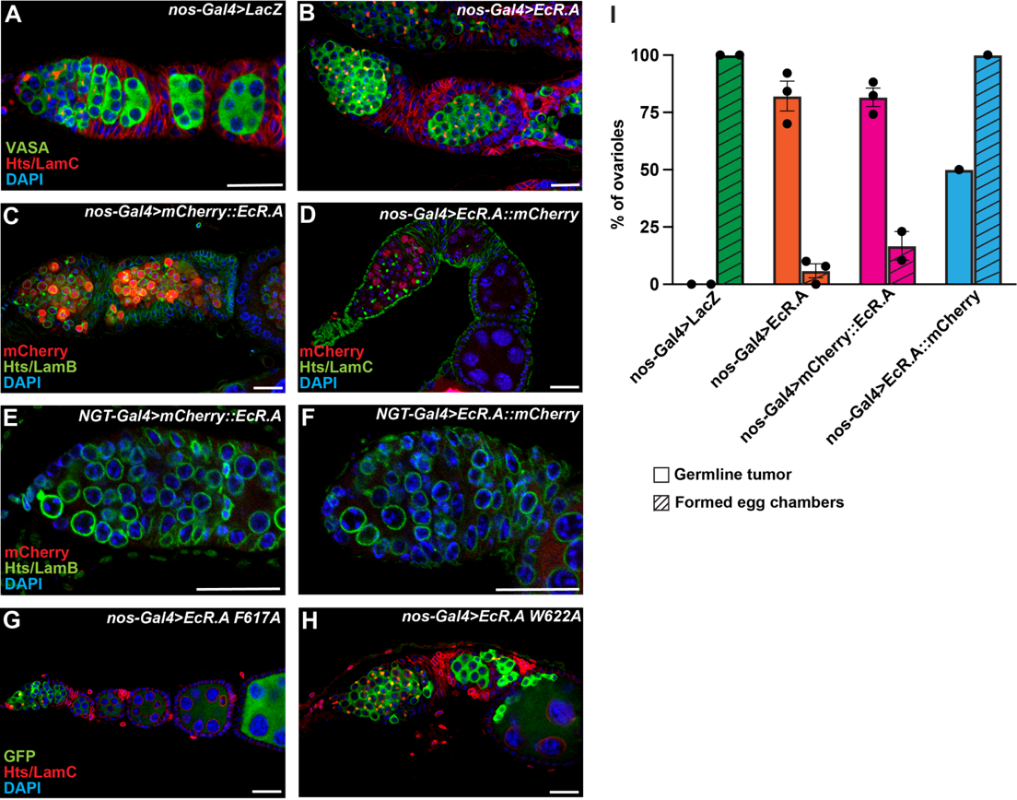
Figure 8: Over-expression of EcR.A phenocopies EcR.B1. (A-B) Germaria with nos-Gal4∷VP16 driving expression in the germ cells. Vasa which stains germ cells in green, Hts and LamC in red, and DAPI in blue. (A) LacZ control germaria with various stages of cyst development. (B) Over-expression of EcR.A where there are only cystoblast-like tumors. (C-D) nos-Gal4∷VP16 driving expression. mCherry in red, Hts and LamB in green, and DAPI in blue. (C) Over-expression of N-terminally tagged EcR.A, where mCherry localized to the nucleus and cytoplasm. Germline tumors were formed and we see no nurse cell nuclei. (D) Over-expression of C-terminally tagged EcR.A, where mCherry localized to the nucleus. There is some later stages of cyst development and egg chambers produced from the niche. (E-F) Weaker, germ cell driver NGT-Gal4 driving expression. mCherry in red, Hts and LamB in green, DAPI in blue. (E) Expression of N-terminally tagged EcR.A at lower levels with no detectable signal in the germline or tumor formation. (F) Expression of C-terminally tagged EcR.A at lower levels with no detectable signal in the germline or tumor formation. (G-H) nos-Gal4, UASp-GFP driving expression of EcR.A dominant-negatives. GFP which marks germ cells in green, Hts and LamC in red, and DAPI in blue. (G) Over-expression of EcR.A^{F617A} in the germline, where cysts and egg chambers developed progressively. (H) Over-expression of EcR.A^{W622A}, where germline tumors are formed. (A-H) Scale bar = 20 μM. (I) Bar graph showing percentage of tumorous ovarioles and formed egg chambers. Dots represent percent from each sample group, bars represent standard error, and sample size is at the bottom of each bar. * p < 0.05, ** p <0.01, *** p < 0.001, and **** p < 0.0001.

EcR over-expression causes GSC loss and stem-like tumors.
Although germ cells in EcR over-expression ovaries fail to differentiate properly to produce cysts, it is plausible that is due to failure of turning off their stem cell program. BMP signaling is a well characterized pathway necessary for ovarian germline stem cells. BMP ligands, decapentapalegic (dpp) and glass bottom boat (gbb), are secreted by the somatic cap cells and are received by the cell-surface receptors thick veins (Tkv) or Saxophone (Sax) and Punt (Xie & Spradling, 1998; Xie & Spradling, 2000;). Upon binding of dpp or gbb and the dimerization of the receptors, the type I receptors (Tkv or Sax) phosphorylate the transcription factor Mothers against decapentaplegic (Mad). Phosphorylated Mad (pMad) along with Medea, translocate to the nucleus and repress differentiation genes such as bag of marbles (Bam) (Chen & McKearin, 2003a; Song et al., 2004). After GSC division the cystoblast moves further away from the BMP source and no longer receives the signal to repress differentiation (Chen & McKearin, 2003b).
To identify if germline tumors express stem cell markers appropriately, we stained them with an antibody against phosphorylated Mad (Figure 9A). We were able to identify pMad positive stem cells correctly positioned within the niche in control and EcR.B1 over-expression (Figure 9B). However, in EcR.B1 overexpression we find that the average number of GSCs is decreased, indicating that increased levels of EcR also impacts self-renewal (Figure 9E).
Interestingly, in the EcR overexpression ovaries, pMad positive cells were also detected outside of the GSC niche. While BMP ligand is secreted from cap cells for the GSCs, the follicle cells of the mid-stage egg chambers are also a source of dpp protein (Rust et al., 2020). In the occasion where the EcR overexpression ovaries formed egg chambers with nurse cells, smaller, pMad-positive germline tumors could be identified (Figure 9 C and D). This shows that the EcR germline tumors remain competent to respond to dpp signals.
Stem-like cells could be derived from over-proliferative GSCs or mitotically active tumor cells. To see if the tumors are still mitotically active, we stained ovaries for phospho-histone 3 (PHH3), which positively marks cells during mitosis, and EdU, which labels cells during S phase. At five days after eclosion, we find that germ cells throughout the ovary are mitotically active (Figure 9H). This suggests that the tumors developed from symmetric and complete divisions of the stem-like tumor cells.

Germline tumors caused by EcR.B1 do not express differentiation markers.
Other genes expressed in the BMP signaling pathway can be indicative of tumor cell differentiation. Daughters against dpp (Dad) is a protein induced by dpp signaling and is found typically in control GSCs and cystoblast (Casanueva & Ferguson, 2004) (Figure 10J). Using a Dad-LacZ reporter, we find β-gal expression in the GSCs of EcR.B1 over-expressing germaria. Using a Bam-GFP reporter line, we can identify if these tumor cells turn on one of the critical differentiation promotion genes. In control germaria, GFP can be detected in 2 and 4-cell cysts (Figure 10G). In EcR.B1 over-expression, majority of tumor cells are GFP negative, but there is sporadic expression of GFP in cells throughout the ovary (Figure 10H). This expression indicates that these germ cells are not differentiating properly due to lack of proper gene expression.
Outside of the canonical BMP signaling pathway, other proteins are also critical for the promotion of early germ cell differentiation. Rbfox1 is an RNA binding protein that is specifically upregulated in the cystoblast to repress pumilio translation (Carreira-Rosario et al., 2016). Using an antibody against Rbfox1, protein can be levels are high enough to be visualized
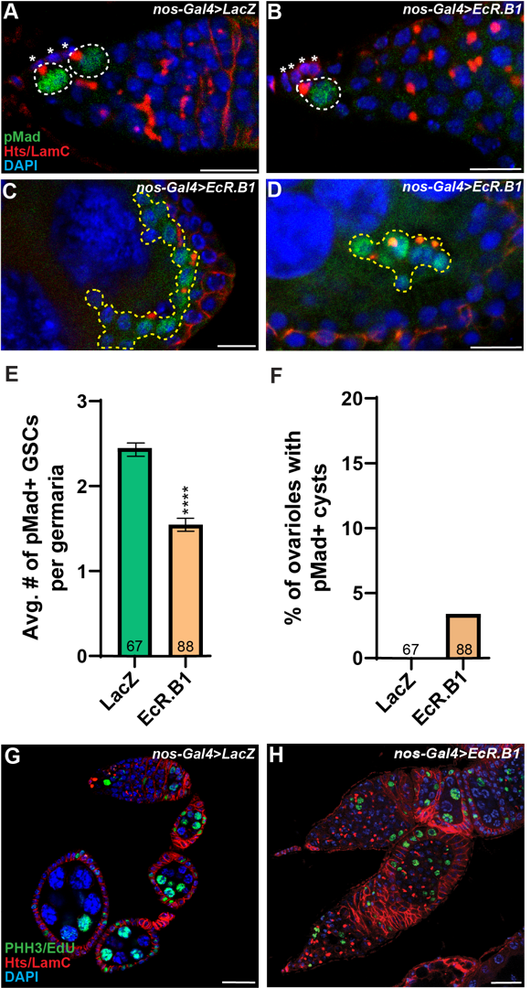
Figure 9: EcR over-expression causes GSC loss and stem-like tumors. (A-D) Ovaries stained for the stem cell marker, pMad. Asterisks mark cap cells, dotted white lines outline GSCs, and dotted yellow lines outline pMad positive tumors. pMad in green, Hts and LamC in red, and DAPI in blue. Scale bar = 10 μM. (A) LacZ control germaria. (B) EcR.B1 over-expression germaria. (C-D) EcR over-expression tumors in egg chambers. (E-F) Ovaries stained for PHH3 and EdU in green, Hts and LamC in red, and DAPI in blue. Scale bar = 20 μM. (E) LacZ control ovariole. (F) EcR.B1 over-expression. (G) Bar graph showing average number of pMad+ GSCs per germaria. Significance measured using student’s t-test. (G) Bar graph of percent of ovarioles with pMad+ cysts. Bars represent standard error, and sample size is at the bottom of each bar. * p < 0.05, ** p <0.01, *** p < 0.001, and **** p < 0.0001.
starting around the 4-cell cyst stage in controls (Figure 10D). In EcR.B1 tumors, Rbfox1 antibody is not detected in the germ cells (Figure 10E). Other differentiation markers such as, Orb, an oocyte-specific protein, can also indicate if tumors have terminally differentiated (Barr et al., 2019) (Figure 10A). In EcR.B1 over-expression germ cells, Orb protein was not detected (Figure 10B).

EcR.B1 and Tkv^{ACT} tumors reveal striking transcriptional similarity.
Comparing our EcR.B1 over-expression phenotype to other known tumor phenotypes can also provide insight into germ cell fate determination. Manipulation of the BMP signaling pathway in the germline also generates germline tumors. In Bam mutant ovaries, undifferentiated germ cell tumors are produced because of the loss of the ability for cysts to differentiate (McKearin & Spradling, 1990; McKearin & Ohlstein, 1995). Like Bam mutants, over-expressing a constitutively active Tkv protein (Tkv^{ACT}) also generates stem-like germline tumors (Casanueva & Ferguson, 2004) (Figure 11B). The Tkv^{ACT} protein constituitively phosphorylates Mad irrespective of ligand binding, promoting repression of differentiation genes. Like EcR over-expression, this leads to an over-production of stem-like undifferentiated germ cells (Figure 10 C, F, I, L).
To identify the transcriptional changes of EcR.B1 over-expression germ cell tumors and how it compares to overactive BMP signaling, we utilized single-cell RNA-sequencing (scRNA-seq). Several labs have been successful using this technique in the ovary and been able to resolve both germ and somatic population transcriptional profiles (Slaidina et al., 2021; Rust et al., 2020; Jevitt et al., 2020). In this approach, we anticipated that using wild-type ovaries as a comparison for the EcR.B1 over-expression sample would not permit sufficient resolution, since the GSCs
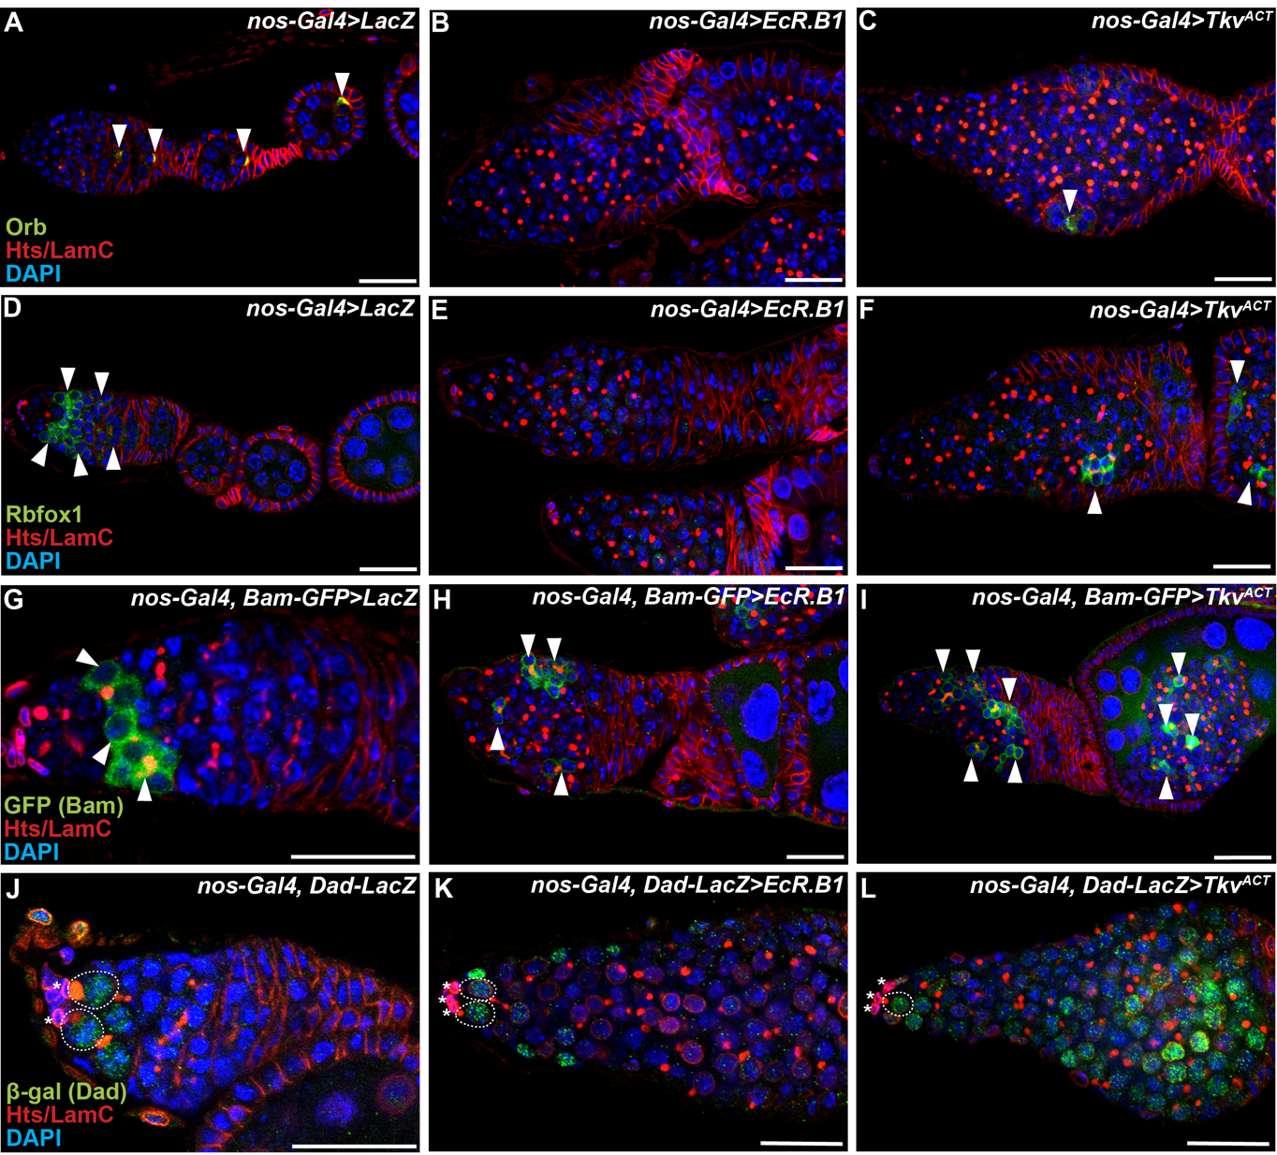Figure 10: Germline tumors caused by EcR.B1 do not express differentiation markers. (A-C) Germaria stained for the Orb in green, Hts and LamC in red, and DAPI in blue. Arrowhead points to oocyte marked by orb. Scale bar = 20 μM. (D-F) Germaria stained for RbFox1 in green, Hts and LamC in red, and DAPI in blue. Arrowhead points to RbFox1+ cysts. (G-H) Over-expression driven by nos-Gal4, Bam-GFP. GFP in green, Hts and LamC in red, and DAPI in blue. Arrowheads point to Bam+ cysts. (J-L) Over-expression driven by nos-Gal4, Dad-LacZ. β-gal in green, Hts and LamC in red, and DAPI in blue. Asterisks mark the cap cells and Dad+ GSCs are outlined in white dashed lines.
and cystoblasts are a small fraction of total cells. Instead, we opted to compare EcR.B1 over-expression to Tkv^{ACT} over-expression since both enrich for early germ cells.
Pooling both the EcR and Tkv samples and projecting them into a UMAP, we visualize two main groups from 16 clusters (Figure 10C). The lower, strawberry-shaped group was highly enriched for germ cell markers nanos and Vasa (clusters 2,3,4,5,6, and 14) (Figure 10D). Whereas the upper, flower-shaped group enriched for various somatic cell markers such as traffic jam, fasclin3, and eyes absent.
We then identified six germ cell subpopulations (Figure 10E). In the tSNE spatial projections, the EcR.B1 and Tkv^{ACT} sample are minimally overlapped from one another but share the same six subpopulations in varying proportions (Figures 10 F-K). Looking at the expression of early germ cell/GSC markers such as benign gonial cell neoplasm (bgcn) or meiotic p26 (mei-p26) we see consistent expression in all clusters (Li et al., 2012; Ohlstein et al., 2000) (Figure 10 L-M). It cannot be determined with confidence which subpopulation of the germ cells are the true stem cells because GSCs do not have an enriched, discrete transcriptional identifier.
Looking at the germ cells in bulk, there are very few genes significantly and highly upregulated or highly downregulated comparing these two over-expression samples. One highly upregulated gene, in the EcR.B1 sample is an uncharacterized gene, CG43134 (Log2 fold change = 3.65, p = 8.43 e-6). Although it is a relatively small protein at 82 amino acids, there are no predicted functions, and we cannot draw conclusions on how this is involved in germ cells. Female sterile (1) k10 (Fs(1)k10) is a gene that is downregulated in the EcR.B1 sample (Log2 fold change = -3.96, p = 1.03 e-40). Fs(1)k10 has been previously implicated in oogenesis and dorsoventral patterning, as it is necessary for gurken mRNA localization in the developing oocyte (Serano et al., 1995). Interestingly, Rps19b is downregulated in the EcR.B1 sample. Rps19b is a ribosomal protein enriched in the GSCs and early cysts and modulates the translation of the differentiation factor, Rbfox1 (McCarthy et al., 2022). The downregulation of this ribosomal protein could be one of the indirect or direct targets EcR acts upon to restrict differentiation.

Analysis of a germline tumor transcriptome.
While over-expressing either EcR.B1 or Tkv^{ACT} generates early germ cells, there is variability in the germ cells produced. Looking at differential expression in the six germ cell subclusters, we see discrete expression across the clusters indicating that EcR.B1 or Tkv^{ACT} germline tumor are heterogenous with some variability in identity (Figure 12A). Cluster 14 shows the most distinct transcriptional profile. Interestingly, the most-upregulated genes such as sidestep (side), pale (ple), and Rab3-GEF, are all enriched in neurons (Fly Cell Atlas). However, it is not likely that Cluster 14 cells are neurons due to the absence of stereotypical neuronal markers such as N-cadherin, elav, or nSyb. This cluster is also enriched for two Snail family transcription factors escargot (esg) and scratch (scrt) which work to negatively regulate Notch-mediated neuronal cell fate commitment (Remat et al., 2016). Although dispensable for spermatogenesis, escargot is a male sex-specific GSC marker (Streit et al., 2002). While there is no evidence that these neuronal-associated genes have a role in the typical germline, they strike curiosity about their potential role in differentiation and regulation by EcR or BMP signaling.
With the high level of similarity between the two tumor transcriptomes, it is plausible that these signaling pathways regulate one another. We know by over-expressing Tkv^{ACT}, we increased the level of its expression; but, when we compare it to level of Tkv expression in the
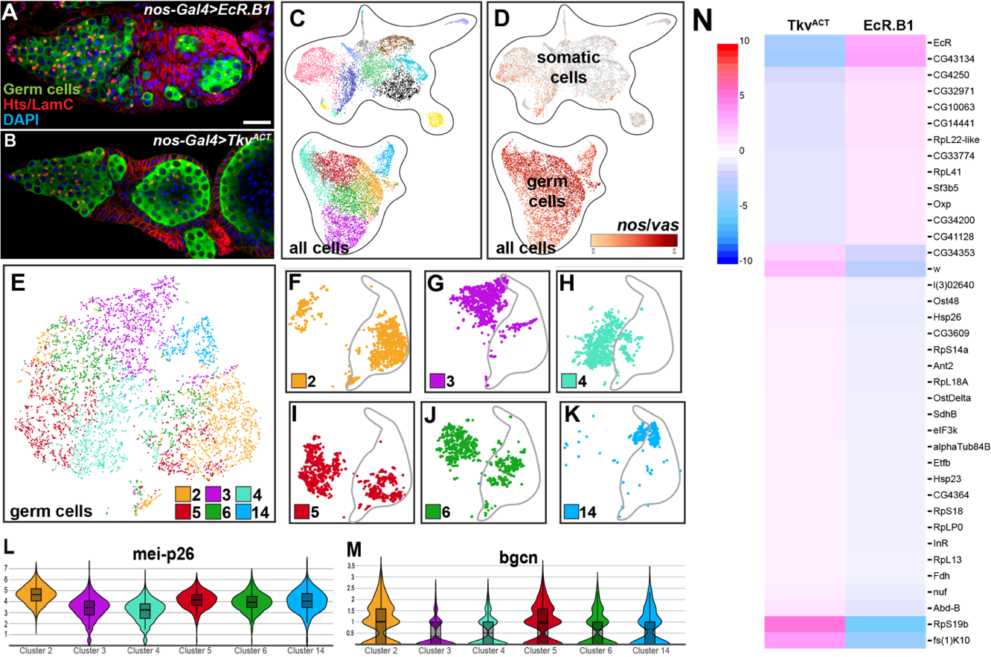
Figure 11: EcR.B1 and Tkv^{ACT} tumors reveal striking transcriptional similarity. (A-B) Images of germline tumors with germ cells in green, Hts and LamC in red, and DAPI in blue. Scale bar = 20 μM. (A) EcR.B1 over-expression tumors. (B) Tkv^{ACT} over-expression tumors. (C) UMAP projection of all cells from both EcR.B1 and Tkv^{ACT} samples. Each color denotes a different cluster identified, and each dot represents one cell. (D) Germ cells, identified by nanos and Vasa expression (red). (E) tSNE project of only germ cells from both EcR.B1 and Tkv^{ACT} samples. (F-K) tSNE projections of each germ cell subcluster from both samples. EcR.B1 cells outlined in grey, and Tkv^{ACT} cells are un-outlined. (L) Violin plot of mei-p26 expression in the six germ cell subclusters. In the box plot, the bottom line represents the lower 25% and the upper represents the upper 25%, the solid line denotes the median, and the dashed line denotes the mean of the cells in the cluster. (M) Violin plot of bgcn expression. (N) Heatmap comparing Log2Fold change of gene expression in Tkv^{ACT} and EcR.B1 germ cells. Pink = high expression and blue = low expression.
EcR.B1 sample there is no statistical difference in expression (Figure 12B). This indicates that by over-expressing EcR.B1, we also increased Tkv expression. This could be a mechanism by which these signaling pathways interact.
Knowing ecdysone levels are important for the EcR.B1 over-expression phenotype, it is important to look for evidence of germ cells synthesizing their own ecdysone. There are ten enzymes that belong to the Halloween gene family that convert dietary cholesterol to 20E (Rewitz et al., 2006). Looking at six of the Halloween genes (phantom, shadow, shade, neverland, disembodied, and spooky) we found no expression in the germ cells (Figure 12C). This is not surprising, as other transcriptomic analysis of the ovarian germ cells have also found no evidence of early germ cell ecdysone biosynthesis.
Canonical EcR targets were also identified in the germ cell clusters from both EcR.B1 and Tkv^{ACT} samples. mRNA of the orphan nuclear receptor, Ftz-f1, was found in all six subclusters (Figure 12F). Ftz-f1, an orphan nuclear receptor, has a characterized role in follicle cells for egg chamber survival and has enhancer activity in mid-stage egg chamber germ cells but does not have a described role in early germ cells (Beachum et al., 2021, McDonald et al., 2019). E75 had more discrete expression and was only found in clusters 2 and 14 (Figure 12E). Unexpectedly, an ecdysone inducible protein, E63E, was expressed in all six subpopulations (Figure 12G). E63E encodes a cyclin dependent kinase that interacts with Cyclin Y (Stowers et al., 2000; Liu & Finley, 2010). While the mechanisms by which E63E and Cyclin Y function are not well understood, they are both necessary for developmental processes across the lifespan (Liu & Finley, 2010). For these three canonical targets, their expression is the highest in clusters 2 and 14 which are also the clusters with the highest EcR expression. From this analysis, we predict that Ftz-f1, E75, and E63E are direct targets of EcR.
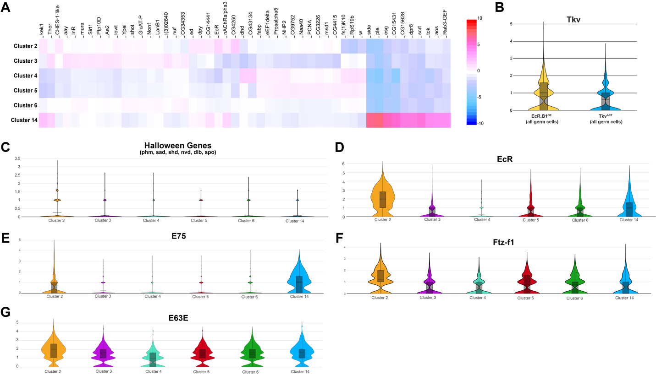
Figure 12: Analysis of a germline tumor transcriptome. (A) Heatmap of Log2Fold change in gene expression between germ cell subclusters. Red = high expression and blue = low expression. (B) Violin plot comparing Tkv expression from the two samples. In the box plot, the bottom line represents the lower 25% and the upper represents the upper 25%, the solid line denotes the median, and the dashed line denotes the mean of the cells in the cluster. Between EcR.B1 and Tkv^{ACT} samples, there is no significant difference in Tkv expression. (C) Violin plot of six Halloween Genes: phantom (phm), shadow (sad), shade (shd), neverland (nvd), disembodied (dib), and spooky (spo), where we see no expression in the six germ cell subclusters. (D) Violin plot of EcR expression, where there is expression in all six clusters, but highest in clusters 2 and 14. (E) Violin plot of E75 expression, where it is expressed in clusters 2 and 14. (F) Violin plot of Ftz-f1 expression in all six subclusters. (G) Violin plot of E63E expression in all six subclusters.

Loss of EcR mRNA causes GSC loss in an autonomous manner.
If EcR over-expression caused an increase in stem-like fate, we predicted that loss of EcR would decrease stem fate and GSC maintenance. GSC loss had been observed in EcR global mutants, but it had not been demonstrated in a germ cell autonomous manner (Konig et al., 2011, Ables & Drummond-Barbosa, 2010; Morris & Spradling, 2012). We drove expression of EcR RNAi 6-4 in only the germ cells and found equivalent numbers of GSCs in EcR-depleted and driver-only germaria at eclosion (Figure 13C). However, over time the average number of GSCs decreased in EcR-depleted germaria and was significantly lower than control at 3, 6, and 10 days after eclosion (dae) (Figure 13C). This demonstrates that EcR is necessary in GSCs autonomously for their self-renewal.

EcR is necessary for cyst encapsulation.
Interestingly, we also found that loss of EcR mRNA in the germline resulted in encapsulation defects of 16-cell cysts in regions 2B and 3. In these regions, follicle cells should extend between adjacent cysts and zipper them into an egg chamber as they exit the niche. In EcR knockdown, there was a lack of follicle cells partitioning cysts, causing cyst collisions which became most prominent at 6 days after eclosion (Figure 14D). Even when cysts weren’t captured in a collision state, they had a shortened distance between adjacent cysts compared to the control (Figure 14H). Lastly, it was observed that the shape of the region 3 cysts in the EcR knockdown had a flattened shape rather than the stereotypical globular which was measured by an aspect ratio. At 0-1 and 3 dae the average aspect ratio was significant but became consistent with the control at later time points (Figure 14L).

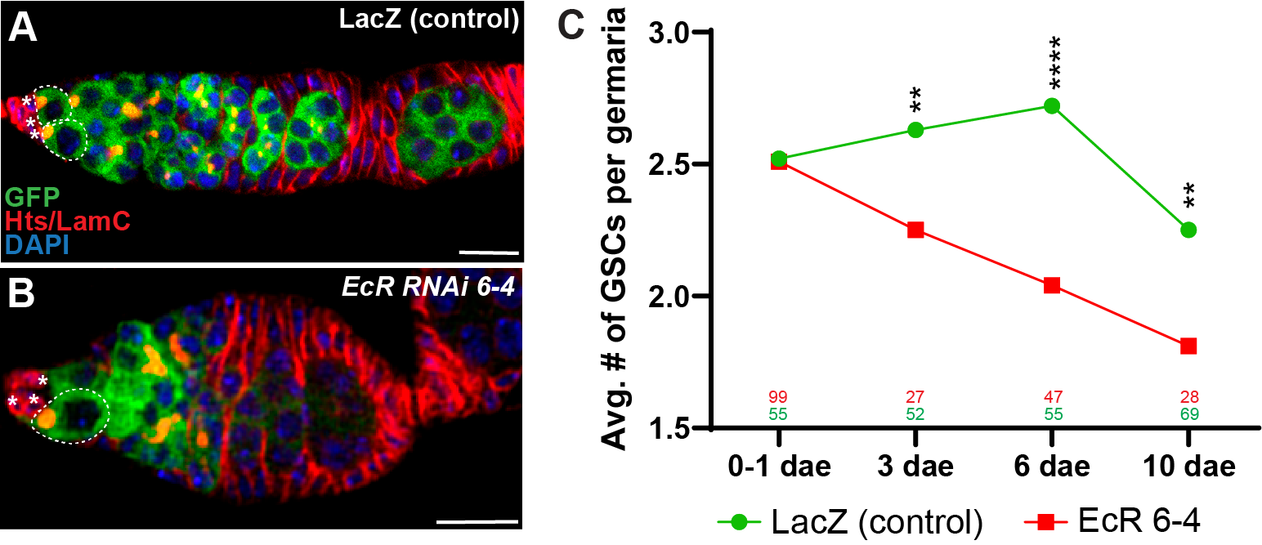

Figure 13: Loss of EcR mRNA causes GSC loss. (A-B) nos-Gal4∷VP16, UASp-GFP driving expression of EcR RNAi 6-4. Asterisks mark cap cells and GSCs are outlined in white dashed lines. GFP in green, Hts and LamC in red, and DAPI in blue. (A) LacZ control germaria. (B) EcR RNAi germaria. (C) Line graph showing the average number of GSCs at four time points. In the EcR RNAi samples, we see a significant decrease in the average number of GSCs compared to the control at all time points except 0-1 dae. Sample size is listed above each time point. *p<0.05, **p<0.01, ***p<0.001, ****p<0.0001 (Student’s T-test).
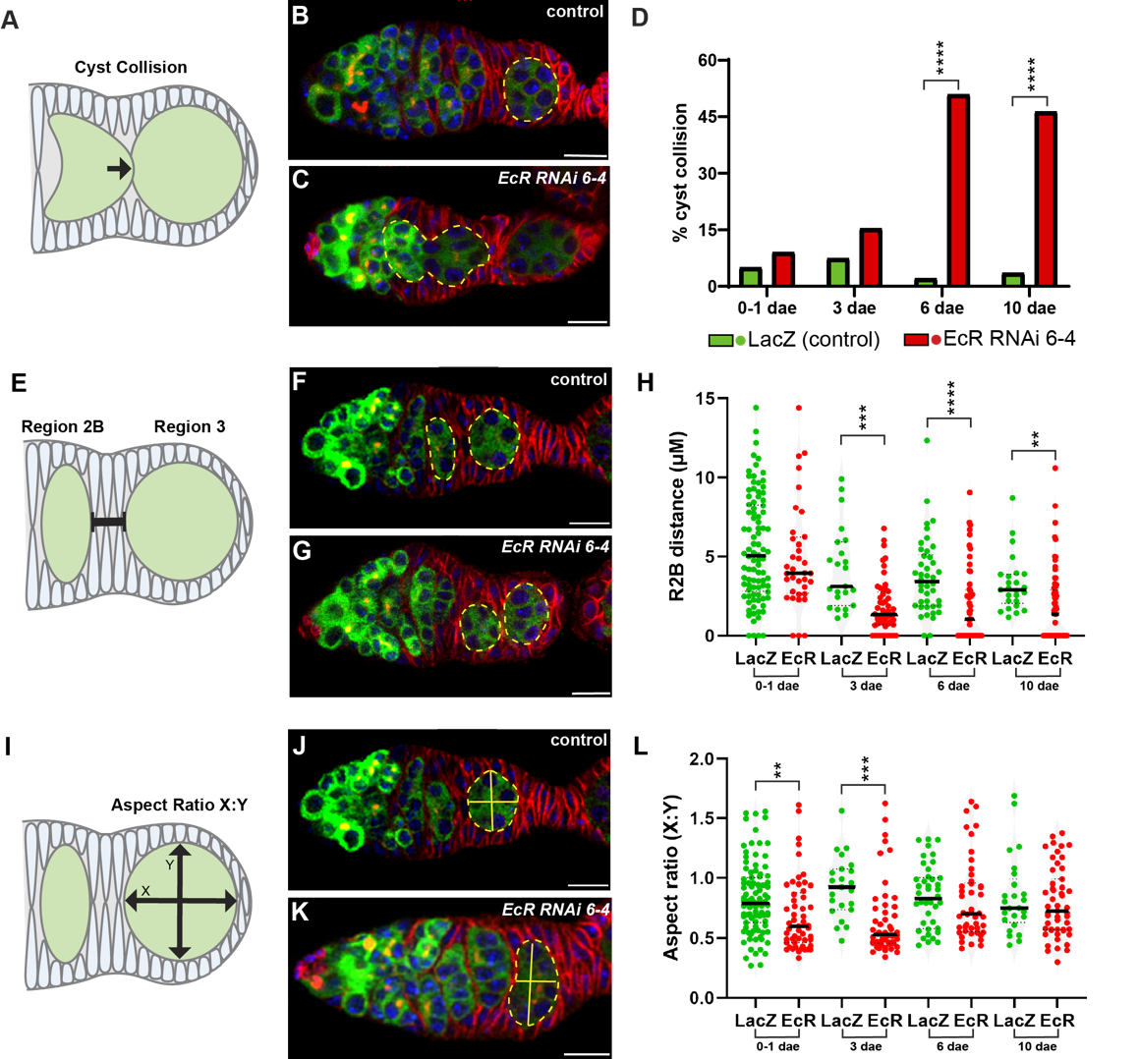
Figure 14: EcR is necessary for cyst encapsulation. EcR RNAi 6-4 was driven in all germ cells using nos-Gal4::VP16, UASp-GFP. Samples were stained with GFP in green, Hts and LamC in red, and DAPI in blue. Yellow dashed lines outline region 2B/3 cysts. Scale bars represent 10 µM. * p < 0.05, ** p <0.01, *** p < 0.001, and **** p < 0.0001. (A) Diagram of cyst collision. (B-C) Germariums of LacZ control and EcR RNAi 6-4 germaria. (D) Percent of germariums with cyst collision over time, significance tested using Fisher’s exact test. (E) Diagram of region 2B/3 measurement. (F-G) Germariums of control and EcR RNAi 6-4 (H) Violin plot of region 2B/3 distance, bar represents mean, significance tested using student’s T-test. (I) Diagram of cyst aspect ratio. (J-K) Germariums of control and EcR RNAi 6-4 (P) Violin plot of region 3 cyst aspect ratios, bar represents mean, significance tested using student’s T test.
EcR is required in an ecdysone dependent manner in 16-cell cysts for encapsulation.
When EcR.B1 dominant negatives were expressed in the germ cells those germaria had encapsulation defects resembling EcR RNAi 6-4. Looking at EcR.B1^{F645A} and EcR.B ^{DBL}, that did not generate tumors, there was a significant frequency of cyst collisions in the 2B/3 region (Figure 15H). While loss of EcR showed that it is necessary for encapsulation, this data shows that this role is ecdysone dependent.
We were also curious if there was a spatial requirement for EcR for proper encapsulation. Utilizing a different Gal4 driver, Bam-Gal4, that expresses in the early mitotic cysts we also found that EcR.B1^{F645A}, EcR.B1^{DBL}, and EcR.B1^{W650A} cause did not cause an increase in cyst collisions (Figure 15H). This suggests that EcR is dispensable in early mitotic cysts for encapsulation and is necessary in the 16-cell cysts.

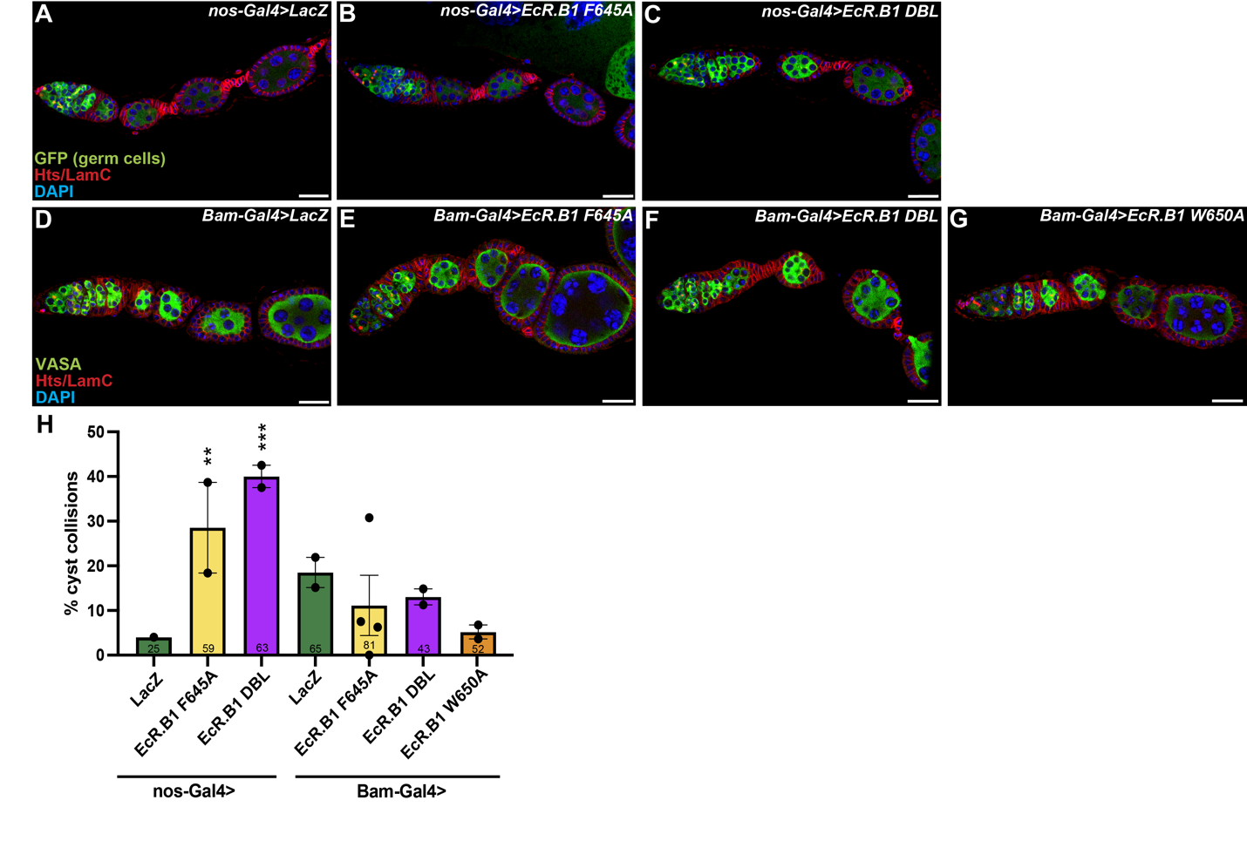
Figure 15: EcR is required in an ecdysone dependent manner in 16-cell cysts for encapsulation. (A-C) nos-Gal4, UASp-GFP driving expression. (A) LacZ control germaria. (B) EcR.B1^{F645A}. (C) EcR.B1^{DBL}. (D-G) Bam-Gal4 driving expression in early mitotic cells. (D) LacZ control germaria. (E) EcR.B1^{F645A}. (F) EcR.B1^{DBL}. (G) EcR.B1^{W650A}. (A-G) Scale bar = 20 μM. (H) Bar graph showing percentage of germaria with cyst collision under nos-Gal4 and Bam-Gal4 control. Dots represent percent from each sample group, bars represent standard error, and sample size is at the bottom of each bar. Significance measured using Fisher’s Exact test. * p < 0.05, ** p <0.01, *** p < 0.001, and **** p < 0.0001.

DISCUSSION

EcR is necessary autonomously for GSC self-renewal
Depleting EcR mRNA in the germline revealed that EcR is necessary for GSC self-renewal autonomously. Further investigation on GSC maintenance over time using the dominant negatives, EcR.B1 F645A and EcR.B1 DBL, could determine if EcR is required in an ecdysone-dependent role. However, over-expressing EcR that can bind ecdysone and activate transcription also generated a reduced number of GSCs at a stagnant time point. In this model, EcR is necessary for GSC self-renewal, but excess EcR promotes an undifferentiated fate in both the GSC and daughter cell. Together, these data reveal that the balance of EcR is necessary for GSC maintenance.

EcR is necessary and sufficient in GSCs and cystoblasts for promoting an undifferentiated fate
Driving over-expression of EcR.B1 resulted in undifferentiated, stem-like germ cell tumors. Although we were able to identify transcriptional changes of EcR in the germline by scRNA-seq, we cannot conclude which of these genes are direct targets. Using CUT&RUN to identify the sequences of the genome where EcR is binding, we could identify which of these genes are being upregulated in EcR.B1 over-expression using the mCherry tagged line. This could also reveal EcR enhancer sequences that are unique to the germline. CUT&RUN could also identify if EcR directly regulates the three upregulated canonical EcR targets (Ftz-f1, E75, and E63E). With the capabilities to build germline-compatible tools, it would be interesting to look at each of these canonical targets independently to see how they modulate cell fate. If EcR is acting indirectly on germ cell differentiation through one of these targets, we could recapitulate the tumor phenotype by over-expressing them singularly.
Importantly, this role is dependent on ecdysone binding and ability to transactivate. Over-expressing EcR proteins that can bind ecdysone but cannot transactivate, EcR.B1^{F645A} or EcR.B1^{DBL}, did not generate germline tumors. However, over-expression of EcR.B1^{W650A} did generate tumors similar to EcR.B1^{ΔC655}. It is unclear why this protein appears to not work as a dominant negative in the germline, when we find that it is sufficient to knockdown EcR in the lethality screen. The ligand affinity for the F645A and W650A proteins have only been tested in vitro (Cherbas et al., 2003). Further in vivo analysis on these proteins ability to bind enhancer sequences, bind ecdysone, and transactivate could discern their function.
We found that while the amount of EcR protein is important for controlling differentiation, so is the amount of available ligand. Feeding supplemental ecdysone in EcR.B1 over-expression females decreased the frequency of tumors. We had also found no evidence of these germ cells synthesizing their own ecdysone. It has been suggested that somatic escort cells or late stage follicles are a local source of ecdysone production (Xi et al., 2020). A local source of ecdysone could add another level of regulation of EcR in the germline, and the importance of germline-somatic communication.

EcR and BMP signaling may work together to control germ cell fate
From the transcriptional analysis of EcR over-expressing germ cells, it can be hypothesized that EcR may directly target components of the BMP signaling pathway to promote a stem-like fate. If knocking down a BMP component in an EcR over-expression is able to rescue the phenotype we could discern whether EcR is upregulating BMP signaling.
Another hypothesis is that EcR is opportunistically binding the chromatin landscape of the stem-like tumors and perpetuating their cell fate. In the ovary, GSCs are euchromatin rich while the differentiating daughter cells become increasingly rich for heterochromatin (Pang et al., 2023). It is likely that excess EcR is binding these open chromatin regions in the stem cells and upregulating genes promoting GSC fate. This is equally plausible for the BMP transcriptional regulator, pMad. We could identify if this is the case by doing an ATAC-sequencing analysis on EcR.B1 and Tkv^{ACT} over-expression germ cells.

EcR is necessary for proper encapsulation
Loss of EcR mRNA or EcR’s transactivating function resulted in encapsulation defects. Encapsulation of cysts requires coordination between the germline and soma, but little is known about the mechanisms of this communication. Interestingly, ecdysone signaling is necessary specifically in the somatic cells for encapsulation and specification of primordial germ cells (Morris & Spradling, 2012; Gancz et al., 2011). While this highlights the importance of ecdysone signaling in both germ and somatic cells, more work is needed to understand how follicle cells and cysts interact for follicle formation to identify the mechanism of EcR in this process.

Understanding the role of ecdysone in the germline is of large developmental importance but had yet been investigated directly. In this study, we described an autonomous and direct role for the ecdysone receptor in GSC self-renewal and promotion of differentiation. Ecdysone signaling has been known to be necessary for GSC maintenance and using new germline-compatible tools to knockdown and over-express EcR we found that this is an autonomous role. We find a novel role for EcR in promoting an undifferentiated fate in GSCs. Germline tumors formed from over-expressing EcR have a high level of similarity transcriptionally and phenotypically to over-expression of the BMP receptor, Tkv. Additionally, we find that loss of EcR or its transcriptional activation results in encapsulation defects. These data underscore the importance of understanding the role of hormones on stem cell differentiation that is imperative for oogenesis.

MATERIALS AND METHODS

Drosophila strains and husbandry
Flies were kept at 22-25°C on a standard diet of cornmeal/molasses/yeast/agar. Progeny were collected within 24 hours of eclosion and maintained at 25°C on standard medium supplemented with wet yeast paste for 5 days (changed daily) prior to ovary dissection.

Construction of EcR over-expression and dominant negative transgenics
To generate EcR.B1 over-expression and dominant-negative constructs, the coding domain sequence of ΔC655 (EcR.B1), EcR.B1 F645A, EcR.B1 W650A, and EcR.B1 DBL (from Cherbas et al., 2003) were amplified out of pUC57 mini plasmids (GenScript) and cloned into the BamHI site of the pUASz-1.0 plasmid using Takara’s In-fusion Snap Assembly Cloning. Plasmid sequences were verified via nanopore at Plasmidsaurus. Plasmid DNA was injected into embryos by BestGene and integrated into the attp40 locus.
The CDS to over-express EcR.A was designed to have the same early termination as the EcR.B1 ΔC655 CDS in the conserved ligand binding domain (EcR.A ΔC627). The same 3 dominant negatives were also designed to have the equivalent amino acid substitutions- EcR.B1 F645A = EcR.A F617A, EcR.B1 W650A = EcR.A W622A, EcR.B1 DBL = EcR.A DBL.
The EcR.A CDS was amplified out of a pUC57 mini plasmid (GenScript) and integrated into pUASz 1.0 at the BamH1 site by In-fusion cloning. The A isoform dominant negatives were cloned by Site Directed Mutagenesis (SDM) in the pUASz 1.0 EcR.A deltaC627 plasmid. Plasmid sequences were verified via nanopore at Plasmidsaurus. Plasmid DNA was injected into embryos by BestGene and integrated into the attp40 locus.

Construction of EcR mCherry tagged transgenics.
EcR and mCherry CDS were amplified out of pUC57 vectors and cloned into the BamHI restriction site of pUASz 1.0 using Takara In-fusion cloning. Plasmid sequences were verified via nanopore at Plasmidsaurus. Plasmid DNA was injected into embryos by BestGene and integrated into the attp40 locus.

Ovary dissection and immunostaining
For standard protocol- ovaries were dissected into Grace’s insect medium and fixed in cold 5% paraformaldehyde in Grace’s for 13 minutes at room temperature. Samples are rinsed with 0.1% phosphate buffered saline with Triton X-100 (PBST) and washed for 10 minutes three times, then permeabilized with 0.5% PBST for 20 minutes. Samples were blocked in 5% BSA, 5% normal goat serum, and 0.1% Triton X-100 in PBS solution for 3 hours at room temperature. Primary antibodies incubated overnight in block overnight at 4°C. After four, 30-minute washes at room temperature, samples incubated in secondaries overnight at 4°C. Samples were washed four times for 30 minutes, incubated in DAPI (1:1000 in 0.1% PBST) for 15 minutes, washed and stored in mounting media (90% glycerol and 20% n-propyl gallate) at 4°C until slide preparation.
For EdU incorporation- Ovaries were dissected, and incubated in EdU solution for 1 hour, then followed typical fixation and staining protocol.
For pMad antibody staining- ovaries were dissected in phosphatase inhibitor in PBS. Samples were fixed in 4% PFA in PBS for 15 minutes. Samples were rinsed with 0.3% PBST and washed 3 times for 10 minutes. Samples incubated in primary antibody in block (3% BSA in 0.3% PBST) overnight at 4 degrees C. Samples then followed typical fixation and staining protocol.
For VASA staining- ovaries were dissected, fixed, and stained as described in Greider et al., 2000.

Microscopy
Mounted ovaries were imaged with the Zeiss LSM700 confocal microscope using 1-micron optical sections using Zen Black.

Phenotypic analysis
GSCs were identified by fusome morphology adjacent to the cap cells according to Ables & Drummond-Barbosa, 2013. Germaria were counted as tumorous by high number of cystoblast-like cells and an absence of a 16-cell cyst. Egg chambers were identified if there were enlarged germ cell nuclei encased by a monolayer of follicle cells. Cyst collisions were determined by lack of follicle cells partitioning adjacent cysts in region 2B/3 of the germarium. To capture aspect ratio of 16-cell cysts, the ‘measure’ tool in Zen Blue was used to measure the X and Y-axis at the z-stack with most central view of the cyst. The ‘measure’ tool was also used to measure distance between cysts at the z-stack with closest proximity.

Statistical analysis
Student’s T-test (two tailed, unequal variance) was performed in Excel. Fisher’s exact for was performed in Graph Pad Prism.

Ovary dissection and dissociation for single-cell RNA-sequencing
Protocol was adapted from Method A in Slaidina et al., 2021. 100 ovaries from each genotype were dissected in Grace’s insect medium and disassociated in a 0.5% type 1 collagenase, 1% trypsin 1:250 in PBS solution for 15 minutes using vigorous pipetting every few minutes to enhance dissociation. Disassociation was stopped by adding Grace’s insect medium with 10% fetal bovine serum. Suspended cells were strained through a Flowmi 40-micron filter tip and then centrifuged at 5 rpm for 3 minutes. Supernatant was decanted, cells were resuspended in 0.04% BSA in PBS and centrifuged again at 5 rpm for 3 minutes. Final suspension was in Grace’s insect medium and then preserved on ice. Live/dead count was measured on the Invitrogen Countess 3FL Cell Counter. Approximately 1.70x10⁶ cells from the TkvACT sample were collected with 89% being live. Approximately 1.17x10⁷ cells from the EcR.B1 sample were collected with 95% being live.

scRNA-seq data analysis
Library was constructed using 10X Genomics Chromium single cell 3’ V3 kit. 5,741 cells were sequenced from the EcR.B1 sample with a total of 136,771,995 reads (an average of 23,799 reads per cell). 96.70% of reads were valid barcodes and 74.6% mapped confidently to the genome. The median UMI counts per cell was 4,112. For the Tkv^{ACT} sample, 7,043 cells were sequenced with a total of 116,346,480 reads (an average of 16,519 per cell). 97.40% of reads were valid barcodes and 96.8% mapped confidently to the genome. The median UMI count per cell was 6,934. The aggregated data set of EcR.B1 and Tkv^{ACT} were analyzed using the 10X Loupe Browser platform. The aggregated data of both samples pipeline-generated 16 clusters. When measuring differentially expressed genes between clusters and groups, Log2 fold change is the ratio of the normalized mean gene UMI counts in the cluster relative to all other clusters. P-values were adjusted using the Benjamini-Hochberg correction for multiple tests.

DROSOPHILA STOCKS | Source | Identifier
UASp-LacZ | D. Drummond-Barbosa
UASp-tubGFP | Bloomington Stock Center | BDSC #7373
Nos-gal4::VP16-nos.UTR | D. Drummond-Barbosa (Rørth, 1998b; Van Doren et al., 1998) | BDSC #4937 or 7253
P{otu-GAL4::VP16.R}1, w1118 | Bloomington Stock Center | #58424
y[1] w[*]; P{w[+mC]=GAL4-nos.NGT}40; P{w[+mC]=GAL4-nos.NGT}A | Bloomington Stock Center | #64308
Bam>Gal4 ,Bam>Gal4/CyO;Bam>Gal4/TM6 | (Clemot et al., 2018)
FlyFos015150(pRedFlp-Hgr)(bam29830::2XTY1-SGFP-V5-preTEV-BLRP-3XFLAG)dFRT | Vienna Drosophila Resource Center | 318001
Dad-lacZ | D. Drummond-Barbosa and T. Xie (Kai and Spradling, 2003; Song et al., 2004)
y[1] w[*]; TI{GFP[3xP3.cLa]=CRIMIC.TG4.1}aub[CR02423-TG4.1]/SM6a | Bloomington Stock Center | 92663
UASz-EcR.B1 ΔC655/CyO | This paper
UASz-EcR.B1 F656A/CyO | This paper
UASz-EcR.B1 W650A/CyO | This paper
UASz-EcR.B1 DBL/CyO | This paper
UASz-mCherry::EcR.B1/CyO | This paper
UASz-EcR.B1::mCherry/CyO | This paper
UASz-EcR.A ΔC627/CyO | This paper
UASz-EcR.A F617A/CyO | This paper
UASz-EcR.A W622A/CyO | This paper
UASz-EcR.A DBL/CyO | This paper
UASz-mCherry::EcR.A/CyO | This paper
UASz-EcR.::mCherry/CyO | This paper
UASp-EcR RNAi 6-4 | This paper
CHEMICALS AND REAGENTS | Source | Identifier
Grace’s insect medium | Caisson Labs
Phosphate buffered saline (pH 7.4) | Fisher Scientific
Triton X-100 | Fisher Scientific | BP151-500
5% bovine serum albumin | Sigma Aldrich
5% normal goat serum | MP Biomedicals
16% Paraformaldehyde | Fisher Scientific | 18505
Phosphatase Inhibitor Mini Tablets | Thermo Fisher | A32957
ANTIBODIES AND STAINS
Mouse anti-Hts (1:10) | DSHB | 1B1; RRID: AB_528070
Mouse anti-LamC (1:100) | DSHB | LC28.26; RRID: AB_528339
Mouse anti-LamB (1:100) | DSHB | ADL67.10
Chicken anti-GFP (1:2000) | Abcam | #AB13970
Rabbit anti-VASA (1:1000) | P. Lasko (Lasko & Ashburner et a., 1990)
Mouse anti-orb (1:500) | DSHB | 4H8
Mouse anti-orb (1:500) | DSHB | 6H4
Guinea pig anti-RbFox1 | M. Buszczak (Tastan et al., 2010)
Chicken anti-β gal | Abcam | AB9361
X anti-PHH3 (1:200) | Millipore | #06-570
Click-iT EdU Cell Proliferation Kit for Imaging, Alexa Fluor 647 dye | Fisher Scientific | Invitrogen C10340
Rabbit anti-pMad (1:100) | Abcam | AB52903
Rat anti-dsRed (1:500) | Takara | 632496
Goat anti-mouse  AlexaFluor 488, 568, 688 (1:200) | Life Technologies
Goat anti-chicken  AlexaFluor 488 (1:200) | Life Technologies
Goat anti-rabbit  AlexaFluor 488, 568 (1:200) | Life Technologies
Goat anti-rat  Alexa Fluor 488 (1:200) | Life Technologies
4’-6-diamidino-2-phenylindole (DAPI) (0.5 μg/mL) | Sigma
SOFTWARE
Excel | Microsoft
Zen Blue | Zeiss
Zen Black | Zeiss
Prism 10 | Graph Pad
Loupe Browser 7 | 10X Genomics
Photoshop | Adobe
Illustrator | Adobe
PLASMIDS
pUASz-1.0 | Drosophila Genetic Resource Center
mCherry | R. Hughes
pUASz-1.0-EcR.B1 ΔC655
pUASz-1.0-EcR.B1 F645A
pUASz-1.0-EcR.B1 W650A
pUASz-1.0-EcR.B1 DBL
pUASz-1.0-mCherry::EcR.B1
pUASz-1.0-EcR.B1::mCherry
pUASz-1.0-EcR.A ΔC627
pUASz-1.0-EcR.A F617A
pUASz-1.0-EcR.A W650A
pUASz-1.0-EcR.A DBL
pUASz-1.0-mCherry::EcR.A
pUASz-1.0-EcR.A::mCherry
pUC57-EcR.B1 ΔC655
pUC57-EcR.B1 F645A
pUC57-EcR.B1 W650A
pUC57-EcR.B1 DBL
pUC57-EcR.A ΔC627
MOLECULAR CLONING REAGENTS
PrimeSTAR HS premix | Takara | #R040A
BamH1-HF | New England BioLabs
In-fusion Snap Assembly Cloning | Takara | #638948
Stellar Competent Cells
Wizard Plus SV Minipreps DNA Purification System | Promega | A1460
Monarch PCR & DNA Cleanup Kit | New England BioLabs | #T1030
PRIMERS
EcR.B1 deltaC655 FWD  EcR.B1 F645A FWD  EcR.B1 W650A FWD  EcR.B1 DBL FWD |  | AAAAATCAAAGGATCATGAAGCGGCGCTGGTCG
EcR.B1 deltaC655 REV  EcR.B1 F645A REV |  | TACCCTCGAGGGATCCTAGATGGCATGAACGTCCCAG
EcR.B1 W650A REV  EcR.B1 DBL REV |  | TACCCTCGAGGGATCCTAGATGGCATGAACGTCGGC
EcR.A deltaC627 FWD |  | AAAAATCAAAGGATCATGTTGACGACGAGTGGACAAC
EcR.A deltaC627 REV |  | TACCCTCGAGGGATCCTAGATGGCATGAACGTCCCAG
mCherry FWD  (for mCherry::EcR.B1 and mCherry::EcR.A)) |  | TCA TGC CAT CAT GGT GAG CAA GGG CGA GG
mCherry REV  (for mCherry::EcR.B1 and mCherry::EcR.A) |  | AGT GGT ACC CTC GAG GGA TCT TAC TTG TAC AGC TCG TCC ATG CC
EcR.B1 FWD  (for mCherry::EcR.B1) |  | AAA AAA AAA ATC AAA GGA TCA TGA AGC GGC GCT GGT CG
EcR.B1 REV  (for mCherry::EcR.B1) |  | TGC TCA CCA TGA TGG CAT GAA CGT CCC AGA TCT CC
EcR.A FWD  (For mCherry::EcR.A) |  | AAA AAA AAA ATC AAA GCA TCA TGT TGA CGA CGA GTG GAC AAC
EcR.A REV  (for mCherry::EcR.A) |  | TGCTCA CCA TGA TGG CAT GAA CGT CCC AG
EcR.B1 FWD  (for EcR.B1::mCherry) |  | AAAAAAAAAATCAAAGGATCATGAAGCGGCGCTGGTCG
EcR.B1 REV  (for EcR.B1::mCherry) |  | TGCTCACCATGATGGCATGAACGTCCCAGATCTCC
mCherry FWD  (for EcR.B1::mCherry) |  | TCATGCCATCATGGTGAGCAAGGGCGAGG
mCherry REV  (for EcR.B1::mCherry) |  | AGTGGTACCCTCGAGGGATCTTACTTGTACAGCTCGTCCATGCC
EcR.A FWD  (for EcR.A::mCherry) |  | AAAAAAAAAATCAAAGGATCATGTTGACGACGAGTGGACAAC
EcR.A REV  (for EcR.A::mCherry) |  | TGCTCACCATGATGGCATGAACGTCCCAG
mCherry FWD  (for EcR.A::mCherry) |  | TCATGCCATCATGGTGAGCAAGGGCGAGG
mCherry REV  (for EcR.A::mCherry) |  | AGTGGTACCCTCGAGGGATCTTACTTGTACAGCTCGTCCATGCC
EcR.A F617A FWD |  | AGGCCCTCGAGGAGATCTGGGACGTTCATGCCATC
EcR.A F617A REV |  | TCTCCTCGAGGGCCTTGGGCAGTTTGCGGTTTTTG
EcR.A W622A FWD |  | GGAGATCGCCGACGTTCATGCCATCTAGGATCCC
EcR.A W622A REV |  | ACGTCGGCGATCTCCTCGAGGAACTTGGGC
EcR.A DBL FWD |  | CCCTCGAGGAGATCGCCGACGTTCATGCCATCTAGGATCCC
EcR.A DBL REV |  | CGATCTCCTCGAGGGCCTTGGGCAGTTTGCGGTTTTTG
scRNA-seq REAGENTS
1% Collagenase | Thermo Fisher | #17018-029
0.5% Type 1 Trypsin | Thermo Fisher | #27250018
Fetal Bovine Serum | Invitrogen | #10082-147
Flowmi Tip Strainers | Sigma Aldrich | H13680-0040
10X Chromium single cell 3' reagent kit V3 | 10X Genomics

REFERENCES

Ables, E. T., & Drummond-Barbosa, D. (2010). The steroid hormone ecdysone functions with intrinsic chromatin remodeling factors to control female germline stem cells in Drosophila. Cell stem cell, 7(5), 581–592. https://doi.org/10.1016/j.stem.2010.10.001
Ables, E. T., & Drummond-Barbosa, D. (2013). Cyclin E controls Drosophila female germline stem cell maintenance independently of its role in proliferation by modulating responsiveness to niche signals. Development (Cambridge, England), 140(3), 530–540. https://doi.org/10.1242/dev.088583
Ables, E. T., & Drummond-Barbosa, D. (2017). Steroid Hormones and the Physiological Regulation of Tissue-Resident Stem Cells: Lessons from the Drosophila Ovary. Current stem cell reports, 3(1), 9–18. https://doi.org/10.1007/s40778-017-0070-z
Ameku, T., & Niwa, R. (2016). Mating-Induced Increase in Germline Stem Cells via the Neuroendocrine System in Female Drosophila. PLoS genetics, 12(6), e1006123. https://doi.org/10.1371/journal.pgen.1006123
Barr, J., Gilmutdinov, R., Wang, L., Shidlovskii, Y., & Schedl, P. (2019). The Drosophila CPEB Protein Orb Specifies Oocyte Fate by a 3'UTR-Dependent Autoregulatory Loop. Genetics, 213(4), 1431–1446. https://doi.org/10.1534/genetics.119.302687
Beachum, A. N., Whitehead, K. M., McDonald, S. I., Phipps, D. N., Berghout, H. E., & Ables, E. T. (2021). Orphan nuclear receptor ftz-f1 (NR5A3) promotes egg chamber survival in the Drosophila ovary. G3 (Bethesda, Md.), 11(2), jkab003. https://doi.org/10.1093/g3journal/jkab003
Bender, M., Imam, F. B., Talbot, W. S., Ganetzky, B., & Hogness, D. S. (1997). Drosophila ecdysone receptor mutations reveal functional differences among receptor isoforms. Cell, 91(6), 777–788. https://doi.org/10.1016/s0092-8674(00)80466-3
Brown, H. L., Cherbas, L., Cherbas, P., & Truman, J. W. (2006). Use of time-lapse imaging and dominant negative receptors to dissect the steroid receptor control of neuronal remodeling in Drosophila. Development (Cambridge, England), 133(2), 275–285. https://doi.org/10.1242/dev.02191
Buszczak, M., Freeman, M. R., Carlson, J. R., Bender, M., Cooley, L., & Segraves, W. A. (1999). Ecdysone response genes govern egg chamber development during mid- oogenesis in Drosophila. Development (Cambridge, England), 126(20), 4581–4589. https://doi.org/10.1242/dev.126.20.4581
Carney, G. E., & Bender, M. (2000). The Drosophila ecdysone receptor (EcR) gene is required maternally for normal oogenesis. Genetics, 154(3), 1203–1211. https://doi.org/10.1093/genetics/154.3.1203
Carreira-Rosario, A., Bhargava, V., Hillebrand, J., Kollipara, R. K., Ramaswami, M., & Buszczak, M. (2016). Repression of Pumilio Protein Expression by Rbfox1 Promotes Germ Cell Differentiation. Developmental cell, 36(5), 562–571. https://doi.org/10.1016/j.devcel.2016.02.010
Casanueva, M. O., & Ferguson, E. L. (2004). Germline stem cell number in the Drosophila ovary is regulated by redundant mechanisms that control Dpp signaling. Development (Cambridge, England), 131(9), 1881–1890. https://doi.org/10.1242/dev.01076
Caygill, E. E., & Brand, A. H. (2016). The GAL4 System: A Versatile System for the Manipulation and Analysis of Gene Expression. Methods in molecular biology (Clifton, N.J.), 1478, 33–52. https://doi.org/10.1007/978-1-4939-6371-3_2
Chen, D., & McKearin, D. (2003a). Dpp signaling silences bam transcription directly to establish asymmetric divisions of germline stem cells. Current biology : CB, 13(20), 1786–1791. https://doi.org/10.1016/j.cub.2003.09.033
Chen, D., & McKearin, D. M. (2003b). A discrete transcriptional silencer in the bam gene determines asymmetric division of the Drosophila germline stem cell. Development (Cambridge, England), 130(6), 1159–1170. https://doi.org/10.1242/dev.00325
Cherbas, L., Hu, X., Zhimulev, I., Belyaeva, E., & Cherbas, P. (2003). EcR isoforms in Drosophila: testing tissue-specific requirements by targeted blockade and rescue. Development (Cambridge, England), 130(2), 271–284. https://doi.org/10.1242/dev.00205
Clémot, M., Molla-Herman, A., Mathieu, J., Huynh, J. R., & Dostatni, N. (2018). The replicative histone chaperone CAF1 is essential for the maintenance of identity and genome integrity in adult stem cells. Development (Cambridge, England), 145(17), dev161190. https://doi.org/10.1242/dev.161190
Davis, M. B., Carney, G. E., Robertson, A. E., & Bender, M. (2005). Phenotypic analysis of EcR-A mutants suggests that EcR isoforms have unique functions during Drosophila development. Developmental biology, 282(2), 385–396. https://doi.org/10.1016/j.ydbio.2005.03.019
de Cuevas, M., Lilly, M. A., & Spradling, A. C. (1997). Germline cyst formation in Drosophila. Annual review of genetics, 31, 405–428. https://doi.org/10.1146/annurev.genet.31.1.405
DeLuca, S. Z., & Spradling, A. C. (2018). Efficient Expression of Genes in the Drosophila Germline Using a UAS Promoter Free of Interference by Hsp70 piRNAs. Genetics, 209(2), 381–387. https://doi.org/10.1534/genetics.118.300874
Eliazer, S., & Buszczak, M. (2011). Finding a niche: studies from the Drosophila ovary. Stem cell research & therapy, 2(6), 45. https://doi.org/10.1186/scrt86
Gancz, D., Lengil, T., & Gilboa, L. (2011). Coordinated regulation of niche and stem cell precursors by hormonal signaling. PLoS biology, 9(11), e1001202. https://doi.org/10.1371/journal.pbio.1001202
Grieder, N. C., de Cuevas, M., & Spradling, A. C. (2000). The fusome organizes the microtubule network during oocyte differentiation in Drosophila. Development (Cambridge, England), 127(19), 4253–4264. https://doi.org/10.1242/dev.127.19.4253
Hinnant, T. D., Merkle, J. A., & Ables, E. T. (2020). Coordinating Proliferation, Polarity, and Cell Fate in the Drosophila Female Germline. Frontiers in cell and developmental biology, 8, 19. https://doi.org/10.3389/fcell.2020.00019
Jevitt, A., Chatterjee, D., Xie, G., Wang, X. F., Otwell, T., Huang, Y. C., & Deng, W. M. (2020). A single-cell atlas of adult Drosophila ovary identifies transcriptional programs and somatic cell lineage regulating oogenesis. PLoS biology, 18(4), e3000538. https://doi.org/10.1371/journal.pbio.3000538
King-Jones, K., & Thummel, C. S. (2005). Nuclear receptors--a perspective from Drosophila. Nature reviews. Genetics, 6(4), 311–323. https://doi.org/10.1038/nrg1581
Knapp, E., & Sun, J. (2017). Steroid signaling in mature follicles is important for Drosophila ovulation. Proceedings of the National Academy of Sciences of the United States of America, 114(4), 699–704. https://doi.org/10.1073/pnas.1614383114
König, A., Yatsenko, A. S., Weiss, M., & Shcherbata, H. R. (2011). Ecdysteroids affect Drosophila ovarian stem cell niche formation and early germline differentiation. The EMBO journal, 30(8), 1549–1562. https://doi.org/10.1038/emboj.2011.73
Kozlova, T., & Thummel, C. S. (2002). Spatial patterns of ecdysteroid receptor activation during the onset of Drosophila metamorphosis. Development (Cambridge, England), 129(7), 1739–1750. https://doi.org/10.1242/dev.129.7.1739
Li, Y., Maines, J. Z., Tastan, O. Y., McKearin, D. M., & Buszczak, M. (2012). Mei-P26 regulates the maintenance of ovarian germline stem cells by promoting BMP signaling. Development (Cambridge, England), 139(9), 1547–1556. https://doi.org/10.1242/dev.077412
Liu, D., & Finley, R. L., Jr (2010). Cyclin Y is a novel conserved cyclin essential for development in Drosophila. Genetics, 184(4), 1025–1035. https://doi.org/10.1534/genetics.110.114017signaling. Development (Cambridge, England), 139(9), 1547–1556. https://doi.org/10.1242/dev.077412
Manning, L., Sheth, J., Bridges, S., Saadin, A., Odinammadu, K., Andrew, D., Spencer, S., Montell, D., & Starz-Gaiano, M. (2017). A hormonal cue promotes timely follicle cell migration by modulating transcription profiles. Mechanisms of development, 148, 56–68. https://doi.org/10.1016/j.mod.2017.06.003
Martin, E. T., Sarkar, K., McCarthy, A., & Rangan, P. (2022). Oo-site: A dashboard to visualize gene expression during Drosophila oogenesis suggests meiotic entry is regulated post- transcriptionally. Biology open, 11(5), bio059286. https://doi.org/10.1242/bio.059286
McCarthy, A., Sarkar, K., Martin, E. T., Upadhyay, M., Jang, S., Williams, N. D., Forni, P. E., Buszczak, M., & Rangan, P. (2022). Msl3 promotes germline stem cell differentiation in female Drosophila. Development (Cambridge, England), 149(1), dev199625. https://doi.org/10.1242/dev.199625
McDonald, S. I., Beachum, A. N., Hinnant, T. D., Blake, A. J., Bynum, T., Hickman, E. P., Barnes, J., Churchill, K. L., Roberts, T. S., Zangwill, D. E., & Ables, E. T. (2019). Novel cis-regulatory regions in ecdysone responsive genes are sufficient to promote gene expression in Drosophila ovarian cells. Gene expression patterns : GEP, 34, 119074. https://doi.org/10.1016/j.gep.2019.119074
McKearin, D. M., & Spradling, A. C. (1990). bag-of-marbles: a Drosophila gene required to initiate both male and female gametogenesis. Genes & development, 4(12B), 2242–2251. https://doi.org/10.1101/gad.4.12b.2242
McKearin, D., & Ohlstein, B. (1995). A role for the Drosophila bag-of-marbles protein in the differentiation of cystoblasts from germline stem cells. Development (Cambridge, England), 121(9), 2937–2947. https://doi.org/10.1242/dev.121.9.2937
McLaughlin, J. M., & Bratu, D. P. (2015). Drosophila melanogaster Oogenesis: An Overview. Methods in molecular biology (Clifton, N.J.), 1328, 1–20. https://doi.org/10.1007/978-1-4939-2851-4_1
Morris, L. X., & Spradling, A. C. (2012). Steroid signaling within Drosophila ovarian epithelial cells sex-specifically modulates early germ cell development and meiotic entry. PloS one, 7(10), e46109. https://doi.org/10.1371/journal.pone.0046109
Mouillet, J. F., Henrich, V. C., Lezzi, M., & Vögtli, M. (2001). Differential control of gene activity by isoforms A, B1 and B2 of the Drosophila ecdysone receptor. European journal of biochemistry, 268(6), 1811–1819.
Ohlstein, B., Lavoie, C. A., Vef, O., Gateff, E., & McKearin, D. M. (2000). The Drosophila cystoblast differentiation factor, benign gonial cell neoplasm, is related to DExH-box proteins and interacts genetically with bag-of-marbles. Genetics, 155(4), 1809–1819. https://doi.org/10.1093/genetics/155.4.1809
Pang, L. Y., DeLuca, S., Zhu, H., Urban, J. M., & Spradling, A. C. (2023). Chromatin and gene expression changes during female Drosophila germline stem cell development illuminate the biology of highly potent stem cells. eLife, 12, RP90509. https://doi.org/10.7554/eLife.90509
Phipps, D. N., Powell, A. M., & Ables, E. T. (2023). Utilizing the FLP-Out System for Clonal RNAi Analysis in the Adult Drosophila Ovary. Methods in molecular biology (Clifton, N.J.), 2626, 69–87. https://doi.org/10.1007/978-1-0716-2970-3_4
Ramat, A., Audibert, A., Louvet-Vallée, S., Simon, F., Fichelson, P., & Gho, M. (2016). Escargot and Scratch regulate neural commitment by antagonizing Notch activity in Drosophila sensory organs. Development (Cambridge, England), 143(16), 3024–3034. https://doi.org/10.1242/dev.134387
Romani, P., Gargiulo, G., & Cavaliere, V. (2016). The ecdysone receptor signalling regulates microvilli formation in follicular epithelial cells. Cellular and molecular life sciences : CMLS, 73(2), 409–425. https://doi.org/10.1007/s00018-015-1999-7
Rust, K., Byrnes, L. E., Yu, K. S., Park, J. S., Sneddon, J. B., Tward, A. D., & Nystul, T. G. (2020). A single-cell atlas and lineage analysis of the adult Drosophila ovary. Nature communications, 11(1), 5628. https://doi.org/10.1038/s41467-020-19361-0
Schauer, S., Callender, J., Henrich, V. C., & Spindler-Barth, M. (2011). The N-terminus of ecdysteroid receptor isoforms and ultraspiracle interacts with different ecdysteroid response elements in a sequence specific manner to modulate transcriptional activity. The Journal of steroid biochemistry and molecular biology, 124(3-5), 84–92. https://doi.org/10.1016/j.jsbmb.2011.01.013
Slaidina, M., Gupta, S., Banisch, T. U., & Lehmann, R. (2021). A single-cell atlas reveals unanticipated cell type complexity in Drosophila ovaries. Genome research, 31(10), 1938–1951. https://doi.org/10.1101/gr.274340.120
Song, X., Wong, M. D., Kawase, E., Xi, R., Ding, B. C., McCarthy, J. J., & Xie, T. (2004). Bmp signals from niche cells directly repress transcription of a differentiation-promoting gene, bag of marbles, in germline stem cells in the Drosophila ovary. Development (Cambridge, England), 131(6), 1353–1364. https://doi.org/10.1242/dev.01026
Streit, A., Bernasconi, L., Sergeev, P., Cruz, A., & Steinmann-Zwicky, M. (2002). mgm 1, the earliest sex-specific germline marker in Drosophila, reflects expression of the gene esg in male stem cells. The International journal of developmental biology, 46(1), 159–166.
Stowers, R. S., Garza, D., Rascle, A., & Hogness, D. S. (2000). The L63 gene is necessary for the ecdysone-induced 63E late puff and encodes CDK proteins required for Drosophila development. Developmental biology, 221(1), 23–40. https://doi.org/10.1006/dbio.2000.9685
Swevers L. (2019). An update on ecdysone signaling during insect oogenesis. Current opinion in insect science, 31, 8–13. https://doi.org/10.1016/j.cois.2018.07.003
Talbot, W. S., Swyryd, E. A., & Hogness, D. S. (1993). Drosophila tissues with different metamorphic responses to ecdysone express different ecdysone receptor isoforms. Cell, 73(7), 1323–1337. https://doi.org/10.1016/0092-8674(93)90359-x
Tastan, O. Y., Maines, J. Z., Li, Y., McKearin, D. M., & Buszczak, M. (2010). Drosophila ataxin 2-binding protein 1 marks an intermediate step in the molecular differentiation of female germline cysts. Development (Cambridge, England), 137(19), 3167–3176. https://doi.org/10.1242/dev.050575
Terashima, J., & Bownes, M. (2006). E75A and E75B have opposite effects on the apoptosis/development choice of the Drosophila egg chamber. Cell death and differentiation, 13(3), 454–464. https://doi.org/10.1038/sj.cdd.4401745
Truman, J. W., Talbot, W. S., Fahrbach, S. E., & Hogness, D. S. (1994). Ecdysone receptor expression in the CNS correlates with stage-specific responses to ecdysteroids during Drosophila and Manduca development. Development (Cambridge, England), 120(1), 219–234. https://doi.org/10.1242/dev.120.1.219
Xie, T., & Spradling, A. C. (1998). decapentaplegic is essential for the maintenance and division of germline stem cells in the Drosophila ovary. Cell, 94(2), 251–260. https://doi.org/10.1016/s0092-8674(00)81424-5
Yatsenko, A. S., & Shcherbata, H. R. (2018). Stereotypical architecture of the stem cell niche is spatiotemporally established by miR-125-dependent coordination of Notch and steroid signaling. Development (Cambridge, England), 145(3), dev159178. https://doi.org/10.1242/dev.159178

