Bonding Through Books: Enhancing Neurodevelopment and Parental Bonding for Infants in Neonatal Intensive Care

Amy Sue Brown Price
College of Nursing, East Carolina University
Doctor of Nursing Practice Program
Dr. Terri Isaacs
July 12, 2023

Notes from the Author
I want to extend my dearest thanks to my site champion, Teandra Ramos-Hardy, and my colleagues, Rachelle Cabeceiras Beavers and Natasha Poindexter, for sticking with this project through all the hard work and effort it took to make it a success. This project is what it is with each of you. We will touch the lives of many parents and infants that we will never meet. You should be very proud.
Thank you to Dr. Terri Isaacs, my DNP Project Faculty, for your many hours of guidance, reflection, and support throughout this project. I would also like to thank Dr. Jan Tillman, overseeing DNP Faculty, for your feedback and help in setting up this project with Reach Out and Read.
Lastly, thank you to my loving and supportive husband and children for all your patience, feedback, and love throughout this process. Specifically, thank you to my husband, John, who spent many nights cooking dinner as I worked on this, and my children, Ian and Erin, for answering my questions about graphic design and technology. I could not have done this without your support.
Abstract
Reach Out and Read (ROR) is a national 501(c)3 nonprofit started in 1989. In recent years, it has expanded its program to Neonatal Intensive Care Units (NICUs) to provide families with the knowledge and resources they need to make reading a part of their daily routine as young as possible. Several studies indicate the benefit of implementing this program in the NICU to increase the brain development of premature infants, increase the infant's parental bond, and decrease parental anxiety and postpartum depression. Reading is an excellent, nonintrusive way to adapt to barriers faced by NICU infants and is well-accepted by staff and caregivers. Currently, a neonatologist or advanced practice practitioner (APP) implements the ROR program in the NICU. ROR hopes to revise its site roles to include a third role that partners with the neonatologist to implement the program. This Doctor of Nursing Practice (DNP) project will assist NICU infants' neurodevelopment and parental bonding by discovering which NICU position will be best suited as the third role. This DNP project also validates the effectiveness of delivering healthcare education in a team model. With positive outcomes, this project will continue to expand and develop.
Keywords: Reach Out and Read, NICU, infant bonding, infant reading, reading and neonatal intensive care unit, caregiver-infant bonding, infant neurological development

Table of Contents
Notes from the Author ………………………………………………………………………...... 2
Abstract …………………………………………………………………………………………. 3
Section I: Introduction ..………………………………………………………………………… 6
Background……………………………………………………………………………… 6
Organizational Needs Statement………………………………………………….………6
Problem Statement………………………………………………………………………10
Purpose Statement………………………………………………………………….……10
Section II: Evidence……………………………………………………………………….…….11
Literature Review………………………………………………………………….…….11
Evidence-Based Practice Framework…………………………………………….……..15
Ethical Consideration and Protection of Human Subjects…………….…………..……17
Section III: Project Design…………………………………………………………….………..18
Project Site and Population………………………………………………………….….18
Project Team………………………………………………………………………….…19
Project Goals and Outcomes Measures…………………………………………………20
Implementation Plan……………………………………………………………………21
Timeline………………………………………………………………………….……..21
Section IV: Results and Findings………………………………………………………………23
Results………………………………………………………………………………….23
Discussion of Major Findings………………………………………………………….24
Section V: Interpretation and Implications…………………………………………………….27
Costs and Resource Management……………………………………………………...27
Implications of the Findings………………………………………………….………28
Sustainability ……………………………………………………………….………..30
Dissemination Plan …………………………………………………………….…….30
Section VI: Conclusion………………………………………………………………….……32
Limitations and Facilitators…………..……………………………...……….………32
Recommendations for Others……………………………………………….……..…33
Recommendations for Further Study………………………………………….……..33 Final Thoughts……………………………………………………………………….33
References……………………………………………………………………………………35
Appendices…………………………………………………………………………………..38
Appendix A: Literature Review Search Log………………………………………..38
Appendix B: IRB QI/Program Evaluation Self-Certification Tool Guidance
Form 8272.22………………………………………………………………………..39
Appendix C: DNP Project Approval Tool Form 8272.5……………………………42
Appendix D: Surveys………………………………………………………………..46
Appendix E: Project Timeline……………..………………………………………..52
Appendix F: Survey Responses ……………..……………………………………..53
Appendix G: Pie Charts……………..……………………………………………....67
Appendix H: DNP Project Poster ……………..…………………………………….68

Section I. Introduction
Background
Reach Out and Read (ROR) is a national 501(c)3 nonprofit started in 1989. They aim to increase young brain development and language skills by integrating books into pediatric doctor visits through a program encouraging parents and caregivers to read aloud to children. ROR works with healthcare providers in pediatric and primary care clinics where patients and their caregivers receive age-appropriate books at well visits. Most practices give books to children from six months to five years of age (Reach Out and Read, 2022). In recent years, ROR has expanded the program to Neonatal Intensive Care Units (NICUs) nationwide. ROR's goal is to provide families with the knowledge and resources they need to make reading a part of their daily routine as young as possible. Several studies indicate the benefit of implementing this program in the NICU to increase the brain development of the premature infant, increase the infant's parental bond, and decrease parental anxiety and postpartum depression.
Organizational Needs Statement
ROR started its first NICU pilot program at the University of North Carolina (UNC) Health's NICU on August 14, 2018. It is active in eight NICUs nationwide, and two additional NICUs are implementing ROR (T. Ramos Hardy, personal communication, July 2, 2022).
ROR program implementation in a NICU is done by a neonatologist or advanced practice practitioner (APP) who spearheads program implementation. Then that neonatologist will assign a NICU Medical Doctor (MD), Nurse Practitioner (NP), or Physician Assistant (PA) to complete preparation for implementing the ROR NICU program. For a NICU to fully participate in the ROR program, at least 75% of neonatologists and NPs must complete provider and NICU Pathwright training. Around 770 providers have completed this training (T. Ramos Hardy, personal communication, July 12, 2022).
The quick expansion of the ROR NICU program generated difficulty in consistent implementation in the NICU, thus interfering with all NICU parents receiving the education and books for ROR. Volunteers are advocates for the program, yet, together with support staff, including physical therapists (PT) and occupational therapists (OT), have yet to be included in the program's implementation. ROR hopes to revise their site roles to include not only a Medical Consultant who oversees the program at the site and the implementer of the program with NICU families and a Site Coordinator who is responsible for ordering the ROR books but also a Site Champion who partners with the neonatologist to implement the program with NICU families (T. Ramos Hardy, personal communication, February 10, 2023).
Increasing implementation and ongoing support for ROR programs in NICUs are crucial for neonatal and parental bonding. The first days after birth are when attachment between parents and the infant begins. Friedman et al. (2015) report that parental bonding may be delayed or impaired for premature infants. Barriers to bonding include early separation and physical distance due to NICU availability at birth. Friedman and colleagues also note that the high-stress environment of the NICU impedes bonding as neonates spend a substantial amount of time in an incubator. Parents may also have difficulty with intuitive parenting and need additional guidance in responding to infant cues (Friedman et al., 2015).
According to a study by Jain et al. (2021), premature infants are in jeopardy of neurodevelopmental delays, which could adversely affect their future school and work performance. This study attributed these delays to a lack of in-utero language exposure, which aids speech growth, auditory processing, and reading skills. Delays manifest in language and reading. The study also noted another contributory factor in these delays: time spent in the loud environment of the NICU that is devoid of direct speech to the infant during the last couple of months of critical brain development. Decreasing harmful stimuli and increasing voice stimuli improve the infant's brain development. Caretakers may also struggle to initiate spontaneous parenting in such environments.
Moreover, if parents lack support during this stressful early time, parenting skills, including reading to their infant, may not develop (Jain et al., 2021). Decreased parenting skills may contribute to the infant's lower cognitive development, adversely affecting future grades and employment opportunities. (Friedman et al., 2015).
Jain et al. (2021) noted that improved brain development improves language and intellect. Interventions such as Kangaroo Care and ROR can help enhance the infant's brain plasticity, improving brain development (Jain et al., 2021). Kangaroo Care is a skin-to-skin connection between parents and infants that helps establish the bond between parents and infants and promotes infant neurodevelopment. It may also decrease parental anxiety and postpartum depression (Friedman et al., 2015). Kangaroo Care is routine care for all stable premature infants (Jain et al., 2021). ROR has shown the same benefits and is appropriate to use with unstable premature infants when Kangaroo care cannot be done (Jain et al., 2021).
Healthy North Carolina (NC) (2030). A Path Toward Health (2020) report sets state benchmarks regarding ROR, stating that early reading proficiency is crucial for academic and career success later in life. The report indicated that third grade is pivotal because reading is taught in third grade and below, and after this grade, children learn through reading (North Carolina Institute of Medicine, 2020). According to this report, NC has over 40% of students each year who are not at a third grade reading level by the end of this grade, placing them at risk for ongoing academic difficulties, dropping out of school, and poor employment options. North Carolina Institute of Medicine (NCIOM) put NC's rate for reading proficiency at a third-grade level for 2018-2019 at 56.8%. The NCIOM set a 2030 target of 80% for this rate. It listed ROR directly as a Lever for Change to help reach this goal. The report shared a desire to expand evidence-based literacy programs connected to health care like ROR as part of NC's Early Childhood Action Plan (NCIOM, 2020).
Federal benchmarks set by The Healthy People 2030 report published by the US Department of Health and Human Services (DHHS) (2020) set similar goals. It stated that caregivers reading to children would improve their language and literacy skills. It also said there was a link between reading aloud to a child and improved behavior and health of that child. Reading to children also helps with supportive interactions. Early interventions can increase awareness of the importance of reading aloud to children. Therefore, they set a goal for families to read to their children at least four days per week. They also developed a target goal of increasing the percentage of families of children aged five years who read aloud for at least four per week to 63.2 % by 2030. The baseline was 58.3% in 2016-2017. 2018-2019 that decreased to 55% (US DHHS, 2020).

Problem Statement
ROR would like to expand its presence in NICUs nationally. Since the program's initiation, the barrier to expansion is the need for neonatologists and advanced practice practitioners to implement the program with NICU families. They need updated data that focuses on who would consistently be able to implement ROR in the NICU so that all infants have the benefits of the ROR program in the NICU, such as increased brain development in infants. This implementer would cover what ROR is and how it works, why its use in the NICU is essential, anticipatory guidance to assist in continued use by families, and book handout/ workflow schedule. This will help standardize participation in this program and increase implementation and follow-through of the program nationally.
Purpose Statement
This project aims to develop a process for the consistent use of ROR in a NICU by discovering who would be the best implementor of the program under the guidance of the Neonatologist and advanced practice practitioner. The intervention will be implemented later after the national meeting of ROR reviews our findings.

Section II. Evidence
Literature Review
After a careful review of available literature on the issues premature infants and their families face in the NICU and the possible benefits of reading intervention, it was apparent that there was an overwhelming amount of information and a plethora of resources that could aid in the goals of this DNP project. Therefore, this project will focus on the bonding issues between these families and infants by conducting a comprehensive literature search Laupus Health Science Library One Search. To narrow the results, inclusion criteria incorporated in all inquiries were at most five years, English language, Scholarly and Peer-reviewed, full text available online, open access, and Medicine. The first search conducted used the terms "NICU and bonding." This search yielded 29 results; after evaluating titles and reading abstracts, three went into the kept pile since they appeared to relate directly to bonding in the NICU. The keywords "NICU and reading" yielded 13 results; again, three articles went into the saved stack for further review as they appeared to relate directly to using reading to enhance bonding in the NICU.
Then, "Reach Out and Read and Infant" was used as keywords. This search yielded seven results, but none were usable since they involved no NICUs. The following search keywords were "reading and neonatal intensive care unit." This yielded 34 articles, but only one was chosen for further review as the others did not relate to reading in the NICU. The final keywords were "hospital staff, parent, education, and video." This search led to the discovery of 26 articles, two of which proved suitable for this project. The 11 articles utilized to complete this DNP project offered insight into interventions to improve family-infant bonding in the NICU. These articles were then read in-depth, deemed appropriate, and applicable to this project. (See Appendix A).
Current State of Knowledge
Much of the available literature involved reading to infants and children at home, not in a NICU setting. The benefits discussed often included the linguist and brain development benefits, with little discussion of the immediate and long-term positive effects of enhanced attachment and improved psychosocial impacts of this intervention. There are no guidelines on NICU interventions. Current literature indicates that reading to infants in the NICU will have positive short-term and long-term effects on enhanced attachment and improved psychosocial parent-infant interactions.
Attachment between caregivers and infants usually forms through daily interactions such as feeding and bathing. The NICU can prove a challenging environment for these bonds to grow. A study by Neri et al. (2021) defined premature birth as occurring before the end of gestational age 37 weeks and is known to cause long-term detriment to the infant's development, including dysfunctional caregiver-infant bonding and impaired language and cognitive development, due to the infant's immaturity at birth and the stresses placed on it by living in the NICU. According to Neri et al., these births occur right at a critical time for infant cerebral and auditory development that must happen in a NICU incubator instead of the womb. Instead of hearing a maternal voice and rhythmic heartbeat, neonates get inundated by numerous, unpredictable sounds. Neri et al. state that utilizing the Newborn Individualized Developmental Care and Assessment Program (NIDCAP) developed by Heidelise Als, Ph.D., gives structured guidelines governing the NICU environment to protect against loud noises. It also encourages caregiver participation in infant care and stimulation by stroking, caressing, and talking to their infant.
Neri and colleagues (2021) point out that a potential impediment to caregivers engaging in these behaviors is the infant's illness, the NICU environment, and the infant's need to be in an incubator. Reading is an excellent way to guide parents to adopt these interventions. Neri et al. found that reading is a highly investigated intervention in older infants with positive results on the caregiver-infant bond and brain function. They note that in the NICU, it is well accepted by staff and caregivers, nonintrusive, increased caregiver knowledge on how and when to read to their infants, and improved caregiver attitudes toward reading. NICU reading programs guide the caregiving of preterm infants while helping caregivers give the affection and attention these infants need along with their many physical needs (Neri et al., 2021).
Harding et al. (2019) point out that the caregivers of NICU infants are at higher risk of suffering from psychological stress that impacts caregiver-infant bonding. Mothers of these infants are at higher risk of developing postpartum depression, feeling disempowered, and long-term stress and anxiety, which negatively impacts bonding and interaction skills. Finding ways to increase parental care activities in the NICU, such as reading to the infant, can help these caregivers develop these bonds and interaction skills. Harding and colleagues mention a study in their systemic review that observed infant interactions with adults talking. They witnessed these interactions at gestational ages 32 and 36 weeks, with follow-up measures at corrected ages 7 and 18 months. These infants demonstrated significantly increased communication and cognitive scores. Unfortunately, the studies reviewed in the article ranged from 2004-2014. Limited studies from the past five years explicitly examine the NICU ROR program's effect on the caregiver-infant bond and interaction skills (Harding et al., 2019).
Current Approaches to Solving Population Problem(s)
The current body of knowledge in literature demonstrates the overwhelmingly detrimental aspects of NICU hospitalization on early caregiver attachment and psychosocial development for preterm infants. Friedman et al. (2015) state that premature infants have an increased risk of dysfunctional caregiver-infant bonds and interaction skills. Separating these infants into the NICU also increases parental stress (Friedman et al., 2015). According to Lean et al. (2018), current interventions include Kangaroo care and the Family Nurture Intervention (FNI). FNI focuses on quality caregiver-infant interactions, reinforcing bonding, enabling better infant development, and decreasing caregiver distress. This intervention uses sustained touch, vocal soothing, eye contact, and active caregiving. These interventions address NICU caregivers' psychosocial needs (Lean et al., 2018).
A randomized control trial by Heo & Oh (2019) used King's theory of goal attainment and looked at specific strategies to promote caregiver participation in the care of NICU infants. They developed a Parent Participation Improvement Program with the goals of successfully feeding, bathing, clothing, holding, and recognizing infant signals. They found that the attachment scores of the caregivers were statistically significantly increased after the program's initiation (Heo & Oh, 2019). This study did not investigate a reading intervention.
Caregiver involvement with unstable infants is critical, primarily focusing on effective communication to increase attachment and decrease postpartum depression and caregiver/ infant stress. A lack of studies exists that looks at the specific intervention of ROR's program that includes measurable metrics to support the program's efficacy. Jain et al. (2021) is one study that examined a reading intervention like ROR in the NICU. This study demonstrated that reading aloud to NICU infants showed similar benefits to Kangaroo care: decreased caregiver stress and enhanced caregiver-infant interactions and bonding (Jain et al., 2021).
A Meta-analysis by Xie et al. (2018) reviewed the effects of caregiver reading to young children interventions specifically on the psychosocial functioning of these individuals. The intervention group received structured training on the intervention and reading materials, much as the participants in ROR supply their clients. It found that the psychosocial effects were the same for children ages zero to three years and children ages three to six. It also found that this intervention positively impacts the psychosocial function of caregivers and children.
A narrative review by Boissel et al. (2022) found that reading interventions increase caregiver sensitivity toward their child while decreasing caregiver stress and anxiety. It also found that NICU settings offer few opportunities for language exposure. One Canadian study discussed by Boissel et al. (2022) that reviewed reading interventions in the NICU found that 69% of caregivers felt the intervention led to feeling closer to their infant. An Italian study mentioned in the article had similar findings (Boissel et al., 2022).
Evidence to Support the Intervention
Improving and standardizing the implementation of ROR provides valuable insight into guiding future research development, implementation, and evaluation of the benefits of reading in the NICU on caregiver-infant attachment and stress. This project created a web-based Survey to explore barriers to implementing ROR in the NICU; specifically, the requirement that the medical program consultant is the only one to introduce ROR to NICU families impedes the consistent use of ROR with all NICU families. Increasing consistent use will help meet the national goals set by Healthy People 2030 and state-level goals such as those developed by Healthy NC 2030.
Evidence-Based Practice Framework
This DNP project employed the Reach-Effectiveness-Adoption-Implementation- Maintenance (RE-AIM) framework. In addition, this project utilized the Plan-Do-Study-Act (PDSA) cycle model to direct the steps of the project. Incorporating these frameworks helped to plan and execute the intervention reinforced by the goals of ROR of the Carolinas and evaluate the successes, applicability, limitations, and barriers of the proposed intervention.
In an article by Meldgaard et al. (2022), they developed a similar intervention for the Health Literacy in Pregnancy (HeLP) program, using the RE-AIM framework and PDSA cycle model. They looked at ideas for improvements related to materials, training, or manuals for the plan. The ROR intervention plan phase looked at improvement ideas related to the survey results. Do refers to project implementation and evaluation. In the study phase, a review of implementation goals takes place with NICU survey results. Finally, in the act phase, the information from the NICU surveys guided recommendations made to ROR (Meldgaard et al., 2022).
This intervention used evaluation to understand its success. Kwan et al. (2019) found that the RE-AIM framework effectively plans and evaluates healthcare projects. It addresses five areas. Reach refers to the individuals participating or affected by the intervention. Potential survey questions to address this area are: What factors contribute to using ROR in the NICU? Effectiveness is the intervention's impact, whether negative or positive. Will this intervention have a meaningful effect and benefit? Were there any unanticipated outcomes of the intervention? Did the intervention work with typical healthcare professionals in a real-world setting? Adoption is who initiates the intervention. Was the intervention adopted nationally by ROR? What barriers reduce intervention adoption?
Implementation refers to adapting the intervention and associated implementation strategies, including consistency of delivery, time, and costs. Was the intervention delivered as intended? Finally, maintenance is how the intervention becomes part of routine organizational practices and policies. Is the institutionalized intervention part of this NICU site's everyday culture and norms? (Kwan et al., 2019).
Ethical Consideration & Protection of Human Subjects
DNP students completed the Collaborative Institutional Training Initiative (CITI) modules to prepare for formal project approval. These modules provided in-depth education and testing on the research process and ethical considerations in research. Using this knowledge, the DNP students collaborated with ROR of the Carolinas to create a survey of NICU sites that had already implemented ROR, sites that decided not to implement ROR and sites that use another program besides ROR in their NICUs. The survey monkey link was anonymous. The project generated no personal or health information; therefore, no consent was necessary. This DNP project required no further International Review Board (IRB) review and approval. The IRB QI/Program Evaluation Self-Certification Tool Guidance Worksheet (form 8272.22) and the Project Approval Form (form 8272.5) established the project as a quality improvement (QI) project, not a research project (See Appendices B and C).

Section III. Project Design
Project Site and Population
This Doctor of Nursing Practice (DNP) project was completed in collaboration with Reach Out and Read (ROR), a nonprofit organization that works with numerous Neonatal Intensive Care Units (NICUs) across the United States. The national ROR new chapter goals include increasing the program's early implementation in NICUs nationally. This initiative aimed to provide a foundation for the consistent use of ROR in NICUs nationally by recognizing barriers for NICU providers, staff, volunteers, and caregivers in the early implementation of the ROR program. In line with this initiative, ROR participated in a quality improvement project implemented by East Carolina University (ECU) DNP students to provide a survey of NICUs already using ROR, NICUs that do not use ROR or any other reading programs, and NICUs that currently use another reading program such as Bookworms or Babies with Books. This DNP project worked with the ROR Carolinas branch and two other ECU DNP candidates. The intervention will create a consistent, more easily used process of implementing ROR with NICU families. These students collaborated directly with key members from the Carolinas branch of the ROR organization to develop the survey content and a list of who should receive the survey. The Regional Director of Medical Engagement and Training was the project site champion. Associated potential barriers to the project included the possibility of small sample sizes and data collection delays, COVID-19 pandemic consequences and regulations, the potential impact of the virus on students and staff, and the number of new NICU enrollments.
Description of the Setting
ROR Carolinas has yet to have an official office. Eight active NICUs are fully enrolled in the program nationally, and two are currently working on enrolling. Three of the seven are in the ROR Carolinas region across South Carolina (SC), North Carolina (NC), Virginia (VA), and the District of Columbia (DC). Two of them are in NC, and the other is in VA. These sites, along with Novant Health, Forsyth Medical Center NICU, Atrium Health NICU, Duke NICU, and Wake Med NICU, which do not use an early reading program, and MUSC NICU, which uses a different early reading program, were used to in this DNP project.
Description of the Population
While this DNP project did not directly collaborate with community stakeholders such as NICU infants, parents/ caregivers, volunteers, and healthcare practitioners, it did use survey data from healthcare providers. The target population included current staff members in NICUs. By targeting this population, the utilization of the ROR program in NICUs nationwide will hopefully increase, hopefully increasing brain development in NICU infants, improving staff satisfaction, and enriching parent/ infant bonding initiated in the NICU.
Project Team
This DNP project involved collaborating with two other ECU DNP students and the regional and national medical engagement and training director for ROR to create a survey and a list of appropriate individuals to send the survey to. Additionally, an ECU DNP clinical professor was the project's faculty member, resource, and guide. They ensured that this project met all DNP project standards and requirements throughout all project stages, including the project's formulation, the approval process, implementation needs, and project paper interpretation and presentation. The regional director of medical engagement and training for ROR Carolinas also served as the project site champion and a liaison resource. The project site champion communicated inquiries and expectations and provided information. Furthermore, the site champion will ensure that collected data will be presented at this year's national ROR conference.
Project Goals and Outcome Measures
This DNP project aimed to develop a process for consistently implementing and using ROR in NICUs by investigating what role would be the best for becoming a Site Champion who works with the neonatologist who is the Medical Champion. The process involved creating a survey that ROR will use to create a third role in their program to partner with NICU providers in implementing the program with NICU families to increase ROR program use in NICUs.
The ECU process for project approval involved determining the need for the International Review Board (IRB) full review of the project through a Qualtrics project tool (form 8272.22) and the Project Approval Form (form 8272.5). The tool determined that this project was low-risk and did not need further IRB review. While there is no formal process for site approval within ROR, the DNP project approval arose from both the site champion and the regional director of ROR. Students analyzed the project indirectly through survey responses. A thorough project analysis, completed after receiving data, assisted in determining the need for process changes and providing adjustment recommendations (see Appendixes B and C).
Description of the Methods and Measurement
This project used a link to a survey generated in Survey Monkey, embedded in an email. The DNP students used the responses from this survey to evaluate users' perceptions of who would be best to assist NICU Providers in implementing ROR (see Appendix D).
Discussion of the Data Collection Process
Once the implementation of the DNP project occurred, data collection began. The data collection process involved analyzing the SurveyMonkey responses. A Microsoft Excel spreadsheet stored the data as the DNP students received it. The data collected came from the surveys through SurveyMonkey. The Excel data was stored in ECU OneDrive, accessible only to each DNP student involved in the project.
Implementation Plan
The process for this DNP project involved creating a survey from which ROR will use the results to develop a third role in their program. This survey was generated in SurveyMonkey, and a link was embedded in an email sent to the NICU sites chosen by the leadership of ROR Carolinas. These sites included NICUs that currently use the ROR program, sites that use another program, and places that do not use any reading programs. The DNP students used the responses from this survey to evaluate users' perceptions of who would be best to assist NICU Providers in implementing ROR by analyzing the SurveyMonkey responses. A Microsoft Excel spreadsheet stored the data as the DNP students received it. The Excel data was stored in ECU OneDrive, accessible only to each DNP student involved in the project.
Timeline
This DNP project timeline started in June 2022. It ended in June 2023 with the presentation of a case study document to ROR Carolina’s leadership to present to national leadership with a suggestion of what role is best suited to aid Neonatologists in implementing the ROR program in the NICU. Initial discussions about the project with ROR Carolinas and ECU faculty began in June 2022. Further meetings with the faculty were conducted at least monthly throughout the project. Meetings with the project site champion occurred as needed. Data collection was initiated with project implementation when the SurveyMonkey link was sent out on March 17, 2023. Follow-up emails were sent on March 24, 2023, and March 31, 2023. The DNP project group met on April 5, 2023, to perform a PDSA cycle to ensure the best data was received. Data collection occurred as it was received. DNP group members meet every two weeks to analyze and discuss the data. The information from this project was first presented in a poster at the DNP Poster Workshop on May 16, 2023. A concise report of the survey findings and how they relate to the implementation of ROR in the NICU was presented by the group members to the leadership of ROR Carolinas in the first week of June 2023. This DNP project, in its entirety, was presented by each group member the week of June 12, 2023 (see Appendix E).

Section IV. Results and Findings
Results
This Doctor of Nursing Practice (DNP) project's initial implementation was in the spring of 2023. Three surveys were created to assess which position would best be suitable to function as a third role in the implementation of the Reach Out and Read (ROR) program in the Neonatal Intensive Care Unit (NICU); ROR in the NICU survey, Early Literacy in the NICU survey, and Book Program in the NICU survey. This third role would work with the Neonatologist and Advanced Practice Practitioner (APP) in enrolling families into the ROR program. The surveys were emailed to the director of the NICUs chosen by the leadership of ROR of the Carolinas. These directors then sent the survey link to their staff. For the ROR in the NICU survey, which went to NICUs already enrolled in the ROR program, we had 14 completed. For the Early Literacy in the NICU survey sent to NICUs without an early literacy program, we had 23 responses. Finally, one survey response was received from the Book Program in the NICU survey sent to NICUs with an early literacy program other than ROR. This survey response indicated that bedside Registered Nurses (RNs), Clinical Social Workers (CSW), or Psychologists in the unit completed their program education.
The survey responses for the NICUs without an early literacy program clearly showed that cost and time were significant barriers to implementing these programs. Also, RNs do most of the family education and are most worried about having time to do additional education. Other identified barriers to implementation were a need for knowledge by NICU staff, cell phone use by NICU families, and how involved families are in the infant's care. RNs primarily initiate the ROR program in those NICUs currently enrolled. Factors contributing to use were access to books, knowledge about the program, and the ability to educate families. The NICU Quality Coordinator completed program enrollment for the NICU with the early literacy program other than ROR. Sites utilizing ROR identified bedside RNs as most often implementing ROR education.
Additionally, RNs were identified as providing the most ROR education to families. The survey responses suggested that the neonatologist's interaction with the family was reported as usual or sometimes but rarely reported as always. The utilization of ROR and the additional book program was reported as usual and sometimes used but never reported as always used. Barriers that reduce the implementation of these early literacy book programs listed in order of how often they were reported included lack of knowledge by staff, cell phone use by families, how involved the parents are in the infant’s care, and limited access to reading material for English as a second language (ESL) families. The most reported factors contributing to using ROR included having sufficient education about ROR and access to free books or a budget to buy books.
Organizations that lack early literacy programs listed barriers to implementation as time constraints for care providers, no connection with an early literacy program, lack of belief in its importance, acuity of patients, availability of parents/volunteers, lack of resources, and inconsistent assignments. The most common barrier to implementing a program included cost/budget concerns and time restraints of care providers. Concerningly, 70% of these respondents reported that their unit had never considered implementing an early literacy program (see Appendixes F and G).
Discussion of Major Findings
The surveys demonstrated that most families enrolled in ROR felt positive about the program. Responses for the NICUs without an early literacy program also demonstrated that cost and time were significant barriers to implementing these programs. Although the RN completes most education, time constraints could impact the implementation of ROR.
The barriers and limitations that affected the implementation of the surveys included a lack of time to accomplish implementation, small sample sizes, and data collection delays. These barriers and limitations impacted the project implementation and outcome by impeding the narrowing down of a role to partner with the neonatologist and advanced practice practitioner to enroll and educate families on the program. A larger pool of NICUs to send surveys to would have helped narrow down the choices of who would best fit the third role to partner with the neonatologist and APP.
It is well established that NICU stays adversely affect infants and their families. Neri et al. (2021) point out potential impediments to caregivers engaging in bonding behaviors and infant brain development as the infant's illness, the NICU environment, and the infant's need to be in an incubator. Reading is an excellent way to adapt to these impediments since it is a highly investigated intervention in older infants with positive results on the caregiver-infant bond and brain function. Reading aloud to infants is well-accepted by caregivers and healthcare team members. It is nonintrusive, increases caregiver knowledge of how and when to read to their infants, and improves caregiver attitudes toward reading (Neri et al., 2021). Harding et al. (2019) point out that caregivers of NICU infants are at higher risk for psychological stress that impacts caregiver-infant bonding. Mothers of these infants are at higher risk of developing postpartum depression, negatively impacting bonding and interaction skills. Finding ways to increase parental care activities in the NICU, such as with reading, can help counteract this psychological stress for both infants and mothers. Jain et al. (2021) demonstrated that reading aloud to NICU infants showed similar benefits to Kangaroo care (Jain et al., 2021).
This knowledge demonstrates why increasing the implementation of ROR in NICUs nationwide is crucial. ROR has already established through their communication with neonatologists that having program implementation done only by two roles is a barrier to enactment. Survey responses received showed that creating a third role would be highly beneficial to increasing implementation. This third role could be filled by a non-RN position, such as with the NICU with a different early literacy program or by a charge or bedside RN. With the current state of nursing staffing shortages that have worsened since the pandemic, it may be best to have some fluidity with who feels this third role.

Section V. Interpretation and Implications
Costs and Resource Management
The financial cost and resources required to complete this Doctor of Nursing Practice (DNP) project were manageable. Many financial and non-financial things contributed to the overall cost of this DNP project. This DNP project took significant time; approximately 150 hours were dedicated to completing this project by East Carolina University (ECU) DNP students at no cost to Reach Out and Read (ROR). The creation of a survey and time spent analyzing the results cost nothing. This DNP project utilized free versions of SurveyMonkey for the Neonatal Intensive Care Unit (NICU) surveys and the free access to Excel that ECU provides students for data collection. Overall, this quality improvement project cost ROR nothing.
Sustainability is critical when analyzing the cost vs. benefit of an intervention. For ROR, the cost to continue this project is $0. If ROR would like to expand the project to send out more surveys or create new educational videos they also need, they could reach out to another DNP cohort to see if they would agree to these projects, which could also be done for $0.
This DNP project could be replicated in many different forms. A proposed budget for a similar project done entirely with professional design/development would cost approximately 20 hours per week worth of labor time. An average RN’s salary would be approximately $760 weekly while surveys were being created and analyzed. It is important to note that all these would be additional costs depending on the organization.
This project's potential impact on premature infants' brain development, enhanced parental bonding, and decreased overall parental anxiety and postpartum depression is highly significant. Premature infants are in jeopardy of neurodevelopmental delays, which could adversely affect their future school and work performance. Decreasing harmful stimuli and increasing voice stimuli improve the infant's brain development. Caretakers may also struggle to initiate spontaneous parenting in the NICU environment. Decreased parenting skills may contribute to the infant's lower cognitive development, adversely affecting future grades and employment opportunities. The infant may then be at risk for future abuse, neglect, drug use, and incarceration, all of which are expensive taxpayer and society burdens. The cost of this DNP project or any other potential projects would be worth the investment to prevent such a difficult life and high financial cost.
Implications of the Findings
In recent years, ROR has expanded its program to NICUs nationwide to provide 100% of NICU families with the knowledge and resources they need to make reading a part of their daily routine, starting in the NICU. Several studies indicate the benefit of implementing this program in the NICU to increase the brain development of premature infants, increase the infant's parental bond, and decrease parental anxiety and postpartum depression. Since the program's initiation, the barrier to its expansion has been the need for neonatologists and advanced practice practitioners (APPs) to implement the program with NICU families. ROR would like to create a third role to cover what ROR is and how it works, why its use in the NICU is essential, anticipatory guidance to assist in continued use by families, and book handout/ workflow schedule. This will help standardize participation in this program and increase implementation and follow-through of the program nationally.
A non-healthcare team member could fill a third role or develop into a Registered Nurse (RN) champion role. By creating a ROR committee in the NICU, multiple RNs would be educated and capable of enrolling families and ensuring consistent implementation. Establishing this role would relieve stress on potential ROR NICU sites to designate a Neonatologist to enroll families. This implementation model change could lead to higher site enrollment.
Implications for Patients
Increasing implementation and ongoing support for ROR programs in NICUs are crucial for neonatal and parental bonding. The first days after birth are when attachment between parents and the infant begins. Parents may also have difficulty with intuitive parenting and need additional guidance in responding to infant cues. Having a ROR committee in the NICU implementing ROR to all families can strengthen these bonds, and families can feel like they are contributing to their infant's care, increasing their confidence as caregivers. Increasing utilization of the ROR program in NICUs nationwide will hopefully also increase brain development in NICU infants, improve staff satisfaction, and decrease maternal postpartum depression rates.
Implications for nursing practice.
Education and access to healthcare resources are among the essential concepts in the nursing profession. Unfortunately, the global pandemic only worsened staffing shortages and burnout rates. Nurses must find ways to adapt for our patients to receive vital education to improve their health. Finding creative and effective ways to reach caregivers and patients is essential. This DNP project validates the effectiveness of delivering healthcare education in a team model, so everything does not just fall on one role. The nursing profession must continue promoting, researching, and developing projects like this to increase the effectiveness of implementing important health projects such as ROR. After all, what could be more critical than the infants of today that will be tomorrow's leaders? To support these future leaders, ROR implementation in the NICU maximizes their neurodevelopment and parental bonding by supplementing the infant's cerebral and auditory development and bonding, typically occurring in the womb and right after birth.
Impact on Healthcare System(s)
The survey results showed that caregivers view ROR favorably. Due to this, healthcare systems that initiate ROR in the NICU can have high patient satisfaction surveys. Higher patient satisfaction surveys can lead to higher health ratings. Health ratings and patient satisfaction scores now determine medical insurance reimbursement rates. This is an inexpensive way for hospitals to increase their reimbursements for NICU care. NICU care is critical care, which has higher costs but can have lower reimbursements from insurance. This is a good investment that costs the healthcare system little to initiate.
Sustainability
The DNP project received tremendous support from the partnering ROR organization. It has the potential to continue evolving and growing. The shared belief and vision of the students and the ROR organization will help the project advance. The DNP project is simple and sustainable. It costs $0 to initiate and would not cost additional money for ROR to continue. If ROR would like to expand the project to send out more surveys or create the new educational videos they also need, they could reach out to another DNP cohort to implement this for $0.
Dissemination Plan
The DNP project was presented to ROR Carolina's leadership in June 2023. The DNP students worked closely with the ROR Carolinas organization on this project. As a result, the leadership from ROR Carolinas presented the project recommendations at the ROR National meeting that summer to discuss model change for ROR NICU implementation. The ROR site champion will be given copies of the findings and a paper write-up to discuss the future of this project at this meeting. The DNP project and DNP project poster were also presented at the East Carolina College of Nursing in July of 2023 and published at “The ScholarShip” in July 2023 (see Appendix H).

Section VI. Conclusion
Limitations and Facilitators
This Doctor of Nursing Practice (DNP) project showed excellent collaboration between students, faculty, and the Reach Out and Read (ROR) organization. This partnership created an opportunity for future projects and new ideas. Challenges and barriers required teamwork and modification before and during implementation. Ongoing meetings between all involved and closely monitoring the project's development helped identify areas of improvement and modify the original plan of action.
The project was conducted differently than initially planned due to losing our project site in the fall of 2022. We had several months of meetings with faculty and ROR Carolina's leadership to choose a new direction, ultimately delaying the implementation of our project until April of 2023.
The COVID-19 pandemic was also a barrier in multiple ways. The DNP students could not go to their original NICU site. The NICU site surveys were emailed due to visitor restrictions in response to the pandemic. Since we did not have a physical presence in the NICUs, this may have decreased the data collected from the surveys.
The barriers and limitations that contributed to the gaps between the planned project and the actual implementation accomplishments included a shortened period for project implementation, small sample sizes, data collection delays, COVID-19 pandemic consequences and regulations, and the number of new NICU enrollments. These barriers and limitations impacted the project implementation and outcome. They impeded the narrowing down of a third role to partner with the neonatologist and APPs to enroll and educate families on the program.

Recommendations for Others
If this project continues, it is essential to examine many of the limitations and facilitators and find creative ways to minimize constraints for the future and the implementation of similar projects. Finding ways to work within the limitations experienced during the COVID-19 pandemic is critical. The pandemic still affects nursing after two years and is becoming a new way of life. One recommendation is for students to contact their site for visitor and infection control guidelines, especially if they are not employees. Another recommendation is that if working in a group, it would be favorable for every group member to be allowed access to the site, which many sites only do if you are an employee; that way, if a group member is lost, the project can continue.
Recommendations Further Study
The DNP project opened the door to expanding the idea of improving ROR implementation in the NICU and offered endless opportunities for other projects. The DNP project could be expanded to follow up on the recommendations made to initiate a site liaison role that could be filled by a non-healthcare team member or create an RN champion role. More surveys could be done to see if creating this third role has impacted the implementation of ROR in the NICU to a higher percentage of families.
Final Thoughts
In recent years, ROR has rapidly expanded the program to NICUs nationwide. ROR's goal is to provide families with the knowledge and resources they need to make reading to their children a part of their daily routine as young as possible. Several studies support the benefits of implementing this program in the NICU to increase the brain development of the premature infant, increase the infant's parental bond, and decrease parental anxiety and postpartum depression.
This DNP project will assist NICU families and infants in bonding through books. By doing this, the NICU infants’ neurodevelopment will be enhanced while improving the bonding of NICU infants and their caregivers. This goal was achieved by making recommendations to the local and national leadership of ROR for a third position in their implementation plan that will assist the neonatologists and advanced practice practitioners in educating the caregivers on the benefits and use of the program. This DNP project validated the effectiveness of delivering healthcare education in a team model, so everything does not just fall on one role. This DNP project will help ROR increase its utilization in the NICU, giving the smallest among us a fighting chance as they start their life's journey.

References
Boissel, L., Guilé, J-M., Viaux-SavelonS., Mariana, C., Corde, P., Wallois, F., & Benaro,
X. (2022, September 11). A narrative review of the effect of parent-child shared reading in preterm infants. Frontiers in Pediatrics, 10https://doi.org/10.3389/fped.2022.860391 https://www.frontiersin.org/articles/10.3389/fped.2022.860391/full
Friedman, S.H., Thomson-Salo, F., & Ballard, A. R. (2015). Support for the family. In Ed. R. J.
Martin, A. A. Fanaroff, & M. C. Walsh (Eds.), Fanaroff and Martin's neonatal-perinatal
Medicine: Diseases of the fetus and infant (11th ed., pp. 690-702). Elsevier/Saunders.
https://www-clinicalkey-com.jproxy.lib.ecu.edu/#!/content/book/3-s2.0-B9780323567114000420?scrollTo=%23top
Harding, C., Levin, A., Crossley, A.L., Murphy, R., & Van den Engel-Hoek, L. (2019). Effects
Of early communication intervention on speech and communication skills of preterm infants in the neonatal intensive care unit (NICU): A systematic review. Journal of Neonatal Nursing, 25(4). pp. 177-188. https://www.clinicalkey.com/nursing/#!/content/playContent/1-s2.0-S1355184119300419
Heo, Y. J & Oh, W.-O. (2019). The effectiveness of a parent participation improvement program
for parents on partnership, attachment infant growth in a neonatal intensive care unit: A randomized controlled trial. International Journal of Nursing Studies, 95. pp. 19-27.
https://www.sciencedirect.com/science/article/pii/S0020748919300860#bibl0005
Jain, V. G., Kessler, C., Lacina, L., Szumlas, G. A., Crosh, C., Hutton, J. S., Needlman, R., &
Dewitt, T. G. (2021, May 1). Encouraging parental reading for high-risk neonatal
intensive care unit infants. Journal of Pediatrics, 232. pp. 95-102.
https://www-clinicalkey-com.jproxy.lib.ecu.edu/#!/content/journal/1-s2.0-S002234762100007X
Kwan, B. M., McGinnes, H. L., Ory, M. G., Estabrooks, P. A., Waxmonsky, J. A., & Glasgow,
R. E. (2019, November 22). RE-AIM in the real world: Use of the RE-AIM framework for program planning and evaluation in clinical and community settings. Frontiers in Public Health, 7, doi:10.3389/fpubh.2019.00345 https://www.frontiersin.org/articles/10.3389/fpubh.2019.00345/full
Lean, R. E., Rogers, C. E., Paul, R. A., & Gerstein, E. D. (2018, January 24). NICU
Hospitalization: Long-Term implications on parenting and child behaviors. Current Treatment Options Peds, 4. pp. 49–69. https://doi.org/10.1007/s40746-018-0112-5
Meldgaard, M., Maimburg, R. D., Damm, M. F., Aaby, A., Peeters, A., & Maindal, H. T. (2022).
The health literacy in pregnancy (HeLP) program study protocol: Development of an antenatal care intervention using the Ophelia Process. International Journal of Environmental Research and Public Health, 19(8), 4449. https://www.mdpi.com/1660-4601/19/8/4449
Neri, E, De Pascalis, L., Agostini, F., Genova, F., Biasini, A., Stella, M., & Trombini, E. (2021). Parental book-reading to preterm born infants in NICU: The effects on language
development in the first two years. International Journal of Environmental Research and Public Health, 18, 11361. https://doi.org/10.3390/ijerph182111361
North Carolina Institute of Medicine. (2020). Healthy North Carolina 2030: A path toward
health. https://nciom.org/wp-content/uploads/2020/01/HNC-REPORT-FINAL-Spread2.pdf
Reach Out and Read. (2022). About. https://reachoutandread.org/about/
US. Department of Health and Human Services. (2020). Healthy people 2030.
https://health.gov/healthypeople/objectives-and-data/browse-objectives/children/increase-proportion-children-whose-family-read-them-least-4-days-week-emc-02
Xie, Q.-W., Chan, C. H. Y., Ji, Q., & Chan, C. L. W. (2018). Psychosocial effects of
parent-child book reading interventions: A meta-analysis. Pediatrics, 141(4). doi:10.1542/peds.2017-2675. https://pubmed.ncbi.nlm.nih.gov/29588337/

Appendix A
Literature Review Search Log

Appendix B

IRB QI/Program Evaluation Self-Certification Tool Guidance

Form 8272.22
Project Information:
Name of Project Leader: Teandra Ramos-Hardy
Project Title: Bonding Through Books, Using Voice to Facilitate Infant Bonding and Brain Growth with the Reach Out and Read Program in the NICU
Brief Description of Project/Goals (please summarize your project description).
The purpose of this project is to help ROR implement standardized, consistent training to future and current staff members in NICUs by designing videos to be used in the education of staff and volunteers that will be uploaded to ROR’s online learning community.
Questions: Please review each questions and check yes or no as related to your project.
- Q1: Will the project involve testing an experimental drug, device (including medical software or assays), or biologic (i.e. vaccines, blood products, gene therapy, tissues)?
  - The Research Decision Tool is based on the definition of research pursuant to the Common Rule (45 CFR 46.102(d)). The purpose of this question is to determine whether federal regulations beyond the Common Rule, such as FDA regulations, need to be applied to a project. If the answer to this question is “Yes,” IRB review is likely required. Please contact the IRB Office for additional guidance.
[ ] Yes [ X ] No

- Q2: Has the project received funding (e.g. federal, industry) to be conducted as a human subject research study?
  - The purpose of this question is to determine whether the project has received funding to be conducted as a research study and not, for example, quality improvement or program evaluation. If you are unsure, consider contacting your program officer for the funding or funding entity to determine whether the funding source requires a specific level of IRB review and oversight. If the funding source considers the project to constitute human subjects research, this IRB QI/Program Evaluation Self-Certification Tool is not a sufficient indicator of whether IRB review is required. If the answer to this question is “Yes,” IRB review may be required. Please contact the IRB Office for additional guidance.
[ ] Yes [ X ] No

- Q3: Is this a multi-site project (e.g. there is a coordinating or lead center, more than one site participating, and/or a study-wide protocol)?
  - This question is intended to determine whether the project is limited to local activities or whether multiple sites are conducting the same activities. The latter is an indication that the results may be generalizable. If multiple institutions are conducting the activities, it’s less likely that the outcomes will be used for quality improvement or program evaluation at the local institution. As a result, for multi-site projects, this IRB QI/Program Evaluation Self-Certification Tool is not a sufficient indicator of whether IRB review is required. If the answer to this question is “Yes,” IRB review may be required. In this case, please contact the IRB Office for additional guidance.
[ ] Yes [ X ] No

- Q4: Is this a systematic investigation designed with the intent to contribute to generalizable knowledge (e.g. testing a hypothesis, randomization of subjects, comparison of case vs. control; observational research; comparative effectiveness research; or comparable criteria in alternative research paradigms)?
  - The focus of this question is to evaluate the primary intent and design of the project.
  - Simply publishing or presenting the results of a QI project does not make it research. The key question is what the primary intent of the project is from the outset. If the primary intent of the project is not generalizability (e.g., it is program evaluation/practice improvement related to a specific initiative) OR the project is not designed in a way that the findings would be generalizable (i.e., limitations to project design), then the answer to this question is "No".
  - The design of the project plays a key role in determining intent. If the project is standardized using systematic research methodologies with strong external validity in order to obtain reproducible results, then it would be considered research. If the intended outcome is simply to report on what happened at the institution/program, this does not indicate research design or intent as it may or may not be generalizable outside of the institution.
[ X ] Yes [ ] No
- Q5: Will the results of the project be published, presented or disseminated outside of the institution or program conducting it?
  - The purpose of this question is to determine whether, at the outset of the project, the intention is to disseminate results outside of the institution or program conducting the project. If there is no intention for disseminating results outside of the institution or program conducting the project, the answer should be “No”. Lack of dissemination of information is generally a strong indicator that a project does not constitute research. If there is a potential for results to be disseminated outside of the institution or program conducting the project, then the answer is “Yes”. Note that program evaluation and QI projects can be published or presented, but they should not be described as research studies.

[ X ] Yes [ ] No

- Q6: Would the project occur regardless of whether individuals conducting it may benefit professionally from it?
  - If the project is being done primarily to bolster one’s own scientific career path and advance his/her program of research, then “No” should be selected in response to this question. In contrast, if someone is required to complete a project for their medical residency, or mandated to conduct a program evaluation by a funding agency, this indicates that the project would have to be conducted regardless of any professional benefit and in this case, the answer to this question would be, "Yes".
  - The question is not focusing solely on whether an individual will professionally benefit, but rather whether they would conduct the project regardless of the potential for professional benefit.
[ X ] Yes [ ] No

- Q7: Does the project involve "no more than minimal risk" procedures (meaning the probability and magnitude of harm or discomfort anticipated are not greater in and of themselves than those ordinarily encountered in daily life or during the performance of routine physical or psychological examinations or tests)?
  - The purpose of this question is to determine if the risk of participation in the activity would be considered above and beyond what would be acceptable or ordinarily expected with QI/PE. Increased risk secondary to participating in a project may indicate the project is human research that requires IRB review and approval.
[ X ] Yes [ ] No

- Q8: Is the project intended to improve or evaluate the practice or process within a particular institution or a specific program, and falls under well-accepted care practices/guidelines?
  - If the intention upon designing and conducting the project is not to improve or evaluate a specific practice/program, then the answer should be "No" which indicates research intent and IRB review is likely required.
  - This question is also trying to identify the specificity of a project, hence the use of “particular institution” or “specific program”. If it is being conducted in a multi-site context with a common protocol across sites, then the results could be generalizable and thus constitute research. In this case, the answer should be "No" which indicates research intent and IRB review is likely required.
[ X ] Yes [ ] No

Appendix C
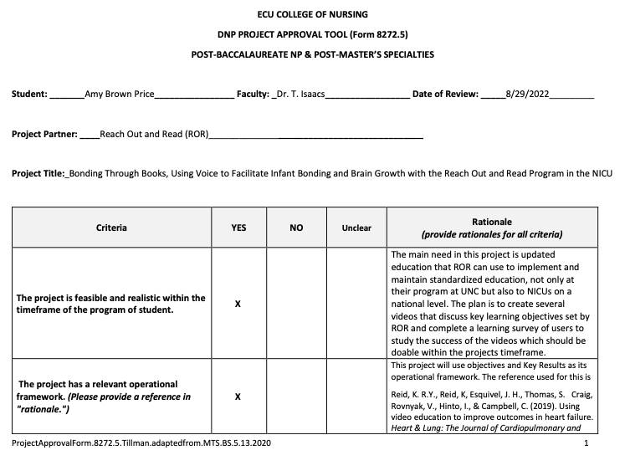
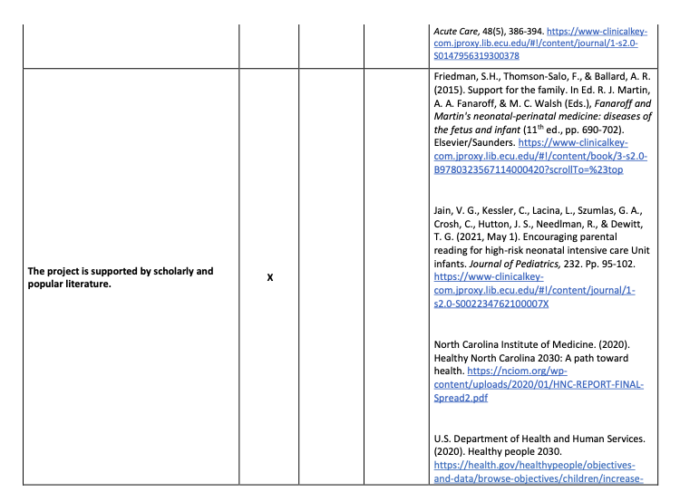
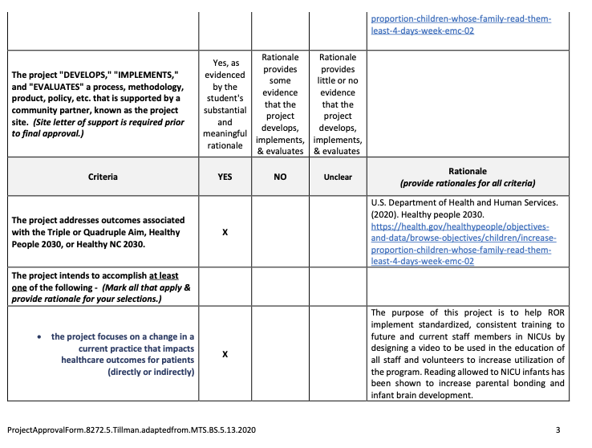
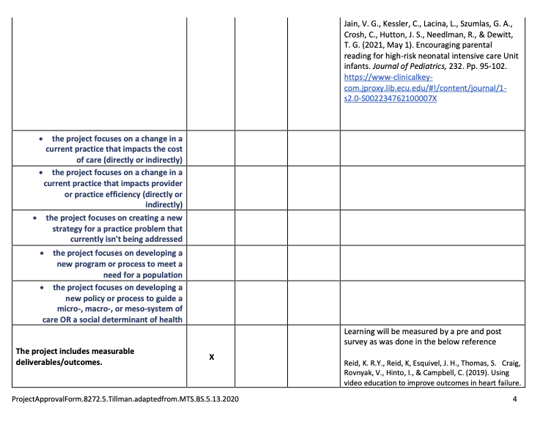
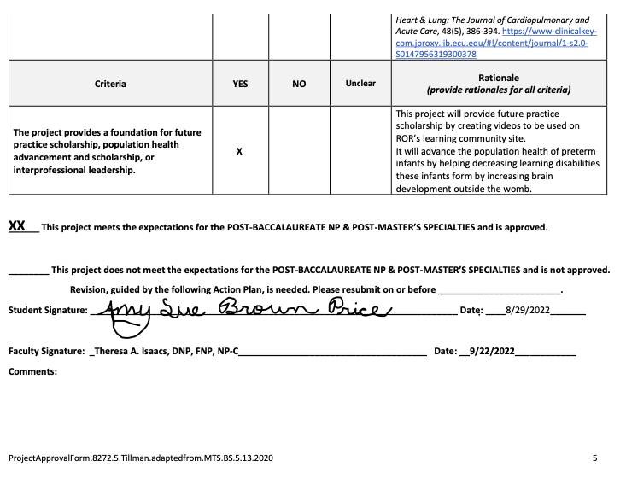
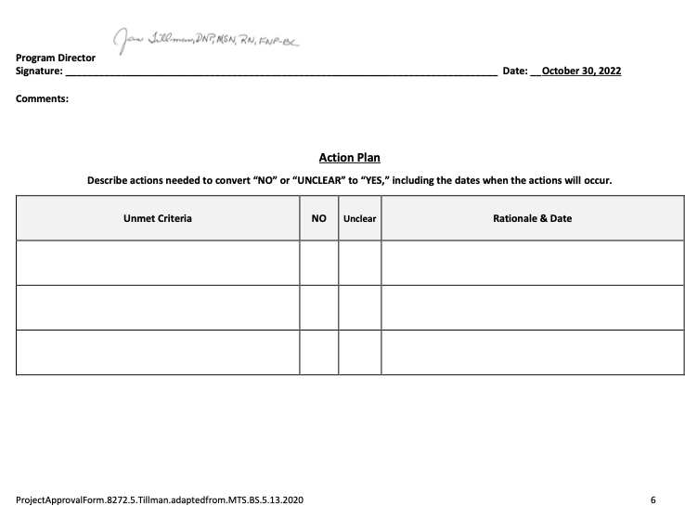
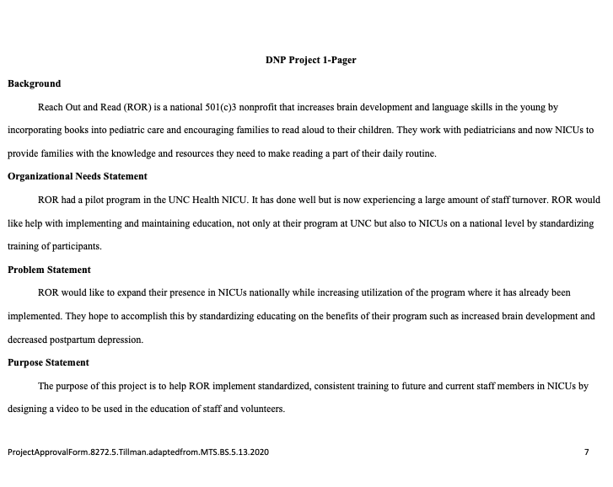

Appendix D
Surveys

Reach Out and Read (ROR) in the NICU
Thank you for taking our short survey regarding ROR in the NICU. We value your time and input.
Top of Form

1. What is your role in the NICU?
Unit Manager
Supervisor/Educator
Charge RN
RN
Other (please specify)

2. What healthcare team member initiates patient/family enrollment in the ROR program?

3. How many patients/families would you say receive education to start the program?
All
Most
Some
A few
None

4. How do patients/families typically respond to being enrolled in ROR?
Very positive
Positive
Neutral
Negative
Very negative

5. Do you find parents utilize ROR books in the NICU?
Always
Usually
Sometimes
Rarely
Never

6. What factors contribute to the use of the program?

7. What barriers reduce the implementation of the program with NICU families?

8. In your unit, what healthcare team member(s) provides most of the education to patients and families? Please be specific (examples: PT, OT, RN, APP, Volunteers, Other).

9. What healthcare team members are provided ROR training and education? Please include all disciplines involved with patient care.

10. How much interaction would you say the Neonatologist/Neonatal NP has with the families?
Always
Usually
Sometimes
Rarely
Never

ESTIMATED COMPLETION RATE
60 % Completed
ESTIMATED TIME TO COMPLETE
4 Minutes

Bottom of Form

Early Literacy in the NICU
Top of Form
Thank you for taking our short survey regarding early literacy programs in the NICU. We value your time and input.

1. What is your role in the NICU?
Unit Manager
Supervisor/Educator
Charge RN
RN
Other (please specify)

2. Has your unit considered an early literacy program for NICU infants and their families?
Yes
No

3. Can you identify barriers that are preventing the initiation of an early literacy program in your unit?

4. In your unit, what healthcare team member(s) provides most of the education to patients and families? Please be specific (examples: PT, OT, RN, APP, Volunteers, Other).

5. How much interaction would you say the Neonatologist/Neonatal NP has with the families?
Always
Usually
Sometimes
Rarely
Never

ESTIMATED COMPLETION RATE
72 % Completed
ESTIMATED TIME TO COMPLETE
2 Minutes

Book Program in the NICU
Thank you for taking our short survey regarding early literacy programs in the NICU. We value your time and input.
Top of Form

1. What is your role in the NICU?
Unit Manager
Supervisor/Educator
Charge RN
RN
Other (please specify)

2. What healthcare team member initiates patient/family enrollment in your book program?

3. How many patients/families would you say receive education to start the program?
All
Most
Some
A few
None

4. How do patients/families typically respond to being enrolled in the book program?
Very positive
Positive
Neutral
Negative
Very negative

5. Do you find parents utilize books in the NICU?
Always
Usually
Sometimes
Rarely
Never

6. What factors contribute to the use of the program?

7. What barriers reduce the implementation of the program with NICU families?

8. In your unit, what healthcare team member(s) provides most of the education to patients and families? Please be specific (examples: PT, OT, RN, APP, Volunteers, Other).

9. What healthcare team members are provided with early literacy training and education? Please include all disciplines involved with patient care.

10. How much interaction would you say the Neonatologist/Neonatal NP has with the families?
Always
Usually
Sometimes
Rarely
Never
Bottom of Form

ESTIMATED COMPLETION RATE
59 % Completed
ESTIMATED TIME TO COMPLETE
4 Minutes

Appendix E

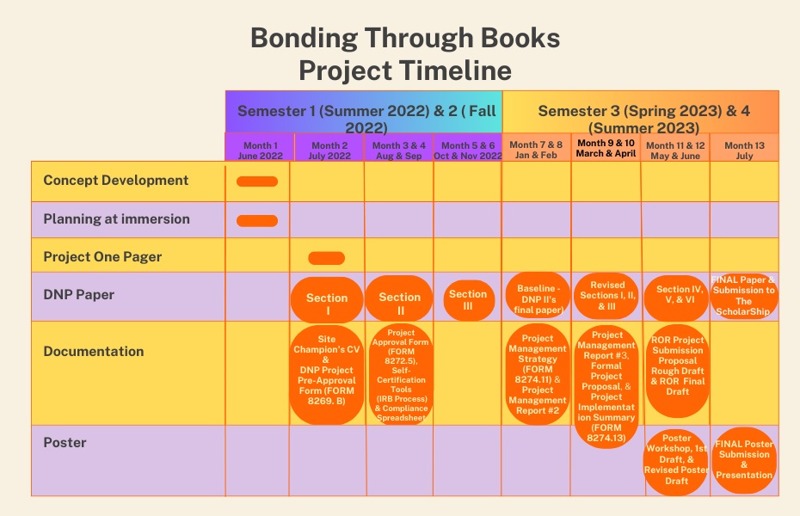
Bottom of Form

Appendix F
Survey Responses
ROR in the NICU Survey Response
Respondents' Role in the NICU | Responses Q 1
Unit Manager | 0
Supervisor/Educator | 0
Charge RN | 3
RN | 7
Project Manager | 1
Family Support Director | 1
Director | 1
Neonatologist | 1
Physician | 1

Healthcare team member who initiates ROR enrollment | Responses Q 2
Bedside RN | 8
Family Support Coordinators | 1
Social Worker | 1
Child life | 1
Families are enrolled by default | 1
Neonatologist | 1
Family paid partner and developmental care specialist | 1
None | 1

Number of NICU families who receive education to start ROR | Responses Q 3
All | 3
Most | 5
Some | 2
A Few | 2
None | 2

NICU Families response to being enrolled in ROR | Responses Q 4
Very positive | 2
Positive | 9
Neutral | 3
Negative | 0
Very negative | 0

NICU Families utilization of ROR | Responses Q 5
Always | 0
Usually | 7
Sometimes | 3
Rarely | 2
Never | 2

Factors contributing to the use of ROR | Responses Q 6
Parents coming in to hold their baby during the scheduled touch times | 1
Benefits of reading | 1
Having the ability to educate families and then reinforce it/ Knowledge and education about the program and availability | 3
Access to free books | 3
Not been rolled out yet | 1
Universal enrollment for all patients in a particular sub-unit, positive buy-in from multidisciplinary team members, consistency among team members | 1
Providing books in their native language and educating them on the importance of ROR | 1
Parents wanting a sense of normalcy when in the NICU | 1
Encouragement | 1

Barriers that reduce implementation of ROR | Responses Q 7
Infants on IVH precautions requiring low stimulation environment | 1
Cell phone use, Parents want to hold baby and face time with family/ Unit acuity | 2
Bedside nurse not having adequate time to visit with all of the families | 1
Lack of knowledge within medical teams/ education | 3
Not enough books or nurses that promote program | 1
None | 1
How often the parents visit or how involved they are in care | 2
Books only available in a subset of languages; lower levels of written literacy in certain cultures/communities | 1
ROR has not been rolled out yet | 1
Not reminding families how important the program is and the benefits it can have | 1
Healthcare team member(s) that provides most ROR education to NICU families | Responses Q 8
RN | 8
RN, OT, PT, Volunteers | 2
Neonatologist MD/NP/PA | 1
Neonatologist MD/NP/PA, RN | 1
Child Family Life | 1
None | 1

Healthcare team members provided with ROR training | Responses Q 9
RN | 3
Neonatologist MD/ NP/PA, RNs | 3
All staff members through staff meetings | 1
Child Family Life | 1
Neonatologist MD/NP/PA, RN, OT, PT, Child Family Life, Volunteers | 2
None | 1
Unsure | 1
None | 2

Interaction between the Neonatologist MD/NP/PA and NICU families enrolled in ROR | Responses Q 10
Always | 7
Usually | 4
Sometimes | 2
Rarely | 1
Never | 0

Early Literacy in the NICU Survey Results
Respondents Role in the NICU | Responses Q 1
Unit Manager | 1
Supervisor/Educator | 1
Charge RN | 3
RN | 19
Other | 0

Has your unit considered an early literacy program for the NICU | Responses Q 2
Yes | 6
No | 16

Barriers preventing initiation of an early literacy program | Responses Q 3
Lack of RN/parent interaction | 1
Control by different disciplines | 1
Lack of access to books | 1
Cost/ Budget concerns | 6
Time constraints for care providers | 5
No connection with an early literacy program | 1
Lack of belief in its importance | 1
Acuity of patients | 1
Availability of parents/volunteers | 1
We give books to babies, but I am not sure what else you would mean in regards to an early literacy program | 1
Lack of Resources | 1
Inconsistent assignments | 1
None/ Unsure | 4

What healthcare team member(s) provides most of the education to NICU families | Responses Q 4
RN | 13
PT/OT/RN, Neonatologist NP/PA | 2
RN, Neonatologist MD/NP/PA | 2
RN, Neonatologist MD/NP/PA, PT, OT, Home Monitoring | 3
RN, PT, OT, Home Monitoring | 2

Interaction between the Neonatologist MD/NP/PA and NICU families enrolled in ROR | Responses Q 5
Always | 5
Usually | 10
Sometimes | 8
Rarely | 0
Never | 0

Book Program in the NICU Survey Results
Respondents Role in the NICU | Responses Q 1
Unit Manager | 0
Supervisor/Educator | 0
Charge RN | 0
RN | 0
NICU Quality Coordinator | 1

Healthcare team member who initiates book program enrollment | Responses Q 2
Bedside RN, CSW, or Psychologist in the unit | 1

Number of NICU families who receive education to start book program | Responses Q 3
All | 0
Most | 1
Some | 0
A Few | 0
None | 0

NICU Families response to being enrolled in book program | Responses Q 4
Very positive | 1
Positive | 0
Neutral | 0
Negative | 0
Very negative | 0

NICU Families utilization of book program | Responses Q 5
Always | 0
Usually | 1
Sometimes | 0
Rarely | 0
Never | 0

Factors contributing to the use of book program | Responses Q 6
Encourages bonding, skin to skin interaction | 1

Barriers that reduce implementation of book program | Responses Q 7
Very difficult to locate books in foreign languages | 1

Healthcare team member(s) that provides most book program education to NICU families | Responses Q 8
Neonatologist MD/ NP/PA, RN, CSW, Psychologist | 1

Healthcare team members provided with book program training | Responses Q 9
Neonatologist MD/ NP/PA, RN, CSW, Psychologist | 1

Interaction between the Neonatologist MD/NP/PA and NICU families enrolled in book program | Responses Q 10
Always | 1
Usually | 0
Sometimes | 0
Rarely | 0
Never | 0

Appendix G
Pie Charts
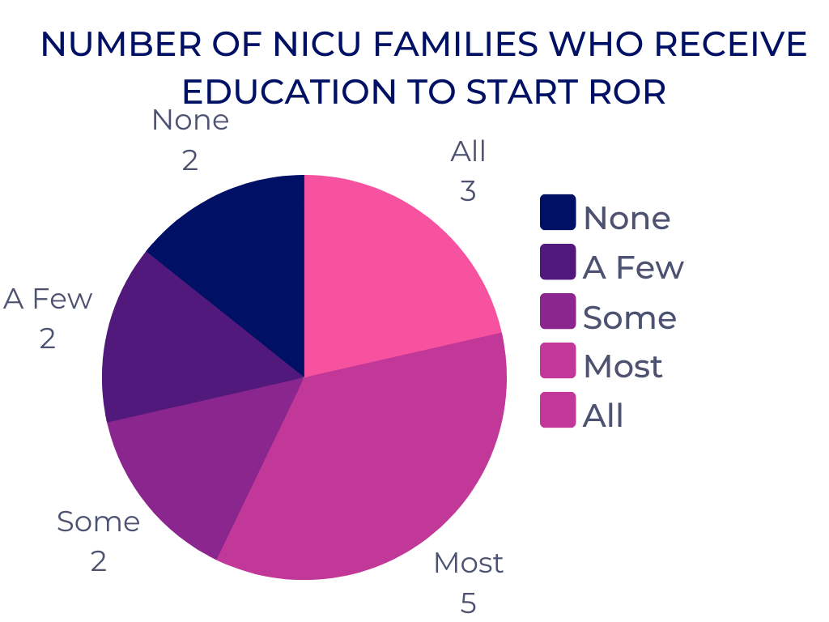
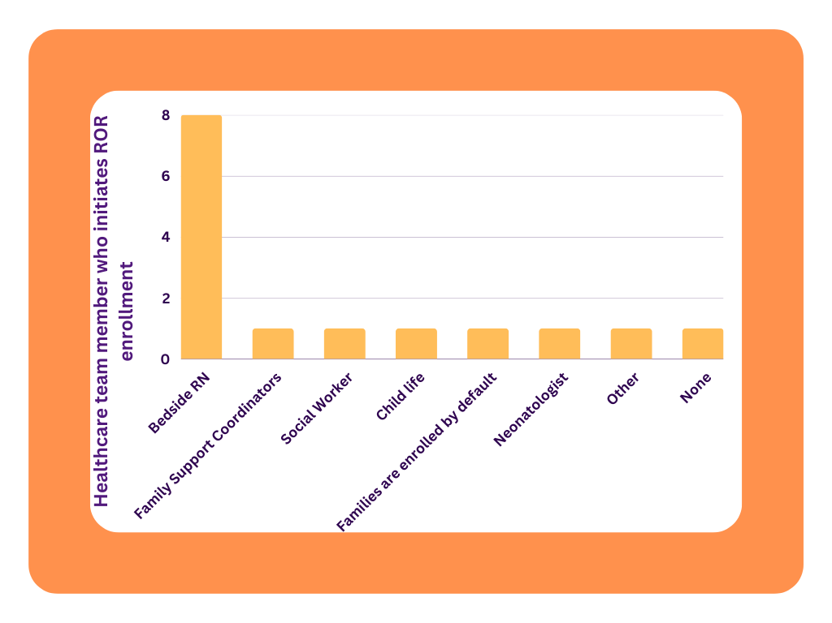

Appendix H
DNP Project Poster

