Implementation of COPD guidelines and an action plan at a Community Health Center
Kelly Wilkins
East Carolina University

Table of Contents
Abstract 6
Chapter One 7

GOLD Guidelines 7

COPD: Morbidity and Mortality 7

Triple aim 7

Purpose 8

Project goals 8

Problem Statement 8

Justification of Project 9

Project hypothesis 9

Theoretical Framework 10

Diffusion of innovation theory 10

Studies using diffusion of innovation theory 11

Definition of Terms 12

COPD 12

Exacerbations 13

Community health centers 13

Summary 14
Chapter Two: Research Based Evidence 15
Cost 15

Cost of exacerbations 16

Comorbidities 17

Rural Areas 17

Tobacco Use 17

Barriers to Chronic COPD Care 18

COPD Action Plans 19

American lung association initiative programs 19

Provider step-by-step action plans 19

Systemic review of action plans 19

Self-management action plans 20

Gaps in the Literature 20

Summary 20

Chapter Three: Methodology Project Design 22

Project Design 22

Sample 22

Protection of Human Rights 23

Methods 23

Educational in-service 24

Gold guideline implementation 25

Resources Used 25

Instruments 25

Data Collection 26
Data Analysis 27

AGREE instrument 27

Cost 28

Summary 28
Chapter Four: Results 30

Purpose 30

Participant Demographics 30

Intended Outcomes 30

Finding 31

Summary 32
Chapter Five: Implications for Nursing Practice 34

Practice Implications 34

Essential I: Scientific underpinnings for practice 35

Essential II: Organization and system leadership for quality improvement and systems thinking 35

Essential III: Clinical scholarship and analytical methods for EBP 35

Essential IV: Information Systems/Technology and Patient Care Technology for the Improvement and Transformation of Health Care 36

Essential V: Healthcare policy for advocacy in healthcare 36

Essential VI: Interprofessional Collaboration for Improving Patient and Population Health Outcomes 37

Essential VII: Clinical prevention and population health for improving the nation’s health 37

Essential VIII: Advanced nursing practice 38

Summary 38
Chapter Six: Final Conclusions 39

Significance of Findings 39
Project Strengths 39

Project Limitations 40

Project Benefits 40

Practice Recommendations 41

Final Summary 41
Reference 43
Appendix 50

Abstract
Chronic Obstructive Pulmonary Disease (COPD) is a global health problem. It is the third leading cause of death in the United States (Center for Disease Control and Prevention [CDC], 2016). COPD affects approximately 30 million United States citizens (COPD Foundation, 2017). The prevalence of COPD in adults in North Carolina is 6.9 percent (American Lung Association, 2016). COPD’s prevalence, its increasing cost and health care providers need to reduce such costs prompted a QI project on using evidenced based COPD guidelines. The project site was a Community Health Center in Cumberland County, NC. The site recognized a need to focus on COPD from within the center. Approximately 400 patients with COPD were identified at this center. The QI project will implement (1) the Global Initiative for Chronic Obstructive Lung Disease (GOLD) Guidelines (2017) and (2) an action plan for Community Health Center in Cumberland County. This project goal is to reduce COPD burden in this this population.
Keywords: COPD, community health center, Gold Guidelines, COPD action plan, rural areas,

Chapter One
According to the National Heart Lung and Blood Institute (NHLBI), COPD is the cause of death for more than 135,000 Americans each year (2017). That equates to one every four minutes. More than 11 million people in the United States are diagnosed with COPD and many more likely have COPD and don’t know it (American Lung Association, 2018). This respiratory disease has long-term effects that contribute to disability and death.
GOLD Guidelines
Health care providers can use the Global Initiative for Chronic Obstructive Lung Disease (GOLD) Guidelines (2017) to: (1) reduce burden and to (2) improve outcomes. The guidelines were recently changed to include knowledge gained from the last update (GOLD, 2017). Thus, existing data have been incorporated into the new guidelines. This QI project will implement these new recommendations in a community health center and a COPD action plan.
COPD: Morbidity and Mortality
Globally, COPD has a high prevalence with increasing morbidity and mortality. COPD is the third leading cause of death in the United States (American Lung Association, 2018). According to GOLD (2017), comorbidities such as diabetes, depression, and heart disease are a major contributor to COPD. Comorbidities have a significant impact on COPD prognosis. Another concern is that diseases with the same symptoms as COPD, i.e., breathlessness resulting from heart failure and lung cancer, may lead to a COPD diagnosis to be missed (GOLD, 2017).
Triple aim. Teaching staff these new COPD guidelines and providing an action plan should increase rates of compliance with the GOLD guidelines, which reflect the national Triple Aim priorities. The Institute for Healthcare Improvement (IHI) has a vision that the best care and health possible should be available to all and the IHI has the mission to improve health and healthcare worldwide (IHI, 2016). These Triple Aim priority goals are: improving the experience of care, improving the health of populations, and reducing per capita costs of healthcare. The goals are not independent of one another; changing one goal can affect the other two (IHI, 2016).
Purpose
The purpose of this study was to teach staff new GOLD guidelines and implement a COPD action plan. Staff requested a QI project designed to improve a COPD action plan. Details of their requests resulted in the project’s goals.
Project goals. Goals provide direction to future desired outcomes (Zaccagnini & White, 2014). Project goals are: (1) One educational in-service will be attended by providers and medical assistants, (2) Staff will gain knowledge about new GOLD guidelines, (3) Staff will use COPD action plans that will be individualized, (4) Providers will address smoking and its cessation (5) Retrospective chart reviews were performed to determine if the COPD action plan, smoking cessation teaching, and spirometry were implemented.
Problem Statement
In Cumberland County, chronic lower respiratory disease is the third leading cause of death (NC Health and Human Services, 2016). At Stedman-Wade Health Services, located in Cumberland County, there are approximately 400 documented patients with the diagnosis of COPD. In 2016 there were nearly 300 COPD encounters. The purpose of this project is to teach staff the new COPD guidelines, and to implement an action plan. The overall goal is to improve COPD patient outcomes at the project site (GOLD, 2017). The new revision “builds on the strengths from prior published recommendations and incorporates new knowledge” (GOLD, 2017, p. 1). This knowledge is key in providing appropriate care and management for COPD populations.
Justification of Project
Justification of this QI project includes addressing low socioeconomic status, low health literary, and lack of insurance. For example, when working with populations using community health centers, patients are likely to have low socioeconomic status (SES) and/or low health literacy. The patient population at the project site included a mix of underinsured, living below the poverty level, and those with private insurance who were financially stable. The majority of patients are poor, have low literacy rates and lack resources to manage chronic conditions (National Association of Community Health Centers, 2017).
Healthcare costs associated with COPD can be astronomical. By 2020 the cost of care is expected to be more that $90 million dollars in the United States (CDC, 2014). Total cost of COPD healthcare in North Carolina adjusting for demographics in 2010 was $1,035,998 (Ford et al., 2015). To improve COPD and its effects, the CDC urges clinicians to use interventions that reduce COPD’s clinical complications (CDC, 2014). This QI project will help staff better understand this CDC goal through staff training in evidence-based guidelines.
Members of the Congressional COPD Caucus urged The National Institute of Health (NIH) and the CDC to create a blue print to care for the millions of COPD patients (National Heart, Lung, and Blood Institute, 2017). This blueprint is titled: The COPD National Action Plan. This plan has five overreaching goals designed to cover a range of topics on COPD (National Heart, Lung, and Blood Institute, 2017) (Table 1). COPD National Action Plan Goals encourage caring for COPD patients in an appropriate manner driven by national guidelines. This project will help accomplish the goals of the NIH to diagnosis, prevent, treat, and manage COPD (National Heart, Lung, and Blood Institute, 2017).
Project hypothesis
It is hypothesized that teaching staff COPD guidelines and implementing individualized COPD action plans will result in staff having evidence based research to guide their practice. This therefore, this result will enhance clinical decision-making.
Theoretical Framework
The Diffusion of Innovation Theory by Rogers will be used as the theoretical framework for this project (Rogers, 2003). Rogers defined diffusion as the process by which an innovation is communicated through certain channels over time among members of a social system (Rogers, 2003). Innovation is described as an idea that an individual identifies as new (Rogers, 2003). An innovation that is less complex is more likely to be accepted by users (Rogers, 2003). The Diffusion of Innovation Theory helps to explain how an idea gains motion and is spread through a specific population (Rogers, 2003). The theory is often regarded as a valuable change model for helping to guide innovation. It is ideal for nursing and this project as it focuses on a change in provider practice. In this project, the evidenced-based guidelines and individualized action plans are considered innovations. This model seeks to answer the questions: How and under what conditions are new ideas acceptable (Rogers, 2003).
Diffusion of innovation theory. Diffusion of Innovation theory has four components: Innovation, communication channels, time, and social system (Rogers, 2003). “An innovation is an idea, practice, or object that is perceived as new by an individual or other unit of adoption” (Rogers, 1995, p. 11). According to Rogers (2003), there are several characteristics that affect how one receives new knowledge such as experience, need of the innovation, attitude regarding change, and the work environment of the individual (Rogers, 2003).
Awareness of the innovation then hopefully leads to the beginning of communication. However, being aware of a new idea does not necessarily mean that one will be accepting of it. The next component is communication and it is “the process by which participants create and share information with on another in order to reach a mutual understanding” (Rogers, 1995, p. 17). Time element is the third process. “The time dimension is involved in diffusion: (1) in the innovation-decision process by which an individual passes from first knowledge of an innovation through its adoption or rejection, (2) in the innovativeness of an individual or other unit of adoption, (3) in an innovation’s rate of adoption in a system” (Rogers, 1995, p. 19). The social system as defined by Rogers (1995) is a “set of interrelated units that are engaged in joint problem-solving to accomplish a common goal” (p. 23). Rogers has also characterized the individuals of a social system into five groups based on their attitudes toward an innovation: innovators, early adopters, earlier majority, later majority and laggards (Rogers, 2003). 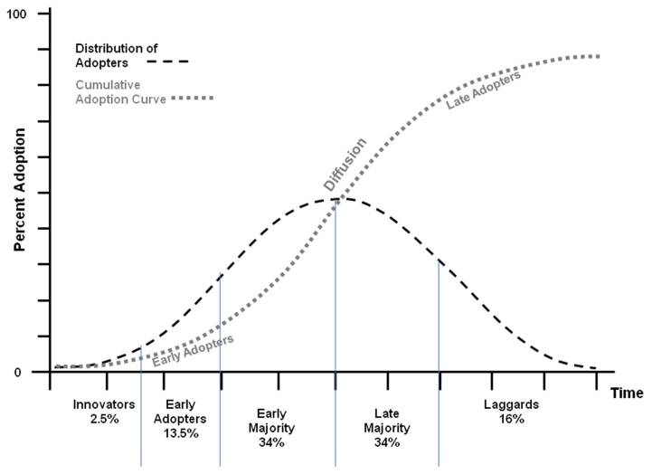
Figure 1: Roger’s Diffusion of Innovation theory (Rogers, 2003)
Studies using diffusion of innovation theory. Diffusion of Innovation theory has been used in a quality improvement project to screen mental health patients on atypical antipsychotics for metabolic syndrome with particular attention to waist circumference (Parrinello, 2012). The study was conducted in a psychiatric hospital in a large suburban tertiary care facility (Parrinello, 2012). The theory was used due to the focus on innovation and because Rogers’ theory outlines crucial components needed for an innovation to be accepted in an organization and integrated into practice (Parrinello, 2012). Another study used the theory to understand factors impacting patient acceptance and use of consumer e-health innovations (Zhang, Yu, Yan, & Ton, 2015). According to this study, the more an innovation can integrate with existing values, the greater its changes for diffusion and adoption (Zhang, Yu, Yan, & Ton, 2015). “This theory was used in the study as the theoretical framework to examine and explain the impact of factors, in particular, the characteristics of innovations and innovative decision-making processes, on patient acceptance and ongoing usage of an e-appointment scheduling service” (Zhang, Yu, Yan, & Ton, 2015, p. 3). Results showed that the adoption rate of the e-appointment service increased from 1.5% at 3 months after implementation to 4% at 29 months, which meant only the innovators had used this new service (Zhang, Yu, Yan, & Ton, 2015).
This theory has been used to describe how to disseminate diabetes prevention strategies (Lien & Jiang, 2017). “The main objectives of innovative strategies are to not only provide knowledge, but ensure diffusion of the innovation and its acceptance by the population for a sustained long‐term effect” (Lien & Jiang, 2017, p. 259). According to the editorial, this theory can be used to encourage the general public to implement lifestyle modification.
Definition of Terms
COPD. GOLD has defined COPD as “a common, preventable and treatable disease that is characterized by persistent respiratory symptoms and airflow limitation that is due to airway and/or alveolar abnormalities usually caused by significant exposure to noxious particles or gases” (2017, p. 6). The most common symptoms are dyspnea, cough, and/or sputum and these may be under-reported by patients (GOLD, 2017). Risk factors for COPD include environmental exposure, but tobacco smoking is the main risk factor (GOLD, 2017). COPD may have exacerbations. In most patients, COPD exacerbations are associated with significant comorbidities that increase morbidity and mortality (GOLD, 2017).
Exacerbations. Exacerbations are defined by an event that leads a provider to prescribe to an antibiotic or steroids or both or that can lead to a hospitalization (Hurst et al., 2010). Exacerbations become more frequent as the COPD severity increases and they usually become more severe (Hurst et al, 2010). Data from NIH describe exacerbation as “a sudden onset of worsened cough, wheeze and labored breathing which are typically induced by bacterial and/or viral infection” (2011).
Community health centers. Community Health Centers are community-based health care centers that deliver high quality primary care services, mental health, substance abuse, and oral health services (National Association of Community Health Centers, 2018). Community health centers offer these services in areas where “economic, geographic, or cultural barriers limit access to affordable health care services” and “health centers deliver care to the nation’s most vulnerable individuals and families, including people experiencing homelessness, agricultural workers, residents of public housing, and the Nation’s veterans” (HRSA, n.d., para 1). This also includes veterans (HRSA, 2017). 24 million people access care from a Health Resource & Service Administration (HRSA) funded center for primary care. One in three adults, and four in ten children living in poverty receive care from community health centers. HRSA funded centers also see more than 305,000 veterans – and more than 8.4 million rural area patients (HRSA, 2017). Community health centers provide care to those who otherwise could not receive it. These centers have the ability to reach and serve the vulnerable and are in some ways immeasurable. The definitions of terms are defined and are important for clarity moving forward.
Summary
Implementation of the COPD practice guidelines is needed in primary care. Implementing updates at project site is important. The goal of the QI project is to educate and engage providers. By implement these guidelines along with an action plan, COPD patients will have the potential for improved outcomes. The focus of this project is of particular interest due to the prevalence of COPD and the growing number of cases as well as the economic impact. Through the implementation of these guidelines there can be an overall improvement of outcomes as well as putting patients in a place to better care for themselves outside of the clinic setting.
The Diffusion of Innovation theory is the theoretical framework for this project. COPD care plans are innovations for patients that will create dialogues between patients and their providers. The COPD action plan is the communication channel between the provider and the patient. Another operational definition of Roger’s communication channel is the information taught to staff and health care providers. In this project the element of time is the process between the educational opportunity through the adoption or rejection of the knowledge. The social system for this quality improvement project is the providers and COPD patients at a community health center.

Chapter Two: Research Based Evidence
A literature review was completed using the databases CIHAHL and PubMed. This was a librarian-assisted search. There were 2,265 potentially relevant articles on COPD and the keywords economic burden, rural areas, community health centers, tobacco use, chronic care, and barriers. Exclusions were made based on articles (1) non-English, (2) rural areas and community health centers outside of the United States, (3) duplicates, and not pertinent to desired concepts. Search was limited to the past five years. There were 10 potentially relevant articles on barriers to chronic disease management, 15 on the cost burden of COPD, 15 on rurality and COPD prevalence, and 39 on COPD guideline adherence. Of these articles 10 were hand selected based on the purposes of this project.
Levy and Elis (2006) listed the following reasons to conduct a literature review: help understand the existing body of knowledge, provide a solid theoretical foundation, substantiating the presence of research problems, justifying a proposed study, and framing goals and research questions. Levy & Ellis, (2006) also suggested a three-step approach to an effective literature review process. Input, the first step, involves gathering manuscripts for an effective review (Levy & Ellis, 2006). Processing, the second step, uses the information so that there is a foundation upon which to build new research. Output, which is the third step, provides literature reviews that are logical and support academic writing.
Cost
COPD is a disease with high direct and indirect costs (Guarascio, Ray, Finch & Self, 2013). The prevalence of COPD is considerable. Because of its prevalence, it is important to understand costs associated with COPD. According to Guarascio, et al., (2013) mean estimated healthcare costs are over $4,000 per patient per year. Indirect costs are also important to consider. Indirect costs must factor in wages lost due to illness. A patient with COPD who is away from employment multiple times is likely to be replaced by another (Foo et al., 2016). According to Foo et al., (2016), of twelve countries, the US had the highest proportions of working age persons with COPD prevented from working at a rate of 52%. Foo et al., (2016) also points out that interventions aimed at delaying disease progression, preventing exacerbations, and optimizing medication usage will attempt to reduce the economic burden of COPD. Also, Ford et al estimated that the total cost of COPD in the US would increase to $49.0 billion by 2020 (2015). This project will attempt to reduce the economic burden in Cumberland County, NC.
The Center for Disease Control (CDC) and Prevention reported that in 2010, the total national medical cost attributable to COPD was estimated at $32.1 billion dollars annually (CDC, 2014). In 2014, absenteeism, estimated at 16.4 million days (COPD), and its associated costs cost 3.9 billion for a total burden of $36 billion (CDC, 2014). Medical costs are projected to rise from $32.1 billion in 2010 to $49 billion by 2020 (CDC, 2014). As COPD healthcare costs soar, healthcare providers need to promote EBP treatments to decrease financial burden. One of the goals of The Triple Aim is to decrease cost related to healthcare (IHI, 2016).
Cost of exacerbations. Exacerbations contribute to COPD healthcare costs. According to Yu, et al, (2011), and their retrospective claims analysis revealed COPD exacerbation costs (2011). “After adjusting for patient demographics, mean incremental cost was $11, 261 per patient-quarter. Range of costs depended on severity of an exacerbation. Severe exacerbation resulted in $3439 per patient-quarter, non-severe exacerbation resulted in $1509 per patient-quarter, and any exacerbation compared no exacerbations resulted in higher health care costs per patient-quarter (Yu, et al., 2011)
Comorbidities
Two or more chronic conditions commonly affect people with COPD. Chronic conditions such as: heart disease, depression, diabetes, and gastroesophageal reflux (GERD) are among the comorbidities affecting COPD patients. Cardiovascular diseases are important comorbidities. GERD is associated with an increased risk of exacerbations (GOLD, 2017). Osteoporosis and depression/anxiety are associated with poor prognosis in patients with COPD (GOLD, 2017). It is important to recognize these conditions and appropriately treat them. Presence of comorbidities should not alter COPD treatment (GOLD, 2017).
Westney, Foreman, Xu, King, Flenaugh & Rust (2017) conducted a retrospective cohort study that focused on depression as a COPD comorbidity. The results indicated that the depression cohort was 48 percent more likely to have had an emergency room visit and 77 percent more likely to have COPD related hospitalizations than the COPD-only group.
Rural Areas
COPD has been more common among poor and rural communities than wealthier, urban communities (Raju et al., 2015). According to Raju et al., (2015), data from 2009 to 2011 indicated COPD was prevalent in 7.2 percent of participants nationwide with 11.9 percent of participants in rural, poor communities. The researchers concluded that rural residence and poverty level contributed to a risk for developing COPD (Raju et al., 2015). Globally, rural areas with environmental pollutants and indoor biomass burning have a high disease burden (Raju et al., 2015,). Westney et al., (2017) found that COPD related ED visits were more common among rural people than among urban people. Caring for people in poor rural communities presents challenges resulting from socioeconomic determinants.
Tobacco use
Tobacco smoking is the most common cause of COPD (Mehta, Desai, & Patel, 2016; Marc, Wim, & Marc, 2012; Westney, Foreman, Xu, King, Flenaugh, & Rust 2017, CDC, 2017). Fabbri further suggests that smoking, not COPD, should be treated as the disease (2016). Woodruff et al concluded “although they do not meet the current criteria for COPD, symptomatic current or former smokers with preserved pulmonary function have exacerbations, activity limitation, and evidence of airway disease” (2016, p. 1811).
Patients who smoke should be urged to stop smoking. Providers should take every opportunity discuss smoking cessation with their patients (GOLD, 2017). “Smoking cessation has the greatest capacity to influence the natural history of COPD” (GOLD, 2017, p. 44). Smoking cessation is the one risk factor that can make the biggest impact on health outcomes among patients who have COPD. Brief strategies to help patients quit smoking are: Ask at every visit, advise cessation, assess willingness to quit, assist patients in quitting, and arrange follow-up contact (GOLD, 2017).
Barriers to Chronic COPD Care
Barriers do exist in providing care to COPD patients (Salinas, et al., 2011 & Johnston, Grimmer-Somers, Young, Anitc, & Frith, 2012). Providers reported lack of awareness, lack of time, lack of available services and a perceived difficult referral process as barriers to care provision for COPD patients (Johnston, et al., 2012). Salinas, et al., commented that although there are available guidelines, providers managing COPD are not using those recommendations consistently (2011). This finding was attributed to providers unfamiliar or insufficiently familiar with practice guidelines so that their treatment patterns are inconsistent with practice recommendations (Salinas, et al., 2011). Furthermore COPD is “often under-diagnosed and misdiagnosed in the primary care setting” (Salinas, et al, 2011, p. 172).
COPD Action Plans
American lung association initiative programs. The COPD action plan is a tool implemented in October of 2012 by the American Lung Association (American Lung Association [ALA], 2015). This tool was part of a lung health initiative created by a medical board of COPD experts. As of this writing, the tool has not been validated. It is used with the ALA’s initiative programs (Personal Communication, L. Yoynker, February 19, 2018). Two of these initiative programs are Lung Force and Better Breathers Club. Facilitators who are COPD medical experts, registered nurses, and respiratory therapist lead these programs. This is a simple tool that is be used by the ALA facilitators within these programs (Personal Communication, L. Yoynker, February 19, 2018).
Provider step-by-step action plans. Effective strategies to reduce COPD exacerbations are essential. Some evidence shows that about 20% of all hospitalized COPD patients are readmitted within 30 days of discharge (Guarascio, Ray, Finch & Self, 2013). Action plans are step-by-step plans for patients to use when they COPD symptoms worsen: Increased sputum, wheezing, or difficulty with breathing on exertion. Providers write these plans for their patients to take home as guides with simple instructions. Written plans are individualized and vary from patient to patient.
Systemic review of action plans. Howcroft, Walters, Wood-Baker and Walters (2016) completed a systematic review to compared effects of an action plan for COPD combined with a short educational component versus usual care among COPD patients. The systematic review included seven parallel-group randomized control trials totaling 1550 study participants. The data are current to November 2015. This review showed that the use of a COPD exacerbation action plan with education and support showed there were reduced hospitalizations. Along with these findings there was an increase in treatment of exacerbations with steroids and antibiotic (Howcroft, et al., 2016). The authors concluded that people given a COPD action plan have fewer emergency room visits and hospital stays. (Howcroft, et al., 2016). Although reducing morbidity rates COPD action plans are unlikely to increase or decrease mortality (Howcroft, et al., 2016).
Self-management action plan. Self, Patterson, Headley, and Finch (2014) reviewed treatment of COPD exacerbations as part of self-management action plans. Two randomized controlled trials (N = 933 patients) indicated that a combination of comprehensive COPD action plans and oral corticosteroids decreased hospitalization, (Self et al., 2014). This finding was not replicated in three other trials (N =790) did not reveal decreased hospitalization rates (Self et al., 2014, p. 2607). Kirby, Dennis, Bazeley, & Harris (2011) wrote “many readmission due to acute exacerbations of COPD could be prevented if patients self-managed” (p. 220).
Gaps in the Literature
While there are numerous studies on COPD in the literature, there were few studies on management of COPD patients who receive care in rural community health centers. There also is a lack of research on validity of a COPD action plan. Ongoing research efforts are needed to determine how COPD affects rural populations. Lack of research is partly due to the social determinants faced by people living in rural areas. Further disparities research is needed to understand contributions to COPD prevalence in poor, rural areas (Raju, et al., 2015).
Summary
There is strong evidence that COPD is costly to patients, employees and employers. Some of the high costs reflect expenditures on COPD comorbidities, i.e., heart disease. Rural care for COPD patients is less available than urban care for COPD. Availability of appropriate treatment is necessary for desired patient outcomes. Smoking cessation is the most effective behavior to reduce incidence and severity of COPD. Smoking cessation may be incorporated into individualized COPD action plans. Action plans appear to increase self-management skills. Gaps in the literature indicate that the issue of limited access to health care in rural areas must be addressed. However, this is little data on care of the COPD patient in a community health center. Lack of data suggests that a project focused on COPD patients in a community health center is needed. Those in a rural and underserved area may benefit from a quality improvement project. A quality improvement project in a community health center will be beneficial in this setting because of the lack of resources that some of these centers experience.

Chapter Three: Methodology
Project Design
This is a quality improvement (QI) approach involving the collection and analysis of data to measure change. “Quality improvement projects in health care encompass those efforts that seek to improve services for the future” (Moran, Burson, & Conrad, 2014, p. 128). This project was designed for a rural community health center. The project goal was to improve care of COPD patients at this clinic. In the beginning phase of the project, the site contact Ms. Perez, recommended focusing on COPD. Ms. Perez was directly involved in quality improvement projects and thought that patients would benefit from COPD action plans. This recommendation coincided with the release of new GOLD Guidelines. It was agreed to teach staff these new guidelines and implement COPD action plans. The ALA authored the COPD action plan most familiar to clinic staff. Data collection took place from September 21, 2017 through October 31, 2017.
Setting
Setting for this project was two offices with Stedman-Wade Health Services. Both offices are in Cumberland County, North Carolina. These two offices are a part of one large community health center that serves about 400 COPD patients. The Wade clinic is a more rural community compared to the more urban Fayetteville office.
Sample
Participants for this project included two physicians, one physician assistant, and twelve medical assistants (MA) combined from both offices. Due to recent staff turnover the number of medical providers decreased from six to three providers. There is also one case manager and one clinical coordinator involved with the project.
Protection of Human Rights
The International Review Board (IRB) is in place to protect the rights of human participants. East Carolina University’s Office of Research Integrity and Compliance is the division that will oversee this process and grant permission to complete this QI project (East Carolina University, 2017). The process is complete and IRB approval was granted to move forward
Methods
Prior to the start of this project, one of the physician assistants became the clinic site champion. She is involved in patient care as well as coordination of quality improvement for Stedman-Wade Health Services. She pointed out the large volume of COPD patients and identified a need for a COPD action plan (S.Perez, Personal Communication, January 2018). The three providers felt that they could improve adherence to the GOLD guidelines for COPD into their daily practice. The COPD action plan was a tool that was underutilized. Further discussion with the providers led to the decision to focus on increasing the use of an action plan in the hopes of improving COPD patient care. After further review, it was determined that the new COPD GOLD guidelines were appropriate for this clinic as well (GOLD, 2017). Written approval for the project was obtained from the CEO of the organization.
Plan-Do-Study-Act (PDSA) is a quality improvement method that was utilized in this project. The PDSA is intended to determine areas that may be deficient and put a plan in place to correct these deficiencies. This cycle is used in the real work setting to test change (IHI, 2016). In the plan phase a problem is analyzed and the plan includes an intervention for the problem. In the do phase the intervention is carried out. Study happens when the intervention is studied and analyzed. The last phase is act, which involves refining the intervention and repeating the PDSA if needed. Goals for the project will be evaluated using the PDSA (Table 2).
Educational in-service.
Verbal notification was provided to all staff. This education module was included in the yearly paid two day training that took place at the Stedman-Wade location in downtown Wade. Medical and administrative staffs were taught the new COPD guidelines and implementing individualized action plans. Participants during the educational in-service included providers, medical assistants, office managers, and administrative staff. All were in present company wide, with the exception of one administrative staff member. The educational in-service consisted of a review of the GOLD (2017) Guidelines and a sample COPD action plan. The education was provided through a PowerPoint presentation. The time allotted for this training was 45 minutes. Presentation outline was:
- Definition and Review of COPD
- Diagnosis and Assessment
- Prevention and Maintenance Therapy
- Smoking cessation and vaccinations
- Pharmacologic therapy for stable COPD
- Management of Stable COPD
- Treatment of stable COPD
- Management of Exacerbations
- Implementation of COPD Action Plan
Those in attendance were given a hard copy of the presentation for reference.
Gold guideline implementation. Implementation of the GOLD guidelines included determining smoking status of patients, teaching smoking cessation, and ensuring that spirometry is documented in the chart and current. Spirometry completed in the last two years is considered current. During morning huddle, the provider and MA determined the COPD patients scheduled for the day. The MA prepopulated the action plan into patients’ medical record at triage. They also documented smoking status. Providers completed the face-to-face visit and the action plan. Their provider taught smokers smoking cessation.
Resources Used
The GOLD (2017) guidelines and the ALA’s COPD action plan are the two main resources used. GOLD guidelines are evaluated using the Appraisal of Guidelines for Research and Evaluation II Instrument (AGREE II). The AGREE instrument evaluates the process of practice guideline development and the quality of reporting. It has been updated and methodologically refined as AGREE II (AGREE, 2013). This tool has been tested with validity and reliability published in peer-reviewed journals.
GOLD guidelines are produced by utilizing a PubMed search using the terms: COPD, all fields, adult 19+ years, only items with abstracts, clinical trial, meta-analyses, human (GOLD, 2017). A summary of citations and all abstracts were given to members of the GOLD committee. Members then evaluate these by answering four questions from a short questionnaire (GOLD, 2017). The committee meets two times a year to discuss each publication that has the potential to impact the management of COPD (GOLD, 2017). The full committee then reaches a consensus on whether or not to include in the final report (GOLD, 2017). This is the basic process of producing the new recommendations.
Instruments
The COPD action plan used for this project was authored by the ALA (2015). This COPD action plan for patients and providers was obtained from its website (American Lung Association, 2015). GOLD (2017) guidelines were used as a guide for staff education. Staff was familiar with this action plan and used it in the past.
A COPD action plan essentially is used to guide the patient’s self-management of COPD. The patient’s provider gives education on the action plan. This is usually guided by use of inhalers, oral steroids, and/or the use of an antibiotic. Unfortunately, COPD action plans have been sparsely investigated (Jalota, 2015). However, the GOLD (2017) guidelines give clear direction on actions that need to be taken for the care of the COPD patient.
All patients with COPD should be offered bronchodilator treatment (GOLD, 2017). According to the GOLD guidelines, the use of steroids can improve lung function in an acute exacerbation (GOLD, 2017). Recommended dosage is 40mg for five days (GOLD, 2017). Antibiotics, when indicated, can shorten recovery time (GOLD, 2017). They should be used if there are signs of bacterial infection for 5-7 days with the antibiotic of choice being amoxicillin with clavulanic acid, a macrolide, or tetracycline.
Data Collection
During the review process, a staff member designated from medical records retrieved charts for the student to have for review. The DNP student had access to those records to review for pertinent data. Before the charts were accessed a HIPAA (Health Insurance Portability and Accountability Act) form was completed at the request of administration at Stedman-Wade Health Services. Charts were reviewed at the clinic.
Retrospective data extracted from the electronic health record (EHR) was used to evaluate clinical outcomes. No personal health information was gathered. Charts were reviewed for 1) COPD action plan implementation; 2) if the patient was a smoker; 3) if smoking cessation educated was documented for smokers, and 4) if spirometry is documented. This method was economical and efficient as well as appropriate for this project design. The data collection tool was in a word document. The primary project outcome was to assess these four components.
The project began with education of all medical and administrative staff, which took place during the annual training day. Charts were reviewed for use of the COPD action plan, smoking status, smoking cessation education, and spirometry. Charts were reviewed weekly for six weeks (n=63). A PDSA was completed during the project (Appendix B). At the end of the project data was compiled and distributed to the quality assurance staff member for review. Data collection began September 21, 2017 and was completed October 30, 2017.
Data Analysis
Data gathered included information gathered from retrospective chart reviews following education for the following information: COPD action plan, smoking status/smoking cessation education, and spirometry. This was gathered with yes or no answers. Yes if data was present and no if data was absent. Human subjects were not identified. Data obtained from the tracking tool was then analyzed. This data will help the providers determine where to focus their continued education.
Figure 2: Frequency counts
Tobacco use | Smoking cessation | Spirometry | COPD action plan
39% (n=25) | 28% (n=7) | 28% (n=18) | 41% (n=26)

AGREE instrument. Healthcare providers rely on clinical practice guidelines to guide their daily practice patient care (Quaseem, et al., 2010). To determine if guidelines are appropriate there should be a method to evaluate them. This project used the AGREE II instrument to evaluate the GOLD guidelines. AGREE II stated that no overall score is calculated to determine if a guideline is recommended or not recommended (AGREE, 2013). AGREE II has six domains, which are used to assess guideline quality, scope and purpose of the guideline, stakeholder involvement, rigor of development, clarity of presentation and editorial independence (AGREE, 2013). For the GOLD (2017) guidelines, the following scores were compiled by me: scope and practice 21, stakeholder involvement 19, rigor of development 52, clarity of presentation 21, applicability 26, and editorial independence 14. Domain scores are useful for comparing guidelines and will inform whether a guideline should be recommended the Consortium has not set minimum domain scores to differentiate between high quality and poor quality guidelines (AGREE, 2013).
Cost
Cost of the project involved time away from work for the student as well as providing childcare to be away from home (Table 3). There was minimal cost for copies of the presentation that were used. The majority of the copies came from within the clinic.
Summary
This QI project involved teaching staff updated GOLD (2017) guidelines, implementing them, and providing individualized COPD action plans. These GOLD guidelines were evaluated using the AGREE II tool. These practice changes improved healthcare patients receive at project site. The resources available to a community health center were limited. Teaching staff on the GOLD (2017) guidelines and implementing a COPD action plan helped fulfill patient care needs in this underserved population. IRB approval was obtained to complete this quality improvement project at a community health center. Data collection was completed by retrospective chart reviews over six weeks. Charts were analyzed for the following: COPD action plans, spirometry, smoking cessation, and smoking cessation education. The incurred cost was addressed.

Chapter Four: Results
Purpose
The purpose of this chapter is to evaluate the results of a quality improvement project implemented at a community health center. This project had a core focus of change within a healthcare organization. When implementing change, many circumstances may inhibit or require re-evaluation of a practice change. To improve healthcare of the COPD population individualized COPD action plans combined with teaching the new GOLD (2017) guidelines were initiated.
The community health center providers determined that there was a need to improve care for COPD patients. Specifically, there was a lack of consistency among providers who used COPD action plans. The group decided this was an area they wanted to improve. Staff education focused on presenting data as outlined in the GOLD (2017) guidelines. This chapter describes the chart review findings that consisted of four areas: COPD action plans, smoking status, smoking cessation education, and documented spirometry. Data collection began September 21, 2017 and was completed October 30, 2017.
Participant Demographics
Participants of this project were the health care providers from a community health center in southeastern North Carolina. There were three providers that participated in the project: one physician assistant and two board certified medical doctors. Each provider along the MAs participated in the education. There was a total of 12 MAs. There was also one case manager and one clinical coordinator who participated.
Intended Outcome
The first intended outcome was to teach staff and providers the (revised) GOLD (2017) guidelines. Instruction was completed in one session with all staff in attendance with the exception of one administrative staff member. At the conclusion of the instruction, everyone received a summary of these guidelines with evidence-based recommendations for COPD patient care.
The second intended outcome was to implement a COPD action plan. The overall goal was to reduce health disparities in this population due to COPD exacerbations. Desired goal was: Benefits of focusing on providers would continue beyond the project. Improved provider consistency with GOLD guidelines should continue to reduce health disparities in this COPD population.
Findings
There was full attendance at the mandatory educational event. After the instruction was completed, several job turnovers and changes in job assignments resulted in confusion when chart reviews began. At that point it was necessary to discuss projected methods for this project with the medical assistants and the clinical coordinator. This anticipated problem was part of the PDSA and was successfully resolved.
After GOLD guideline presentation, project data were collected by chart review. COPD patient charts with documented visits during the study period were pulled for review. Charts were reviewed weekly for six weeks at the Wade location. There were 63 charts reviewed during the six-week study period. Tobacco use was documented in 25 (39%) charts. Of those 25 smokers, only 7 charts (28%) had documented smoking cessation education. Eighteen (28%) the 63 patient charts had a documented spirometry in the last two years. Twenty-six (41%) of the 63 patient charts had a documented COPD action plan.
Recommended care of COPD patients is to follow up with providers every 3 months. This QI project discovered follow up visits did not occur. Of 400 COPD patients, there were about 300 documented encounters in 2016. Lack of follow up visit is problematic because if patients are not getting regular follow-up visits, they (1) are likely not having medications refilled or (2) may be experiencing unreported exacerbations.
Non-adherence to GOLD guidelines also results in lost revenue. On average, a routine visit from Medicare is around $75.00. Forty-two percent of patients seen at a CHC are uninsured in North Carolina. About 26% of who seen at a CHC have Medicaid (National Association of Community of Health Centers, 2015). Considering these numbers, if 42% of the 400 patients are uninsured this could results in 228 patients with a billable visit. Medicaid rate of $75.00 per 228 patients is potentially $17,100 for one follow-up visit. At four follow up visits per year, revenue loss from 228 Medicaid patients, for example, is $68,400 for these clinics.
During the implementation phase there was some confusion about the project that occurred among staff. One of these was the implementation of the COPD action plan into the EHR. Another concern was that some of MAs were not following the process of having the COPD action plan populated into the chart during triage. These concerns were addressed with a PDSA and the project continued without any further incident.
The percentages reflect that there is room for improvement. The providers and MAs need continued encouragement to implement these project goals into their daily practice. This may be as simple as the providers accurately documenting that smoking cessation was discussed. It could reflect more complex issues such as a patient not being able to afford spirometry testing.
Summary
The purpose of this chapter is to discuss in further detail findings of this quality improvement project. Participation and support in this project was optimal. There was some confusion during the weekly chart review about roles due to turnover in staff as well as new roles that occurred as a result. This was a hurdle that was addressed and managed in a way for the project to be a success. Findings reflect room for improvement on implementing this project into daily practice. Lost revenue is a concern when a patient does not come in for routine care.

Chapter Five: Implications for Nursing Practice
Implications for nursing practice have the potential to overcome barriers that could prevent living a healthier life with COPD. Individuals who access a community health center may be faced with many socioeconomic factors. These factors can have a negative impact on their overall health. Some of these are: living with COPD, coping with complexities of comorbid conditions, challenges of quitting smoking and maintaining cessation, dealing with second-hand smoke, false beliefs and myths about quitting smoking, difficulty paying for medications, and overall satisfaction with the clinic health care providers (Glasser et al., 2016). Care delivery through evidence based GOLD guidelines and individualized COPD action plans can reduce COPD exacerbations.
There is no known cure for COPD. Early detection and evidence-based treatment can change its course (CDC, 2017). COPD affects more than 15 million Americans and more than 140,000 Americans die each year of COPD (CDC, 2017). The CDC (2017) recommends focusing on areas such as smoking cessation and early detection through spirometry. This project focused on implementing these components. Complications can be avoided by early detection and treatment. Some complications are activity limitations, being unable to work, oxygen need, memory loss, emergency room visits, or depression (CDC, 2017). Furthermore, the goal for implementing a COPD action plan for the patents at Stedman Wade Health Care was a quality improvement goal to improve management of these patients.
Practice Implications
It is important to discuss how this project can reach across nursing and how it is reflective of the Doctor in Nursing Practice Essentials. The American Association of Colleges of Nursing established the Essentials of Doctoral Education for Advanced Nursing Practice (AACN, 2006). There are eight components of the DNP program. The DNP project allows fusion of the essentials through application of evidence into practice (Brown & Crabtree, 2013). “The DNP prepares graduates to practice at the most advanced level of nursing and to evaluated current practice approaches, to appraise evidence, and to use this knowledge to create clinical strategies that improve practice and health outcomes” (Brown & Crabtree, 2013, p. 330).
Essential I: Scientific underpinnings for practice. Using nursing science, as a basis for patient care, is one of the abilities of a DNP prepared Advance Practice Registered Nurse (APRN). One completed goals of this project was to teach staff the GOLD (2017) guidelines. This evidence based guidelines offers needed treatment decision pathways when caring for COPD patients. An extensive librarian assisted literature review was also performed to identify needs for this quality improvement project.
Essential II: Organization and system leadership for quality improvement and systems thinking. Interprofessional engagements and organizational outcomes were an early part of the project. These engagements began pre-project as a brainstorming session with the designated site contact on potential project ideas. More consistent use of a COPD action plan was the most evident need. Implementation of the new GOLD (2017) guidelines was also evident needs. The guidelines will help the current COPD population and will positively impact the COPD population once the project was completed. Determining the most effective way to communicate with each participant had to be considered to avoid disrupting the provider’s daily workflow. It became evident that the best way to reach participants was during the annual training day.
Essential III: Clinical scholarship and analytical methods for EBP. Implementation of a COPD action plan came at the request of the staff at Stedman Wade Health Care (S. Perez, personal communication, January 2017). Teaching of the new GOLD (2017) guidelines is used as the evidence based guideline. The intent of this quality improvement was a more consistent approach using a COPD action plan among providers. One implication of this project is more consistent care of the COPD population at this CHC. Knowledge presented in the GOLD guidelines would be applied to the COPD action plan. This connection was applied through the scholarship of integration. This translation of research into practice and the dissemination and integration of new knowledge are a key activity of DNP graduates.
Essential IV: Information Systems/Technology and Patient Care Technology for the Improvement and Transformation of Health Care. The COPD action plan was implemented in the electronic medical record for ease of access and documentation. Using technology was important in the merging the COPD action plan into the electronic medical record. Through working with the clinical coordinator the action plan was made a part of the electronic health record. Also, chart reviews were completed on site. This involved data extraction from the practice information system and database.
Essential V: Healthcare policy for advocacy in healthcare. Stedman Wade Health Care is a Federally Qualified Health Center. This designation means that these centers are community-based health that receives funds from HRSA. Health centers funded through HRSA are evaluated on a set of performance measures that emphasize health outcomes. These measures provide a look at a health center’s services toward common conditions that may affect underserved communities. Performance measures align with national standards and are reported in the Uniform Data System (UDS) that are included in the Clinical and Financial Measure Service Area Competition and Budget Period Renewal grant opportunities.
Quality care measures are documented at Stedman Wade Health Center. Each year health center grantees report on their performance using measures defined in the UDS. This healthcare policy is important for this center. One piece of data reported each year through the UDS is tobacco use screening and cessation intervention. Advocating for this measure was another important aspect of this project.
Essential VI: Interprofessional Collaboration for Improving Patient and Population Health Outcomes. This project allowed the DNP student to organize a QI project and become a team leader. Being responsible for the complete process, building an interprofessional team, and collaborating to promote a culture of change in a healthcare center prepared me to be competent in this essential. Because of the changing dynamics among staff during the implementation phase, this presented several hurdles. These barriers had to be analyzed and addressed so that the project could continue. Taking time to contact important members of the group resolved this issue. The DNP student dealt with issues when working with a group within the multi-faceted healthcare system.
Essential VII: Clinical prevention and population health for improving the nation’s health. The CDC (2017) recommends smoking cessation and early detection through spirometry are important components to prevent COPD. This project focuses on these goals as well as those outlined in the GOLD (2017) guidelines. Implementation of clinical prevention and population health activities is essential for the DNP graduates. Prevention of further detrimental effects of COPD is important in reducing the burden of this disease. According to AACN (2016), unhealthy lifestyles account for 50 percent of preventable deaths in the United States, yet prevention interventions are underutilized in health care settings. This project addressed preventing adverse COPD consequences by chart audits. Frequency counts of COPD action plans, tobacco use, smoking cessation, and spirometry indicated the clinic is not following GOLD guidelines. Results of QI alerted providers consistent practice of GOLD guidelines essential if improved patient outcomes was desired.
Essential VIII: Advanced nursing practice. DNP students are involved in completing a comprehensive health assessment, implementing interventions, sustaining therapeutic relationships, demonstrating advanced clinical judgment, supporting other nurses, guiding individuals through complex health transitions, and applying analytical skills (AACN, 2006). The APRN nurse is prepared to design, implement, and be a disseminator of information across the health care spectrum, in communities and across the nation. While implementing this project on a local level, this information can be disseminated among a multitude of individuals and has a far-reaching effect.
Summary
Throughout this project, applying the eight “Essentials of Doctoral Education for Advanced Practice Nursing” (AANC, 2006) provided guidelines and insight into what is needed for the completion of this project. An effective COPD plan may positively impact hundreds of patients. This project provided a fundamental learning opportunity for all participants. By implementing a COPD action plan and the GOLD guidelines (2017) COPD patient care can be improved. Reduced exacerbations will reduce morbidity and may reduce mortality in this population. Decreased morbidity and mortality rates decrease COPD expenditures. This result aligns with IHI’s Triple Aim goals of improving the health of populations and reducing the per capita health care cost (IHI, 2016).

Chapter Six: Final Conclusions
CHCs are unique for many reasons. Working and providing care to the population that utilizes this center offers insight through a lens in which you gain a greater appreciation for the difficulties many face. Patients with COPD also face comorbidities that make managing this disease more of a challenge (GOLD, 2017). Comorbidities include but are not limited to: coronary artery disease, peripheral vascular disease, hypertension, anxiety, and depression (GOLD, 2017). All of these factors combined make an even stronger case for the need of a COPD based quality improvement project in a community health center.
Significance of Findings
One finding that was apparent was that of education to the patient about smoking cessation. Smoking cessation education was provided to 3 providers and 12 MAs. This clinic has a policy that every smoker should have documented smoking cessation at every visit. With the project data this shows a lower than expected rate of smoking cessation education. A secondary finding was that the overall number of COPD patients and COPD encounters for the year did not correlate with the recommend three-month follow-up. With the clinic having about 400 COPD patients there was around 300 encounters for the 2016-year. When factoring in COPD exacerbation visits, this would put these 400 patients below the anticipated 3 month follow up. This was something that would not have been as evident without the implementation of this project.
Project Strengths
The strengths of this project made it successful. First and foremost was the support from the clinical site. Their support and dedication to this project was exceptional. Second, having the educational opportunity with all staff present was a unique opportunity. The coordination of this meeting was in place before the project came to fruition. This lined up with the project timeline (Appendix I). It would have been a challenge to get all the providers together at one time and in one location. This was not an issue and made implementing the project a smoother process. Another strength was the timing of the release of the GOLD guidelines (2017). They were released the same month that the project was started. This was a major advantage. Having these guidelines to implement along with a COPD action plan gave another
Another strength was the timing of the release of the GOLD guidelines (2017). This occurred in January 2017. This was the same time that the project development occurred and when the site requested that a COPD action plan be implemented. These guidelines strengthened this project and enhanced it tremendously.
Project Limitations
The one project limitation was the lack validity and reliability of the COPD action plan. The other is the lack of data in support of using a COPD action plan. Other limitations include staff turnover. Because of turnover this made it important to re-educate some staff to ensure that everyone was aware of the process that had been previously discussed at the training day. This made utilizing the PDSA an important component. Another limitation was the length of the educational presentation. Originally this was designated to have been an hour. Due the schedule of other speakers the time allotted was reduced to 45 minutes. That extra time could have been used to drive home some important components.
Project Benefits
One project benefit that was immediate was the education of staff at the clinic. This included clinical as well as well as non-clinical staff. Having the entire staff together for an educational opportunity us a unique occasion. Research in the literature shows that there is a need for continued education and initiatives with the population that receives care at a community health center as well as individuals with COPD. Long-term benefits include having a COPD action plan integrated into the EHR, the individual that receives instruction from their provider who gained a better understanding of managing symptoms, and efforts made to decrease COPD exacerbations in this community health center.
Practice Recommendations
For this practice, recommendations include ongoing monitoring of charts for the implementation of a COPD action plan and adherence to the GOLD (2017) guidelines. Continued education and ongoing efforts to communicate is important for the project to continue to make a positive impact. Including the MA in the morning huddle on identified COPD visits will continue to be helpful. Having the COPD in the EHR makes this piece of communication easily accessible to the provider. When the action plan was implemented into the care of the COPD patient it opened a dialogue with the patient, encouraged communication, and provided a place to document what information is given to the patient.
Final Summary
This project design and implementation demonstrated advanced clinical judgment and thinking which is a vital component of a DNP scholarly project. This enhanced the individual patient, which in turn improved families and communities. There were many learning opportunities through the course of identifying, planning, implementing, and evaluating this project. These opportunities evolved over the course of two years. The final project proved to be successful as evidence by a completed educational opportunity, implementation of a COPD action plan, and integration of that plan into the EHR. These were initial goals identified by the staff at the center as well as the student completing the project. The GOLD (2017) guidelines proved to be an integral part and strength of this scholarly project. Utilizing evidence-based guidelines encourages improved patient outcomes.

References
American Association of Colleges of Nursing. (2006). The essentials of doctoral education for advanced nursing practice. Washington D.C. Retrieved from http://www.aacnnursing.org/DNP/DNP-Essentials
AGREE Next Steps Consortium. (2013). The AGREE II instrument [Electronic Version].
Retrieved from http://www.agreetrust.org
American Lung Association. (2018). How serious is copd? Retrieved from
http://www.lung.org/lung-health-and-diseases/lung-disease-lookup/copd/learn-
about-copd/how-serious-is-copd.html
American Lung Association. (2015). My copd action plan. Retrieved from

http://www.lung.org/assets/documents/copd/copd-action-plan.pdf

Brown, M.A. & Crabtree, K. (2013). The development of practice scholarship in DNP programs:

A paradigm shift. Journal of Professional Nursing, 29(6), 330-337, doi:

10.1016/j.profnurs.2013.08.003

Centers for Disease Control and Prevention. (2016). Chronic obstructive pulmonary disease.

Retrieved from https://www.cdc.gov/copd/index.html

Centers for Disease Control and Prevention. (207). Disease of the week: COPD. Retrieved from

https://www.cdc.gov/dotw/copd/index.html

Centers for Disease Control and Prevention. (2014). Increase expected in medical care costs of

copd. Retrieved from CDC Reports Annual Financial Cost of COPD to be $36 Billion in

the United States. (2014, July 25). Targeted News Service. Retrieved from

https://login.jproxy.lib.ecu.edu/login?qurl=http://go.galegroup.com.jproxy.lib.ecu.edu/ps/

i.do?p=STND&sw=w&u=ncliveecu&v=2.1&it=r&id=GALE%7CA376048036&asid=d2

d4d1c595164fa753bbe0c60aa5ac

Communication Theory. (2010). Diffusion of innovation theory. Retrieved from

http://communicationtheory.org/diffusion-of-innovation-theory/

Dalal, A.A., Shah, M., Lunacsek, O., & Hanania, N.A. (2011). Clinical and economic burden of

depression/anxiety in chronic obstructive pulmonary disease patients within a managed

care population. COPD: Journal of Chronic Obstructive Pulmonary Disease, 8(4), 293-

299, doi: 10.3109/15412555.2011.586659

East Carolina University. (2017). University & medical center institutional review board.

Retrieved from https://www.ecu.edu/irb/

Fabbri, L. M. (2016). Smoking, not COPD, as the disease. The New England Journal of

Medicine, 374(19), 1885-1886. Retrieved from

http://search.proquest.com.jproxy.lib.ecu.edu/docview/1788577582?accountid=10639

Foo, J., Landis, S. H., Maskell, J., Oh, Y., Molen, T. V., Han, M., … Punekar, Y.

(2016). Continuing to confront COPD international patient survey: Economic impact of

COPD in 12 countries. PLoS One, 11(4), 1-15.

doi:http://dx.doi.org.jproxy.lib.ecu.edu/10.1371/journal.pone.0152618

Ford, E.S., Murphy, L.B., Khavjou, O., Giles, W.H., Holt, J.B., & Croft, J.B. (2015). Total and

state-specific medical and absenteeism costs of COPD among adults aged ≥ 18 years in

the united states for 2010 and projections through 2020. Chest, 147(1), 31-45,

doi:10.1378/chest.14-0972

GBD 2015 Mortality and Causes of Death Collaborators. (2016). Global, regional, and national

life expectancy, all-cause mortality, and cause-specific mortality for 249 causes of death,

1980-2015: A systematic analysis for the global burden of disease study

2015. Lancet, 388(10053), 1459-1544, doi:S0140-6736(16)31012-1

Glasses, I., Want, F., Reardon, J., Vergara, C.D., Salvietti, R., Myrtha, A., . . .& Fortunato, G.

(2016). Improving copd care in a medically underserved primary care clinic: A

qualitative study of patient perspective. COPD, 13(5), 616-621

doi:10.3109/15412555.2015.1126570

Global Strategy for the Diagnosis, Management, and Prevention of Chronic Obstructive

Pulmonary Disease, 2017 Report. (2017). Global Initiative for Chronic Obstructive Lung

Disease (GOLD). Retrieved from http://goldcopd.org

Guarascio, A. J., Ray, S. M., Finch, C. K., & Self, T. H. (2013). The clinical and economic

burden of chronic obstructive pulmonary disease in the USA. ClinicoEconomics and

Outcomes Research : CEOR, 5, 235-245, doi:10.2147/CEOR.S34321

Health Resources & Services Administration. (2017). Health center program fact sheet.

Retrieved from https://www.bphc.hrsa.gov/about/healthcenterfactsheet.pdf

Health Resources & Services Administration. (n.d). What is a health center? Retrieved from

https://bphc.hrsa.gov/about/what-is-a-health-center/index.html

Howcroft, M., Walters, E.H., Wood-Baker, R., & Walters, J.E. (2016). Action plans with brief

patient education for exacerbations in chronic obstructive pulmonary disease (review).

Cochrane Database of Systemic Reviews,12, 1-11,

doi:10.1002/14651858.CD005074.pub4.

Hurst, J. R., Vestbo, J., Anzueto, A., Locantore, N., Müllerova, H., Tal-Singer, R., . . .&

Jadwiga, A. (2010). Susceptibility to exacerbation in chronic obstructive pulmonary

disease. The New England Journal of Medicine, 363(12), 1128-1138,

doi:10.1056/NEJMoa0909883

Institute for Healthcare Improvement. (2016). The IHI triple aim. Retrieved from

http://www.ihi.org/engage/initiatives/tripleaim/pages/default.aspx

Institute for Healthcare Improvement. (2017). Science of improvement: How to improve.

Retrieved from

http://www.ihi.org/resources/Pages/HowtoImprove/ScienceofImprovementHowtoImprov

e.aspx

Jalota, J.L. (2015). Action plans for copd: Strategies to manage exacerbations and improve

outcomes. International Journal of Chronic Obstructive Pulmonary Disease, 11(1),

1179-1188, https://doi.org/10.2147/COPD.S76970

Johnston, K., Grimmer-Somers, K., Young, M., Antic, R., & Frith, P. (2012, November). Why

chronic obstructive pulmonary disease care recommendations have low implementation

and why? A pilot study. BMC Research Notes, 5, 652, http://doi.org/10.1186/1756-0500

Kirby Sue E., Dennis Sarah M., Bazeley Pat, Harris Mark F. (2011) What distinguishes

clinicians who better support patients for chronic disease self-management? Australian

Journal of Primary Health 18, 220-227, https://doi.org/10.1071/PY11029

Levy, Y, & Ellis, T.Y. (2006). A systems approach to conduct an effective literature review in

support of information systems research. Informing Science Journal, 9, 181-211.

Retrieved from

http://www.scs.ryerson.ca/aferworn/courses/CP8101/CLASSES/ConductingLiteratureRe

view.pdf

Lien, A.S., & Juang, Y., D. (2017, May). Integration of diffusion of innovation theory into

diabetes care. Journal of Diabetes Investigation, 8(3), 259-260, doi: 10.1111/jdi.12568

Lutz, R. (2015, Sept 29). COPD is more common among poor and rural populations. MD

Magazine. Retrieved from http://www.mdmag.com/medical-news/copd-is-more-

common-among-poor-and-rural-populations

Marc, D., Wim, J., & Marc, M. (2012). Chronic obstructive pulmonary disease. The Lancet,

379(9823), 1341-51. Retrieved from

http://search.proquest.com.jproxy.lib.ecu.edu/docview/1000411466?accountid=10639

Mehta, V., Desai, N., & Patel, S. (2016). When pulmonary function test is available, should we

wait for the COPD symptoms to develop? Journal of Clinical Diagnostic Research,

10(10), 8-12. doi:10.7860/JCDR/2016/21006.8705

Moran, K., Burson, R., & Conrad D. (2014). The doctor of nursing practice scholarly project: A

framework for success. Burlington, MA: Jones & Bartlett Learning.

National Association of Community Health Centers. (2015). North carolina 230 health center

delivery sites. Retrieved from http://www.nachc.org/wp-

content/uploads/2016/03/NACHC_North-Carolina.pdf

National Heart, Lung, and Blood Institute. (n.d.). What is copd? Retrieved from

https://www.nhlbi.nih.gov/health/educational/copd/what-is-copd/

National Heart, Lung, and Blood Institute. (2017). COPD national action plan. Retreived from

https://www.nhlbi.nih.gov/health-pro/resources/lung/copd-national-action-plan

National Heart, Lung, and Blood Institute. (2011). Commonly prescribed antibiotic reduces

acute COPD attacks. Retrieved from https://www.nhlbi.nih.gov/news/press-

releases/2011/commonly-prescribed-antibiotic-reduces-acute-copd-attacks

NC Health and Human Services. (2016). Cumberland county health assessment 2013

Retrieved from http://publichealth.nc.gov/lhd/cha/docs/chareports/2013/Cumberland-

2013-CHA.pdf

Parinello, M. (2012). Prevention of metabolic syndrome from atypical antipsychotic

medications: Applying rogers' diffusion of innovations model in clinical practice. Journal

of Psychosocial Nursing & Mental Health Services, 50(12), 36-44.

doi:http://dx.doi.org.jproxy.lib.ecu.edu/10.3928/02793695-20121107-02

Raju, S., Keet, C. A., Matsui, E. C., Drummond, M. B., Hansel, N. N., Wise, R. A., …

McCormack, M. C. (2015). C15 Novel epidemiology of asthma and copd: The impact of

poverty and rural residence on chronic obstructive pulmonary disease (COPD)

prevalence: A nationwide analysis. American Journal of Respiratory and Critical Care

Medicine, 191, 1-2. Retrieved from

http://search.proquest.com.jproxy.lib.ecu.edu/docview/1857360330?accountid=10639

Rogers, E. M. (2003). Diffusion of innovations (5th, ed.) .New York: Free Press.

Rogers, E. M. (1995). Diffusion of innovations (4th ed.). New York: Free Press

Qaseem, A., Snow, V., Gosfield, A., Gregg, D., Michl, K., Wennberg, D., . . . Schneider, E.C.

(2010) Pay for performance through the lens of medical professionalism.

Ann Intern Med. 152, 366-369. doi:10.7326/0003-4819-152-6-201003160-00006

Salinas, G.D., Williamson, J.C, Kalhan, R., Thomashow, B., Scheckermann, J.L., Walsh,

J., . . . Foster, J.A. (2011). Barriers to adherence to chronic obstructive pulmonary disease

guidelines by primary care physicians. International Journal of Chronic Obstructive

Pulmonary Disease, 6, 171-179, doi: 10.2147/COPD.S16396

Self, T.H., Patterson, S.J., Headley, A.S., & Finch, C.K. (2014). Action plans to reduce

hospitalizations for chronic obstructive pulmonary disease exacerbations: Focus on oral

corticosteroids. Current Medical Research & Opinion, 30(12), 2607-2615,

doi:10.1185/03007995.2014.934795

Westney, G., Foreman, M.G., Xu, J., King, M.H., Flenaugh, E., & Rust, G. (2017). Impact of

comorbidities among medicaid enrollees with chronic obstructive pulmonary disease,

united states, 2009. Preventing Chronic Disease, 14, E31, doi: 10.5888/pcd14.160333

Woodruff, P.G., Graham Barr, R., Bleecker, E., Christenson, S.A., Cooper, D., Curtis, J.L.,

. . .Han, M.K. (2016). Clinical significance of symptoms in smokers with preserved

pulmonary function. The New England Journal of Medicine, 374(19), 1811-1821.

Retrieved from

http://search.proquest.com.jproxy.lib.ecu.edu/docview/1788577539?accountid=10639

Yu, A.P., Yang, H., Wu, E.Q., Setyawan, J., Mocarski, & Blum, S. (2011). Incremental third

party cost associated with copd exacerbation: A retrospective claims analysis. Journal of

Medical Economics, 14(3), 315-323, doi: 10.3111/13696998.2011.576295

Zaccagnini, M. E. & White, K. M. (2014). The Doctor of Nursing Practice Essentials: A

model for advanced practice nursing (2nd Ed.). Burlington, MA: Jones &Bartlett

Learning.

Zhang, X., Yu, P., Yan, J., & Ton A M Spil, I. (2015). Using diffusion of innovation theory to

understand the factors impacting patient acceptance and use of consumer e-health

innovations: a case study in a primary care clinic. BMC Health Services Research, 15, 71.

http://doi.org.jproxy.lib.ecu.edu/10.1186/s12913-015-0726-2

Zwerink, M., Kerstjens, H.A., van der Palen, J., van der Valk, P., Brusse-Keizer, M. Zeilhuis, G.,

& Effing, T. (2016). Cost effectiveness of self-treatment of exacerbations in patients with

CPD 2 years follow-up of a RCT. Respirology, 21(3), 497-503, doi: 10.1111/resp.12697

Appendix A

COPD National Action Plan Goals
- Empower people with COPD, their families, and caregivers to recognize and reduce the burden of COPD
- Improve the diagnosis, prevention, treatment, and management of COPD by improving the quality of care delivered across the health care continuum.
- Collect, analyze, report, and disseminate COPD-related public health data that drive change and track progress
- Increase and sustain research to better understand the prevention, pathogenesis, diagnosis, treatment, and management of COPD
- Translate national policy, educational, and program recommendations into research and public health care actions.
Table 1: COPD National Action Plan Goals

Appendix B

PDSA

 | Plan | Do | Study | Act
Week 3 | Improve use of COPD action plans | Discuss with case manager and clinical coordinator to remind each MA to discuss at morning huddle | Determine those with COPD prior to morning huddle | Populate COPD action plan into charts at check-in; follow up weekly during staff meeting
Table 2: PDSA

Appendix C

Budget

Day of Education and follow up with staff | 1- Wage total-$300  2- Wage total-$300
Car-Mileage | Travel for education, follow up with staff, and chart reviews  8 round trips – 640 miles
Hours away from work | Day wage total – 6 days for chart reviews $1200
Childcare | $10/hr each day for chart reviews
Table 3: Budget

Appendix D

Data Collection Tool

Week | COPD Action Plan in place Yes or no | Are they a smoker  Yes or no | Has smoking cessation been implemented  Yes or no | Has spirometry been documented in the chart  Yes or no
1
2
3
4
5
6
Table 4: Data Collection Tool

Appendix E

Site Approval Letter

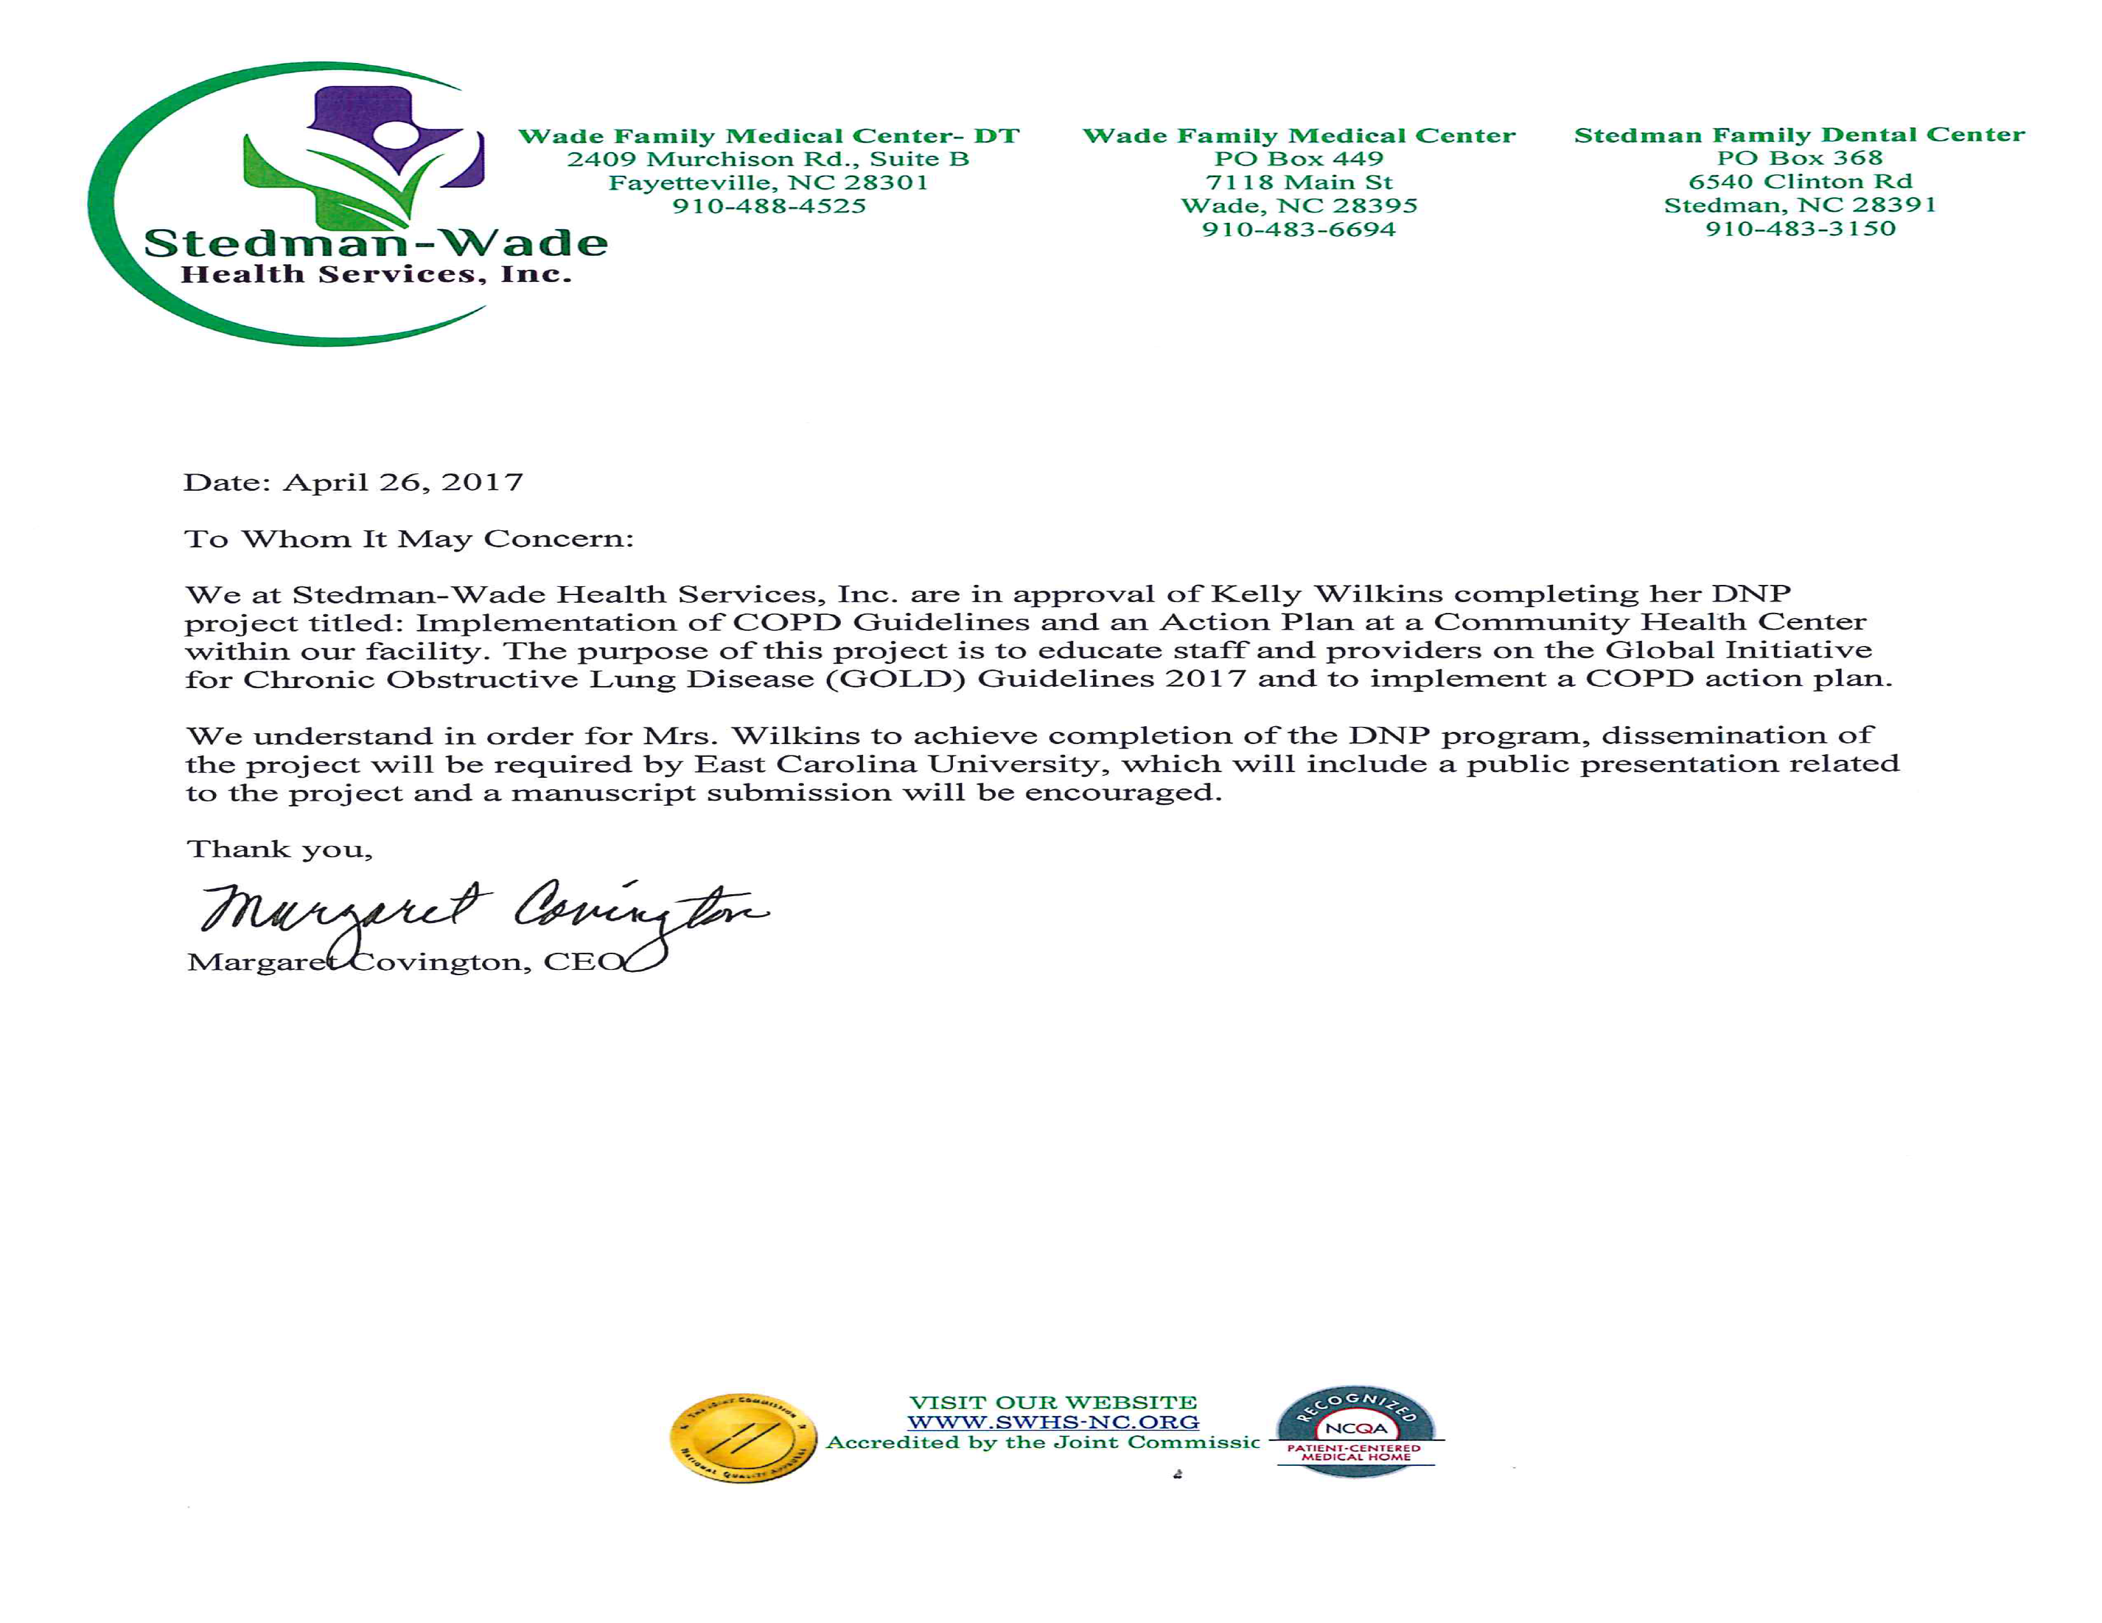
Appendix F

COPD Action Plan
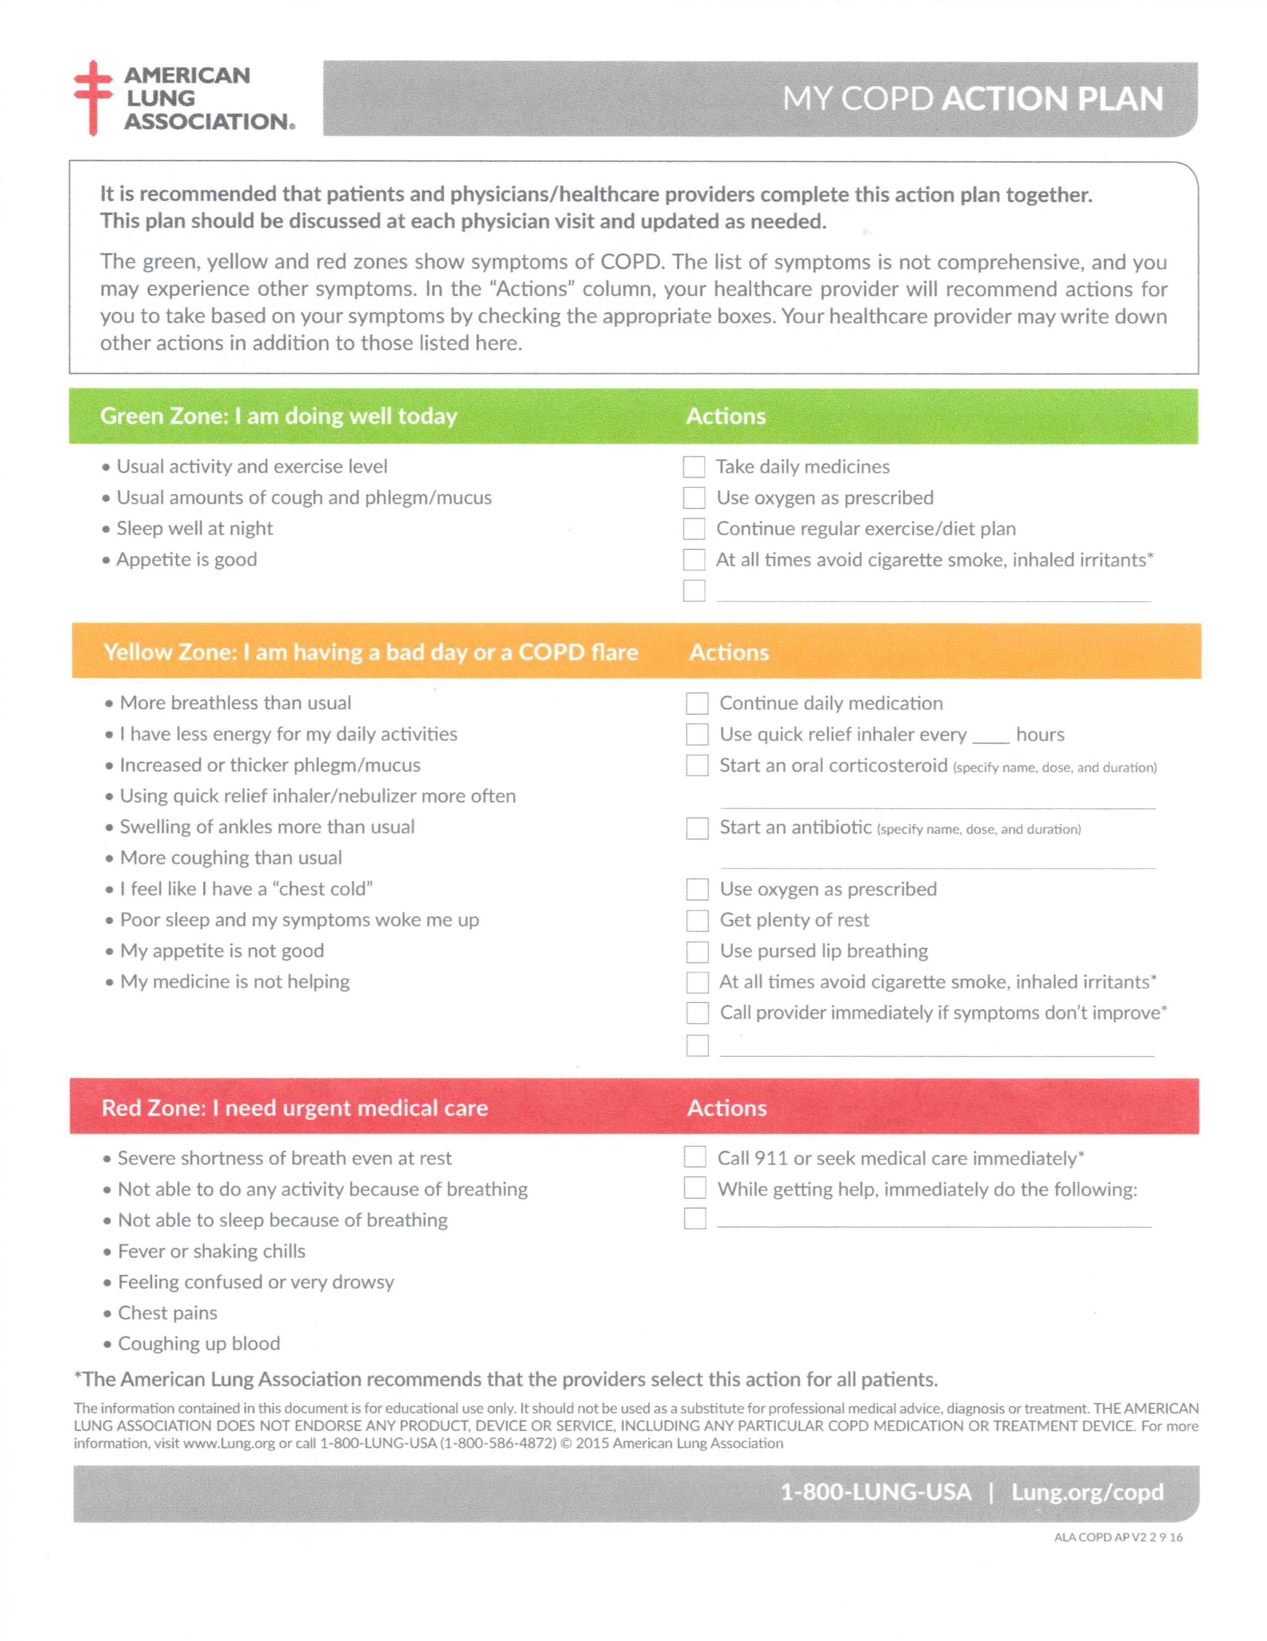
Appendix G

Literature Matrix
Author | Title | Name Of Journal | Study Design | Sample Size | Summary | Evaluation | In-Text Citation | Full Citation | Comments
Guarascio, A. J., Ray, S. M., Finch, C. K., & Self, T. H. | The Clinical and Economic  Burden of Chronic Obstructive Pulmonary Disease in the USA | ClinicoEconomics and Outcomes Research (blind peer review) | n/a | n/a | The objective of this article is to summarize the economic and clinical burdens of COPD in the USA for the general clinician. | Critically appraised topic | (Guarascio, Ray, Finch & Self, 2013). | Guarascio, A. J., Ray, S. M., Finch, C. K., & Self, T. H. (2013). The clinical and economic  burden of chronic obstructive pulmonary disease in the USA. ClinicoEconomics and  Outcomes Research : CEOR, 5, 235-245, doi:10.2147/CEOR.S34321 | Evidence-based diagnosis and management was also discussed including future directions for COPD therapy.
GOLD International Committee | Global Initiative for Chronic Obstructive Lung  Disease (GOLD | Global Strategy for the Diagnosis, Management, and Prevention of Chronic Obstructive  Pulmonary Disease, 2017 Report | n/a | n/a | Strong evidence for care of COPD patients | Systemic Review | (GOLD, 2017) | Global Strategy for the Diagnosis, Management, and Prevention of Chronic Obstructive  Pulmonary Disease, 2017 Report. (2017). Global Initiative for Chronic Obstructive Lung  Disease (GOLD). Retrieved from http://goldcopd.org | Great resource, strong evidence based on systematic review. This is the main reference for care of the COPD patient.
Yu, A.P., Yang, H., Wu, E.Q., Setyawan, J., Mocarski, & Blum, S | Incremental Third Party Cost Associated With copd Exacerbation: A Retrospective Claims Analysis. | Journal of Medical Economics (peer reviewed) | COPD patients with at least one exacerbation were identified in the Thomson Reuters MarketScan administrative claims database. A total of 2644,174 patient-quarters, derived from 228,978 COPD patients, were included in the analysis. The average patient was followed an average of 2.9 years. | COPD patients with at least one exacerbation were identified in the Thomson Reuters MarketScan administrative claimsdatabase.  A total of 2644,174 patient-quarters, derived from 228,978 COPD patients, were included in the analysis. | Exacerbations are a major contributor to the large burden of treating chronic obstructive pulmonary disease (COPD)  Exacerbations, especially severe ones, result in a significant economic burden for third-party payers. | Retrospective claims analysis | (Yu, et al., 2011) | Yu, A.P., Yang, H., Wu, E.Q., Setyawan, J., Mocarski, & Blum, S. (2011). Incremental third party cost associated with copd exacerbation: A retrospective claims analysis. Journal of  Medical Economics, 14(3), 315-323, doi: 10.3111/13696998.2011.576295 | This article was used in light of being 6 years old at the start of the project. It gives evidence of the importance of effective COPD management to reduce healthcare costs.
Westney, G., Foreman, M.G., Xu, J., King, M.H., Flenaugh, E., & Rust, G | Impact of  Comorbidities Among Medicaid Enrollees with Chronic Obstructive Pulmonary Disease,  United States, 2009 | Preventing Chronic Disease (peer reviewed) | Retrospective cohort design to analyze the effects of comorbidities on health care outcomes among people with COPD | The study population was drawn from the 2009 Medicaid Analytic eXtract (MAX) file obtained from Centers for Medicare and Medicaid Services  n=291,978 | This study documented the high prevalence of comorbid conditions among people with COPD enrolled in Medicaid in 28 states and the District of Columbia. It also documented the high frequency of ED visits among people with COPD. | Retrospective cohort design | (Westney, Foreman, Xu, King, Flenaugh & Rust, 2017) | Westney, G., Foreman, M.G., Xu, J., King, M.H., Flenaugh, E., & Rust, G. (2017). Impact of  comorbidities among medicaid enrollees with chronic obstructive pulmonary disease,  united states, 2009. Preventing Chronic Disease, 14, E31, doi: 10.5888/pcd14.160333 | This article gives great evidence on the impact of comorbidities in COPD patients.
Self, T.H., Patterson, S.J., Headley, A.S., & Finch, C.K. | Action plans to reduce  hospitalizations for chronic obstructive pulmonary disease exacerbations: Focus on oral  corticosteroids. | Current Medical Research & Opinion | n/a | n/a | The objective of this article is to review the evidence evaluating home OCS treatment of COPD exacerbations as part of a comprehensive self-management action plan. | Critically appraised topic | Self, Patterson, Headley, and Finch (2014) | Self, T.H., Patterson, S.J., Headley, A.S., & Finch, C.K. (2014). Action plans to reduce  hospitalizations for chronic obstructive pulmonary disease exacerbations: Focus on oral  corticosteroids. Current Medical Research & Opinion, 30(12), 2607-2615,  doi:10.1185/03007995.2014.934795 | Further randomized trials are needed to establish that home use of OCS therapy, as part of a comprehensive action plan, reduces the rate of hospitalizations
Howcroft, M., Walters, E.H., Wood-Baker, R., & Walters, J.E. | Action plans with brief  patient education for exacerbations in chronic obstructive pulmonary disease (review) | Cochrane Database of Systemic Reviews | n/a | n/a | Use of COPD exacerbation action plans with a single short educational component along with ongoing support directed at use of the action plan, but without a comprehensive self-management program, reduces in-hospital healthcare utilization and increases treatment of COPD exacerbations with corticosteroids and antibiotics. | Systemic review | Howcroft, Walters, Wood-Baker and Walters (2016) | Howcroft, M., Walters, E.H., Wood-Baker, R., & Walters, J.E. (2016). Action plans with brief  patient education for exacerbations in chronic obstructive pulmonary disease (review).  Cochrane Database of Systemic Reviews,12, 1-11,  doi:10.1002/14651858.CD005074.pub4. | Per this article, use of COPD action plans in this context is unlikely to increase or decrease mortality. Additional benefits may be derived from the use of a COPD action plan but cannot be determined from this article.
Raju, S., Keet, C. A., Matsui, E. C., Drummond, M. B., Hansel, N. N., Wise, R. A,, Peng, R.D., & McCormack, M.C. | C15 Novel epidemiology of asthma and copd: The impact of  poverty and rural residence on chronic obstructive pulmonary disease (COPD)  prevalence: A nationwide analysis. | American Journal of Respiratory and Critical Care | n/a | n/a | Study goals were to 1) identify the nationwide prevalence of COPD in urban and rural areas in the U.S., and 2) determine the impact of rural residence, region, neighborhood poverty, race/ethnicity, household poverty, and housing characteristics on COPD prevalence.  Poor and rural areas continue to have a high level of disease burden. | Critically appraised topic | (Raju et al., 2015) | Raja, S., Keet, C. A., Matsui, E. C., Drummond, M. B., Hansel, N. N., Wise, R. A., … McCormack, M. C. (2015). C15 Novel epidemiology of asthma and copd: The impact of  poverty and rural residence on chronic obstructive pulmonary disease (COPD)  prevalence: A nationwide analysis. American Journal of Respiratory and Critical Care  Medicine, 191, 1-2. Retrieved from http://search.proquest.com.jproxy.lib.ecu.edu/docview/1857360330?accountid=10639 | This article emphasis the need for continued education for COPD patients living in a poor community.

Appendix H

ECU IRB Approval Letter
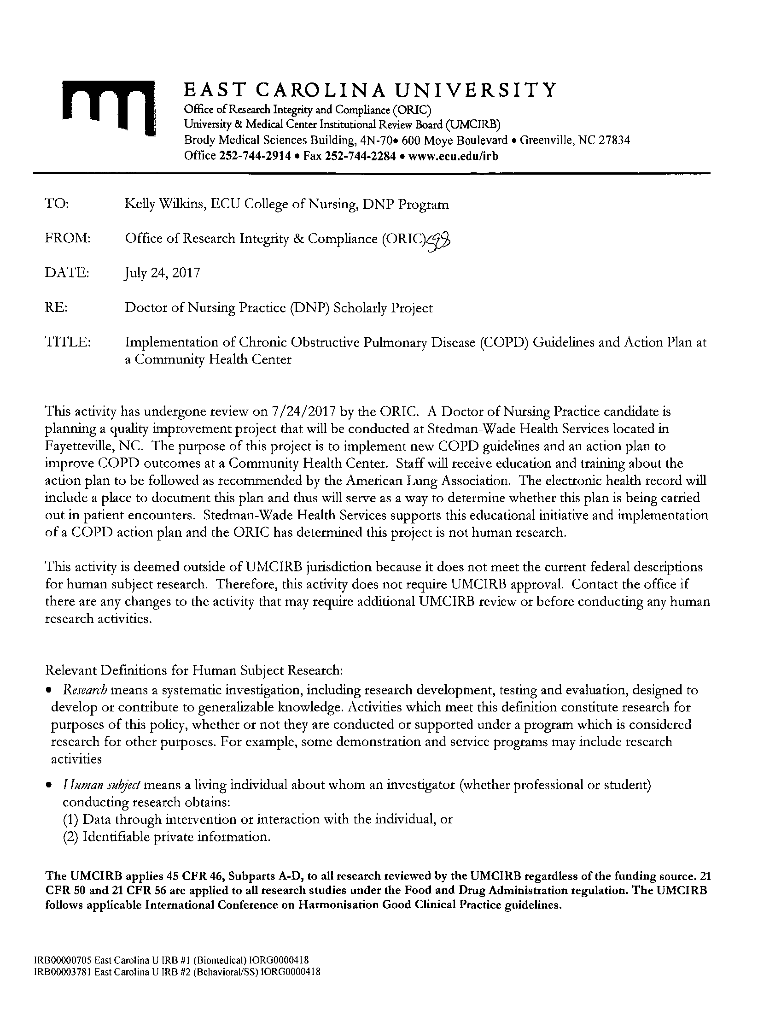

Appendix I

DNP Project Timeline
January 2017 - Complete
Explore project ideas
Narrow idea and explore options with S. Perez
Determine topic and identify how to proceed to meet needs of clinic with S. Perez

February 2017 - Complete
Continue to research topic and communicate with project chair
Determine how project will be carried out in clinic
Research topic

March 2017 – Complete
Research topic
Continue to develop project with feedback from S. Perez and project chair
Search COPD guidelines
Determine theoretical framework
Begin to develop paper

April 2017 – Complete
Continue to develop paper
Continue to research literature and guidelines

May 2017 - Complete
Work on research of literature
IRB process
Meeting with S. Perez on project details
Determine COPD action plan

June 2017 - Complete
DNP intensives
IRB process

July 2017 – Complete
IRB process
Continue on paper development
Work on research of literature

August 2017 - Complete
Educate staff at clinic on COPD guidelines/action plan
Begin implementation of project

September 2017 – Complete
Began chart reviews
PDSA to determine how guidelines are working for staff
DNP intensives

October 2017 - Complete
Complete chart review for compliance of COPD guidelines and action plan
Provide feedback for S. Perez on findings
Incorporate findings into paper

November 2017 - Complete
Complete paper for semester

January 2018 – Complete
Complete project evaluation and findings
Begin chapters four and five

February 2018 - Complete
Complete chapters four and five
Develop poster presentation
DNP Intensives

March 2018 – Complete
Complete poster for presentation
Submit midterm paper for project
Submit midterm time log
Present findings to clinical site

April 2018 – Incomplete
Complete poster presentation
Submit final paper for project
Submit final time log with signatures

