A Protocol for the Prevention of Central Line Occlusion and Central Line-Associated Bloodstream Infection in Home Health
Felicia C. Holston
East Carolina University

Acknowledgments
For many years I have been a vascular access nurse and have witnessed how central line infection can cause undue patient suffering and a waste of health care dollars. Because of this, I became passionate about infection control. This project exemplifies my desire to prevent infection by using my expertise to educate others in the optimal care of central lines. I would like to especially thank my chair, Dr. Donna Roberson, for her unwavering support of my vision, and for her continued guidance and conscientious editing of this paper over the last four semesters. I would never have finished this project without her continued encouragement throughout this process. I would also like to thank my committee members and course professors, Drs. Cheryl Duke, Tracey Bell, Dianne Marshburn, Mary Frances Pate, and Carol Ann King, for their guidance, editing, and keeping me on task.
Another person who has been very important to me is my advisor and course professor, Dr. Candace Harrington, who has always believed in my abilities. She has been my champion throughout my doctoral education, and was always there to listen when I needed a boost. I will never forget that she was able to see my vision on this project, although she believed this topic was one that healthcare may not be ready to tackle. However, she understood how important infection control and CVAD care was to me. She knew I was capable of being successful, but not without hard work and perseverance. For this, I thank her from the bottom of my heart.
I want to thank my husband, children, parents, and friends for their support, encouragement, and tolerance throughout my education. It has been by far the most difficult time in my life, and they have all stood by me.
Lastly, I want to thank my mother, RoseAnn Pestritto Costa, who spent many long hours being my Editor in Chief. Without her undying love and support, I would not have made it this far. She was the person who helped me brainstorm and organize my papers, used her accounting background to teach me about finance for my class, went to my sites for the implementation of this project as moral support, and never once hesitated to be my sounding board – for school or my personal life. Mom, I love you so very much…and I dedicate this paper and my success to you!

Abstract
Problem Statement: Central line-associated blood stream infection (CLABSI) is a significant healthcare acquired infection that is usually caused by inappropriate maintenance of central lines and leads to increased health costs, sepsis, and mortality. Purpose: The home health care setting has not been well researched for common central line complications, nor are there published evidence-based standardized protocols. The purpose of this project was to establish an evidence-based home healthcare protocol for the care of central lines targeting the prevention of the common central line complication of occlusion. Method: An evidence based protocol was designed and implemented at a home health agency in North Carolina, used by the clinical staff to prevent and/or treat clotted ports of central lines. The protocol included proper flushing techniques, troubleshooting steps, and thrombolytic treatment of clotted ports. Analysis: The first part of the analysis compared the retrospective number of clotted lines for three months prior to the implementation of the protocol to the number of clotted lines three months after implementation. The second part of the analysis reviewed how the protocol performed in the prevention of and resolution of clotted lines. Finally, input from the staff on the usability of the protocol and suggestions for refinement were obtained at the end of the implementation period. Significance: This project demonstrated that there was an improvement in the number of problems associated with line occlusion, there was appropriate treatment with a thrombolytic agent as stipulated in the protocol, and there were no delays in therapy related to improvements in line functionality.
Keywords: central line associated blood stream infection, central line, occlusion, home health care, central line guidelines

Approval Page
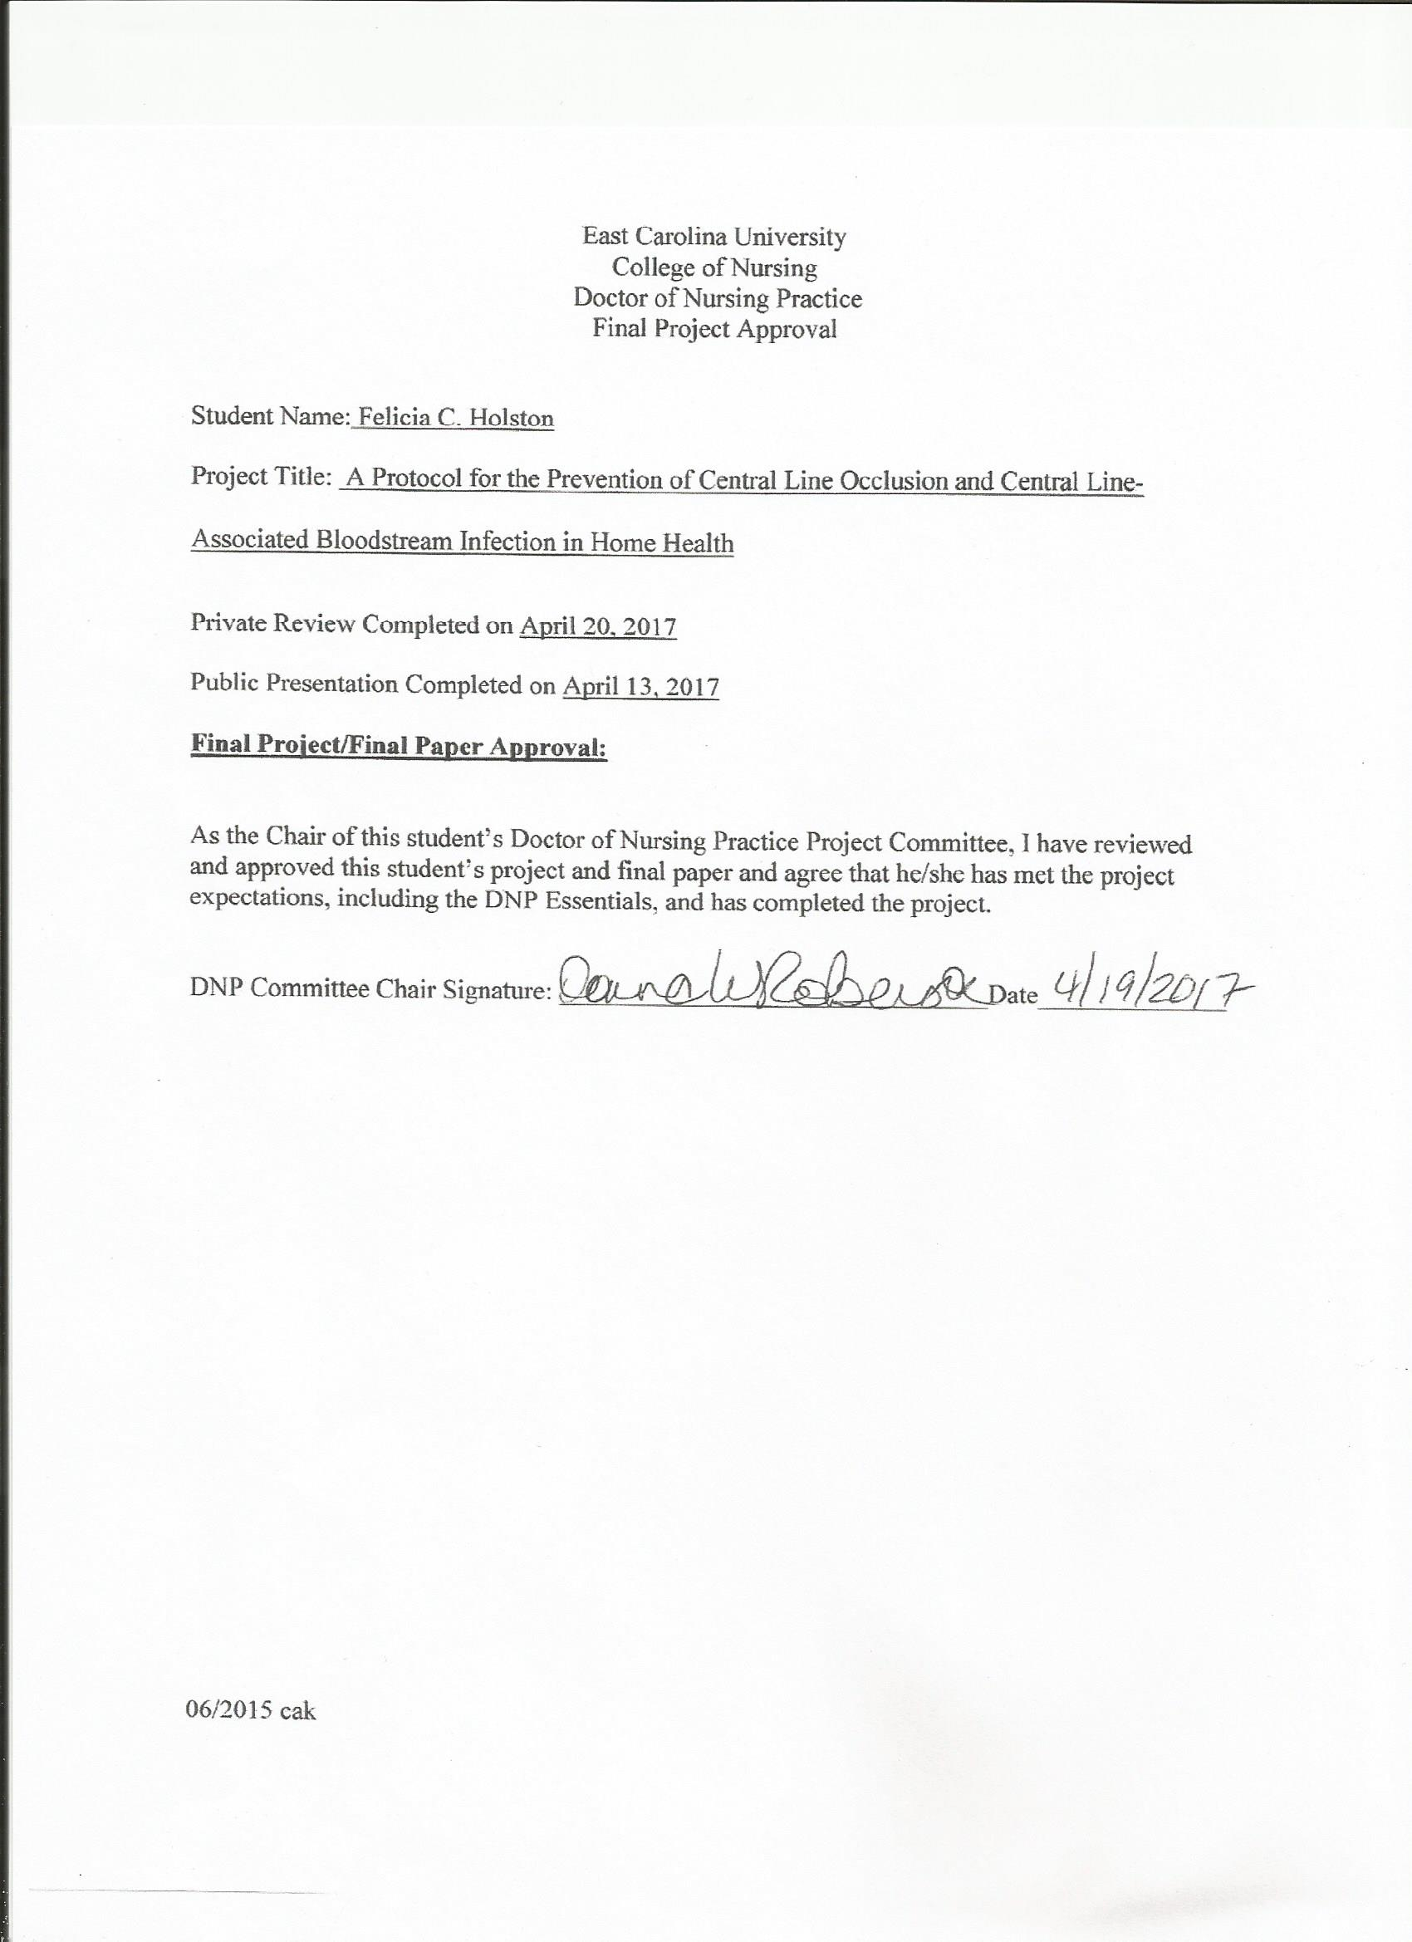

Table of Contents
Abstract……………………………………………………………………………………………2
Approval Page……………………………………………………………………………………..5
List of Appendices and Tables..……...……………………………………………………………8
Chapter 1. Introduction…………………………………………………………………………9
Problem Statement……………………………………………………...………………………..11
Justification of Study………………………………………………..……….…………………..11
Theoretical Framework…………………………………………………………………………..12
Assumptions……………………………………………………………………………………...14
Implementation Plan and Goals………………………………………………………………….15
Summary…………………………………………………………………………………………15
Chapter 2. Research Based Evidence…………………………………………………………16
Types of CVADs…………………………………………………………………………………16
CLABSI Definition and Risk Factors……………………………………………………………19
CLABSI Rates and Significance…………………………………….…………………………...21
CVAD Complications……………………………………………………………...…………….22
CVAD Occlusion………………………………………………………………………………...23
Treatment and Prevention of CVAD Occlusion………………………………….………………25
Evidence Based Guidelines………………………………………………….…………………...29
Conclusion………………………………………………………………………………….……31
Chapter 3. Methodology………………………………………………………………….……32
Design…………………………………………………………………………………….……...32
Conceptual Framework………………………………………………………………….……….33
Table of Contents
Setting……………………………………………………………………………………………33
Sample……………………………………….…………………………………………………..34
Methods……………………………………………………………………………………….…34
Protection of Human Subjects……………………….…………………………………………..36
Instruments………………………………………………………………………………………37
Data Collection…………………………………………………………………………………..37
Data Analysis…………………………………………………………………………………….38
Conclusion……………………………………………………………………………………….39
Chapter 4. Results……………………………………………………………………………..40
Sample Characteristics…………………………………………………………………………..40
Major Findings…………………………………………………………………………………..41
Chapter 5. Discussion………………………………………………………………………….47
Introduction………………………………………………………………………………………47
Implications of Findings…………………………………………………………………………47
Limitations……………………………………………………………………………………….51
Delimitations……………………………………………………………………………………..53
Recommendations………………………………………………………………………………..53
Conclusion……………………………………………………………………………………….54
References………………………………………………………………………………………..55

List of Appendices and Tables
Appendix
Appendix A Theoretical Model…………………………………………………………61
Appendix B Infection Routes Illustration………………………………………………62
Appendix C IRB Approval Letter………………………………………………………63
Appendix D Agency Letter……………………………………………………………..64
Appendix E Protection of Data Letter…………………………………………………65
Appendix F Flushing Protocol……………………………………………….……..66-68
Appendix G Occlusion Protocol…………………………………………………….69-71
Appendix H Occlusion Algorithm……………………………………………………...72
Appendix I Post-Implementation Questionnaire……………………………………...73
Appendix J Retrospective Chart Review……………………………………………...74
Appendix K Post-Implementation Data Collection……………………………………75

List of Tables
Table 1……………………………………………………………………………………18
Table 2……………………………………………………………………………………41
Table 3……………………………………………………………………………………42
Table 4……………………………………………………………………………………43

A Protocol for the Prevention of Central Line Occlusion and Central Line-Associated Bloodstream Infection in Home Health

Chapter 1

Introduction
Central line-associated bloodstream infection (CLABSI) is a healthcare-associated infection (HAI) that is a substantial concern due to its threat to patient safety by causing undue harm, and the resultant increase in health care cost. However, there is a lack of evidence based protocols used for the prevention of CLABSI in the home care or outpatient setting. According to Scholtz et al. (2013), approximately 4,000 patients die every year from CLABSI in the United States. In addition, these CLABSIs may result in almost three weeks of unexpected hospitalization at a cost of more than $30,000 per occurrence. These costs often are absorbed by the hospitals because Medicare and Medicaid Services will not reimburse for infections caused by hospital procedures. Most CLABSIs are preventable through the performance of proper sterile technique during insertion and standardized nursing care protocols for aseptic care and maintenance. (Scholtz et al., 2013).
Complications that occur with central venous access devices (CVADs) constitute the most prevalent cause of CLABSI. In this era of healthcare reform, more patients are being discharged from hospitals with CVADs for the purpose of in-home long term intravenous therapy, such as chemotherapy, antibiotic therapy, and parenteral nutrition. This transition of care can increase the risk of CVAD complications. A complication that is largely under-recognized is catheter occlusion, which can cause a delay in patient care, unsafe medication administration, and potential harm to the patient (Nailon & Rupp, 2015).
A broad overview of the literature indicated that CLABSI results from multifactorial processes including: poor hand hygiene, improper aseptic and/or sterile technique, lack of nursing education and competence in central line maintenance, ill-defined evidence based standards of care within organizations, patient condition, staff attitudes, and preventative strategies (i.e. de-clotting of ports, dressing and cap changes, etc.) in the maintenance of central lines. According to the literature from 1997 – 2015, CVAD thrombosis increased the incidence of CLABSI. Clotted catheters have the potential to enhance risk of CLABSI due to adherence of microbes intraluminally or extraluminally on the catheter. Microbes attach to the fibrin from the clot formation within the catheter and begin to create biofilm that can travel to the bloodstream (Linnemann, 2014; Nakazawa, 2010; Zhang, Gowardman, Morrison, Runnegar, & Rickard, 2015). Intraluminal sources of bacteria come from poor hand hygiene, needleless connectors, and contaminated intravenous therapy tubing. Extraluminal sources come from skin flora or bacteria at the insertion site (Nakazawa, 2010; Zhang et al., 2015). In addition, the literature highlighted evidence based practices from national organizations such as The Joint Commission (TJC), Centers for Disease Control and Prevention (CDC), Infusion Nurses Society (INS) and The Society for Healthcare Epidemiology of America (SHEA) that recommend a standardized care model to reduce CLABSI including checklists to guide appropriate care, and formal guidelines for practice.
There is a great deal of ambiguity in CLABSI prevention practices in home healthcare, and standardization is needed to improve outcomes (Bambi, Lucchini, & Giusti, 2014). In addition, the lack of federal mandates on home health agencies warrants future research on clear CLABSI policies and the monitoring of care being given to susceptible patients with CVADs (Nailon & Rupp, 2015; Rinke et al., 2013a). Improvement of CLABSI surveillance is necessary in both acute care and home health so that the significance of CVAD complications and cost burden can be identified, leading to possible solutions (TJC, 2011).
Problem Statement. One of the major CVAD complications in home health is central line occlusions, which causes a delay in patient care, unnecessary procedures, unsafe medication administration, and the possibility of CLABSI. The focus of this project was to prevent CLABSI. The purpose of this project was to create an evidence based standardized competency for the care of CVADs in order to decrease the incidence of line occlusions, and thereby decreasing delays in care, reducing potential harm to the patient, and ultimately diminishing CLABSI.
Justification of Study. Since central line occlusions are a common occurrence in home care and are a potential risk factor of CLABSI, an appropriate standard of care should be implemented to prevent and/or treat clotted catheters. According to a systematic review on pediatric CVAD complications by Ullman, Marsh, Mihala, Cooke, and Rickard (2015), one fourth of all CVADs failed before the end of therapy. Since there are gaps in standardized protocols for CVAD care in home health, this project should serve to meet some of those gaps. Implementation of a protocol should improve catheter functionality, prevent unnecessary removal of non-functioning lines, decrease delays in care, maintain patient safety, and provide necessary education to the nursing staff to improve overall outcomes (Kramer, Doellman, Curley & Wall, 2013; Nailon & Rupp, 2015; Rinke et al., 2013a; Rinke et al., 2013b).
As healthcare reform has brought more patients with CVADs into the home for long term therapies, it is imperative that the expertise of nurse clinicians be improved. According to Sagaria and Hyzy (2013), the yearly estimated number of deaths in intensive care units related to CLABSI was 28,000 with an estimated cost of up to $2.3 billion. Sagaria and Hyzy (2013) reported these facts in relation to intensive care units (ICUs), but these numbers did not include complications and cost in home health. It is more difficult to monitor patients when they are in the home versus the hospital setting because the patients did not receive 24 hour nursing care in the home. The important situation to note is that home health nurses maintain the patency of CVADs with less direct monitoring. The patients requiring long-term therapies are mostly patients treated for cancer, those with diabetes living with difficult to treat infections, patients receiving hemodialysis, and those who require parenteral nutrition that may already be immunocompromised (Lebeaux, Joly, & Zahar, 2014). Therefore, a standardized protocol is a justified necessity in the home health care setting.
Since there is a documented need for CVAD protocols in home care, as well as appropriate surveillance of infection and complication rates, this project was timely. The successful implementation of an evidence based protocol for CVAD care in one agency could then be implemented in many agencies. As there is a gap in evidence regarding the rates of CLABSI outside of the ICU, there is also a gap in knowledge in the ambulatory setting. Demonstrating success with a standardized protocol can potentially assist in filling these gaps in practice, and can aid in the creation of evidence based protocols that can be replicated and sustained for use in home health CVAD care.
Theoretical Framework. The theoretical framework that guided the project is Covell’s middle range theory of nursing intellectual capital. Covell’s theory of nursing intellectual capital is derived from intellectual capital theory and organizational learning theory, which were initially developed in the fields of economics and accounting (Covell, 2008). The nursing intellectual capital theory (NIC) is a parallelism between the concepts of intellectual capital and pertinent concepts in nursing (Covell, 2008). NIC serves as a guide for organizations that wish to invest in continuing professional education of the nursing staff and will assist in evaluating the effectiveness of that education (Covell, 2008). A diagram of the middle-range nursing intellectual capital theory is shown in Appendix A (Covell & Sidani, 2012, p. 1768).
The central concept of central line maintenance and the prevention of CLABSI is that staff education, competence, and awareness is crucial to providing appropriate care to all patients, but applies specifically to this project in a home healthcare setting. If care is not focused on continuing education and competence within organizations, the lives of patients could be at risk (Covell, 2008).
NIC is comprised of two main concepts that are mutually beneficial to nursing and organizations. The propositions are nursing human capital and nursing structural capital. Nursing human capital is the elemental concept of the basis of impalpable knowledge and experience that exists among nurses within an organization, which is owned by each employee and is borrowed by the organization while the staff is employed (Covell, 2008). This knowledge base remains with the employees and travels with them to the next place of employment. There are, however, two main components that affect nursing human capital within the organization: nurse staffing and organizational investment in continuing education. Within the concept of nursing human capital are the resultant outcomes of the patients and the organization, which increases or decreases patient safety depending on the amount of investment the nurse and the organization has in intellectual capital (Covell & Sidani, 2013).
The second proposition is nursing structural capital, which is the bank of knowledge and experience that the institution utilizes in myriad methods to create a framework of knowledge sharing and resources for the staff and the patients (Covell & Sidani, 2013). This structure provides the support for nursing human capital and benefits the entire organization, which in turn, affects patient outcomes (Covell & Sidani, 2013). Therefore, the greater the investment in nursing human capital and nursing structural capital, the better the patient outcomes.
NIC applies to this project as it is the basis for the investment of nursing knowledge and organizational support in the goal of achieving prevention of central line occlusion, thereby reducing the incidence of the interruption of medication delivery, unnecessary central line removal, increased healthcare cost, morbidity, and mortality. The issue examined was the number of central line occlusions that occurred prior to the implementation of the standardized protocol over a three month period versus the number of central line occlusions that occurred for three months after implementation. By utilizing the framework of NIC, the aim was to demonstrate that by increasing nursing education and awareness of the problem, there would be a reduction in the number of central line occlusions, would encourage appropriate treatment of occlusions when they occur, and would prevent further complications and unnecessary expenditures. NIC engages the staff to increase competence in CVAD maintenance, encourages ownership of skills, increases accountability, and demands organizational support (Covell & Sidani, 2013).
Assumptions. The assumptions of the project were: central lines are commonly occluded due to lack of knowledge and expertise in occlusion prevention and treatment, the implementation of a standardized protocol to educate nursing personnel would decrease the incidence of line occlusions, premature removal of lines, and CLABSI, there were no federal mandates on home health care agencies to have appropriate surveillance of CVAD infections and standardized care protocols, and there was a lack of research in the home healthcare setting regarding CVADs.
Implementation Plan and Goals. The implementation of a standardized protocol for the prevention and treatment of central line occlusions in home health care was aimed to decrease occlusion incidence, prevent unnecessary central line removal and replacement, prevent delay in medication administration, and ultimately decrease the risk of CLABSI.
Summary. The issue of central line occlusions in home health care is a prevalent problem that imposes potential health risks to patients, increased healthcare cost, and delays treatment. The application of the principles of NIC will support the accountability of the organization and staff in continuing education and competency in the prevention of central line occlusions. Since federal mandates and research are lacking in the home healthcare realm, the implementation of a standardized protocol for the care and maintenance of central lines will prove useful in the overall prevention of CLABSI and the continuation of care and safety of patients.

Chapter 2

Research Based Evidence
An exhaustive literature search on CLABSI, central lines, occlusion, and central line guidelines in acute care, long term care, and ambulatory settings was performed in PubMed, CINAHL, and Google Scholar. Search terms used for relevant information were central line-associated blood stream infection, central line, occlusion, home health care, central line guidelines, catheterization, central venous, bacteremia/prevention & control, catheter-related infections/prevention & control, guideline standards; home care agencies standards, patient safety/standards, and central venous catheter infection prevention guidelines. The articles utilized for this project range from the years of 2008 to present. It was found that many studies occurred prior to 2006 on this topic but are referenced in recent articles. Search terms utilized returned 50,000 broad articles. The information on home health care and central line care had minimal return with only 4 articles found. Of the 40 references chosen, 2 came from a Google search regarding the site of implementation, and only 4 prior to 2011. Additional searches were performed in PubMed and CINAHL for more specific topics regarding central lines.
Types of CVADs. There are several types of CVADs that are encountered in both acute care and in ambulatory settings. TJC (2012) presented a table that compared the types of catheters, entry sites, the recommended duration of use, and advantages/disadvantages of each. Generally speaking, nontunneled CVADs are for short term use due to the increased risk of CLABSI and tunneled catheters are for long term use, such as in cancer and hemodialysis patients (TJC, 2012). Tunneled catheters are surgically placed under the skin and tunnel to the vessel of choice before it enters the bloodstream (TJC, 2012). The entrance to the vessel is blocked by a Dacron cuff to prevent entry of microorganisms into the bloodstream. Nontunneled catheters are placed percutaneously through the skin and directly into the bloodstream via the vessel of choice. Peripherally inserted central catheters (PICCs) have a lower risk of infection among the nontunneled catheters, and are often placed for long term use for intravenous (IV) antibiotic therapy, chemotherapy, and total parenteral nutrition (TJC, 2012). Implanted ports have the least risk of infection, as they are surgically implanted under the skin and are accessed and de-accessed through the skin when needed for IV therapy (TJC, 2012). A summary of the comparisons are presented below in Table 1.

Table 1
Comparison of the Major Types of Central Venous Catheters (CVCs)
Catheter Type | Entry Site | Duration of Use | Advantages | Disadvantages |  | Comment
Nontunneled CVCs | Percutaneously inserted into central veins (internal jugular, subclavian, or femoral vein) | Short term* | - Percutaneous insertion  - Relatively safe and inexpensive | - Require local anesthesia  - May be inserted in the operating room  - Dressing required over site |  | - Account for majority of CLABSIs  - More commonly used than long term CVCs
Tunneled CVCs | Implanted into internal jugular, subclavian, or femoral vein | Long term† | - Dressing not needed after healed |  | - Require surgical insertion  - Require local or general anesthesia  - Increased cost | - Lower rate of infection than non-tunneled CVCs  - Dacron cuff inhibits migration of organisms into catheter tract when ingrown
Implantable Ports | Inserted in the subclavian or internal jugular vein.  Tunneled beneath the skin; subcutaneous port accessed with a non-coring needle | Long term | - Improved body image (low visibility of port)  - Patient comfort  - Local catheter site care and dressing not needed when not in use |  | - Require surgical insertion and removal  - Require general anesthesia  - Increased cost | - Lowest risk for CLABSI
Peripherally inserted central catheter (PICC) | Inserted percutaneously into basilica, brachial, or cephalic vein and enters the superior vena cava | Usually short to interme-diate | - Ease of insertion, usually at the bedside by a specially trained registered nurse |  | - Can be difficult to position in central vein | - Lower rate of infection than non-tunneled CVCs
Note: * Short term: usually less than three weeks; †Long term: weeks to months. Adapted from “Preventing Central Line-Associated Bloodstream Infections: A Global Challenge, a Global Perspective,” by The Joint Commission, 2012, http://www.PreventingCLABSIs.pdf, Chapter 1, p. 3. Copyright 2012 by The Joint Commission.

CLABSI Definition and Risk Factors. According to TJC’s monograph (2012) on the prevention of CLABSI, there were two terms and definitions for each that refer to intravascular device related infections. CLABSI is defined by the CDC’s National Healthcare Safety Network (NHSN) as:
A primary bloodstream infection (that is, there is no apparent infection at another site) that develops in a patient with a central line in place within the 48-hour period before onset of the bloodstream infection that is not related to infection at another site (TJC, 2012, Introduction, p. v).
The CDC’s Morbidity and Mortality Weekly Report (2011) stated that for CLABSI to be confirmed, there should be a pathogen that is not commonly present on the skin that grows from a single blood culture, or a pathogen that is commonly present on the skin to grow from two or more blood cultures. Next, the term catheter-related bloodstream infection (CRBSI) is defined by the CDC’s NHSN as:
A more rigorous clinical definition and requires specific laboratory testing to identify the catheter as the source of the bloodstream infection, such as culturing the catheter tip or a more elaborate method such as time-to-positivity (TJC, 2012, Introduction, p. v).
CLABSI is the more universal term than CRBSI for surveillance purposes. However, it is sometimes challenging for accurate rates of CLABSI to be estimated due to difficulty with identification of the central line as the cause of the infection versus from another infectious source in the body. Another limitation of accurate estimates of CLABSI is related to a lack of standardized surveillance measures and variability in observational data collection (TJC, 2012). These definitions created by the CDC’s NHSN do not apply to outpatient settings, as most of the research performed regarding CLABSI has been in the inpatient setting. According to Rinke et al. (2013a), this is a definite limitation in the home health care arena since there are no set standards being utilized in these agencies. Rinke et al. (2013a) concluded that future research is necessary to promote the use of standardized practices in home health care supported by evidence based protocols.
According to the CDC guidelines by O’Grady et al. (2011), there are four possible routes of infection of intravascular catheters which include: (a) migration of organisms from the skin that travel through the insertion tract to the catheter where they travel to the catheter tip; (b) contamination of the catheter or catheter hub by direct contact (i.e. hands, contaminated devices or fluids); (c) seeding of catheter from another source of infection from the blood; (d) by catheter infusates. The least likely cause of infection is from infusates and the most common cause is the migration of organisms from the skin to the catheter (O’Grady et al., 2011). In Appendix B, the figure shows the different sources of infection in relation to the catheter.
Risk factors associated with CLABSI are poor hand hygiene of healthcare workers, lack of appropriate care and maintenance of lines, untreated occlusions of ports, poor sterile technique during insertion, patients who are immunocompromised, increased and/or unnecessary length of dwell times, lack of education of staff maintaining central lines, poor organizational support in staff utilizing evidence based guidelines, age of patients with CVADs (pediatric patients with higher risk of CLABSI), male gender, total parenteral nutrition (TPN), bone marrow transplant within 100 days of insertion, type of CVAD used, prior bacteremia from any central line, multiple CVADs, prolonged hospitalization, and increased manipulation of the catheter (Bianco, Coscarelli, Nobile, Pileggi, & Pavia, 2013; CDC, 2011; Harper, 2014; Linnemann, 2014; Nakazawa, 2010; Pittiruti, Hamilton, Biffi, MacFie & Pertkiewicz, 2009; Rinke et al., 2013b; Scheck McAlearney, Hefner, Robbins, Harrison, & Garman, 2015; Staun et al., 2009; TJC, 2012; Ullman et al., 2015). All of applicable factors must be taken into account when caring for any patient with a CVAD, especially if it is a patient neutropenia. In order to properly care for and maintain CVADs, the organization must offer educational support to the staff, and the nurses themselves must take ownership of their knowledge. Covell’s NIC theory serves as the framework for CLABSI prevention through nurse accountability and organizational support.
CLABSI Rates and Significance. As stated in the introduction of this manuscript, CLABSI causes prolonged hospitalizations, increased morbidity and mortality, and results in a substantial increase in health care cost (McElearney et al., 2015). In pediatric patients alone, there is a 1% mortality rate of those with CLABSI with a healthcare cost of $45,000 per episode (Rinke et al., 2013a). According to TJC (2012), the estimated number of CLABSIs that occur in ICUs per year is 80,000; however, this number is not representative of all inpatient areas or outpatient areas. TJC estimated this number to increase to 25,000 CLABSIs if patients outside ICUs are included (TJC, 2012). Between the years 2001 and 2009, there was a decrease in the incidence of CLABSI rates in ICUs of 58% (43,000 to 18,000). In 2009, the decrease in CLABSI rate has possibly saved 6 million lives and $414 million in additional health care spending through the implementation of central line care bundles and protocols. Although there have been major improvements in CLABSI rates through the initiation of evidence based guidelines and zero tolerance for HAIs, it is still a worldwide health concern. It has been reported that 23,000 CLABSIs occurred in areas outside the ICU setting and estimates show that in 2008, 37,000 CLABSIs occurred in ambulatory hemodialysis patients alone (TJC, 2012).
None of the documented CLABSI rates by TJC or the CDC reflect outpatient CLABSI rates, especially those in the home healthcare setting. In a telephone survey performed by Rinke et al. (2013a) of home healthcare agencies that provide care to pediatric hematology/oncology patients, there were no agencies that utilized all aspects of the NHSN surveillance protocols and the central line care bundle. Out of 97 home care agencies that were surveyed, only 10 followed the CDC home care targeted recommendations for the prevention of CLABSI, 14 knew their overall CLABSI rate, and only 6 knew their pediatric CLABSI rate (Rinke et al., 2013a).
CVAD Complications. All types of CVADs are prone to complications. These complications can be infectious, occlusive, or mechanical. As described in an earlier section regarding methods of transmission of infection through central lines, it can be seeded from another part of the body, through infusates (intraluminal), or by skin microbes or contaminated items in contact with the catheter (extraluminal). In addition, a local skin infection and/or phlebitis can occur at the site of insertion for all types of CVADs. All of these methods of transmission can cause CLABSI and therefore, must be prevented (TJC, 2012; Ullman et al., 2015).
Occlusive complications refer to blockage of the catheter lumens. The lumens can be either partially blocked or completely blocked. Line occlusions are caused by mechanical problems, thrombotic obstruction caused by fibrin and biofilm, and a precipitation of medications or TPN (Bolton, 2013; Linnemann, 2013; Ullman et al., 2015). These are common problems with CVADs that can be avoided if appropriately maintained. If not addressed as soon as possible, catheter occlusion can predispose a patient to CLABSI (Yousif, Jamal, & Raad, 2015). Thrombotic central line occlusion is the focus of this project and will be discussed in more detail in later sections.
Another type of occlusive complication with CVADs is deep vein thrombosis (DVT). The size of the vessel, size of the catheter, predisposing coagulopathies of the patient, and mobility are all factors that can contribute to a DVT. Clot formation occurs due to poor blood flow around the catheter or irritation of the vein intima at site of insertion. Once the vessel is damaged or blood flow is impeded, a clot begins to form. Possible signs and symptoms of DVT are swelling, warmth, redness, and pain at or near the insertion site, and distended neck veins. In most cases, when a DVT occurs, the catheter must be removed (Hudman & Bodenham, 2012; Leung, Lee, Tai, Liang, & Lin, 2011; Ullman et al., 2015).
Mechanical complications of CVADs arise from occlusion due to the positioning of the patient, a kinked catheter, or from the tip of the catheter adhering to the vessel wall. If the catheter becomes caught between the clavicle and the first rib, “pinch-off syndrome” results with closure of the lumens. Furthermore, the catheter may become fractured with formation of an embolus, and/or migration and dislodgement of the catheter (Bolton, 2013). Mechanical issues with the catheter may require catheter replacement, but there are troubleshooting techniques that can assist the nurse in assessing the cause(s) of the complication and preservation of the line.
Essentially, most of the complications that can occur with CVADs are preventable through the choice of insertion technique, catheter type, size of chosen vessel, care and maintenance of the line, de-clotting ports as soon as possible, and appropriate assessment and troubleshooting techniques. There is a need for the clinician’s support of evidence based protocols and staff education, so that these complications can be minimized to improve patient safety (Ullman et al., 2015). The purpose of this project is to provide an evidence based protocol in the prevention and treatment of CVAD occlusions in home healthcare which will ultimately save health care dollars and decrease the risk of CLABSI.
CVAD Occlusion. The body’s natural response to the insertion of a foreign device into the bloodstream is to initiate the clotting cascade in an effort to protect itself from the “antigen.” When this occurs, these devices are coated with fibrin, plasma proteins, and blood cells. This fibrin sheath that covers the entire catheter continues to grow over time by attaching more and more blood, platelets, and fibrin that eventually prevent the flow of fluid through the tip of the catheter. However, when the line is first inserted, the clinician will have free flowing ports and a brisk blood return as there is no fibrin sheath impeding flow (Nakazawa, 2010).
The inability to have a brisk blood return when aspirated, sluggish flow of the line, or inability to infuse fluids through the catheter are the initial signs of line occlusion. It is at this point where many clinicians fail to acknowledge the potential for complete occlusion of the line. However, this is the point at which prompt assessment and treatment is required to maintain patency. Clinicians must also consider the disease process of the patient such as: (a) metastatic cancer; (b) hypercoagulable states caused by diabetes, smoking, dehydration, inflammation, or obesity; (c) static or turbulent blood flow; (d) lack of mobility; (e) endothelial damage to vessel from insertion or the friction of the catheter on the wall of the vessel; (f) the catheter tip adhering to the vessel wall. All of these things play a role in causing occlusion of either the catheter or the vessel itself and must be assessed (Nakazawa, 2010).
Biofilm is produced by microorganisms that can readily grow on the surface of the catheter, extraluminally or intraluminally, on a CVAD. This biofilm formation is responsible for the majority of CLABSIs and can be produced from multiple organisms that are difficult to identify in culture. However, most catheter related infections are found to be caused by coagulase negative Staphylococcus, Staphylococcus aureus, gram negative enteric bacilli, Pseudomonas aeruginosa, and Candida species. The biofilm harbors concentrated numbers of microbes that can colonize the catheter itself but can potentially be bolused into the bloodstream through the use of a catheter. When ports become partially or completely occluded by thrombus formation, these microbes adhere to the thrombus and potentially infect the bloodstream resulting in CLABSI. In order to prevent this phenomenon, a small dose of a thrombolytic can de-clot the port and restore full function of the line without increasing the risk of CLABSI (Btaiche, Kovacevich, Khalidi, & Papke, 2011; Linnemann, 2014; Nakazawa, 2010; Zhang et al., 2015).
Treatment and Prevention of CVAD Occlusion. Randomized controlled trials (RCTs) are the highest level of evidence that have been used for creating guidelines for the insertion, care, and maintenance of central lines. However, most of the RCTs were performed in ICUs or in specific clinical situations. The proper procedures, practices and devices have not been well studied in other types of practice settings, such as home health. Therefore, there is a lack of consistency in settings outside of ICUs in the management of CVADs and prompts the need for standardized protocols in home health (Nakazawa, 2010). The recommended prevention and treatment of CVAD occlusions were derived from the past five years of evidence.
Causes of Occlusion. Occlusions are the most common complication of long term CVADs. As stated previously, these occlusions can occur from precipitants, thrombus formation either in the catheter itself or between the catheter and vessel wall (DVT), or from mechanical problems such as kinks, pinch off syndrome, defective or clogged end caps, catheter fracture, or malposition of catheter, and migration of tip location (Gorski, Hadaway, Hagle, McGoldrick, Orr, & Doellman, 2016; Linnemann, 2014).
Mechanical Complications and Treatment. Mechanical complications should be ruled out first because they are the easiest problems to identify and resolve. Caps should be replaced in the case of clotted blood or a drug precipitant causing the occlusion. In the instance of PICC line occlusion, simply extending the arm out to the side will straighten out the catheter and may allow for ease of infusion or aspiration of blood. The PICC could be kinked in the axillary area or between the clavicle and rib when the arm is in the dependent position (pinch-off syndrome). Line fracture could also occur related to kinking and could impede flow. The insertion site should be examined for any visible kinks in the external catheter, and the dressing may need to be changed and replaced when the kink is removed. Depending on the vasculature of the patient, tortuous vessels can kink the catheter or cause decreased flow through the catheter which can eventually cause thrombus formation. In the case of an implanted port, having the patient inhale, place the ipsilateral arm above the head, or changing position of the patient may assist with aspirating blood. Prompt treatment of a drug precipitant must occur and varies depending on the type of infusate(s) used. Lastly, if an internal kink is suspected, a chest x-ray should be obtained to verify that the line is intact and the tip location is in appropriate position (Gorski et al., 2016; Linnemann, 2014).
Thrombotic Occlusions. Once mechanical occlusions are ruled out, intra- or extraluminal clotting of the catheter should be suspected. If the clot is extraluminal and occluding the actual vessel, then a venous Doppler study should be performed to rule out DVT. Depending on the insertion site of the catheter, physical signs and symptoms of DVT are pain at the insertion site, warmth, redness, ipsilateral swelling of the extremity, dilation of the superficial vessels around the site, or swelling in the shoulder, face, or neck. If a DVT is found, prompt removal of the catheter may be warranted. Another option for treatment that has proven to be safe and effective is anticoagulation therapy for 48 hours before the catheter is removed to prevent thromboembolic showering of clots in the bloodstream. Alternatively, if there is high risk of pulmonary embolism, then the catheter should be removed several days after the initiation of anticoagulant therapy. Although these treatments have proven to be safe in small cohort studies using low molecular weight Heparin (LMWH) or Warfarin, there have not been studies in all populations, especially cancer patients with a higher risk of DVT (Linnemann, 2014). In addition, it is not recommended to remove a catheter related to DVT if a patient requires continued IV therapy, has a functioning line, has appropriate tip location, and there is no infection (Debourdeau et al., 2012).
Treatment of Intraluminal Thrombosis. If there are no signs and symptoms of DVT, then an intraluminal clot or clot at the tip of the catheter should be suspected. At this point, the clinician should attempt to flush and aspirate blood from each port. If the port is able to be flushed but blood cannot be aspirated, it could be a withdrawal occlusion caused by a fibrin tail at the tip of the catheter. When the port is flushed, the fibrin tail or clot is pushed away from the tip of the catheter allowing the saline to enter the bloodstream. However, when it is aspirated for blood, the negative pressure creates suction and pulls the fibrin tail over the catheter tip preventing blood from entering the catheter. If a port is sluggish, or takes firm pressure on the plunger of the syringe, it could be partially occluded. When a port cannot be flushed or aspirated, then a total occlusion of the line has occurred (Gorski et al., 2016; Linnemann, 2014). These three types of intraluminal occlusions are the most common problems with CVADs. These issues require prompt treatment to extend the life of the line, prevent delay in treatment, and decrease the risk of CLABSI.
The most effective and safe treatment of the three types of intraluminal occlusions is Alteplase, or tissue plasminogen activator (tPA), also known as Cathflo. Alteplase has been used in numerous studies for the purpose of de-clotting CVADs. According to Anderson, Pesaturo, Casavant, and Ramsey (2013) the drugs of choice for de-clotting occluded CVADs are thrombolytics. However, it has been found that the use of thrombolytics for de-clotting hemodialysis catheters requires further research for its efficacy (Anderson et al., 2013).
Alteplase has been trialed in many studies for CVAD occlusion and has been proven to be safe and effective. The cardiovascular thrombolytic used to open occluded lines (COOL) study used a sample size of 139 patients who were randomly assigned to two groups – one with tPA and one with placebo. They found that 74% of the patients who received one 2mL dose of tPA had patent lines after treatment and only 17% of the patients in the placebo group achieved patency. Furthermore, 90% of the patients who received a second 2mL dose of tPA had full access of the line with no reports of major bleeding. Larger studies have concluded that the administration of tPA in small doses (2mL - the volume amount the CVAD holds intraluminally per port) is safe and effective treatment for CVAD occlusions (Anderson et al., 2013; Baskin et al., 2012; Gorski et al., 2016; Linnemann, 2014). Although tPA is the drug of choice at this time, Baskin et al. (2012) reviewed the literature that showed newer thrombolytic drugs (Reteplase, recombinant Urokinase, Tenecteplase, and Alfimeprase) have shorter dwell times to catheter clearance than Alteplase, but require further research to prove safety and efficacy. Therefore, tPA remains the gold standard of treatment.
Heparin versus Thrombolytics. According to Bolton (2013), catheter occlusions cannot be treated with anticoagulants such as heparin. Anticoagulants are drugs used to prevent clot formation but are not successful in the de-clotting of line occlusions. Debourdeau et al. (2012) found six randomized trials on various treatment options (thrombolytics via the catheter, CVAD removal, and systemic thrombolysis) that had good outcomes, but found insufficient evidence to support the treatment response. Based on these studies, experts concluded that low molecular weight heparin (LMWH) treatment for 3 months or more can be safe and effective for the prevention of catheter related thromboses (Debourdeau et al., 2012).
Heparin versus Saline. The use of heparinized saline versus saline only for the flushing of CVADs has been controversial among studies. In a Cochrane Library systematic review by Lopez-Briz et al. (2014), there was no significant difference between heparin and saline use for intermittent flushing of CVADs in maintaining patency. There was a question of safety with the use of heparin because of the potential for harm to the patient due to the risk of bleeding and heparin-induced thrombocytopenia (HIT), which can be life-threatening. HIT is a severe immunological response that can cause thromboembolism in both arteries and veins without hemorrhage. Since there is no statistical difference in the effectiveness of heparin over saline, the use of heparin is not a cost-effective treatment and carries subsequent risk to the patient (Dal Molin et al., 2015; Lopez-Briz et al., 2014).
Evidence Based Guidelines. As the evidence suggests, most CLABSIs can be prevented by following practice guidelines focused on the insertion, management and removal of CVADs. Any healthcare worker who comes in contact with a CVAD should adhere to evidence based guidelines to decrease morbidity, mortality, and cost related to CLABSI (Langton, 2014).
According to O’Grady et al. (2011) for the prevention of CLABSI, an effective strategy is the elimination of CLABSI in every patient care setting. Eliminating all CLABSI presents a challenge to healthcare workers but with diligence in the adherence to the recommendations put forth by the CDC, CLABSI rates should be reduced. Even though it is difficult to maintain sustained adherence to the guidelines, the focus of this project is to increase awareness of the guidelines and to educate caregivers about appropriate care and maintenance of CVADs in a home healthcare setting (O’Grady et al., 2011). In general, the CDC guidelines include steps to mitigate most high risk behaviors and factors associated with CLABSI (O’Grady et al., 2011).
Focus on Education. In the home health setting, patients/caregivers and nurses function independently without oversight and may not follow set standards. Standard protocols are in place within acute care settings, but there is some lacking in the home health care arena (Kramer, Doellmann, Curley, & Wall, 2013). Alkubati, Ahmed, Mohamed, Fayed, and Asfour (2015) found that most health care workers in ICUs had limited knowledge of central line guidelines in the prevention of CLABSI and did not refer to the guidelines prior to giving care to CVADs, ultimately resulting in negative outcomes for CVAD patients. Although this study was performed in ICUs, Rinke et al. (2013a) stated that little focus has been given to outpatient CLABSI and, for example, there were double the CLABSI rates in pediatric oncology patients compared to inpatient settings. Such high rates can be attributed to a lack of education and competency of staff in home health. In addition, home health care companies are not required by regulatory agencies or insurance companies to report surveillance data regarding CVAD related complications (Nailon & Rupp, 2015). This issue represents a large gap in the health care system which needs to be addressed by implementing checklists, instructions, and competencies that are pertinent to care and maintenance of CVADs in the home (Kramer et al., 2013; Nailon & Rupp, 2015).
In home health care, the educational focus should entail increasing nursing knowledge and competence, positive attitudes toward the prevention of CLABSI, and utilizing evidence based standards for CVAD care. According to Rinke et al. (2013b), CLABSI occurred at three times the rate in ambulatory pediatric patients than in acute care pediatric patients indicating further surveillance and education is required in the home healthcare setting. The nurse must accept accountability for his/her own practice, as well as educating patients and caregivers on the management of CVADs in the home. Nursing practice in this setting should be monitored by the agencies in order to control CLABSI rates and reduce cost (Bianco et al., 2013).

Conclusion
The review of the literature on CLABSI prevention indicated that there have been multiple studies regarding CVAD complications, treatment, application of standard guidelines, care and management of CVADs, and educational strategies. However, most of these research based articles refer to ICU and acute care settings, as opposed to ambulatory care settings. There have been very few studies performed in the home health care arena which contributes to the lack of consistency in standards of care of long term CVADs. Although there have not been large research studies, there is adequate sound evidence to create a protocol for home health care and is well supported by Covell’s NIC theory. Therefore, the goal of this project is to demonstrate that use of an evidence based protocol regarding the prevention and treatment of CVAD occlusions will result in fewer CLABSIs, a reduction in health care cost, and increased patient comfort.

Chapter 3
Several interviews were conducted over the telephone with home health care agency nurse managers and/or company presidents in Carteret and Craven counties in North Carolina (NC). Two out of the several companies in eastern NC are owned by the hospitals in their areas (CarolinaEast Health Systems and Carteret Health Care Medical Center), and the rest were either branches of or single privately owned companies. The chosen agency for this project was a home health agency in NC that was a branch of a home health care company that provided services to 15,000 people across NC, South Carolina (SC), and Virginia (VA) (https://www.libertyhomecare.com/home-care-locations/). A branch of the chosen home health agency was selected to implement a standardized procedure to assist in the de-clotting process, as well as preventive care and maintenance of CVADs supported by evidence based guidelines.

Design
During some of the interviews with nurses and nurse managers at many of the home health agencies contacted, a critical problem identified was CVAD occlusions. Occlusions have been fairly common and cause patients to have delayed care, as well as the need for line removal. Most of the companies perform data collection on the number of CLABSIs, but line occlusions were not always tracked. In addition, several agencies expressed a desire to improve the care and maintenance of patients with CVADs.
The project evaluated the effectiveness of an evidence based protocol on maintaining the patency of all types of CVADs in the home for long term IV therapy that are encountered at the home health agency. The evaluation compared the frequency of occlusions pre- and post-implementation of this protocol. The effectiveness of the treatment in CVAD occlusions when they occur, as well as the prevention of occlusions, was also tracked. A comparison was made of the number of CVAD occlusions (partial and total) from the 3 month period before and after implementation. The goal was to demonstrate a reduction in occlusions and an increase in the appropriate use of Cathflo post-implementation.

Conceptual Framework
The conceptual framework that supports this project is Covell’s NIC theory. By enlisting the support of the organization in the implementation of this evidence based project and ensuring buy-in from the home health agency staff, the NIC theory will be was validated through an improvement in outcomes. This theory engages both the nursing staff and the agency leaders in a plan for outcome improvement. It fostered a culture of teamwork with the expectation of maintaining competence in CVAD skills, and promoted accountability of each staff member (SHEA, 2014). Use of this theory demonstrated that with organizational support, nursing accountability, and desire for improvement in clinical competence with CVAD maintenance and de-clotting of lines, the outcomes of the home health agency patients improved, health care cost was minimized, patient comfort was maximized, and the potential for CLABSI was diminished.

Setting
The setting of the project was at two home health agencies in NC. The two cities for the sites were Morehead City and Jacksonville, NC. Morehead City is considered the hub of the Crystal Coast in rural Carteret County. According to the United States Census Bureau (2014), Morehead City has a total estimated population of 9,030 with a median age of 44.7. The second site was in Jacksonville, which is the location of the United States Marine Corps Base, Camp Lejeune. The total estimated population of Jacksonville is 69,300 with a median age of 23.5 (United States Census Bureau, 2014). Since a large portion of the population in Jacksonville are military residents, accounting for the young median age, the addition of the Morehead City site was expected to yield an adequate sample size. The home health company provides skilled nursing visits, physical therapy, speech pathology, occupational therapy, medical/social services, home health aide visits, medical supplies, palliative care, hospice care and other specialty programs (https://www.libertyhomecare.com/services-2/).

Sample
The inclusion criteria for the sample consisted of all patients with CVADs (any type) that were managed by the home health agency nursing. The sample included all patients with CVADs whether or not a line occlusion or diagnosis of CLABSI occurred. The sample size was 23, with 12 patients pre-implementation and 11 patients post-implementation reviewed for occlusions and/or CLABSI. The majority of the patients had PICC lines, with 2 being tunneled PICCs and one Hickman catheter.

Methods
An evidence based protocol for the nursing staff at the home health agency to follow during implementation was prepared based on the evidence from the literature. In order to maintain evidence based standards, guidelines from the INS served as the main reference of the devised protocol. In addition, medication information and administration techniques for Cathflo was obtained from the Genentech (creator of Cathflo) website and package inserts of the drug. Since the Food and Drug Administration (FDA) requires extensive testing of medical devices and medications, the instructions for the use of Cathflo were based on the results of large clinical trials.
One of the main teaching points of the protocol was on the use of Cathflo. There were some nurses who were not formally introduced to the safety and efficacy of Cathflo for the use of CVAD occlusion. The drug is commonly known under the names of tPA or Activase, and is used as a thrombolytic for myocardial infarction or stroke patients. Many nurses do know that use of the drug carries an increased risk of hemorrhage and multiple contraindications. Some nurses may be apprehensive about administering Cathflo for CVAD clearance and may fear a risk of bleeding. Although there is bleeding risk with thrombolytics in general, the number of episodes of bleeding is extremely small when such are used to treat CVAD occlusion (Linnemann, 2014). Only 3 patients in a sample of 997 showed evidence of major bleeding from the use of tPA in such a small volume (Linnemann, 2014). The dose of Cathflo is calculated to treat the lumen of the catheter only and is not injected into the bloodstream of the patient. Once the dwell time is complete and the line is no longer occluded, the drug is withdrawn from each port and discarded. Therefore, the drug should not reach the systemic circulation of the patient.
Several site visits occurred prior to and during the implementation period to gather the necessary data regarding the 3 month pre-implementation period and review of the current protocols already in place on CVAD care and maintenance. The knowledge level of the nurses regarding troubleshooting techniques for the assessment of mechanical or thrombotic line occlusion was ascertained during the initial interview with the staff. The number of CVAD occlusions (sluggish ports, inability to aspirate, or total), CLABSIs (if they had occurred), and line removals related to an occlusion were obtained. Additionally, any treatment strategies the staff may have used to prevent occlusions were included.
The protocol (See Appendices E and F) was presented to the president, a total of 7 staff nurses, and nurse manager of the home health agency for feedback and approval. At that point, education regarding CVAD occlusions, care and maintenance, and the indications for Cathflo were provided to the staff with the printed flushing/locking protocol, and CVAD occlusion protocol and algorithm. Implementation dates were set according to scheduled staff meetings and nurse manager feasibility to review when the most staff was present. During the implementation meetings in both sites, the protocols and algorithm were presented, questions about the information provided were answered, and common issues in the home the staff encountered were discussed. There was an overwhelming interest taken by the staff in the Jacksonville office, as they stated they had many issues with PICC line functionality. They believed this information was beneficial to their practice. Information regarding documentation practices of the nursing staff was obtained and email addresses were exchanged to facilitate communication between the presenter and staff during the implementation period. Communication with the implementer was also encouraged.
During the implementation phase, the home health agency staff was contacted monthly for a report of their progress of the implementation and to identify barriers to the use of the protocol. The staff was encouraged to communicate any problems to ensure proper use of the implementation tools.

Protection of Human Subjects
A description of the proposed project with the implementation of an evidence based protocol regarding the prevention and treatment of CVAD occlusion in a home health care setting was presented to the University and Medical Center Institutional Review Board (IRB) of East Carolina University and was approved as exempt (See Appendix C).
This project required data collection during the pre- and post-implementation timeframe. However, no patient identifiers were necessary to obtain data about their medical devices and functionality, thereby protecting health information of the subjects during data collection. (See Appendix D and E for organizational approval letter and university statement on the protection of patient health information). The treatment of CVAD occlusion related to intraluminal thrombosis required medication administration of Cathflo according to the protocol. The nursing staff was instructed to obtain orders from the supervising physicians for the Cathflo protocol to be administered at an outpatient infusion unit or emergency room.

Instruments
The first instrument developed for the study was the evidence based protocol for the treatment and prevention of CVAD occlusions. This protocol was organized in a procedural format for the staff to utilize as a step-by-step process. The first section referred to proper flushing techniques to prevent line occlusion, and how to manage occlusions. This also included proper assessment of lines for the identification of early warning signs of potential occlusion. The second instrument was an algorithm for the staff to utilize for troubleshooting CVADs for the four types of occlusions and the appropriate interventions (See Appendices F, G, and H for instruments).
The third instrument used was a post-implementation survey for the nursing staff of the home health agency. The survey was distributed at post-implementation via email to the staff for them to perform electronically. The factors evaluated in the survey was for usefulness, practicality, and sustainability of the protocol. Feedback allowed for modification of the protocol to increase understanding and usability, as well as identifying the limitations of the protocol for potential replication of the quality improvement project (See Appendix I for survey). The results of the survey was presented to the staff including feedback on the project and its sustainability in the chosen home health sites.

Data Collection
The data collection for this project was obtained from the documentation of patients with CVADs and the surveillance records kept by the home health agency related to catheter occlusion and CLABSI in the two sites. The data included were the number of ports completely occluded, sluggishly flushed, and/or having no blood return but were adequately flushed, patients diagnosed with CLABSI, lines that required Cathflo instillation, and lines that were salvaged and/or replaced. Additional comments included pertinent details such as type of CVAD, indications for long term IV therapy, length of treatment, and any other situation that could have contributed to a delay in treatment or risk of CLABSI. Some of the data may have been inconsequential to the purpose of the study, but could be utilized for further comparisons, such as types of infusions or length of time for treatment contributing to catheter occlusion. If the data had shown significant potentials for occlusions, it may have alerted the staff to be aware of an increased risk of occlusions based on those factors. However, there were no significant potentials for occlusion that were deduced from the documentation (See Appendices J and K for data collection tools). Lastly, data pertinent to the experience of the staff with the implementation was collected at the completion of the implementation period.
The original plan was to check in with the staff of the two facilities at two week intervals during the implementation phase to obtain feedback. However, it was quite difficult communicating with the staff nurses because they are out of the office most of the time caring for patients. Reliance had to be placed on input from the nurse manager of the two offices to elicit staff feedback regarding the progress of the implementation.

Data Analysis
Data analysis included a comparison of the number of CVAD occlusions the 3 months prior to and after implementation of the protocol. Furthermore, data collected included the counts of patients diagnosed with CLABSI (which was zero), the number of ports that were clotted or had no blood return, the number of CVADs requiring Cathflo treatment, and whether or not functionality was restored post treatment with Cathflo. Those CVADs that required treatment with Cathflo were evaluated for the restoration of functionality of the line versus how many occlusions warranted line removal pre- and post-implementation. The data analysis compared the percentages of each of the 6 categories evaluated during data collection. The results showed an overall improvement in line functionality and appropriate treatment for occlusions or partial occlusions with Cathflo in 3 of the 6 categories.
At the end of the post-implementation period, the staff survey was distributed to the 5 remaining nurses in the two sites, and only 2 were completed. Based on the surveys received, the nurses felt that the protocols and education provided for appropriate CVAD maintenance were useful, improved the care they provided to patients with CVADs, and felt they gained additional knowledge on CVAD care.

Conclusion
The methodology of this project was solely based on nursing education and evidence based protocols for CVAD care with the aim to maintain line functionality in the home for the duration of treatment. In order to gain an overall view of the effectiveness of the project, 7 categories of line issues/outcomes were compared pre- and post-implementation. Thus, the comparison of the percentages of each category quantified improvement or lack thereof.

Chapter 4
The data obtained for this project came from a chart review of all the CVAD patients in the two sites during the 3 month pre- (July through October) and post-implementation (October through January) time periods. The list of patients with CVADs in each site was provided by the nurse manager. The charts were reviewed to obtain any documentation regarding functionality, inability to aspirate blood for lab draws, or any other problems that had arisen. Even though the patients included in this project were from two locations, the sample population is combined because they have the same characteristics as home health patients.

Sample Characteristics
There was a total sample size of 23 CVAD patients, with 12 being pre-implementation and 11 being post-implementation. During the pre-implementation period, there were 2 patients with implanted ports and 1 patient with a PICC that were excluded from the sample due to the lack of documentation or they were denied home health services. The 11 post-implementation patients were all included. Sample characteristics are found in Table 2.

Table 2
Sample Size and Characteristics
Site Location | # of PICCs |  | # Hickmans |  |  |  | # Implanted Ports |  |  |  |  |  |  | # Excluded
Pre-implementation
Morehead City |  | 6 |  |  | 0 |  |  |  | 0 |  |  | 1
Jacksonville |  | 6 |  |  | 1 |  |  |  | 2 |  |  | 2
Post-Implementation
Morehead City |  | 4 |  |  | 0 |  |  |  |  | 0 |  |  |  |  | 0
Jacksonville |  | 6 |  |  | 1 |  |  |  |  | 0 |  |  |  |  | 0
Totals  Overall Sample Total = 23 |  | 22 |  | 2 (same patient) |  |  |  | 2 |  |  |  |  | 3
Note. Combined overall sample total includes Hickman pre- and post-implementation and excludes 1 PICC and 2 implanted ports due to lack of documentation or denial of home health services.

Major Findings
According to the pre-implementation (Group 1) data of the sample size of 12, there was 1 occluded line, 1 sluggish line, 4 unable to be aspirated lines, 0 Cathflo treated lines, 0 line removals (due to clotting or CLABSI), and 1 line exchange due to 1 of 2 ports of a Hickman catheter that was leaking. The post-implementation (Group 2) data of a sample size of 11 showed there was 1 occluded line, 0 sluggish lines, 2 unable to be aspirated lines, 2 Cathflo treated lines, 0 line removals (due to clotting or CLABSI), and 0 lines being exchanged for continued treatment due to any malfunction. Refer to the tables in Appendix J for the data collected.
Tables 3 and 4 show the data collection tools information. The totals represented in Table 3 compare the pre- and post-implementation of protocols and algorithm regarding flushing and catheter occlusion of CVADs and reflect an improvement in care. Table 4 demonstrates pertinent information regarding issues found within the documentation in the charts.
Table 3
Completed Data Collection Tool
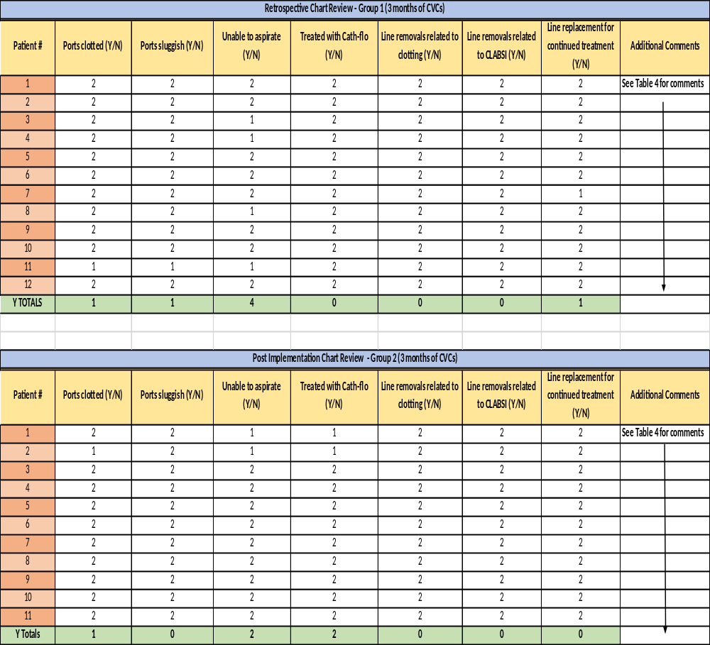
Note. Totals of all Yes questions are located in the bottom rows. The Yes totals will show retrospective and post-implementation numbers of each column heading.

Table 4
Additional Comments Section of Data Collection Tool for Each Patient
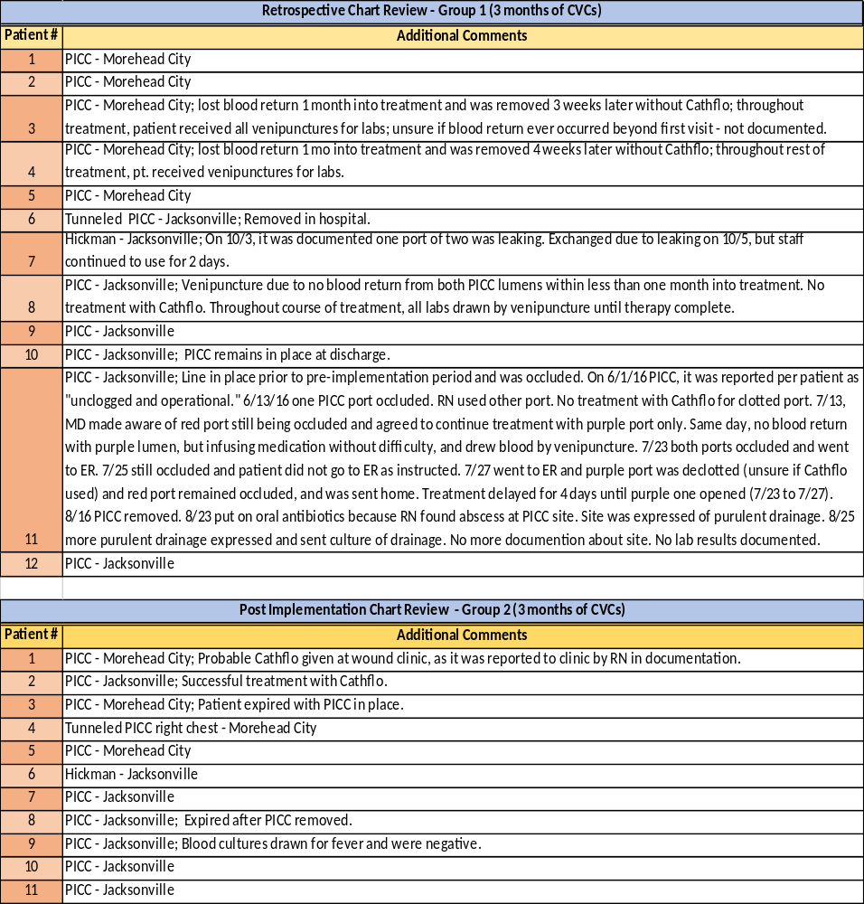
Note: Comparison of pre- and post-implementation documentation of CVAD problems with type of CVAD shown.
There were multiple problems during the pre-implementation period, as opposed to the post-implementation period. In Table 4, “No information” following CVAD type reflects that there were no clotting problems and/or the clotted line was treated with Cathflo during therapy.
The problem statement of the project assumes that the data collected will show improvement in all CVAD functionality based on the education and tools given to the staff for the implementation period. In order to evaluate the statistical significance of the data, the information was imported into SPSS 23 software to perform a Chi-Square test for independence on each measure of line functionality and appropriate treatment. However, for those measures that had differences in data values, the p-values showed no statistical significance; and for those measures which had equal values of zero (no Y data pre- or post-implementation) could not be statistically compared.
Although there was no statistical evidence of improvement, there was definitive clinical significance shown in some of the measures within the data. In Group 1, 8.3% of the lines were sluggish versus 0% of Group 2. Lines unable to be aspirated for blood showed a 15.1% improvement post-implementation (Group 1 = 33.3%, Group 2 = 18.2%). There were no lines treated with Cathflo for clotted, sluggish, or inability to aspirate ports in Group 1, with 1 that had a clotted port; and Group 2 had 2 lines that were treated appropriately with Cathflo, with one port being occluded. This showed an 18.2% improvement in treatment of port occlusion with Cathflo (Group 1 = 0%, Group 2 = 18.2%). The remaining measures (line removals for clotting or CLABSI, line replacements) showed no changes between Groups 1 and 2, except that 1 Hickman catheter was removed pre-implementation due to 1 leaking port out of 2.
The additional comments obtained from the documentation in the medical records of each patient pre- and post-implementation showed that 5 of the 12 patients in Group 1 had line complications and were not appropriately treated with Cathflo, therapies were delayed, and the Hickman catheter remained in place for 2 days with a compromised port (leaking from port rupture or fracture) while the other port continued to be used. The documentation regarding Group 2 patients showed there were 2 of the 11 lines with inability to aspirate blood and 1 patient who was febrile while the catheter was in place. The 2 lines were treated appropriately with Cathflo and maintained functionality post treatment throughout the remainder of therapy. The febrile patient had blood cultures drawn which was an appropriate intervention, and had verified negative bacteremia. All of the treatment failures in Group 1 could have resulted in CLABSI, and would have been preventable with proper education of the staff regarding CVAD care and maintenance.
Following the post-implementation period, a survey created in Qualtrics Survey Software was distributed to the remaining 5 nurses from both sites. A two week period of time was allotted to give the staff time to complete the survey to obtain feedback on the usefulness of the tools provided and knowledge gained from the project. There were 12 questions of which the first 11 were 5 choices based on a Likert scale from “strongly disagree” to “strongly agree.” The last question was for the nurses to respond in text format with any additional comments that each felt was pertinent to the implementation.
Of the 2 respondents, 1 answered “agree” to all 11 questions and gave additional comments, and the other answered “strongly agree” to all but one of the 11 questions. The second respondent answered “agree” to the question regarding changing his/her practice according to the evidence based interventions presented, and chose not to offer additional comments. The first respondent who offered additional comments stated that having physician support for the evidence based protocol would assist with compliance to the recommended interventions and treatment of occlusions. Furthermore, it was stated that once patients are sent to the emergency room for the treatment of occlusions, the home health nurse has no control over the treatment provided. One nurse wrote:
I think the hitch is getting MD's to go along with the protocol & algorithm. Most MD's ordering home nursing care are not familiar with central line issues and just say to send the patient to the ER for issues of occlusion. Nothing short of occlusion gets any attention at all. Even then, if only one lumen is occluded, the nurse is told to use the other one. The home care nurse has absolutely no control of what is done when a patient is sent to an ER.

Chapter 5

Discussion
The results obtained from the evaluation of clinical significance of this project has provided a starting point for CVAD care in the home health setting. Since there has been little research in this setting, it shows the need for performance improvement in home care, as well as the need for appropriate documentation and follow up. With increased understanding of the potential complications that occur with CVADs for long term care, it will decrease health care cost, prevent a delay in care, increase patient comfort, and ultimately, prevent CLABSI. Introduction. The implementation of the project with education, flushing protocol, occlusion protocol, and catheter occlusion algorithm showed definite clinical improvement in 3 of 7 categories evaluated for line functionality and treatment. Overall, Group 2 had less line complications than Group 1, and appropriate treatment with Cathflo was requested from physicians by staff to de-clot occluded ports or those unable to obtain a blood return. Sluggish ports improved by 8.3%, unable to aspirate ports improved by 15.1%, and treatment with Cathflo improved by 18.2% post-implementation. Clotted ports were equal in both groups with 1 in each.

Implications of Findings. During data collection, it was noted that one port of the Hickman catheter was compromised due to a puncture or fracture as evidenced by leaking fluid. Since the line had two ports, the functioning port continued to be used for 2 days by staff for infusions with the other not being used due to leaking. This action placed increased risk to the patient for CLABSI and the patient should have been sent to the hospital for immediate removal.
A second patient, during the pre-implementation phase, had at least 1 occluded port out of 2 throughout the entire time the line was in place. The treatment was delayed for 4 days during therapy due to both ports being occluded, and the patient was instructed to go to the emergency room for de-clotting but never went to receive treatment. Upon discovery of this issue, the home health nurse ensured that the patient go to the emergency room for treatment and the patient returned home with one port still occluded. Throughout therapy, the physician was aware of the clotting issues and approved use of the line with one functioning port. At the end of therapy, the PICC line was removed. At the next visit, the home health nurse found an abscess at the PICC site which was treated with oral antibiotics. A culture of the site was obtained but there was no documentation of the results of the culture to verify if this was a site infection only or if blood cultures were warranted to rule out CLABSI. This is a perfect example of what can happen as a result of a lack of education regarding line functionality and potential for infection.
The evidence based standards of care of CVADs per the INS recommendations had shown the staff that adherence to the education and tools implemented improved outcomes of their CVAD patients. The results indicated an improvement in line functionality through proper flushing technique (push-pause flushing), line assessment for adequate blood return, and use of Cathflo to maintain patency of each line when appropriate (Gorski et al., 2016). The results of the project identified that increasing education, knowledge, and professional accountability of the staff regarding CVAD care was successful in improving line functionality through the evaluation of clotting problems and ability to aspirate for blood return. Therefore, there was a decreased frequency of venipunctures for blood tests, using lines with nonfunctioning ports, and site infections. It can be deduced that the quality of care improved by increasing patient comfort, satisfaction of the patients and staff, timely treatment, and decreased potential for infection.
The post-implementation staff survey results were favorable toward the project. Although the survey was completed by only 2 of the 5 nurses, it provided some useful feedback regarding the project. The respondents agreed or strongly agreed that they gained knowledge regarding CVAD care, found the flushing protocol and occlusion algorithm easy to use, will improve upon their practice with CVADs based on the education and tools provided, and would recommend these tools to other colleagues. Overall, the nurses were satisfied with the implementation process and knowledge gained.
Based on the additional comments made by one of the respondents, some modifications to the implementation process could be made if the project were to be replicated, or when the tools are introduced to the agency’s multistate sites. The nurse believed there was a lack of understanding from the providers treating home care patients with CVADs, and providers opted to automatically send patients to the emergency room for any occlusion problems. They seem to focus only on occlusions because they want to ensure the patients’ were able to receive the course of treatment without delays. For this reason, they allow continued use of the CVAD with only 1 functional port and are unaware of the rationale behind treating all the ports; and the rationale is that any nonfunctioning port can put the patient at an increased risk of CLABSI. Physicians should be included in the education process for evidence based interventions to facilitate an open dialogue between home health nurses and physicians regarding the functionality of CVADs and a working knowledge of the appropriate treatment of line occlusions with Cathflo. Another option for future implementations would be to write a Cathflo order set that the providers can initially review, approve, and that can then be utilized by the agency as standing orders for any home health CVAD patient.
This project substantiated the evidence based literature regarding line maintenance, clinician education, and the need for further study in the home health care setting. For example, the patient who had a port occlusion for the length of treatment resulted in a site infection that was preventable, and most likely caused by a thrombotic occlusion with adherence of biofilm intraluminally and/or extraluminally (Btaiche, Kovacevich, Khalidi, & Papke, 2011; Linnemann, 2014; Nakazawa, 2010; Zhang et al., 2015). As demonstrated by Group 2’s results, there were two lines that were treated in a timely fashion with Cathflo and no infections were documented, which is supported by the literature (Anderson et al., 2013; Baskin et al., 2012; Btaiche, Kovacevich, Khalidi, & Papke, 2011; Gorski et al., 2016; Linnemann, 2014; Nakazawa, 2010; O’Grady et al., 2011; Zhang et al., 2015).
Standardized protocols, education, and competence of staff in home healthcare is lacking according to the literature (Alkubati et al., 2015; Kramer et al., 2013; Nailon & Rupp, 2015). The lack of consistency in home care makes it difficult to keep up continuing education regarding CVAD care and maintenance. However, through this quality improvement project in two small home healthcare offices, there were improvements made in the quality of care provided to the patients as shown by the results of the implementation. When the information was presented to the staff during implementation, they expressed their concern about common problems they had with CVADs and took an interest in the evidence based standards of care. The main issue that concerned the staff was the lack of physician support they may experience regarding Cathflo administration. Ultimately, their responses to the teachings showed professional accountability in providing quality care, as well as a desire to decrease the number of occlusion issues that prevent them from administering medications on time or having the ease of drawing blood without performing unnecessary venipuncture.
This project was well supported by Covell’s NIC Theory. As stated by Covell (2008), this theory can be utilized in organizations where there was an investment in nursing knowledge and competence made by each employee and supported by the overall organization through funding, time, and encouragement. When this theory is achieved within any organization, the overall provision of care to the public will be enhanced and the benefit to the organization is immeasurable (Covell, 2008; Covell & Sidani, 2013). Out of all the agencies contacted regarding this project which was devised to improve patient care, only one agreed to allow staff participation. The agency president was open to suggestions and saw the potential in improving CVAD care in the organization. This is a large agency with multiple sites across NC, SC, and VA, which could improve CVAD care to all sites covering a large area. The effort of the staff, nurse manager, and president proves that the NIC Theory works as a framework for adding value to the organization by instilling a culture of applying learning to practice. This culture increases staff productivity, efficiency, financial performance, employee and patient satisfaction, and the overall quality of care to their patients (Weston, Estrada, & Carrington, 2007). The organization can benefit greatly from knowledge sharing from this project as it can be disseminated to all sites within the agency to improve CVAD care for innumerable people in the future. Thus, organizational and staff buy-in is at the forefront of any quality improvement initiative.
Limitations. There were a multitude of limitations in this project one of the most obvious of which was the small sample size. Two sites were included in the project because of the potential CVAD population being limited by using only one site in this rural area. Traveling to a site in Raleigh with a larger population would have resulted in more significant results, but the cost and time for travel would have made the implementation and data collection much more difficult. Additionally, the 3 month pre- and post-implementation periods limited the size of the sample which narrowed the scope of the project.
The generalizability of the project was adequately supported by the sample of CVAD patients through the inclusion of any CVAD in place for home care use. However, there could have been several confounding factors that may have skewed the results such as the number of home visits of each patient by a clinician depending upon insurance coverage, disease processes (hypercoagulable states, small vessel disease, etc.), types of medications administered, and health literacy of the patients and caregivers. Although there were confounding elements that could have contributed to clotting problems, the standards of CVAD care that were provided and utilized as part of the implementation phase of this project apply to all CVAD patients as recommended by the INS.
Another threat to internal validity of the project was the variability in staff attitudes, possible time constraints of the nurses, and full compliance with the protocols presented. The communication between implementer and staff was lacking even though multiple attempts were made to contact the staff throughout the implementation period. The implementer received two phone calls from staff at the beginning of the post-implementation period to clarify issues regarding Cathflo administration and to ascertain where the patient should be sent for treatment. However, data collection, ongoing feedback conversations, and full knowledge of staff compliance with the protocols was minimal. Also, during the post-implementation period, 3 nurses were lost and one was gained. Therefore, the new nurse may not have been educated by the remaining nurses on the protocol. Due to the lack of consistency in communication, staffing changes, and possible staff time constraints, it is unknown if strict adherence to the protocol occurred.
Another limitation expressed by the staff was physician cooperation for the ordering of Cathflo. As noted in the results, one physician ordered continued use of a line with one occluded port without de-clotting. This demonstrated the physician’s lack of knowledge of appropriate CVAD maintenance and may have contributed to an increased risk of CLABSI. The staff was more inclined to follow the protocol in treating occluded ports if all the physicians were agreeable to this evidence based practice.
Lastly, the documentation regarding CVAD patients was generally useful for data collection, but had some limitations. Due to the inconsistencies in the documentation by the nursing staff, accuracy of the data collection could not be verified. For example, blood return being obtained from each port of the CVAD was not consistently documented; therefore, the implementer had to determine there was no blood return because the patient had blood drawn by venipuncture. Occasionally, the nurse documented a narrative note stating there was no blood return and blood was drawn by venipuncture, which was helpful.
Delimitations. The only delimitation to this project was the small scope which resulted in a small sample size. On the topic of CVAD care in home health, there is minimal study in the literature and a lack of monitoring and consistency in the standards of care. With an abbreviated amount of time allotted in the DNP program to prepare and carry out this project, it was not possible to expand this implementation to multiple sites over a larger area by one person. As a future DNP, this project could be revisited over a larger region and assistance from other interested DNPs or clinicians could be obtained in order to achieve statistically significant results.
Recommendations. The multiple barriers experienced by the staff during the implementation can be overcome by educating the physicians overseeing their patients, encouraging more accurate documentation, and presenting the results of this project to the staff and management. Following these steps could encourage staff adherence to the protocols and instill in them a desire to maintain optimal patient safety and comfort through the provision of evidence based and quality care.
The clinical results have shown there is viability of the replication of this project in the home healthcare industry. The replication could be more easily accomplished by increasing the length of pre- and post-implementation time periods which would allow for a larger sample size to utilize for comparison. Successful implementation would also be supported by physician inclusion in the education process and improved communication between staff and implementer(s). This may facilitate compliance with the protocols, as well as encourage staff to provide consistent and accurate documentation.

Conclusion
This exercise has shown that proper education and training, adherence to evidence based recommendations, commitment to the accountability on the part of the staff, and support of the organization can lead to improved CVAD functionality, prevention of CLABSI, cost, efficiency, and patient safety and comfort. The tools created for this project were instrumental in guiding the staff on the proper steps of assessing, flushing, and de-clotting of CVADs. As a result of this intervention, occlusions, as well as line problems, occurred less frequently, and the use of Cathflo was successful in preventing thrombotic occlusions. This project will pave the way for future quality improvement projects in standardizing CVAD care in home health. Through the dissemination of this paper, home health organizations can be made aware of the importance of quality CVAD care, the education of all the staff involved with providing CVAD care, and may ultimately result in the prevention of CLABSI.

References
Anderson, D. M., Pesaturo, K. A., Casavant, J., & Ramsey, E. Z. (2013). Alteplase for the treatment of catheter occlusion in pediatric patients. The Annals of Pharmacotherapy, 47(3), 405-409. doi:10.1345/aph.1Q483
Bambi, S., Lucchini, A., & Giusti, M. (2014). Insertion site care of central venous catheters: Are guidelines clear enough? The Journal of Hospital Infection, 86(4), 276-277. doi:10.1016/j.jhin.2014.01.008
Baskin, J. L., Reiss, U., Wilimas, J. A., Metzger, M. L., Ribeiro, R. C., Pui, C. H., & Howard, S. C. (2012). Thrombolytic therapy for central venous catheter occlusion. Haematologica, 97(5), 641-650. doi:10.3324/haematol.2011.050492
Bianco, A., Coscarelli, P., Nobile, C. G., Pileggi, C., & Pavia, M. (2013). The reduction of risk in central line-associated bloodstream infections: Knowledge, attitudes, and evidence-based practices in health care workers. American Journal of Infection Control, 41(2), 107-112. doi:10.1016/j.ajic.2012.02.038
Bolton, D. (2013). Preventing occlusion and restoring patency to central venous catheters. British Journal of Community Nursing, 18(11), 539-40, 542-4. doi:10.12968/bjcn.2013.18.11.539
Btaiche, I. F., Kovacevich, D. S., Khalidi, N., & Papke, L. F. (2011). The effects of needleless connectors on catheter-related bloodstream infections. American Journal of Infection Control, 39(4), 277-283. doi:10.1016/j.ajic.2010.07.011
Centers for Disease Control and Prevention (CDC). (2011). Vital signs: Central line-associated blood stream infections--united states, 2001, 2008, and 2009. MMWR.Morbidity and Mortality Weekly Report, 60(8), 243-248. doi:mm6008a4
Covell, C. L. (2008). The middle-range theory of nursing intellectual capital. Journal of Advanced Nursing, 63(1), 94-103. doi:10.1111/j.1365-2648.2008.04626.x
Covell, C. L., & Sidani, S. (2013). Nursing intellectual capital theory: Operationalization and empirical validation of concepts. Journal of Advanced Nursing, 69(8), 1785-1796. doi:10.1111/jan.12040
Dal Molin, A., Clerico, M., Baccini, M., Guerretta, L., Sartorello, B., & Rasero, L. (2015). Normal saline versus heparin solution to lock totally implanted venous access devices: Results from a multicenter randomized trial.European Journal of Oncology Nursing : The Official Journal of European Oncology Nursing Society, 19(6), 638-643. doi:10.1016/j.ejon.2015.04.001
Debourdeau, P., Farge, D., Beckers, M., Baglin, C., Bauersachs, R. M., Brenner, B., . . . Bounameaux, H. (2013). International clinical practice guidelines for the treatment and prophylaxis of thrombosis associated with central venous catheters in patients with cancer. Journal of Thrombosis and Haemostasis : JTH, 11(1), 71-80.
doi:10.1111/jth.12071
Gorski, L., Hadaway, L., Hagle, M. E., McGoldrick, M., Orr, M., & Doellman, D. (2016).
Infusion therapy standards of practice. Journal of Infusion Nursing, 39(S1), S1-S159.
Harper, D. (2014). Infusion therapy: Much more than a simple task. Nursing, 44(7), 66-67. doi:10.1097/01.NURSE.0000446643.87747.1f
Hudman, L. & Bodenham, A. (2012). Practical aspects of long-term venous access. Continuing Education in Anaesthesia, Critical Care & Pain, 13(1), 6-11. doi: 10.1093/bjaceaccp/mks039
Kramer, N., Doellman, D., Curley, M., & Wall, J. L. (2013). Central vascular access device guidelines for pediatric home-based patients: Driving best practices. Journal of the Association for Vascular Access, 18(2), 103-113. doi:10.1016/j.java.2013.03.001
Langton, H. (2014). The management of central venous catheters and infection control: Is it time to change our approach? Journal of Perioperative Practice, 24(6), 141-146.
Lebeaux, D., Joly, D., & Zahar, J. R. (2014). Long-term central venous catheter-related infections [Abstract]. La Revue Du Praticien, 64(5), 626.
Leung, T. K., Lee, C. M., Tai, C. J., Liang, Y. L., & Lin, C. C. (2011). A retrospective study on the long-term placement of peripherally inserted central catheters and the importance of nursing care and education. Cancer Nursing, 34(1), E25-30. doi:10.1097/NCC.0b013e3181f1ad6f
Linnemann, B. (2014). Management of complications related to central venous catheters in cancer patients: An update. Seminars in Thrombosis and Hemostasis, 40(3), 382-394. doi:10.1055/s-0034-1371005
Lopez-Briz, E., Ruiz Garcia, V., Cabello, J. B., Bort-Marti, S., Carbonell Sanchis, R., & Burls, A. (2014). Heparin versus 0.9% sodium chloride intermittent flushing for prevention of occlusion in central venous catheters in adults.The Cochrane Database of Systematic Reviews, 10, CD008462. doi:10.1002/14651858.CD008462.pub2
Nailon, R., & Rupp, M. E. (2015). A community collaborative to develop consensus guidelines to standardize out-of-hospital maintenance care of central venous catheters. Journal of Infusion Nursing : The Official Publication of the Infusion Nurses Society, 38(2), 115-121. doi:10.1097/NAN.0000000000000092
Nakazawa, N. (2010). Infectious and thrombotic complications of central venous catheters. Seminars in Oncology Nursing, 26(2), 121-131. doi:10.1016/j.soncn.2010.02.007
O'Grady, N. P., Alexander, M., Burns, L. A., Dellinger, E. P., Garland, J., Heard, S. O., . . . Healthcare Infection Control Practices Advisory Committee (HICPAC). (2011). Guidelines for the prevention of intravascular catheter-related infections. Clinical Infectious Diseases : An Official Publication of the Infectious Diseases Society of America, 52(9), e162-93. doi:10.1093/cid/cir257
Ogston-Tuck, S. (2012). Intravenous therapy: Guidance on devices, management and care. British Journal of Community Nursing, 17(10), 474, 476-9, 482-4. doi:10.12968/bjcn.2012.17.10.474
Pittiruti, M., Hamilton, H., Biffi, R., MacFie, J., Pertkiewicz, M., & ESPEN. (2009). ESPEN guidelines on parenteral nutrition: Central venous catheters (access, care, diagnosis and therapy of complications). Clinical Nutrition (Edinburgh, Scotland), 28(4), 365-377. doi:10.1016/j.clnu.2009.03.015
Rinke, M. L., Bundy, D. G., Milstone, A. M., Deuber, K., Chen, A. R., Colantuoni, E., & Miller, M. R. (2013a). Bringing central line-associated bloodstream infection prevention home: CLABSI definitions and prevention policies in home health care agencies. Joint Commission Journal on Quality and Patient Safety / Joint Commission Resources, 39(8), 361-370.
Rinke, M. L., Milstone, A. M., Chen, A. R., Mirski, K., Bundy, D. G., Colantuoni, E., . . . Miller, M. R. (2013b). Ambulatory pediatric oncology CLABSIs: Epidemiology and risk factors. Pediatric Blood & Cancer, 60(11), 1882-1889. doi:10.1002/pbc.24677
Sagana, R., & Hyzy, R. C. (2013). Achieving zero central line-associated bloodstream infection rates in your intensive care unit. Critical Care Clinics, 29(1), 1-9. doi:10.1016/j.ccc.2012.10.003
Scheck McAlearney, A., Hefner, J. L., Robbins, J., Harrison, M. I., & Garman, A. (2015). Preventing central line-associated bloodstream infections: A qualitative study of management practices. Infection Control and Hospital Epidemiology, 36(5), 557-563. doi:10.1017/ice.2015.27
Scholtz, A. K., Monachino, A. M., Nishisaki, A., Nadkarni, V. M., & Lengetti, E. (2013). Central venous catheter dress rehearsals: Translating simulation training to patient care and outcomes. Simulation in Healthcare : Journal of the Society for Simulation in Healthcare, 8(5), 341-349. doi:10.1097/SIH.0b013e3182974462
Staun, M., Pironi, L., Bozzetti, F., Baxter, J., Forbes, A., Joly, F., . . . ESPEN. (2009). ESPEN guidelines on parenteral nutrition: Home parenteral nutrition (HPN) in adult patients. Clinical Nutrition (Edinburgh, Scotland), 28(4), 467-479. doi:10.1016/j.clnu.2009.04.001
The Joint Commission. (2011). Variability of surveillance practices for central line-associated bloodstream infections and its implications for health care reform, 13(2), 6-8. Retrieved from http://www.jointcommission.org/assets/1/18/Variability_of_Surveillance.pdf
The Joint Commission. (2012). Preventing central line–associated bloodstream infections
a global challenge, a global perspective. Retrieved from http://www.jointcommission.org/assets/1/18/clabsi_monograph.pdf
The Society for Healthcare Epidemiology of America. (2014). Expert clabsi guidance adds real world implementation strategies. Retrieved from http://www.shea-online.org/View/ArticleId/286/Expert-CLABSI-Guidance-Adds-Real-World-Implementation-Strategies.aspx
The United States Census Bureau. (2014). Profile of general population and housing characteristics: 2014 demographic profile data. Retrieved from http://factfinder.census.gov/faces/nav/jsf/pages/index.xhtml
Ullman, A. J., Marsh, N., Mihala, G., Cooke, M., & Rickard, C. M. (2015). Complications of central venous access devices: A systematic review. Pediatrics, 136(5), e1331-44. doi:10.1542/peds.2015-1507
Weston, M. J., Estrada, N. A., & Carrington, J. (2007). Reaping benefits from intellectual capital. Nursing Administration Quarterly, 31(1), 6-12. doi:00006216-200701000-00005
Yousif, A., Jamal, M. A., & Raad, I. (2015). Biofilm-based central line-associated bloodstream infections. Advances in Experimental Medicine and Biology, 830, 157-179. doi:10.1007/978-3-319-11038-7_10
Zhang, L., Gowardman, J., Morrison, M., Runnegar, N., & Rickard, C. M. (2016). Microbial biofilms associated with intravascular catheter-related bloodstream infections in adult intensive care patients. European Journal of Clinical Microbiology & Infectious Diseases : Official Publication of the European Society of Clinical Microbiology, 35(2), 201-205. doi:10.1007/s10096-015-2530-7

Appendix A
Model of the conceptual-empirical structure for the nursing intellectual capital theory. Adapted from “Nursing Intellectual Capital Theory: Operationalization and Empirical Validation of Concepts,” by C. L. Covell and S. Sidani, 2012, Journal of Advanced Nursing, 69, p. 1768. Copyright 2012 by the Blackwell Publishing Ltd.

Appendix B
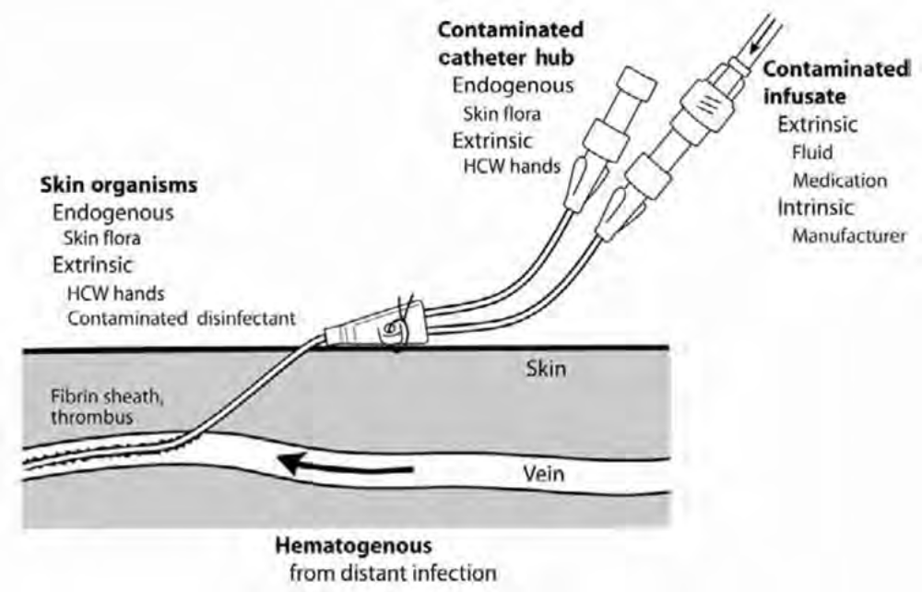
Routes for Central Venous Catheter Contamination with Microorganisms. Potential sources of infection of a percutaneous intravascular device (IVD): the contiguous skin flora, contamination of the catheter hub and lumen, contamination of infusate, and hematogenous colonization of the IVD from distant, unrelated sites of infection. HCW: health care worker. Adapted from “Preventing Central Line-Associated Bloodstream Infections: A Global Challenge, a Global Perspective,” by The Joint Commission, 2012, http://www.PreventingCLABSIs.pdf, Chapter 1, p. 5. Copyright 2012 by The Joint Commission.

Appendix C
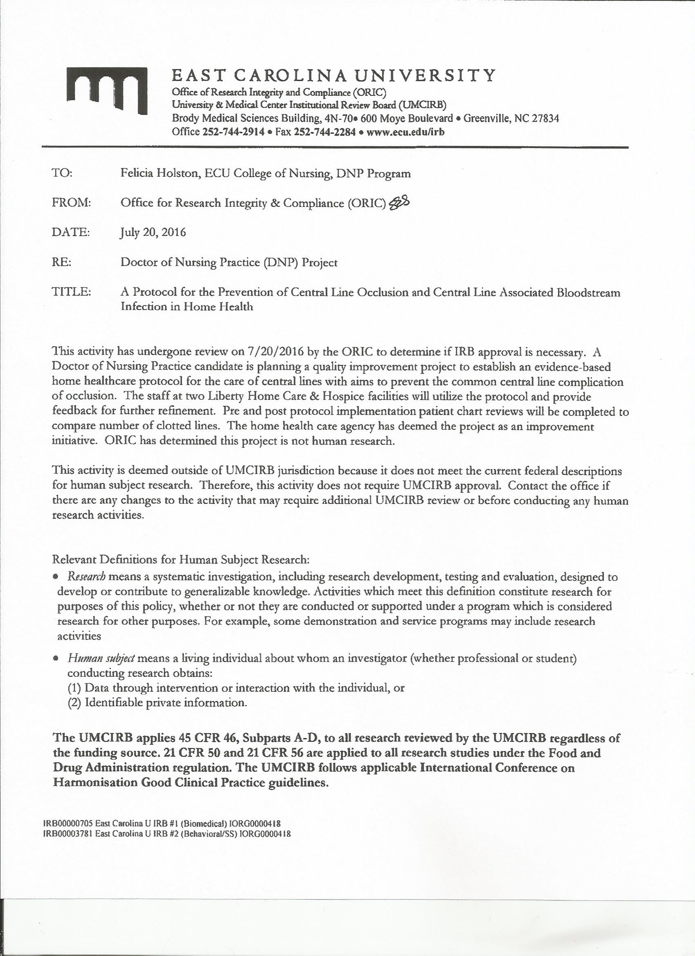
Appendix D
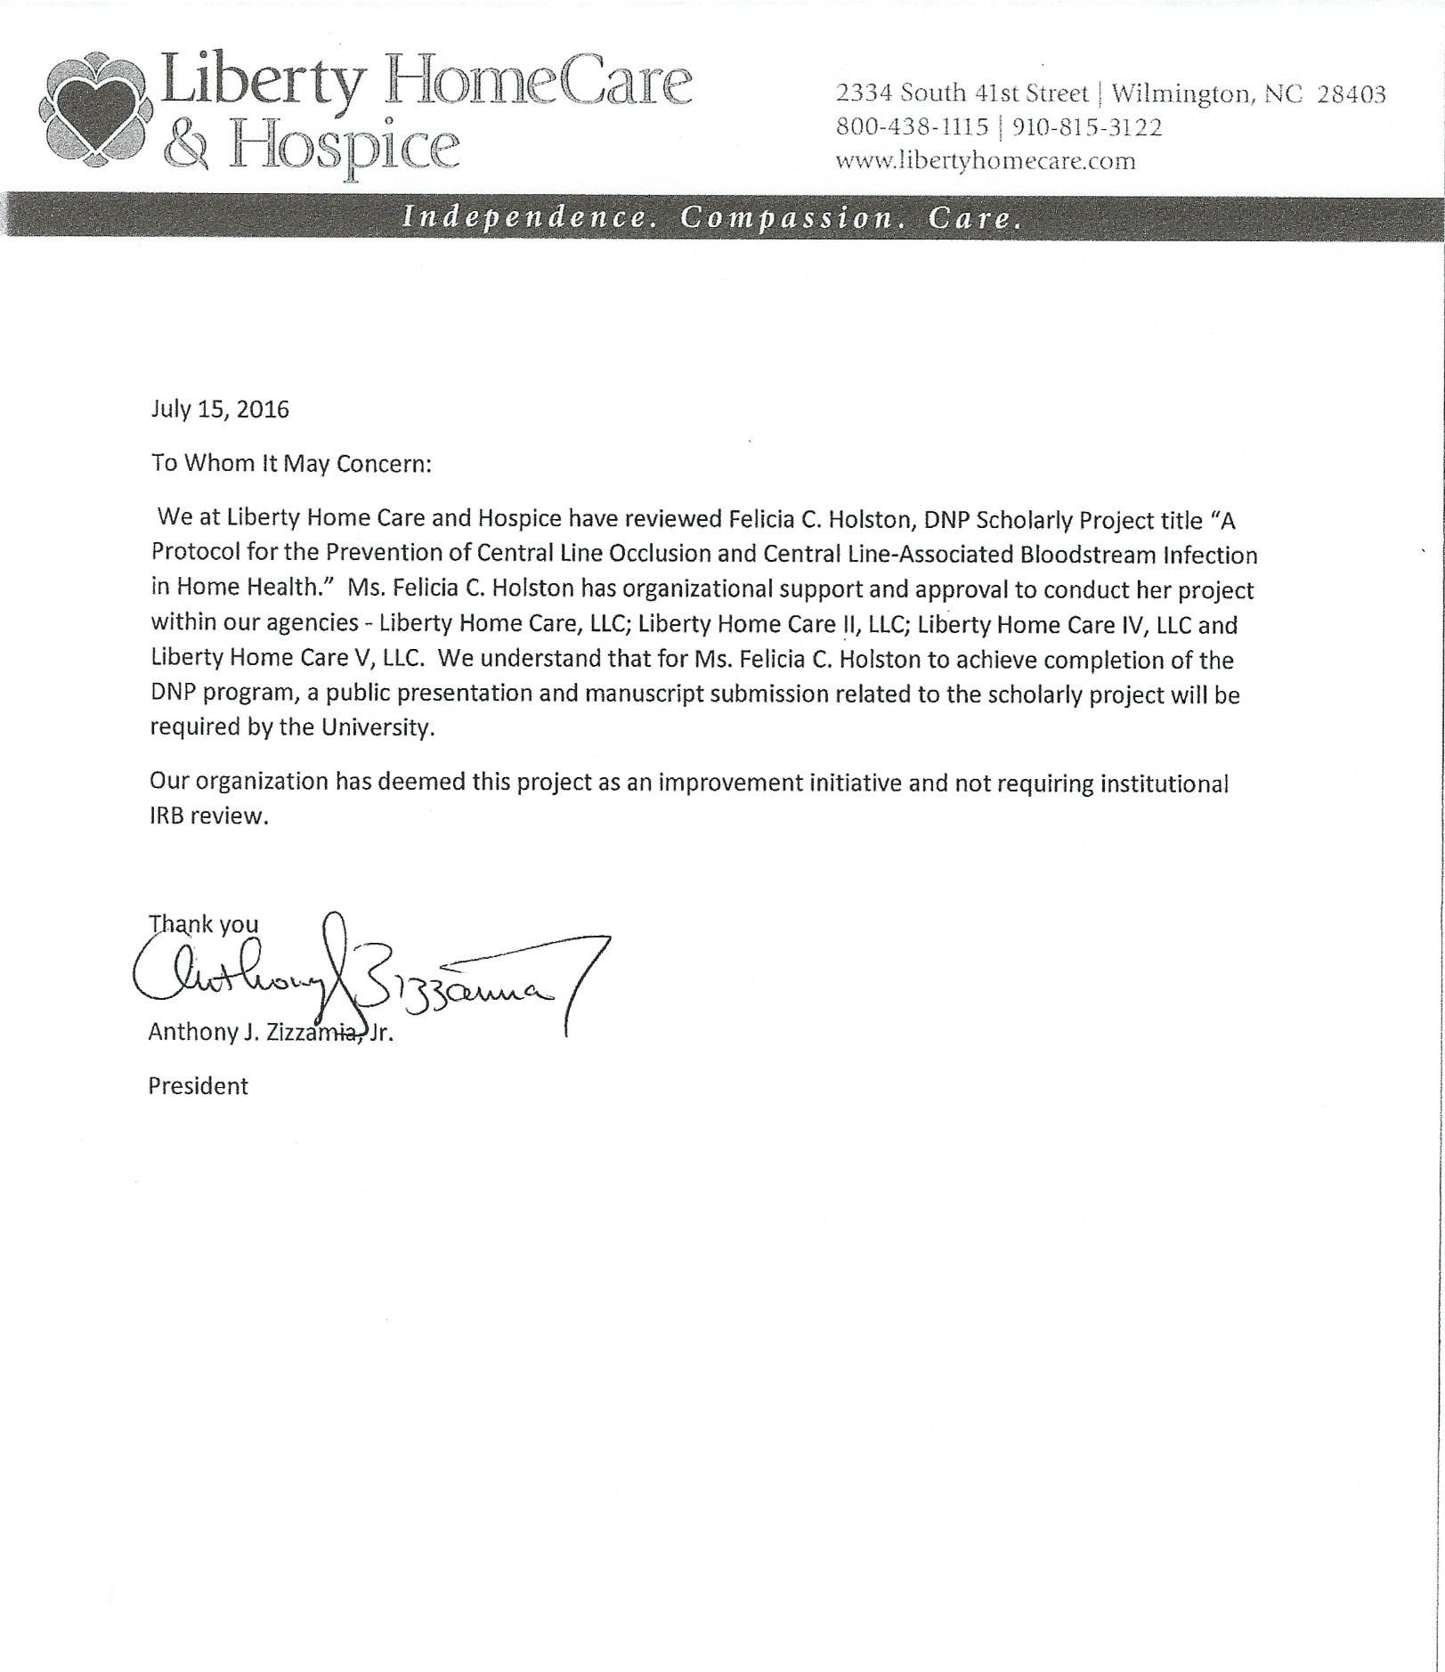

Appendix E


Appendix F
Flushing and Locking - Central Venous Access Devices (CVADs) per the Infusion Nurses Society (INS) Infusion Therapy Standards of Practice (2016)

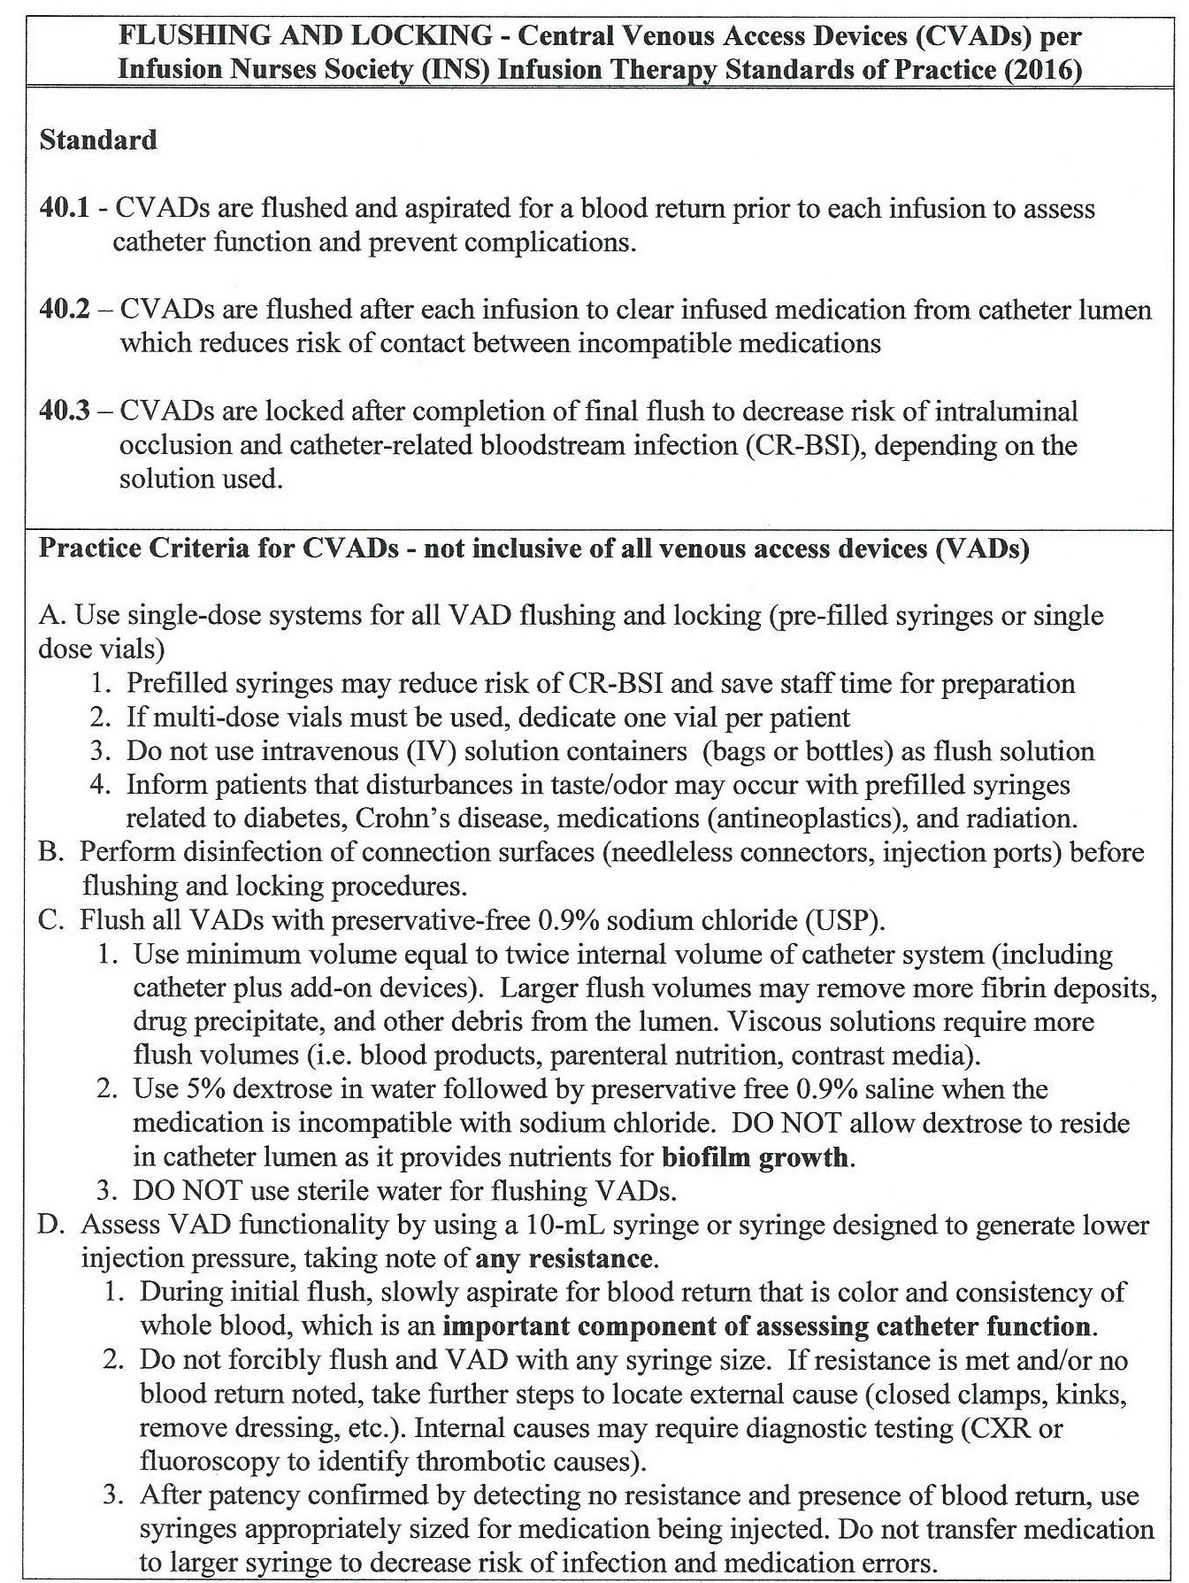

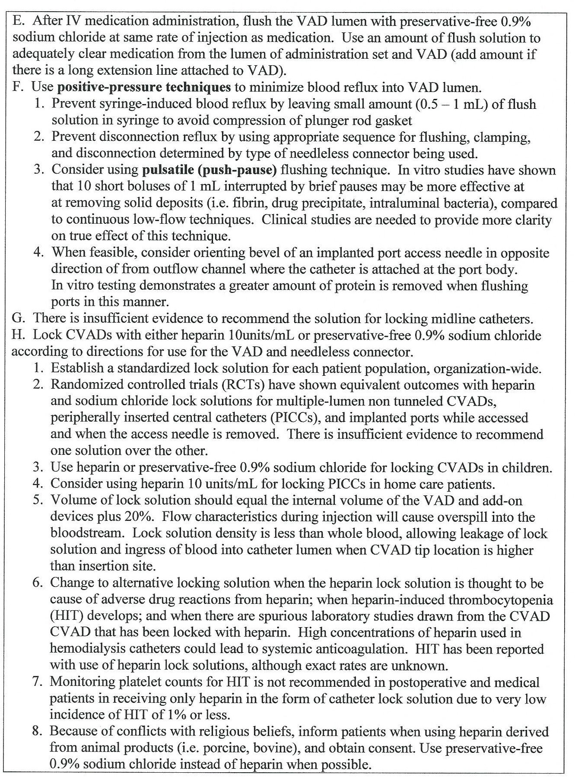

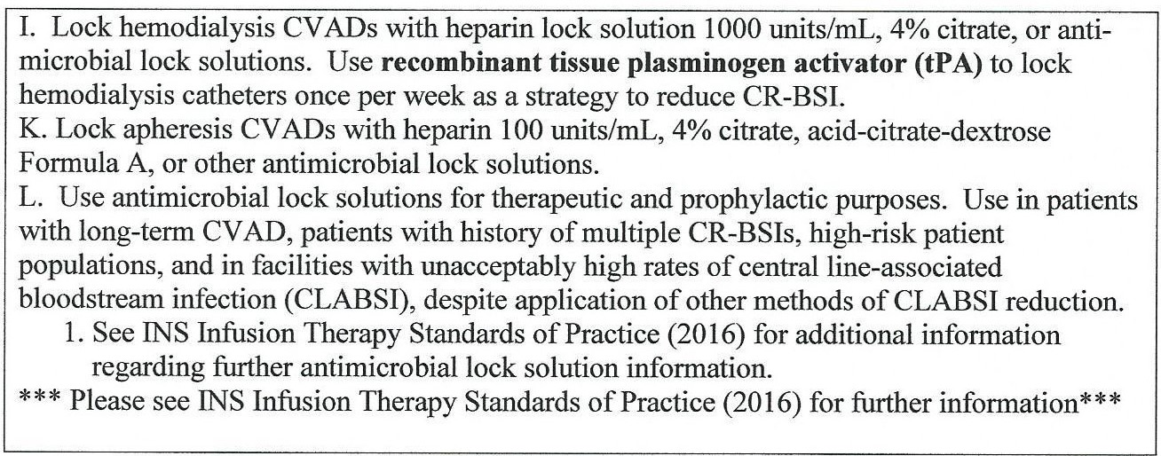
Note. Adapted from “Flushing and Locking,” by L. Gorski, L. Hadaway, M. E. Hagle, M. McGoldrick, M. Orr, and D. Doellman, 2016, Journal of Infusion Nursing, 39, pp. S77 – S80. Copyright 2016 by the Infusion Nurses Society.

Appendix G
Central Venous Access Device (CVAD) Occlusion

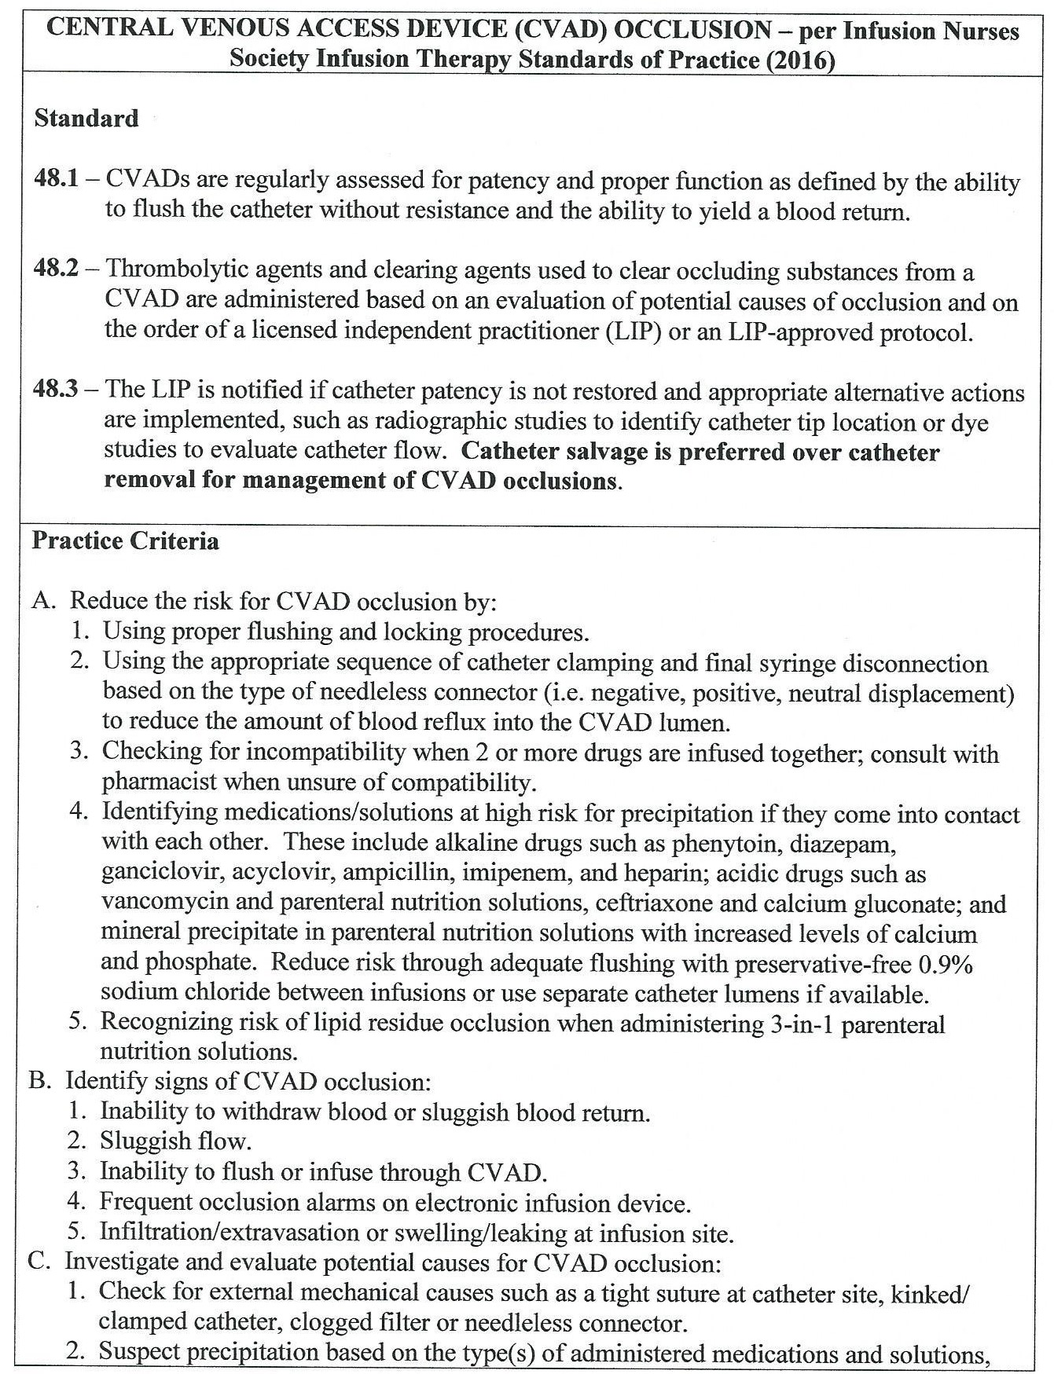

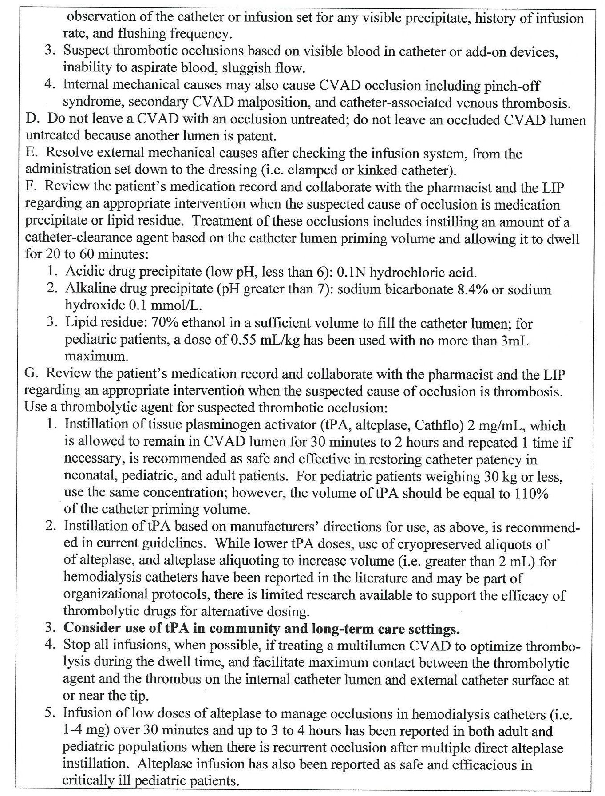
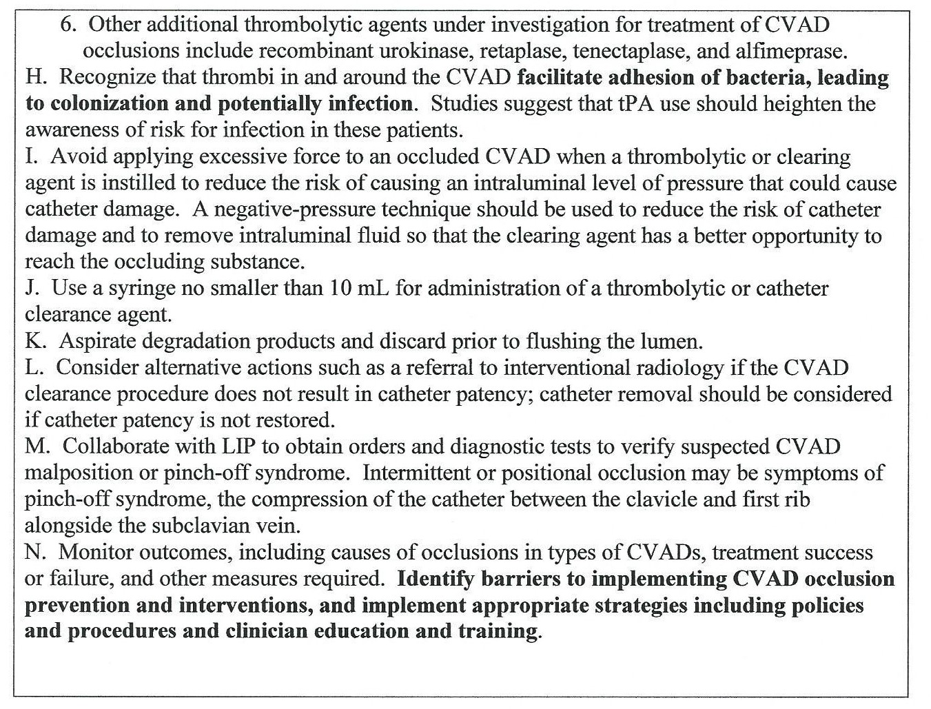
Note. Adapted from “Central Venous Access Device (CVAD) Occlusion,” by L. Gorski, L. Hadaway, M. E. Hagle, M. McGoldrick, M. Orr, and D. Doellman, 2016, Journal of Infusion Nursing, 39, pp. S104 – S105. Copyright 2016 by the Infusion Nurses Society.

Appendix H
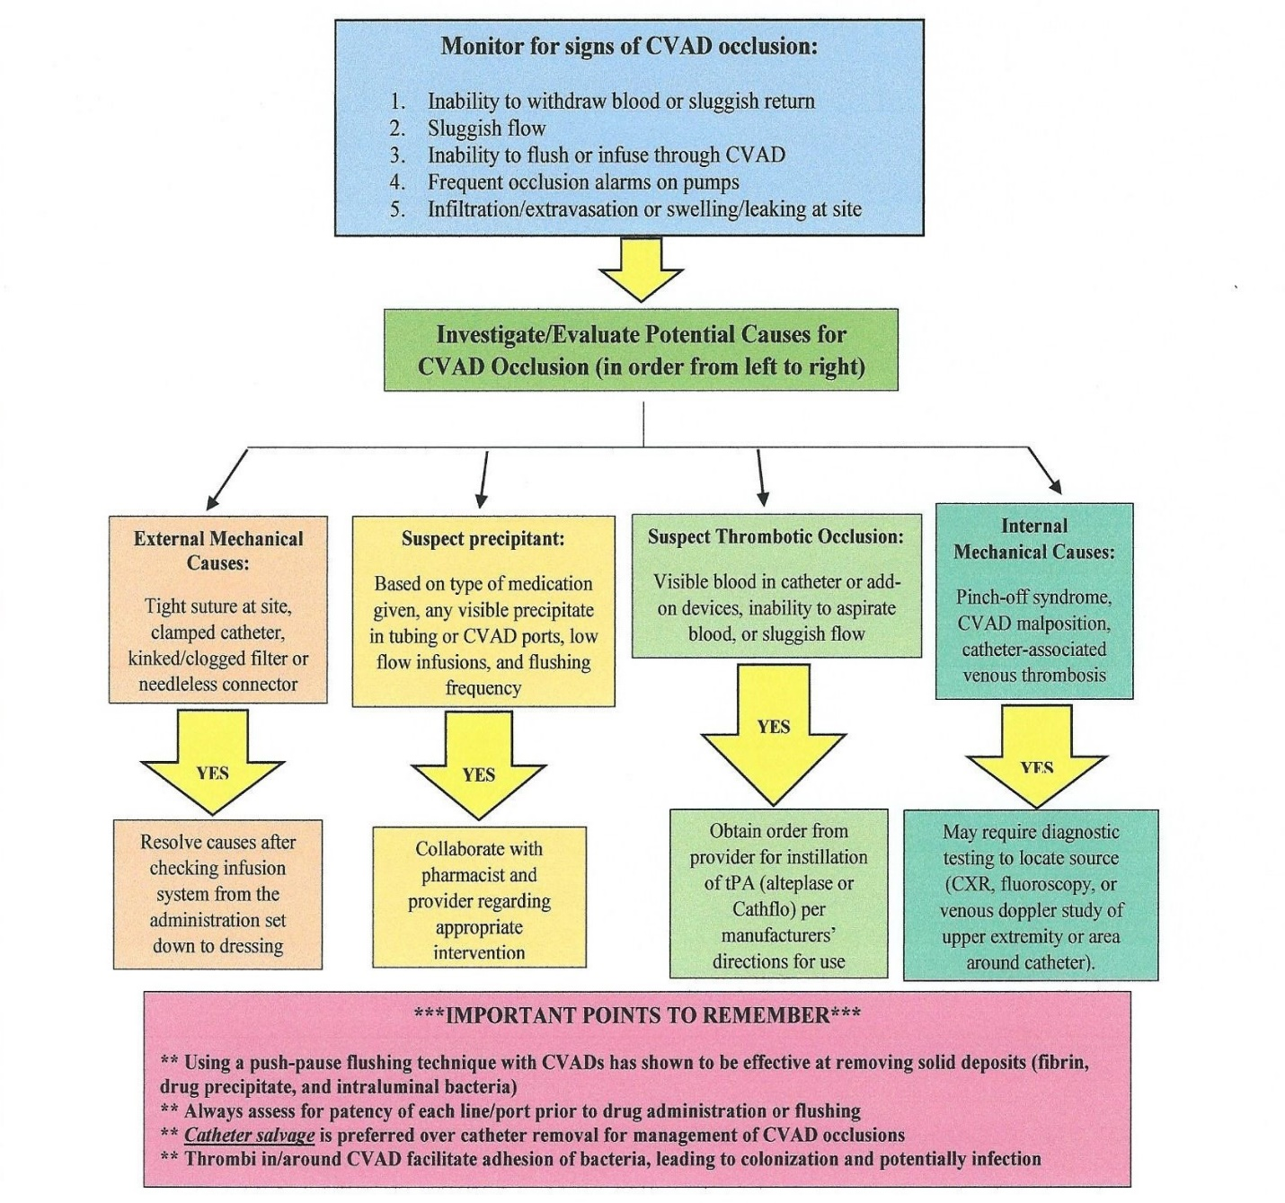
Catheter Occlusion Algorithm. This is a step-by-step flow chart for nursing staff to utilize when troubleshooting catheter occlusions. Adapted from “Central Venous Access Device (CVAD) Occlusion,” by L. Gorski, L. Hadaway, M. E. Hagle, M. McGoldrick, M. Orr, and D. Doellman, 2016, Journal of Infusion Nursing, 39, pp. S104 – S105. Copyright 2016 by the Infusion Nurses Society.

Appendix I
Post-Implementation Evaluation Questionnaire
To help provide feedback on the implementation process and knowledge gained regarding central line care in the home, please complete this online survey. Thank you for your participation, as this will assist with any further quality improvement research on care of central lines in home healthcare. Please provide any comments you wish to share with the project leader in the space(s) provided.
Statement | Strongly Agree | Agree | Neutral | Disagree | Strongly Disagree
I am satisfied with the usefulness of the Flushing and Locking protocol.
I am satisfied with the Catheter Occlusion protocol.
I am satisfied with the Catheter Occlusion Algorithm.
I have gained additional central line care knowledge through the use of the protocols and the algorithm.
I feel that the implementation of this project has assisted in improving the care I provide for my central line patients.
I am likely to recommend the use of the protocols and algorithm to other colleagues in my field of nursing.
I am satisfied with the ease of use of the protocols and algorithm.
I understand the different causes of catheter occlusion.
I will change my practice regarding evidence based interventions presented.
I understand that catheter salvage is recommended over catheter removal in order to increase patient comfort, and decrease risk of CLABSI and health care cost.
Overall, I am satisfied with the implementation process and knowledge gained from this project.

Additional Comments:

Appendix J
Retrospective Chart Review Data Collection Tool
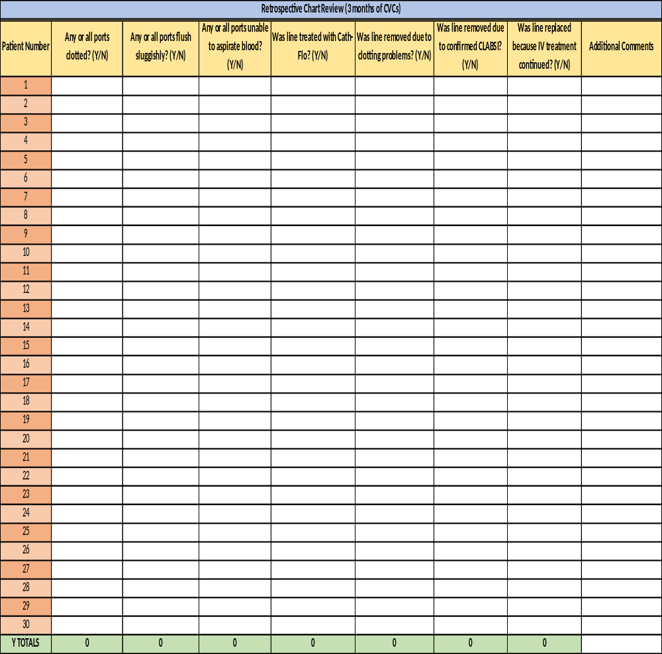
Note. Adapted from an Excel spreadsheet. Totals of all Yes questions are located in the bottom row. The Yes totals will show a retrospective number of each column heading. These totals will be used to compare to the post-implementation of protocols and algorithm regarding flushing and catheter occlusion of CVADs.

Appendix K
Post-Implementation Data Collection Tool
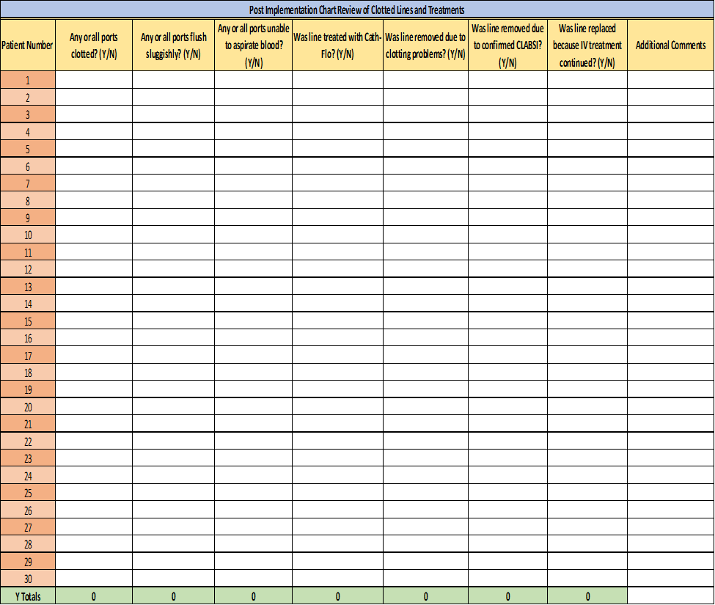
Note. Adapted from an Excel spreadsheet. Totals of all Yes questions are located in the bottom row. The Yes totals will show a post-implementation number of each column heading. These totals will be used to compare to the retrospective totals prior to implementation of protocols and algorithm regarding flushing and catheter occlusion. These numbers will show improvement in numbers of clotted CVADs and line removals.

