RECOGNITION OF BACTERIAL LIPID HEADGROUPS BY FLUORESCENT CROWN ETHER-NAPHTHALIMIDES
by
Sarah Ruth Marshall

A Senior Honors Project Presented to the
Honors College
East Carolina University
In Partial Fulfillment of the
Requirements for
Graduation with Honors

by
Sarah Ruth Marshall
Greenville, NC
April 2015

Approved by:
William E. Allen
Department of Chemistry, Harriot College of Arts and Sciences
East Carolina University

Abstract
Recognition of bacterial lipid headgroups by fluorescent crown ether-naphthalimides
by
Sarah R. Marshall
April 2015
Director of Senior Honors Project: William E. Allen

East Carolina University Honors College

The increasing incidence of antibiotic- resistant bacterial strains is a significant threat to human health. New antimicrobial mechanisms that feature reduced resistance potential are necessary to slow down the rapid evolution of bacteria and to develop more selective treatment. Large crown ethers are known to actively hydrogen bond with ammonium groups (R-NH₃⁺). Such ammonium group binding can be used to molecularly recognize the terminal ammonium unit present in the bacterial membrane lipid, “POPE.” This selective binding would be advantageous in such bacterial lipids present in mammalian hosts, which express lipid “POPC,” which lack the N-H capable of crown interaction. A fluorescently labeled crown ether was synthesized by palladium- catalyzed cross coupling of a 4-bromonapthalimide with 1-aza-18-crown-6. The crown-naphthalimide conjugate is strongly luminescent in nonpolar, organic solvents like dichloromethane and 1-octanol, but is quenched in polar solution such as aqueous phosphate buffer. The integrated fluorescence intensity of the conjugate is approximately three times greater in the presence of POPC liposomes than POPE liposomes, suggesting that the compound may be able to discriminate between mammalian and bacterial cell membranes. While fluorescence spectrophotometry concurs with the original proposal of observable POPE lipid selectivity, other data revealed otherwise. DFT optimization treatments were run to foretell possible interactions and orientations of the desired molecules. The computational analysis predicts that the ammonium group of POPE favors strong hydrogen binding within the crown, however proton NMR and ESI-MS studies have so far not confirmed that this binding mode is operative.

Table of Contents

Abstract 2

Chapter 1: Introduction 5

1.1 The race against antibiotic resistance
1.2 Bacterial membrane selectivity
1.3 Crown ethers as bacterial- selective agents

Chapter 2: Synthesis and properties of azacrown naphthalimide derivatives and their
ammonium cation reactivity 12

2.1 DFT-optimized analysis of naphthalimide-crown ether cation binding
2.2 Synthesis: formation and closure of crown-ether
2.3 Palladium-catalyzed cross coupling
2.4 Properties of 18-crown-6-naphthalimide

Chapter 3: Experimental 28

Chapter 1: Introduction
1.1 The race against antibiotic resistance
There is profound medicinal interest in the ability to selectively deliver antimicrobial compounds to bacteria in the presence of a human host.¹ Within a year of penicillin’s (Figure 1.1) pharmaceutical debut, the earliest resistance activity had already been observed in antibiotic receiving patients, as Fleming had anticipated if it were to be over/misused.⁹ Despite this, even newer antibiotics still target conventional mechanisms aimed at biosynthetic pathways, including inhibition of peptidoglycan synthesis and of DNA/RNA synthesis.¹ The continued use of generic, broad-spectrum antibiotic therapy, especially over extended periods as utilized in tuberculosis patients, creates a worst-case scenario for rapid bacterial selectivity and evolution. Traditional antimicrobials attacking bacterial growth factors are readily overcome, and customary combative strategy of successive drug variants, essentially adds fuel to the fire of natural selection for antibiotic resistance-favoring mutations. Consequentially, the blanket approach is beginning to be replaced by species specificity; innovative antimicrobials incorporating selective localization are gaining popularity.^{1,3,13} Novel selectivity models focus on exploiting unique bacterial membrane constituents as an avenue for direct acceptance of selective antibiotic delivery.

1.2 Bacterial membrane selectivity
Penicillin, once termed the ‘miracle drug’, kills a wide range of infectious microbes by inhibition of the final cell wall biosynthetic enzyme.^{9,11} Inhibition of this transpeptidase enzyme leaves newly formed patches of peptidoglycan cell wall unlinked, efficiently degrading the integrity of the cell in the single repressive step. Penicillin became the go-to in infectious disease treatment, and shortly there after gave rise to resistant bacterial strains. The mechanism of the drug’s action allows for at least three different modes of resistance.^{9,11} Many bacteria now display at least one characteristic of these resistance categories: (1) expression of penicillinase capable of inactivating penicillin, (2) penicillin-tolerance, or (3) competent in acquisition of bacterial DNA encoding for resistance-favoring mutations.¹² Excessive, unnecessary use of penicillin and antibiotics of similar mechanisms, as the universal approach to bacterial infection causes many problems of its own- raising the question if its benefits are worth the cost. Residual destruction of healthy, normal flora actually enables foreign pathogens to flourish and allows opportunistic, typically harmless, microbes to produce infections while escalating the already too large library of unsusceptible strains.

Figure 1.1 Chemical structure of Dr. Alexander Fleming’s penicillin

The bacterial membrane bilayer is composed of an enormous array of components capable of responding to/interacting with an introduced compound. Drug delivery selective to a microbial membrane is becoming a highly promising technique. It rejects universality of antibiotics and proposes compounds created based on structural and chemical isolation of a target while leaving indigenous flora and human cells untouched.^{1,10} Bacterial membranes contain the lipid POPE (1-palmitoyl-2-oleoyl-sn-glycero-3- phosphoethanolamine), featuring a terminal $-{NH_{3}}^{+}$ head group capable of interactions via hydrogen bond donation, unlike its human counterpart. Mammalian membrane bilayers express the lipid POPC (1- palmitoyl-2-oleoyl-sn-glycero-3-phosphocholine), and with an ammonium head group of three methyl units, the positive charge is masked within a hydrophobic “bubble” incapable of H-bond donation. Thus, the POPE head group (Figure 1.2 A) is an appropriate docking point for distinguishing between POPC lipids (Figure 1.2 B) with a synthetic receptor molecule to induce direct interaction with foreign cell.
Figure 1.2. Structural differences based on the ammonium head groups between A) the bacterial lipid POPE and B) human lipid POPC.

1.3 Crown ethers as bacterial- selective agents
It is not a new finding that POPE’s characteristic ammonium hydrogen’s ardently interact with macrocyclic H-bond acceptors. Crown ether molecules, specifically derivatives of 18-crown-6, have previously exploited this interaction as a means of selective recognition of the bacterial POPE lipid.^{2,3} The size of this crown molecule perfectly fits the 3-prong hydrogen complex (Figure 1.3) allowing for variability among atoms involved in binding, while preventing entry of the much larger, tri-methylated POPC group. Like all hydrogen bonds, the association to POPE hydrogen’s is known to be strongest when introduced in organic solvents, but significantly weaker in aqueous solution, where water molecules can “outcompete” for H-bonding sites on the crown.²
B
A

Figure 1.3. Two possible atomic associations of an aza-18-crown-6 with POPE's ammonium head group

Crown ether- lipid interactions (Figure 1.3) can be quantified via optical spectroscopy when a fluorescent label is presented. Naphthalimides are often employed as the reporter fluorophores given their small size, intense and environmentally sensitive emission, and structural variability. When used in bacterial studies, many naphthalimide fluorescent dyes also display antimicrobial activity.^{5,6}
Like other 4-amino substituted napthalimides, a conjugate like that shown in Figure 1.4, crown- naphthalimide fluorophores are expected to be significantly brighter in a nonpolar milieu than in water.¹⁵ These compounds are environmentally sensitive with potential to illuminate characteristics of a membrane it is introduced to and interacting with. Strong association of the fluorescent crown with ammonium cations is well known to be true in organic solvents as opposed to its weak association in aqueous solution.² The residual fluorescence intensity is directly related to the extent of nonpolar nature it is in solution with, highly fluorescent in nonpolar and essentially quenched in aqueous solvent. However the fluorescence amid crown interactions can be analyzed in aqueous phosphate buffer, to consider the membranous lipid effects. POPC lipids are relatively more nonpolar than the target POPE, so intensity changes must be compared to a control crown- naphthalimide that lacks the ability to H- bond to ammonium, in order to account for environmental factors.
Figure 1.4. Crown- naphthalimide
Cation recognition detection by the crown-naphthalimide 1.4 is expected to be paired with photophysical changes.¹⁵ The intense fluorescence that is characteristic of naphthalimides is brought about by the 4-amino group’s ability to donate electrons, generating an intramolecular charge transfer (ICT) excited state of its free electrons.¹³ Cation binding within the macrocycle immobilizes the lone- pair of N, therefore inhibiting ICT. It is proposed, then, that such a crown interaction with the POPE lipid ammonium group would likely result in decreased fluorescence emission. However, it has been noted in18-crown-6-ammonium cation complex experiments, dissimilarly executed in the gas phase, results are not so straightforward.¹⁴ The sensitivity of crown naphthalimides is further depicted in significant photophysical changes upon association with non-target species beyond simply environmental polarity. It is of significant importance in such fluorescence data observations to thoroughly consider the constant possibility of free species effects, such as binding of crown with K⁺ and hydronium ions (causing control of pH to remain a factor) and even self- association/orientation.
The following chapters will detail the works done in relevance to lipid membrane selectivity by fluorescent-crown A, specifically (Figure 1.5 A), which includes a methoxy-propyl “northern” head group for increased water solubility of the fluorophore and minimization of unaccounted for interaction at this end. The same methoxy-propyl napthalimide was coupled with a morpholine (i.e., 1-aza-6-crown-2), (Figure 1.5 B), as a control compound unable to bind ions within its crown unit.

Figure 1.5. Compound A) 4-(18-crown-6)-N-(3-methoxypropyl)-naphthalimide
Compound B) Control compound 4-(morpholine)-N-(3-methoxypropyl)-naphthalimide

Chapter 2. Synthesis and properties of azacrown naphthalimide
derivatives and their ammonium cation reactivity

2.1 DFT-optimized analysis of naphthalimide-crown ether cationic binding
There is a decent grouping of literature support for the idea that successful ammonium hydrogen-bonding to 18-crown-6 would not be diminished by the use of a directly-appended methoxy-naphthalimide reporter fluorophore.^{7,8,14} However, at the outset of this project such a conjugate had not explicitly been synthesized. Computational experiments using DFT optimization were undertaken in order to predict conformations and energetics of ammonium binding.
DFT optimization of the complex between compound A and a truncated POPE ammonium group employing an orientation in which the crown is perpendicular of the plane of naphthalimide fluorophore, is shown in Figure 2.1. The POPE lipid’s terminal ammonium hydrogens are shown in their most favorable state of binding (to three crown ether oxygen atoms). The data show consistent and relatively equal H-bond lengths in the two possible modes of Figure 1.3. As hoped, tight binding of the three-pronged terminal NH₃ to either three crown ether oxygens (Figure 1.3 A) or one nitrogen and two oxygen atoms (Figure 1.3 B) is predicted. Quantitative data are reported below in Table 1 and Table 2, along with the three-dimensional model of the bound 18-crown-6, Figure 2.4. The truncated portion of the POPE lipid, Figure 2.5, was used in computation to conserve computational resources and to ensure the values received were solely based on the interaction between the bacterial lipid head group and the crown fluorophore in question.
Figure 2.1 DFT Computational analysis of compound A's crown ether interaction with ammonium group of truncated POPE bacterial lipid

Figure 2.4 3-Dimensional portrayal of DFT optimized crown-POPE binding

Figure 2.5: Truncated portion of bacterial lipid POPE used in DFT analysis and showing specific ammonium head group of interest

2.2 Synthesis: formation and closure of crown-ether
Emboldened by the computational results, conditions for synthesis of the crown ether ring and compound A were considered. We initially attempted to build the 18-atom crown ring from two components. A portion of the future crown backbone was formed via tosylation of triethylene glycol (Scheme 2.1). Triethylene glycol di-p-tosylate was prepared first, for intended use in a slightly smaller control crown, 15-crown-5, the ring size of which is not ideal for interaction with ammonium ions. It could therefore help tease out environmental effects from any response(s) seen with a larger crown. The glycol chain was tosylated to enhance leaving group ability of the terminal oxygens. Addition of p-toluenesulfonyl chloride via pressure-equalizing dropping funnel to triethylene glycol and potassium hydroxide in dioxane under N₂ afforded the desired ditosylate in good yield (72.8%). We envisioned that cyclization using a deprotonated diethanolamine (Scheme 2.2) would provide 1-aza-15-crown-5.
Scheme 2.1
Compound C 72.8%

Preliminary attempts at production of the crown ether, independent of the naphthalimide fluorophore, were inefficient. Trials of crown synthesis (Scheme 2.2) were run in which the triethylene gycol di(p-toluenesulfonate) of Scheme 2.1 was dissolved in dioxane with diethanolamine and sodium tert-butoxide over low heat. Traces of the product were detected by mass spectrometry, but difficulty was encountered during its isolation by flash chromatography. The fractions of non-fluorescent compound could only be faintly visualized in an iodine chamber, proving this scheme ultimately not worth the solvent-intensive retrieval process.
Scheme 2.2

Further ring closure attempts were performed with the naphthalimide unit already present, making use of its bright coloration for better isolation efficiency. The first of these reactions (Scheme 2.3 A), a nucleophilic aromatic substitution, involved replacement of a 4-bromo group with diethanolamine at high temperature (~140 ˚C), to provide a scaffold for straightforward attachment of the ether backbone prepared in Scheme 2.1. This naphthalimide diol was later treated with triethylene glycol di-(p-tosylate) and sodium hydride to encourage both attachment and closure of triethylene chains (Scheme 2.3 B).
Scheme 2.3
Compound D

The first reaction in Scheme 2.3 did indeed produce the diethanolamine naphthalimide, however, evidence for attachment and closure of the polyethylene glycol (PEG) chain into a crown ether ring was not found by NMR or mass spectrometry. Concurrently, a separate route to the acyclic conjugate shown in Scheme 2.4, in which monofunctional tosyl-PEG was used in a S_{N}2-type reaction, also failed. Even though the tosyl-PEG was used in excess, the poor nucleophilicity of the (presumably) deprotonated 4-amino group of butyl naphthalimide prevented backside attack from occurring.
Scheme 2.4

After these attempts at macrocyclization of the desired crown failed, commercially manufactured 1-aza-18-crown-6 was obtained. Successful molecular synthesis of a fluorescent naphthalimide-crown utilized the pre-made 18-crown-6, and morpholine as control recognition element (instead of 15-crown-5).

2.3 Palladium-catalyzed cross coupling
Post traumatic crown formation failure, literature was found with insight on a successful addition of premade crown to 4-nitro-1,8-naphthalic anhydride. The first direct crown-naphthalimide addition adopted this protocol with substitution of central oxygen in 4-nitro-1,8-naphthalic anhydride oxygen by 1-(aminomethyl)-15-crown-5. The reaction scheme 2.5 was carried out in round bottom flask over heat in 1:1 deionized water and ethanol with water-cooled condenser. The crude target product was obtained as supported by NMR and Mass spectrometry. High-pressure liquid chromatography was done to purify crude product, and lyophilized product reported an extremely low yield of 1.5%. Such low yielding products are characteristic of these northern head group- crown reactions as noted in previous works, consistent with our result, and so further variation to the mechanism was considered.
Scheme 2.5
Compound E (1.5%)
Conditions for the synthesis of aza-18-crown-6 with naphthalimide bromide were adapted from the palladium-catalyzed cross coupling of aryl bromides⁸. Reaction was first attempted using morpholine control crown in reaction with the amine of a 4-aminonaphthalimide. The morpholine was used in place of 15-crown-5 as the control compound for assurance that synthesis and variable control will be effective. The newly adapted synthesis was first tested using the morpholine control compound and palladium catalyzed reaction in pressure tube, over heat, with sodium tert-butoxide in toluene. The 4-(aza-morpholine)-naphthalimide is not a new compound, but synthesis via this novel adaptation gave an impressive pure yield (46%). This same synthesis used for the morpholine-naphthalimide in scheme 2.6 was used, with crossed fingers, to synthesize the newly characterized molecule of 4-(aza-18-crown-6)-naphthalimide, giving a much prettier yield of 15% post flash chromatography, HPLC purification. Confirmation of obtained and isolated fluorescent crown, compounds A, was provided by multiple mass spectrometry and NMR spectra, and shown below.
Scheme 2.6

Figure 2.6 Proton NMR of Compound B, morpholine control crown, in CDCl_{3.} Indicative of successful formation of 4-(aza-morpholine)-naphthalimide via palladium catalyzed cross coupling reaction

Figure 2.7 Proton NMR of Compound A in CDCl_{3.} Indicative of successful formation of 4-(aza-18-crown-6)-naphthalimide via palladium catalyzed cross coupling reaction

2.4 Properties of 18-crown-6-naphthalimide
Definitive characteristics of the newly and successfully formed compound A are not yet completely understood. The sensitivity of the crown is a significant factor during application experiments, so exact replications between the morpholine control and the 18-crown-6-naphthalimide is crucial. Liposomes were prepared with uniform lipid bilayers for absorption and emission analysis. A known concentration of control naphthalimide-morpholine was introduced to blank sodium phosphate buffer, liposomes of POPE and POPC, and 1-octanol, producing a baseline fluorescence plot for emissions varying specifically due to environmental properties, independent of molecular interaction (Figure 2.8). Results correlated with expectations, 1-octanol’s nonpolar, organic environment encouraged intense luminescence while fluorescence was all but quenched in the sole aqueous buffer. Fluorescence titrations prepared with identical protocol, except now for use with compound A as the fluorescent dye, gave striking data (Figure 2.9). The spectrum’s significantly decreased emission with POPE, while maintaining similar response by POPC lipids, gives enticing evidence in support of successful localization of compound A to POPE lipid terminal ammonium hydrogens. Less fluorescent intensity was the originally expected reaction of compound A in the case of successful POPE ammonium group interaction. Binding of the crown head group would reduce ability of intersystem energy transfer, and therefore lower the emission power of the entire compound. This drop in luminescence was also not seen in POPC, alluding proper selectivity, and though POPC lipid creates a generally less polar solution around molecules of compound A, comparison of this result to plot of compound B should effectively rule out possibility of no change in POPC emission as singularly due to more desired environment.
The fluorescence data seemingly in support of the original hypothesis of selective POPE-crown interaction, was soon accompanied by contradicting mass spectrometry and NMR titration results. The mass spectrometry titration performed was prepared in acidified acetonitrile solvent. A spectrum of just azacrown-naphthalimide was obtained first, followed by injection after the addition of solid POPE lipids. No evidence of naphthalimide-crown-POPE complex mass appeared. Similar results appeared in the series of NMR titrations in CDCl₃ solvent. The NMR titration involved gradual addition of CDCl₃ with dissolved POPE lipids to CDCl₃ and dye solution. However, no shifts in crown ether hydrogen’s were observed throughout titration ranging from 5 uL of POPE/CDCl₃ to the full two equivalents of POPE to compound A. Speculation over these contradictory results led to numerous extension projects that time constraints did not allow.
Extensions of the inconclusive titration studies are underway. The addition of simple amine to NMR/ mass spectrometry titrations with compound A and B instead of the full POPE lipid would reveal if the naphthalimide-crown complex inhibits expected interactions, despite DFT predictions. There also could be some discrimination of the selective molecule’s hydrogen bonding capabilities between introductions of full lipids vs. uniformly prepared liposomes. The liposomes present a lipid bilayer membrane which the northern, methoxy-propyl head group could diffuse into. This would be a reasonable conclusion if the earlier mentioned DFT computational results were correct in its description of more than one possible orientation of compound A. If one of these conformations actually folded or twisted in a way in which the large region within the crown was blocked, then occupation of the northern head group by membrane bilayer, would explain evident crown-POPE association in presence of liposomes.

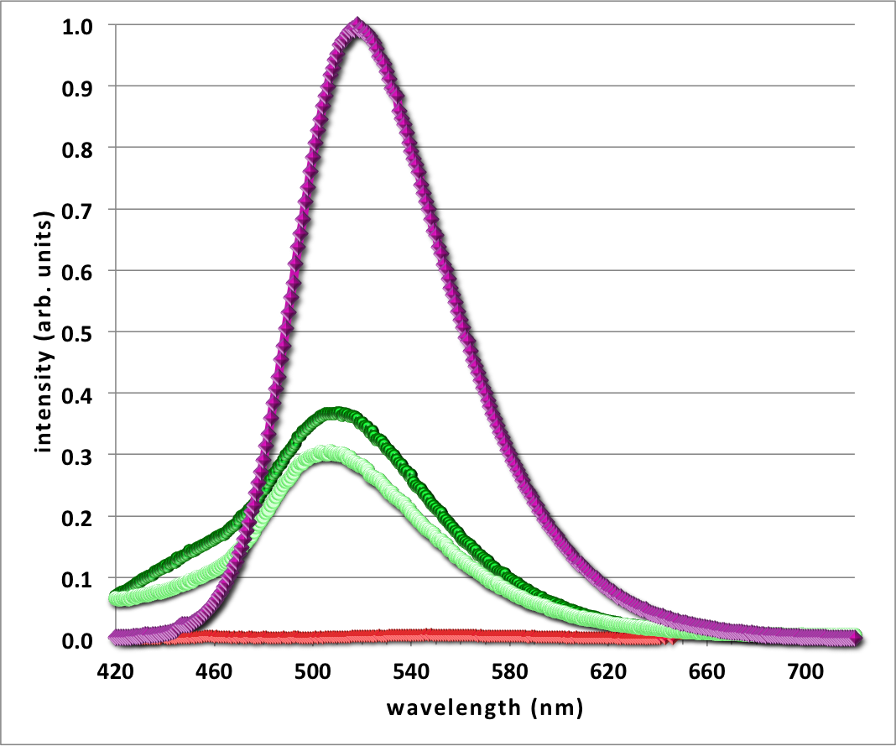

Figure 2.8 Fluorescence spectrophotometry normalized emission plot of compound B, the control morpholine molecule shows environmental properties in presence of 1-octanol (purple), POPC (dark green), POPE (light green) and aqueous sodium phosphate buffer (red)
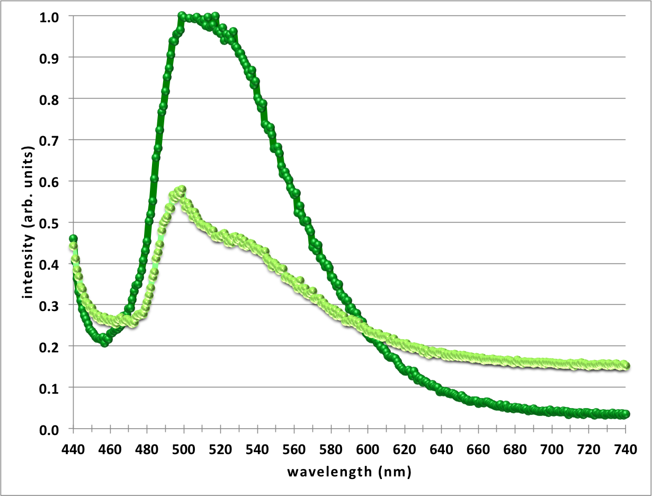

Figure 2.9 Fluorescence spectrophotometry normalized emission plot of compound A, showing a maintained intense fluorescence in presence of POPC liposomes (dark green), and a decreased fluorescence with POPE (light green) as anticipated upon hydrogen binding of POPE terminal ammonium group

Bacterial studies, the big picture of compound A application, are also in progress toward conclusive property data. The initial study involved two separate M9 liquid media (Na⁺ or K⁺), and an assay of 8 separate bacterial strains, all of varying gram stain and membrane properties. Each bacterial strain was inoculated and diluted in LB broth to coordinate equal starting OD counts between both media for each bacterial strain individually. Each test tube received 3 mL of either M9 media, 3 uL of compound A fluorescent dye, and 3 uL of diluted bacteria in LB broth. The tubes were left over night in shaking incubator for 24 hours.
The next day OD600 counts were taken from 1 mL of each test tube (Table 2.3) and 1 mL of each went into a small centrifuge tube and pelleted in centrifuge for 2 minutes. The pelleted bacteria in 1 mL of varying M9 media were observed under UV light for emission designation between luminescence of supernatant vs. that of the bacteria pellet (Figure 2.11).
Bacterial Strain | Na⁺ M9 Media | K⁺ M9 Media
Escherichia coli (E.c) | 0.744 | 1.131
Bacillus subtilis (B.s) | 1.145 | 1.153
Micrococcus luteum (M.l) | 0.936 | 0.591
Staphylococcus epidermitis (S.e) | 0.427 | 0.596
Psuedomonas aeruginosa (P.a) | 1.021 | 1.223
Staphylococcus aureus (S.a) | 0.846 | 1.181
Enterococcus faecalis (E.f) | 0.090 | 0.140
Streptococcus pyogenes (S.p) | 0.020 | 0.001

Figure 2.10 Emission image of pelleted bacteria, top row bacterial strains in potassium M9 media and bottom row in sodium M9 media, upon absorption of UV/Vis light. The far left tubes contain the control, blank sample of either M9 media in absence of bacteria.

Figure 2.10 portrays the pelleted bacteria grown for 24 hours in either M9 media exposed to fluorescent compound A. It is visibly apparent that many of the pellets emit fluorescence, leading to the thought that some sort of interaction is occurring between the bacteria and the dye. It cannot be concluded from this one bacterial study whether that interaction is the targeted POPE lipid ammonium hydrogen binding, or if there is another reaction occurring such as metabolism of the molecule as a carbon source. Further studies with quantitative analysis protocol will be necessary to determine conclusions based on the bacteria as pellet emission varies across both gram-positive and gram-negative species, regardless of POPE ratios of the outer/inner membranes, so more complex associations of the lipids/membranes/ compound A are being considered.
In general, the synthesis of large crown naphthalimides was disappointing in success or yield for all attempts with the one exception of the adaptation of palladium catalyzed cross coupling reaction between the fully formed crown and N-methoxypropyl-4-bromo-1,8-naphthalimide. The purified yield of 4-(aza-18-crown-6)-naphthalimide was still fairly small at 15%, but attempts of more efficient isolation process, specifically throughout the flash chromatography portion are being done. Attachment of the crown as the northern head group was a compound found in previous literature, however as the work forewarned, the yield was negligible compared to effort necessary for its synthesis. Control compound, compound B, was appropriate for the most obvious environmental variables, such as polarity as we were prepared for by referenced literature, but the question of its level of interaction capability is probably not compatible with that of the large ring in compound A. Studies including various crown sizes would reveal more specifics about the extent of high sensitivities these crown ethers present when fluorescently labeled. Mass spectrometry and NMR analysis gave some evidence of various ion binding including hydronium ions in the presence of water, and the atomic size of atoms such as potassium would fit the 18-crown-6 perfectly. This is the reasoning for using various controlled M9 media in the bacterial studies, to observe if the crown is binding potassium ions instead of bacterial lipid ammonium groups resulting in reduced association response. However, the initial study did not give any indication of significantly different effects in pellet fluorescence or OD600 counts between one type of liquid media compared to the other.
The bacterial studies introduced an intriguing facet of compound A in its varying results and appearance of interaction with bacteria across the board, rather than showing any sort of pattern or preference. The Pseudomonas aeruginosa is the bacterial strain that revealed incredibly luminescent pellet and supernatant in Figure 2.10. The current focus of further bacterial studies is on this bacterial strand and why it’s so strikingly different than the response of the other stains. This Psuedomonas strain does secrete a fluorescent by product, which obviously intensifies the supernatant emission, however, the pellet is also highly luminescent. This question is of particular interest and will require a series of quantitatively prepared experiments in the future to determine possible conclusions. The bacterial studies and the liposomal fluorescence spectrophotometry results both appear to be evidence that the 4-(aza-18-crown-6)-naphthalimide has some form of interaction. However, the contradicting data of mass spectrometry and NMR titrations bring conflict to any easy conclusions, since these were done in nonpolar, organic solvents, even with solid POPE lipids instead of prepared liposomes, the odds were all tipped in favor of association with crown as much as possible. Further studies are inevitable to determine outright mechanisms of what compound A does in the presence of all these materials, but enough has been shown with bacterial studies and fluorescence spectrophotometry, that more information is likely well worth it.

Chapter 3. Experimental

Triethylene glycol di(p-toluenesulfonate)(C)
Compound C was synthesized by first adding potassium hydroxide, in large round bottom flask, and allowing it to stir under nitrogen gas in about 30 mL deionized water, over ice bath. The commercially prepared triethylene glycol, about 0.15 eq. of KOH, was dissolved in 60 mL dioxane and added to the reaction mixture. After 25 minutes of magnetically stirring under nitrogen gas, the p-toluenesulfonyl chloride, in 40 mL dioxane, was slowly added via pressure-equalizing funnel under nitrogen, overnight. Deionized water was added to the solution to remove any excess KOH and continued stirring for one hour. A liquid-liquid extraction was performed with ethyl acetate and water, the product was then treated with magnesium sulfate to dry. Magnesium sulfate was filtrated out and then solvent was removed by rotary evaporation. Product slowly cooled into white, crystalline solid. Final purified yield was 72.8% (FW 458.60).

N-methoxypropyl-4-diethanolamine-1,8-naphthalimide (D)

All reactants and 4-bromo-methoxy-1,8-naphthalimide (diethanolamine in 2 eq. excess) were added into 15 mL toluene and put under nitrogen gas. The light brown mixture was heated to reflux for 48 hours. The finished reaction mixture was then allowed to cool and liquid-liquid extraction performed with dichloromethane and water. Obtained washed organic layer with product and treated with sodium sulfate to dry excess water. Filtrated out sodium sulfate and removed solvent via rotary evaporation. The resulting product was an oily liquid, red-brown in color. Further purification of isolated product was done by flash chromatography using 10:1 solvent of dichloromethane and methanol. ¹H NMR (CDCl₃): 2.04 (m, 2H); 3.37 (s, 3H); 3.54 (t, 2H); 3.61 (t, 2H); 4.09 (t, 2H); 4.28 (t, 2H); 6.76 (d, 1H); 7.66 (t, 1H); 8.17 (d, 1H); 8.48 (d, 1H); 8.61 (d, 1H). ESI-MS: m/z 373.0348 (M + H⁺). UV-Vis(CH₂Cl₂): 423 nm/ Fluorescence: 491 nm. UV-Vis(H₂O): 447 nm/ Fluorescence: 542 nm.
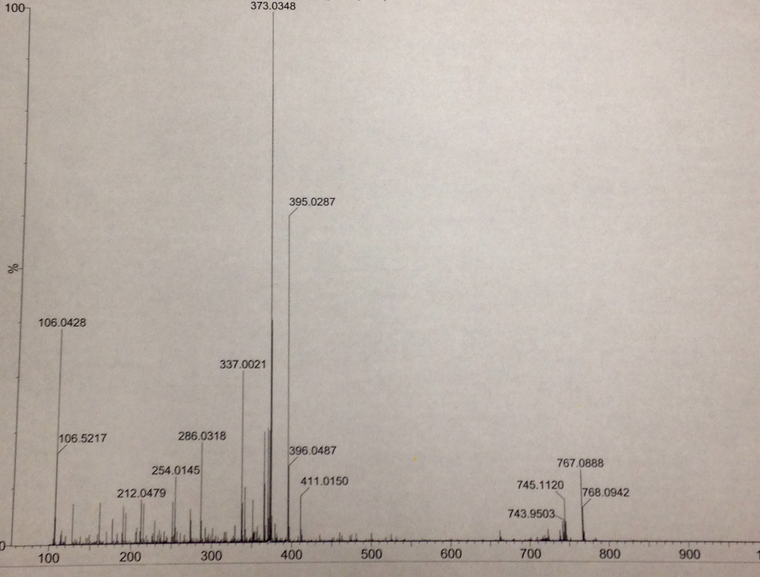
Figure 3.1 Mass spectrometry of compound D, southern diol group on N-methoxypropyl-4-diethanolamine-1,8-naphthalimide (D)

2-((1,4,7,10,13,16-hexaoxacyclooctadecan-2-yl)methyl)-6-amino-1H-benzo[de]isoquinoline-1,3(2H)-dione (E)

The commercially obtained 2-aminomethyl-15-crown-5 was dissolved in 20 mL 1:1 solution of absolute ethanol and spectroscopy grade water. The 4-nitro-1,8-naphthalic anhydride was added in equivalence of crown into round bottom flask. Stirring reaction mixture heated to reflux overnight gave best results, with water-cooled condenser, and reaction began to darken almost immediately from bright yellow to darker, mustard yellow. Once the reaction was taken off heat, it was dried by rotary evaporation of solvent. The product was later reduced, reducing nitro group to amine, via palladium catalyzed hydrogenation followed by mixed solvent HPLC
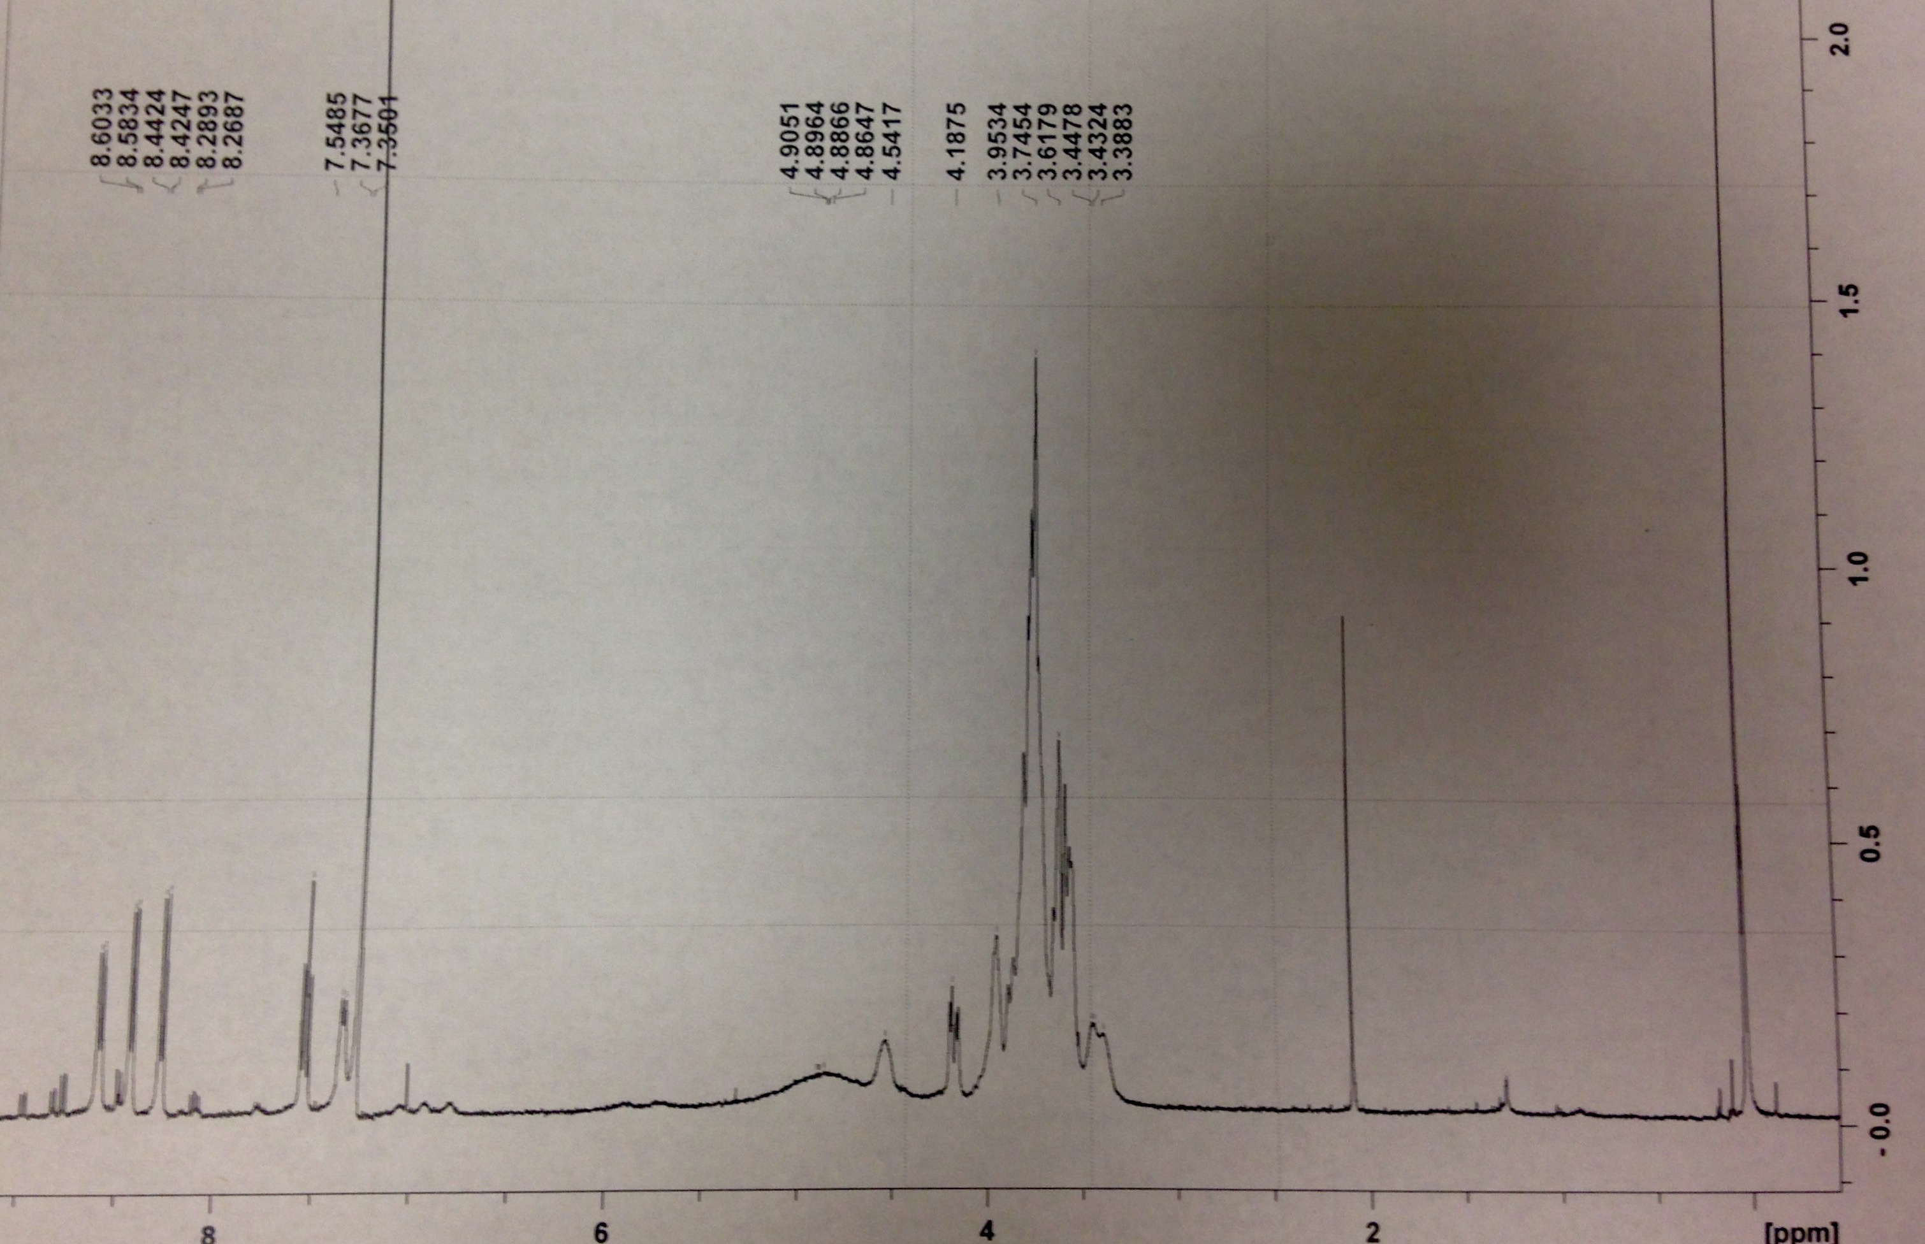
with 1:1 acetonitrile and water. Lyophilized product gave a pure yield of 1.5%.
Figure 3.2 Proton NMR of compound E, attachment of “northern” crown head group
4-(aza-morpholine)-naphthalimide (B)
Bromide naphthalimide and morpholine were combined and allowed to stir in 8 mL of toluene inside of pressure tube. The golden suspension of reactants was treated with the sodium tert-butoxide base, changing the reaction mixture’s appearance to a distinctive wine red. The palladium catalyst was then added and pressure tube was immediately capped and allowed to magnetically stir over 100 °C oil bath. Reaction mixture was intensely fluorescent green under long wavelength UV light. It was then diluted with dichloromethane, filtered and solvent was then removed by rotary evaporation. Flash chromatography gave a purified, lyophilized product yield of 46%.

4-(aza-18-crown-6)-naphthalimide (A)
Followed same procedure as the morpholine control crown synthesis, and allowed to react under nitrogen gas in pressure tube heated by 105 °C oil bath. After only 30 minutes, the 18-crown-6 reaction turned into thick, gel-like solid and stirring couldn’t continue. The product was intensely fluorescent under long wavelength UV light and consumption of the bromide was rapid compared to that observed in the morpholine reaction. The very thick product was not very soluble, even when diluted in dichloromethane, so treatment of methanol was added. Rotary evaporation revealed a dark brown syrup product. Flash chromatography was performed to isolate desired crown-naphthalimide compound in 19:1 dichloromethane, methanol solvent. Eluent strength was not desirable until changed to 1:1 solvent, increasing the diffusion of slowly moving blue band. The final purified, lyophilized compound gave 15% yield, much more desirable than the negligible yield of northern head group attached crown. Mass Spectrometry sample prepared in 1:1 acetonitrile-water/acetic acid. ESI-MS: m/z 460.4729; 482.4692; 531.5890 (M + H)⁺; 553.5854. Possible interaction with hydronium ions- far left ‘hump’ peak found on proton NMR evident of carboxylic acid. UV-Vis absorbance at 430 nm. ¹H NMR (CDCl₃): 2.04 (m, 2H); 3.36 (s, 3H); 3.54 (t, 2H); 3.61-3.77 (m, 24H); 4.28 (t, 2H); 7.46 (d, 1H); 7.68 (t, 1H); 8.52 (d, 1H); 8.58 (dd, 1H); 8.66 (dd, 1H).

Mass Spectrometry Settings:
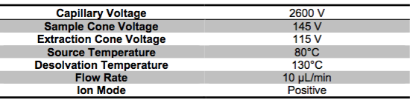

Bacterial Studies Protocols:
Sodium Modified M9 Growth Medium:
Na₂HPO₄ (6 g), NaH₂PO₄ (3 g), NaCl (0.5 g), NH₄Cl (1 g), Casamino acids (2.5 g), Water (1 liter). Stirring mixture in 1 liter glass container, adjust the pH to 7.4 with addition of HCl as needed. Autoclave for one hour, and allow to cool, slowly at first then by water bath. Then add (1 M) MgSO₄ (2 mL), (1 M) CaCl₂ (0.1 mL), 20% glucose (0.5 mL).

Potassium Modified M9 Growth Medium:
K₂HPO₄ (6 g), KH₂PO₄ (3 g), KCl (0.5 g), NH₄Cl (1 g), Casamino acids (2.5 g), Water (1 liter). Stirring mixture in 1 liter glass container, adjust the pH to 7.4 with addition of HCl as needed. Autoclave for one hour, and allow to cool, slowly at first then by water bath. Then add (1 M) MgSO₄ (2 mL), (1 M) CaCl₂ (0.1 mL), 20% glucose (0.5 mL).

Inoculation:
Had M9 medium already made. Pipetted 1 mL of LB broth into small conical centrifuge tubes, 2 tubes for each bacterial strain used, one with sodium modified and the other with potassium modified medium. Inoculated each bacterial strand separately, flaming inoculating loop between each. Spun inoculating loop with bacterial colony in LB broth to ensure full dispersal of bacteria in broth. Retrieved 18 sterile large test tubes, 2 for each of the 8 bacterial strands used, and 2 as the control tube for each type of medium. Pipetted 3 mL of either modified M9 media into designated large test tube and then pipetted 3 uL of compound A dye into each large test tube except the controls. Pipetted 3 uL of LB broth with the bacteria into its large test tube. Tubes were left overnight in shaking incubator, 24 hours.

References

1. Hurdle, J. G.; O'Neill, A. J.; Chopra, I.; Lee, R. E. Targeting bacterial membrane function: an underexploited mechanism for treating persistent infections. Nature Rev. Microbiol. 2011, 9, 62-75.

2. Lambert, T. N.; Smith, B. D. Synthetic receptors for phospholipid headgroups. Coord. Chem. Rev. 2003, 240, 129-141.

3. Späth, A.; König, B. Molecular recognition of organic ammonium ions in solution using synthetic receptors. Beilstein J. of Org. Chem. 2010, 6, 32.

4. Panchenko, P. A.; Fedorov, Y. V.; Fedorova, O. A.; Jonusauskas, G. Comparative analysis of
the PET and ICT sensor properties of 1,8-naphthalimides containing aza-15-crown-5 ether
moiety. Dyes and Pigments 2013, 98, 347-357.

5 El-Azab, A.; Alanazi, A.; Abdel-Aziz, N.; Al-Suwaidan, I.; El-Sayed, M.; El- Sherbeny, M.; Abdel-Aziz, A. Synthesis, Molecular Modeling Study, Preliminary Antibacterial, and Antitumor Evaluation of N-Substituted Naphthalimides and Their Structural Analogues. Med. Chem. Res. 2012, 22, (5), 2360-2375.

6. de la Fuente, R.; Sonawane, N. D.; Arumainayagam, D.; Verkman, A. S. Br. J. Pharmacol.
2006, 149, 551-559.

7. Peters, A. T.; Bide, M. J. Amino derivatives of 1,8-naphthalic anhydride and derived dyes for
synthetic-polymer fibres. Dyes and Pigments 1985, 6, 349-375.

8. Witulski, B. Palladium-catalyzed synthesis of N-aryl-and N-heteroaryl-aza-crown ethers via
cross-coupling reactions of aryl- and heteroaryl bromides with aza-crown ethers. Synlett 1999, 1223-1226.

9. Alanis, A. J. Resistance to Antibiotics: Are We in the Post-Antibiotic Era? Arch. Med. Res. 2005, 36, 697-705

10. Epand, R. M.; Rotem, S.; Mor, A.; Berno, B.; Epand, R. F. Bacterial membranes as predictors of antimicrobial potency. J. Am. Chem. Soc. 2008, 130, 14346-14352.

11. Yocum, R.R.; Rasmussen, J. R. The Mechanism of Action of Penicillin. J. of Bio. Chem. 1980, 255, 3977-3986.

12. Sabath, L. D.; Wheeler, N. A New Type of Penicillin Resistance of Staphylococcus Aureus. The Lancet. 1977. 443-447.

13. Valeur, B.; Bourson, J.; Pouget, J. Ion recognition detected by changes in photoinduced charge or energy-transfer. Fluorescent Chemosensors for Ion and Molecule Recognition 1993, 538, 25-44.

14. Benay, G.; Wipff, G. Ammonium recognition by 18-Crown-6 in Different Solutions and at an Aqueous Interface: A Simulation Study. J. of Phys. Chem. B. 2014. 118.48. 13913-13929

15. Sargent, A. L.; Mosley, B. J.; Sibert, J. W. A theoretical investigation on the Wurster's crown analogue of 18-crown-6. J. of Phys. Chem. A. 2006. 110, 3826-3837.

