Improving Nursing Leadership’s Usage of Real Time, Data-Driven Dashboards
by
Eleanor Hunt

Paper submitted in partial fulfillment of the
requirements for the degree of

Doctor of Nursing Practice

East Carolina University

College of Nursing

November 17, 2017

Acknowledgments
I wish to express my thanks to my advisor and project chair, Bradley Sherrod, DNP, RN at East Carolina University (ECU) and Jane Both, MSN, RN-BC, my project sponsor. Their timely responses, availability, guidance, collegial feedback, and positive attitudes greatly enhanced my learning.
Every ECU College of Nursing DNP faculty member required excellence, yet did so with humor and a nurturing spirit, which resulted in my personal growth. Special thanks to Dr. Bonnie Benetato for her brilliance in teaching theory and statistics, and Dr. Cheryl Kovar, Director of the Post-Master’s Leadership DNP Program, Dr. Skipper, Director of Post-Master’s APRN, and Dr. Robin Corbett, Chair, Department of Advanced Nursing Practice and Education for developing and sustaining such an excellent program at ECU.
My completion of this program could not have been accomplished without the support of the first DNP leadership cohort colleagues including Terri DeWees, Alison Atwater, and Krystle Vinson. Our collective commitment toward the DNP program, unflagging quest for knowledge, and diverse perspectives on leadership based on our individual nursing careers provided me with knowledge that I would not otherwise have obtained.
Finally, special thanks to my family, friends, and work colleagues. My husband and kid’s unending encouragement and patience while I was doing DNP coursework was incredibly comforting. The same goes for my extended family, friends, and work colleagues who were championing my success. My heartfelt thanks.

Dedication
I dedicate this work to my family members, colleagues, and mentors who model lifelong learning. Thank you for teaching me that it is normal to have a continual thirst for information and knowledge, and for championing our collective success.

Abstract
The use of dashboards displaying real-time metrics has been shown to have a positive effect on patient care outcomes. A Plan-Do-Study-Act (PDSA) cycle was conducted to iterate the layout of an existing nursing dashboard at a regional medical center with the goal of increasing nursing’s use of the revised dashboard. A sociotechnical model was used to frame the dashboard intervention. A user-centered design approach was utilized to identify changes needed to the dashboard, which included a heuristic analysis of the dashboard, a formative analysis of the current dashboard, and a summative analysis of the revised dashboard. The changes made to the dashboard included moving metrics used most often to a more prominent location, moving metrics used least often to a less prominent location, and alphabetizing the reports available within the clinical documentation category. Education on the new dashboard was provided to nursing leadership after the Dashboard 2.0 launched. The dashboard’s usage was trended for four months before and after the redesigned dashboard was implemented to assess the impact of the change. Although the dashboard itself was viewed positively with effectiveness, efficiency, and satisfaction improving, actual usage trended down. This decrease could have been related to other factors such as unit leadership turnover, record census, changing accreditation, and an information technology upgrade. Implications for practice include the positive impact of examining the usability of technology and the importance of using real-time data to drive decision making in nursing.

Keywords: Quality improvement; Clinical dashboard; Nurse dashboard; Nurse sensitive outcomes; Nursing; Data analytics; User-centered design; Evidence-based practice; Redesign; Plan-Do-Study-Act (PDSA)

Table of Contents
Acknowledgments 2
Dedication 3
Abstract 4
Chapter One: Problem Identification 9
Problem Statement 9
Project Description 10
Background 10
Significance 11
Project Question 12
Summary 12
Chapter Two: Review of Literature Evidence 14
Theoretical Framework 14
Concept Analysis and Definitions 17
Dashboard 17
Human-Computer Interaction (HCI) 18
Usability 18
Heuristic evaluation 19
Search Strategy 20
Dashboard 20
Theory 21
Usability 21
Analysis of Literature 21
Gaps and Limitations in Literature 24
Summary 24
Chapter Three: Methodology 26
Project Design 26
Implementation Plan 27
Usability analysis 28
Build 29
Launch 30
Data Collection 31
Ethical Considerations 31
Limitations 31
Resources/ Budget 32
Summary 32
Chapter Four: Evaluation of the Practice Change 34
Participant Focus 34
Intended Outcome 35
Findings 35
Dashboard usability 35
Dashboard usage 37
Barriers 38
Summary 39
Chapter Five: Implications for Nursing Practice 40
Practice Implications 41
Essential I: Scientific underpinnings for practice 41
Essential II: Organization and systems leadership for quality improvement and
systems thinking 42
Essential III: Clinical scholarship and analytical methods for evidence-based practice 43
Essential IV: Information systems/technology and patient care technology
for the improvement and transformation of healthcare 44
Essential V: Healthcare policy for advocacy in healthcare 45
Essential VI: Interprofessional collaboration for improving patient and population
health outcomes 46
Essential VII: Clinical prevention and population health for improving
the nation’s health 47
Essential VIII: Advanced nursing practice 48
Summary 48
Chapter Six: Final Conclusions 49
Significance of Findings 50
Project Strengths 50
Project Limitations 51
Project Benefits 51
Practice Implications 52
Final Summary 53
References 54
Appendices 62
Appendix A: Letter of Support 62
Appendix B: Educational Session Objectives 63
Appendix C: PDSA Cycle 64
Appendix D: Sociotechnical Model 65
Appendix E: PDSA and Sociotechnical Model 66
Appendix F: Relationship of the Theoretical Framework to Project Task 67
Appendix G: System Usability Scale (SUS) 68
Appendix H: Nielsen’s Usability Heuristics 70
Appendix I: Nielsen’s Usability Severity Rating Scale 73
Appendix J: Literature Matrix 74
Appendix K: Changes Made to Dashboard 76
Appendix L: Organization Internal Review Board (IRB) Exemption 77
Appendix M: East Carolina University Internal Review Board (IRB) Exemption 78
Appendix N: Permission to use Dashboard Screenshots 79

Chapter One: Problem Identification
The Health Information Technology for Clinical and Economic Health (HITECH) Act (2009) has been successfully incentivizing the adoption of health information technology with the goal of improving health care quality, safety, and efficiency (Office of the National Coordinator, 2016). With most hospital organizations having electronic health records implemented, the vision is for decision making to be supported by system generated analytics (O’Brien, Weaver, Settergren, Hook, & Ivory, 2015). Ongoing monitoring of quality and patient outcome metrics is becoming increasingly important as reimbursement shifts toward being tied to improved patient care outcomes (U.S. Department of Health and Human Services [USDHHS], 2016). The purpose of this chapter is to describe why ready access to metrics provided by electronic health records are becoming a necessary part of workflow to meet the current quality driven financial environment in healthcare.

Problem Statement
A 647-bed regional medical center, located in Southeastern North Carolina, has a nursing dashboard that already displays key performance indicators, documentation, and patient outcome metrics. Monitoring shows that this nursing dashboard is underutilized by nursing leadership despite the need to routinely monitor metrics that affect quality measures, patient outcomes, and patient satisfaction. Although this dashboard had leadership support when it was introduced in March 2016, usage remains low indicating few rely on the dashboard for routine monitoring of metrics. This type of under-utilization is consistent with many quality improvements that go unused after implementation (Health Resources and Services Administration [HRSA], 2011). However, nursing leadership needs to be leveraging electronic tools to manage the quantity of data being generated by electronic health record systems (Baker, 2015; O’Brien et al., 2015).

Project Description
A redesign of the nursing dashboard to Dashboard 2.0 was proposed with the goal of increasing usage rates of this real-time dashboard. This redesign was needed to support a data-driven decision-making approach to monitoring metrics that impact patient care outcomes (O’Brien et al., 2015). A sociotechnical model was used as the framework for the redesign. A user-centered approach was used to involve nursing leadership in the redesign of the dashboard, examine the usability of the dashboard, and determine satisfaction of the design improvements. The effect of the intervention was determined by measuring dashboard usage at baseline, then trended for four months post-redesign to determine whether nursing leadership’s use of the dashboard was impacted.

Background
The USDHHS champions the use of better data through health information technology (HIT) as part of the triple aim of improved care quality, reducing unnecessary cost, and improved population health (Berwick, Nolan, & Whittington, 2008; USDHHS, 2016). The Affordable Care Act (ACA) encouraged widespread use of HIT, and healthcare is now transitioning from using HIT safely to using HIT to improve safety (Institute of Medicine [IOM], 2012; Meeks, Takian, Sittig, Singh, & Barber, 2014). A significant part of the strategy is to leverage HIT to monitor the large amounts of data generated during patient care delivery for events affecting patient outcomes (Meeks et al., 2014; Sittig & Singh, 2010). A dashboard displaying metrics provides a view of the data needed for the type of high quality decision making that positively impacts patient care outcomes (Baker, 2015; Dowding et al., 2015).
A regional medical center implemented a nursing dashboard in their electronic health record to serve as a central location to display key performance and compliance metrics including length of stay, census, percent of advance directives on file, and documentation metrics such as pain control, restraints, and skin assessments. Current access to the nursing dashboard is available to any nurse, but the intended population for this dashboard redesign includes increasing usage by nursing leadership: nurse executives, nurse managers and care coordinators. Despite universal access to the dashboard, in October 2016, it was accessed an average of 19 times a day, with an average of 3 times per month per unique user at this 647-bed facility.

Significance
A dashboard’s real-time metrics and drill-down tools are critical to ensure that decision making is data-driven (Baker, 2015; Dowding et al., 2015; O’Brien et al., 2015). Increasing dashboard usage improves managerial efficiency in identifying issues with patient care that can be immediately and proactively addressed (Harris, Roussel, Dearman, & Thomas, 2016). With Centers for Medicaid and Medicare Services (CMS) not paying for the cost of care of hospital-acquired conditions, combined with weekend admissions occurring more frequently than weekday admissions, viewing dashboard metrics on a Monday morning becomes increasingly important to intervene where needed (Attenello et al., 2015; CMS, 2008; CMS, 2015). For example, ensuring a full admission assessment has been completed, including a skin assessment, could save the organization an average of $43,180/hospital stay for a Stage III or IV pressure ulcer by identifying that a patient was admitted with skin breakdown (CMS, 2008). Monitoring urinary catheter insertions and removals reduces catheter-associated urinary tract infections (CAUTI), which could cost the organization as much as $44,043 per CAUTI (CMS, 2008; Gould et al., 2009). Preventing a fall by ensuring that all patients at risk are identified could save an organization $13,316 per day or an average of $33,894 per hospital stay (CMS, 2008; Wong et al., 2011). Real-time data displayed on dashboards offer a surveillance view of patient care, allowing early identification and treatment of HACs and other potential patient care issues to become possible (Gould et al., 2009; Stone-Griffith, Englebright, Cheung, Korwek, & Perlin, 2012; Wong et al., 2011).

Project Question
The purpose of this evidence-based quality improvement project was to increase the use of the nursing dashboard by nursing leadership within an acute care hospital, so decision making would be driven by real time data. A sociotechnical model was used as a framework to identify the project intervention tasks. An organizational letter of support was obtained for a dashboard redesign project (see Appendix A). A user centered design (UCD) approach was used to redesign the current nursing dashboard and relaunch it as Dashboard 2.0. The UCD approach served the dual purpose of involving thought leaders in the redesign and improving the fit of dashboard information available to information being sought. After the redesign, nursing leadership participated in an educational session with specific learning objectives surrounding data analytics (see Appendix B), and follow-up email aimed at increasing nursing leadership’s knowledge of the information available on the dashboard. Effectiveness of the intervention was measured by comparing dashboard usage before and after the dashboard redesign with the expected outcome that nursing’s usage of the dashboard would increase.

Summary
If real time data and ready access to metrics are not used to monitor patient care, then nurses could miss critical opportunities to proactively impact patient outcomes. In a quality driven financial reimbursement environment, these missed opportunities could have a significant impact on an organization’s finances. Nurses accessed an existing dashboard providing real-time metrics, gathered from the 647-bed regional medical center’s electronic health record, an average of 19 times a day. The goal to improve nursing’s regular usage of a dashboard was identified, and a quality improvement project was initiated to redesign the nursing dashboard using a user centered design approach.

Chapter Two: Review of Literature Evidence
The need for nurses to routinely use real time data was identified as critical to an organization’s financial success. The project goal was to improve a regional medical center’s usage rate of a nursing dashboard displaying real time metrics. This goal was accomplished by conducting a plan-do-study-act (PDSA) cycle to redesign the dashboard, using the sociotechnical model as a theoretical framework to identify and address key areas impacting current dashboard use. These key areas are human-computer interaction (HCI), workflow and communication, internal organizational policies and culture, external rules and regulations, and providing a mechanism to monitor the system. Each key area has specific project tasks addressing the area of concern. The purpose of this chapter is to describe the theoretical framework for this project, provide definitions and concept analyses of key terms, and provide a review of the relevant literature supporting the project.

Theoretical Framework
An iterative, incremental approach to improving the nursing dashboard is supported by the PDSA model. The plan-do-check-act [PDCA] model was developed in the 1930’s by Walter Shewhart as a continuous improvement model and the model was later adapted by W. E. Deming in the 1950’s and is also known as the Deming Cycle (Butts & Rich, 2015). The PDCA model was amended to be PDSA by Deming for those cycles where study is required of the metrics being checked (Moen & Norman, 2010). This study is where Deming felt true improvement could be identified, that the act of checking a metric does not tell the entire story of the improvement. The study provided a mechanism to identify lessons learned and identify how the improvement did not fully meet expectations, which informs the next stage of act, which leads into the next PDSA cycle. It is the study that leads to the cyclic nature of the PDSA cycle (Moen & Norman, 2010).
The cyclic nature of the PDSA model denotes the continuous nature of improvement, with the Plan and Do stages, followed by Check/Study and Act, which leads back into the Plan and Do stage, and so on (Moen & Norman, 2010; Reed & Card, 2016). Figure 1 (see Appendix C) shows Deming’s PDSA cycle and model for improvement (Moen & Norman, 2010). The planning phase includes the identification of the problem, definition of the problem, and the analysis of the problem, identifying the processes that affect the problem. The do stage is the implementation stage, where a change is identified and made. The study stage is the verification stage, where the impact of the change is studied. The act stage is where the change is adopted or abandoned, depending on the results of the study stage. The act stage is also where areas of change that were not accomplished are determined, which then drives the next PDSA cycle. The next PDSA cycle incorporates the lessons learned and the identified opportunities from the last cycle into the planning stage. The PDSA stages mirror the scientific experimental model of hypothesis/collecting data/analysis/interpretation (McEwen & Wills, 2014; Reed & Card, 2016). The PDSA cycle can also be used with a methodological approach such as the sociotechnical model for studying health information technology in the context of a complex adaptive system (Reed & Card, 2016; Sittig & Singh, 2010).
The Sittig and Singh (2010) sociotechnical model for studying health information technology in complex adaptive systems was used as a framework for identifying the interrelated areas affecting this project including usability and leadership’s workflow processes and training on the value of real-time nurse-sensitive metrics. The Sittig and Singh healthcare sociotechnical model has its roots in four related sociotechnical models including Henriksen’s model, Vincent’s framework, Carayon’s Systems Engineering Initiative for Patient Safety model, and Harrison’s Interactive Sociotechnical Analysis framework (Sittig & Singh, 2010). These four models were combined into the eight individual components describing the different aspects affecting the successful use of technology in a healthcare organization. The eight components of the model, shown in Figure 2 (see Appendix D), include: Hardware and software computing infrastructure; clinical content; human-computer interface; people; workflow and communication; internal organizational policies, procedures, and culture; external rules, regulations, and pressures; and system measurement and monitoring (Sittig & Singh, 2010).
The authors of the sociotechnical model propose that it is the interaction between these eight areas that lead to the successful use of health information technology (Sittig & Singh, 2010). Small changes in one area can lead to small, medium, or large changes in another area and that is typical of a complex adaptive system (Sittig & Singh, 2010). Another trait of a complex adaptive system that is pointed out by Sittig and Singh (2010) is that the same functionality might work perfectly well in one area, but fare poorly in another area.
For this project, three components were identified as not having a direct effect on dashboard usage, while five components were identified as having a potential impact on nursing dashboard use. The interaction of the PDSA cycle and the sociotechnical model is illustrated in Figure 3 (see Appendix E). The key areas addressed in this quality improvement project include: Human-computer interface; workflow and communication; internal organizational policies, procedures, and culture; external rules, regulations, and pressures; and system measurement and monitoring. Table 1 (see Appendix F) describes the explicit relationship between each key area and the project task associated with it. For example, the human-computer interaction is improved with a user-centered design approach. The diagram in Figure 3 (see Appendix E) describes the relationship of the human-computer interaction to the other components of the model and project tasks. For example, while formative testing carries out user testing, it also interacts with workflow, internal drivers, and external drivers. The relationship depicted in Figure 3 (see Appendix E) illustrates how user-testing relates to more than just the HCI, as it gathers information from other components that impact dashboard usage. There are no assumptions or relational statements with this interdisciplinary theoretical model.

Concept Analysis and Definitions
Dashboard. A dashboard is used to monitor operational performance processes (Baker, 2015; Carroll, Flucke, & Barton, 2013). A defining attribute of an effective dashboard includes a visual of real-time, essential, decision-related information provided in a single view, with drill-down features that allow the end-user to further explore detail of the summarized information being presented, and the use of color or visual to differentiate urgent areas from non-urgent information (Baker, 2015; Carroll, Flucke, & Barton, 2013; Dolan, Veazie, & Russ, 2013; Spetz et al., 2013). Effective dashboards reduce the cognitive effort required for decision making, and allow the end user to self-regulate the level of detail needed for decision-making (Dolan et al., 2013; Wilbanks & Langford, 2014). A dashboard can visually display a large volume of data such as quality metrics, key performance indicators, benchmarks, and other identified analytics (Wilbanks & Langford, 2014).
Antecedents of effective dashboard displays include an agreement of what information is relevant to the end-user audience (Dolan et al., 2013; Jeffs et al., 2014; Spetz et al., 2013). Consequences of ineffective dashboard displays include lack of use, increased cognitive effort, and poorly understood data (Dolan et al., 2013). A dashboard is not the same as a scorecard but often the two terms are used interchangeably. Dashboards are used to monitor operational performance, while scorecards are used to monitor progress toward tactical and strategic goals (Baker, 2015; Carroll et al., 2013). Dashboards are often used in quality improvement programs to display real-time status of performance indicators in a program (Carroll et al., 2013).
Human-Computer Interaction (HCI). The HCI is the interaction of human users interacting with technology, and includes the parts of technology that users can see, touch, or hear (Sittig & Singh, 2010). HCI technology aspects are comprised of usability and ergonomics concepts. Often, the best fit between humans and computers happen through an iterative approach where the usability of the technology is modified, and the human modifies their thinking and workflow to meet the requirements of the technology (Page & Schadler, 2014; Sittig & Singh, 2010). A user centered design approach is a way to ensure that the HCI does not impact technology use (Page & Schadler, 2014; Sittig & Singh, 2010).
Antecedents of HCI are interactions between humans and technology, such as a nurse using a dashboard in a health information system. Consequences of HCI are that work can be accomplished with good usability and without causing physical harm (good ergonomics). HCI is not the same as good system design. A system can be designed to function well, but have poor usability causing a poor fit between the work that needs to be done and the worker who needs to do the work (Page & Schadler, 2014; Sittig & Singh, 2010; Zhang & Walji, 2011).
Usability. The definition of usability is “how useful, usable, and satisfying a system is for the intended users to accomplish goals in the work domain by performing certain sequences of tasks” (Zhang & Walji, 2011, p. 1056). Defining attributes include: A system is easy to use and error-forgiving, satisfying to use if the users like to use it, and useful if it supports the users work domain, allowing work to be accomplished (Middleton et al., 2013; Zhang & Walji, 2011).
An antecedent of usability is the need to use technology for a task. A consequence of good usability occurs when a user likes the technology, and can easily accomplish a task.
A usability evaluation is used in user centered design to help determine how well system functionality meets the users need “in safeguarding both the quality of care and patient outcomes” (Georgsson, Staggers, & Weir, 2016, p. 77). Usability can be empirically tested through user testing and a heuristic evaluation of the technology. User testing includes formative and summative analyses of users working with the technology. Formative testing is when end-users use technology and describe what they are doing and what they would want to do. Summative testing is done to determine how technology works after changes have been made, and users are given a set of steps to follow and usability of the functionality is empirically assessed. A system usability score (SUS) as shown in Table 2 (see Appendix G) is used to quantify usability testing in both formative and summative testing (System usability score, n.d.). A usability evaluation can be made more comprehensive when a heuristic evaluation is done in conjunction with user testing (Georgsson et al., 2016; Nielsen, 1994).
Heuristic evaluation. A heuristic evaluation is an informal method of determining whether technology follows established usability principles, described in Table 3 (see Appendix H) (Nielsen, 1994; Nielsen, 1995a). Defining attributes are that a heuristic evaluation provides an empirical method for evaluating a user interface and software functionality. Heuristic evaluations are found to find usability problems often overlooked by user testing (Nielsen, 1994). A heuristic evaluation can be done anywhere in the development cycle, using specifications or fully functioning software. A heuristic evaluation is done independently of users, relying on expert evaluator(s) (Nielsen, 1994). As described in Table 3 (see Appendix H), Nielsen (1995a) developed a list of usability heuristics used to categorize usability problems via ten heuristics categories. Nielsen’s (1995b) severity scale listed in Table 4 (see Appendix I) provides a method to empirically evaluate the severity of each heuristic category. The resulting scores are used to prioritize re-development priorities.

Search Strategy
A systematic literature search started with the Cumulative Index to Nursing and Allied Health Literature (CINAHL) and PubMed, and then was expanded to a comprehensive search using OneSearch, which includes 43 databases and journals across multiple disciplines. Inclusion criteria included that the article is in English, full-text, and peer-reviewed. The articles listed in the literature matrix (see Appendix J) were classified by topic area of dashboard, theory, and usability. Dashboard articles and usability research studies were limited to peer-reviewed journal articles in the past five years (2012-2016). The sociotechnical model, triple aim, and usability instrument search was greater than five years to locate seminal articles. Articles were excluded if the focus was on provider decision support or provider order entry as that is not the focus of this project.
Dashboard. A CINAHL search using search terms for nursing practice and dashboard (keyword) yielded 26 articles, of which two were relevant. A CINAHL search using search terms for nurse managers and dashboard (keyword) yielded one article that was relevant. A CINAHL search using search terms for nursing leadership and dashboard (keyword) yielded four articles, none of which were relevant. A CINAHL search using search terms for quality of nursing care and dashboard (keyword) yielded 23 articles, of which four were relevant. A PubMed search using MeSH Terms of nursing and dashboard (keyword) yielded 45 articles of which nine were selected for further review. The term dashboard was not used consistently across databases, so the search included hand searching of references and publications which yielded three additional articles for review and inclusion.
Theory. A CINAHL search with the sociotechnical (keyword) yielded 275 results. Narrowing the search using quality of nursing care yielded no articles. Narrowing the search using user-computer interface yielded 14 articles but none were relevant. None of the original 275 appeared to use the Sittig and Singh (2010) sociotechnical model. A PubMed search for the Sittig and Singh article provided a list of 61 PubMed Central articles that used the sociotechnical model article as a citation. Although these articles were related to technology and healthcare, most cited the article as support in the review of literature or analysis sections. If the sociotechnical model was used as a framework for the journal article, then it was considered relevant and this yielded one article. The PDSA and triple-aim article searches were limited to the seminal article(s) regardless of year published.
Usability. A CINAHL search was conducted with user-computer interface with dashboard (keyword) which yielded nine articles, of which two were relevant but were duplicates of prior searching. PubMed was searched using the MeSH term of user-computer interface and dashboard (keyword) yielding 34 studies, four of which were relevant. User-centered design and usability evaluation and dashboard (keyword) yielded five studies, with one being relevant. System usability satisfaction (SUS) and Nielsen heuristic instruments were identified through hand-searching yielding four articles.

Analysis of Literature
The Affordable Care Act (ACA) increases access to care and improves the quality of health care and patient outcomes across health care settings (U.S. Department of Health and Human Services [USDHHS], 2016). The introduction of the Health Information Technology for Clinical and Economic Health (HITECH) Act of 2009 that incentivized the use of health information technology is moving into a new phase, where information collected in an electronic health record needs to be used to improve the quality of care (USDHHS, 2015). In addition, the ACA encouraged widespread use of HIT and healthcare transitioned to using HIT to improve safety (Institute of Medicine [IOM], 2012; Meeks, Takian, Sittig, Singh, & Barber, 2014). The recent introduction of the Medicare Access and CHIP Reauthorization Act of 2015 (MACRA) further illustrates the movement towards a new payment system which rewards the quality of care, not the quantity of care (Centers for Medicare & Medicaid Services [CMS], 2016; USDHHS, 2016). Improving quality and safety, while reducing the costs of care can be accomplished by leveraging data within the HIT to monitor patient care metrics that negatively affect patient outcomes (Berwick, Nolan, & Whittington, 2008; CMS, 2016; IOM, 2012; USDHHS, 2016).
A dashboard displaying metrics and documentation status offers a snapshot of key indicators needed for high quality decision making, and the use of these dashboards can have a positive effect on care outcomes (Baker, 2015; Dolan et al., 2013; Dowding et al., 2015; Stone-Griffith, Englebright, Cheung, Korwek, & Perlin, 2012). Decision making in healthcare requires large amounts of data to be efficiently assimilated, which is not unique to healthcare. Dashboards are often used in business settings, especially at executive and managerial levels (Carroll et al., 2013). Audit and feedback to improve patient outcomes have been shown to be most effective when the source is a supervisor or colleague, it is provided more than once, and when it includes targets and an action plan (Ivers et al., 2012). Dashboards can also be effectively used by staff at every level, combining operational and clinical measures to allow all staff to track organization and unit based performance measures (Carroll et al., 2013; Dolan et al., 2013; Dowding et al., 2015; Ivers et al., 2012; OʼBrien, Weaver, Settergren, Hook, & Ivory, 2015). Effective dashboards provide real-time, drill-down decision-related information provided in a streamlined, single view, with the use of color or visuals to communicate metrics that require urgent attention (Baker, 2015; Carroll et al., 2013; Clark et al., 2013; Dolan et al., 2013; Frazier & Williams, 2012; Simms et al., 2013).
Nurse-sensitive outcomes can be monitored and improved by using HIT to gather and track patient care data (Dowding, Turley, & Garrido, 2012; Dowding et al., 2015; Frazier & Williams, 2012; Jeffs et al., 2014). For example, the actual rates and rates of patients at risk for metrics such as hospital-acquired pressure ulcers and falls can be monitored in real-time through the use of a dashboard (Carroll et al., 2013; Dowding et al., 2012; Dowding et al., 2015). Metrics aren’t just about driving quality of care over time, but patient-centric metrics can be included so that dashboards support person-centered care (McCance, Hastings, & Dowler, 2015). In addition, documentation completion rates required to meet accreditation or CMS compliance can be monitored via a real-time dashboard (Dowding et al., 2015; Jeffs et al., 2014).
Increasing nursing leadership’s dashboard usage, to use real-time metrics to guide nursing management and practice, is critical to the success of the organization’s ability to meet the changing needs of the healthcare payment model (CMS, 2016; Jeffs et al., 2014; OʼBrien, et al., 2015; USDHHS, 2015; USDHHS, 2016; Weiner, Balijepally, & Tanniru, 2015; Welton & Harper, 2016). User-centered design can be utilized to improve the HCI of the dashboard, which is one of the areas identified by the sociotechnical model framing this project (Page & Schadler, 2014; Sittig & Singh, 2010). A user-centered design approach of a heuristic analysis provides a method for experts to evaluate the technology and provide recommendations for improvement (Georgsson, & Staggers, 2016; Nabovati, Vakili-Arki, Eslami, & Khajouei, 2014; Page & Schadler, 2014). Another aspect of user-centered design approach, using formative and summative analysis, involves users in the redesign, which positively impacts the effectiveness, efficiency, and satisfaction with the technology used in healthcare (Middleton et al., 2013; Nabovati et al., 2014; Page & Schadler, 2014). A user-centered design approach that combines expert opinion with end-users positively impacts the effectiveness, efficiency, and satisfaction of the technology (Georgsson, & Staggers, 2016; Nielsen, 1994; Nielsen, 1995a).

Gaps and Limitations in Literature
The literature does not share what information is best displayed on a nursing dashboard. There are case studies on the implementation of dashboards in nursing, but there are few quantitative studies studying the effectiveness of nursing dashboard metrics on patient outcomes. There is limited information in the literature on how to best incorporate the use of real-time metrics into the management of a unit, from a nurse manager perspective. There are few high-quality qualitative studies on dashboard use in nursing reported in the literature, and none that have been identified describe expected rates of use among nurses.

Summary
To summarize, the use of a real-time nursing dashboard has the potential to positively impact patient safety, improve overall patient outcomes, and improve documentation compliance. Improving safety, outcomes, and compliance are needed to contain costs within an organization and ensure optimum payment for care provided. The use of a real-time, data driven dashboard to monitor operational performance measures is critical to an organization’s ongoing success. Therefore, it was imperative that this regional medical center increases the usage of their nursing dashboard.
The purpose of this project was to increase the usage rates of an existing nursing dashboard. A PDSA cycle was initiated for a dashboard redesign, and a sociotechnical model was used to address specific key areas affecting dashboard use. A user-centered design approach was used to improve the HCI. The user-centered design approach has the added benefit of involving end-users in the project, which led to the identification of workflow issues affecting the project, and internal and external drivers impacting dashboard use.

Chapter Three: Methodology
A plan-do-study-act (PDSA) cycle was conducted on an existing nursing dashboard at a 647-bed regional medical center. The goal was to increase the use of this nursing dashboard by nursing leadership. Dashboard research indicates a link between monitoring real-time metrics and improved patient outcomes, compliance, and patient safety improvements (Baker, 2015; Carroll, Flucke, & Barton, 2013; Clark et al., 2013; Dolan, Veazie, & Russ, 2013; Dowding et al., 2015; Frazier & Williams, 2012; Jeffs et al., 2014; Stone-Griffith et al., 2012). Dashboard metrics at the targeted project site for October, 2016, the month of project conception, showed the dashboard was accessed 581 times by 188 unique users (mean [M]=3.09). The number of times the dashboard was accessed ranged from 1 to 13 times per user in a month. These metrics do not meet the Director of Clinical Informatics’ usage expectations given the goal of metric-driven decision making. Using the sociotechnical model as a framework, this project focused on improving the usability of the dashboard through a user-centered design approach to iterate the dashboard, integrating external and internal process drivers, and then monitoring use to assess for improved usage metrics. The purpose of this chapter is to describe the project design, implementation plan, data collection, limitations, and resources used in carrying out this project.

Project Design
To improve usage of the nursing dashboard, five areas were identified by the sociotechnical model and addressed as part of a PDSA iteration on the existing dashboard as described in Table 1 (see Appendix F). Figure 3 (see Appendix E) illustrates the inter-relationship of the PDSA cycle and the sociotechnical model, and shows how a user-centered design approach served multiple purposes. A user-centered design approach gathered input from nursing leadership via a formative and summative analysis. An expert heuristic analysis of the dashboard was conducted to identify human-computer interaction issues that could be improved in Dashboard 2.0. Nursing dashboard functionality was aligned with internal organizational policies and culture and external drivers via the formative and summative analysis. The information gathered as part of the user-centered design approach in the formative and summative analysis served to incorporate these internal and external drivers. Routine system monitoring of dashboard use captured how often Dashboard 2.0 was accessed.
The project setting was a 647-bed regional medical center in southeast North Carolina using an integrated electronic health record implemented in 2011. Nursing leadership comprised the sample participants using the dashboard and participated in the user-centered design approach iterating the existing dashboard. Nursing leadership included nurse executives, nurse managers, and care coordinators working in the main hospital of the regional medical center. A mixed method approach was used for the project. Usability information on dashboard changes was collected qualitatively and quantitatively through the user-centered design process. Dashboard usage frequency and the number of unique users were measured quantitatively, collected and summarized through reports.

Implementation Plan
The implementation plan had three sections: Determining changes needed to the dashboard, building Dashboard 2.0, and launching Dashboard 2.0 to users. First, the exact changes to the dashboard needed to be defined and this was done through a usability analysis. Then the changes were communicated to the build team who created Dashboard 2.0. Finally, the Dashboard 2.0 was launched and made available for use by the nursing staff, and an educational session was provided to nursing leadership on how and why to use Dashboard 2.0.
Usability analysis. Basic nursing Dashboard 2.0 functionality improvement suggestions were gathered by the Project Manager (PM) via a user-centered design approach. This approach evaluated usability in two ways: The PM conducted a heuristic analysis and a formative and summative process was followed which involved nursing leadership into the process. The changes to the dashboard were distilled into specific requirements, which were then shared with the build team, who then created Dashboard 2.0. First, the PM conducted a heuristic evaluation using a freely available, commonly used heuristic instrument displayed in Table 3 (see Appendix H), and severity scoring described in Table 4 (see Appendix I), to identify and prioritize usability issues on the current nursing dashboard (Nielsen, 1995a). The heuristic evaluation was conducted shortly after the institutional review board (IRB) process was completed in April 2017.
Then, the PM conducted formative and summative analyses that involved nursing leadership. A formative analysis identified usability issues with the current dashboard. In essence, a user’s actions using the dashboard identified what was easy and what was not easy to use on the current dashboard. The PM observed six nurse managers and care coordinators using the dashboard in formative analysis, asking them to verbalize what they were doing and why they were doing it. The PM observed 15 nurse executives, managers and care coordinators using the dashboard in summative analysis at the regional medical center. The timing of the formative sessions was shortly after the IRB process was completed during the last week of April, 2017. The summative sessions were conducted shortly after the changes went live, in mid-May, 2017. This information, from the formative sessions and the heuristic analysis information, was used by the PM to identify and prioritize changes needed to the nursing dashboard. This process is consistent with the International Standards Organization (ISO 9241-11) heuristic evaluation and formative and summative analyses requirements (Georgsson & Staggers, 2016). No individual scores or reporting were released to ensure the protection of any project participants. Usability was assessed in both formative (pre-redesign) and summative (post-redesign) analysis by measuring each user’s effectiveness, efficiency, and satisfaction with the dashboard.
Effectiveness of the existing dashboard was measured by quantifying any errors a user made while using the dashboard. Efficiency was measured by quantifying how long it took a user to complete a defined dashboard task. Satisfaction was measured by asking each formative and summative session participant to fill out a widely used, freely available, system usability satisfaction (SUS) scoring document as listed in Table 2 (see Appendix G; Bangor, Kortum, & Miller, 2009; Georgsson & Staggers, 2016; System Usability Score, n.d.). The SUS scoring used in this project is based on the Bangor et al. (2009) modifications, which added an adjective rating scale, used the term product instead of system for each question, and used the term awkward in place of cumbersome in question eight. The SUS is reported as highly reliable, with a Cronbach alpha score of 0.91, and is technology agnostic so it can be used to evaluate any type of user interface (Bangor et al., 2009).
To summarize, dashboard usability was evaluated via an established process using a heuristic evaluation and usability scores for effectiveness, efficiency, and satisfaction. Session participant’s individual scores were not reported. Instead all usability scores were averaged, and the average formative analysis score was used to identify and prioritize redesign efforts. The average summative analysis score was compared to the average formative score to determine the impact of the redesigned dashboard on effectiveness, efficiency, and satisfaction.
Build. The development build team at the regional medical center updated the existing dashboard to Dashboard 2.0 per the PM’s prioritized list that was developed during the usability analysis described in Figure 4 (see Appendix K). The changes requested included moving existing metrics that were used often to a more prominent position, moving metrics used less often to a less prominent position, and alphabetizing the names of the reports in clinical monitoring. After build team internal testing, Dashboard 2.0 was moved into the live clinical system. A summative analysis was conducted to identify usability issues introduced by the development of the Nursing Dashboard 2.0. During the summative analysis, the PM observed a total of 15 nurse managers, nurse executives, and care coordinators using Dashboard 2.0. These sessions were conducted onsite in the user’s environment. The summative analysis was conducted eight days after the Dashboard 2.0 changes were completed and loaded into production by the development team. This analysis confirmed the user experience was the same or improved from using the original dashboard. If the user experience had worsened, then information from the review could have been used to improve redesign efforts.
Launch. The Nursing Dashboard 2.0 was launched with an in-person demonstration by the PM to nursing leadership including nurse managers, nurse executives, and care coordinators during summative testing. This session demonstrated the value of real-time metrics in monitoring patient care, and how these metrics are easily accessed and incorporated into daily work processes. A discussion was held with the organization’s chief nursing officer (CNO) to reinforce the dashboard workflow process. Talking points in this meeting included the workflow process of checking metrics, incorporation into daily workflow, and opportunities to make changes to a patient’s plan of care to improve patient outcomes. The CNO was encouraged to incorporate metric usage into high level meetings. The Dashboard 2.0 functionality was reinforced one month after training via a system email update. The update email sent to nursing leadership, via the Director of Clinical Informatics, included the process of using the dashboard during daily work. This type of follow-up is consistent with usual practices at this organization when minor changes are made to the system.

Data Collection
Dashboard 2.0 usage is defined as the number of times the dashboard is accessed, and the outcome was measured by determining usage increase. In order to assess the project outcome of increased dashboard usage; baseline dashboard usage was collected for four months prior to initiating the project, then trended for four months after the Dashboard 2.0 training session. The number of unique users were counted each month, to determine if there was an impact on the overall number of unique users.

Ethical Considerations
The organization’s institutional review board (IRB) reviewed this project. The IRB granted this project an exemption due to the quality improvement nature (see Appendix L). The protection of human subjects was ensured by obtaining organization IRB approval or exemption for this quality improvement project. Since this was a Doctor of Nursing Practice (DNP) project, East Carolina University IRB also reviewed this project and provided the project with an exemption (see Appendix M).

Limitations
Dashboard use cannot be restricted to only include nursing users. However, current users were spot checked by looking at the users that accessed the dashboard during the pre-project period. All pre-project users were nurses. In addition, the dashboard metrics offer little value to system users outside of nursing, so access by staff outside of nursing during the project was not expected.
If a single user accesses the dashboard multiple times a day, the usage counter increments, and adds to dashboard usage frequency. This was mitigated by trending both the usage and the number of unique users to differentiate whether the number of users were impacted in addition to overall dashboard use. Another limitation was the regional medical center’s implementation of a major upgrade to the HIT system in August which was during the project timeline. Dashboard 2.0 usage could have been impacted by this major upgrade disrupting usual work processes in both July and August, during data collection.

Resources/ Budget
The regional medical center plans to provide the development resources for the dashboard redesign, meeting and training space, and access to nursing leadership at no additional cost to the PM. Development resources included the approval process for the change, the actual revision, and testing by information technology staff. The usage monitoring report already exists, and there were no additional costs to run the report as needed. The user centered design tools are freely available for use in a usability assessment (System Usability Score, n.d.). Access to nursing leadership for formative and summative analyses and training incurred opportunity costs to the participants. This opportunity cost is offset by the value their input provided to the dashboard redesign effort and by the avoidance of potentially costly hospital acquired conditions.

Summary
A PDSA cycle was conducted to iterate an existing nursing dashboard with the goal of improving usage of the dashboard by nursing leadership. Several aspects of dashboard usage were addressed. These aspects were identified by using a sociotechnical model as the framework for the intervention. This evidence-based project utilized a user-centered design approach to engage nursing leadership in the redesign process in both formative and summative usability analysis. Improvements were identified by nursing leadership, workflow process knowledge sharing occurred, and internal and external factors were incorporated into the dashboard redesign. A heuristic and usability analysis was conducted by the PM which identified and corrected overall design issues with the dashboard. At the launch of Dashboard 2.0, an educational session was provided to nursing leadership to share the design improvements, and describe how this redesign incorporates workflow needs. A follow-up email was sent after the first month of launch to reinforce this educational session. Dashboard 2.0 usage was then monitored to determine if the PDSA cycle affected dashboard usage.

Chapter Four: Evaluation of the Practice Change
A plan-do-study-act (PDSA) cycle was conducted on an existing nursing dashboard at a 647-bed regional medical center. Monitoring of the dashboard usage showed it was underutilized despite the need for routine monitoring of metrics. The dashboard could be used to improve managerial efficiency by identifying issues with patient care that could be immediately and proactively addressed (Harris, Roussel, Dearman, & Thomas, 2016). The goal of this project was to increase the use of the nursing dashboard by nursing leadership. The scope of the project included the following: Assess the usability of the dashboard; implement changes needed to improve usability of the dashboard; conduct individual training sessions to assess user satisfaction with the changes; and teach the value of using the nursing dashboard. A follow-up email describing the changes made to the dashboard was sent to all staff one month after implementation. Dashboard usage metrics were collected before and after changes were made to the dashboard. These usage metrics included the total usage counts and the number of unique users. Metrics were collected for the four months prior to the Dashboard 2.0 launch (January through April 2017) and four months after the launch (May through August 2017). This chapter outlines the findings related to the usability of the dashboard and the usage metrics before and after Dashboard 2.0 launch.

Participant Focus
A large group of 2000 nurse users have access to the nursing dashboard, including 1780 nurses and 220 nurse leaders. The focus of the project intervention was aimed at the 220 nurse leaders comprised of care coordinators, nurse managers, administrators, and executives. This group was targeted as they are responsible for allocating resources and ensuring the quality of care delivered, and could use dashboard data to direct resources and follow-up on concerns that impact patient outcomes.

Intended Outcome
The intended project outcome was to increase the use of the nursing dashboard so decision making would be driven by real time data. The project design included improving the usability of the nursing dashboard and educating the nurse leader group on the value of the nursing dashboard. Increasing dashboard usage is important in identifying issues with patient care that can be immediately and proactively addressed (Harris et al., 2016).

Findings
The defined outcome was measured by assessing changes to the dashboard’s usability and dashboard usage. The dashboard usability findings included effectiveness, efficiency, and satisfaction scores. Dashboard usage findings included the total number of dashboard users and number of unique users.
Dashboard usability. Dashboard usability was analyzed by examining effectiveness, efficiency, and satisfaction with the dashboard before and after the changes for Dashboard 2.0 launch. The effectiveness, or average number of errors, decreased as the average number of errors went from 0.80 to 0.26 (see Table 5). The efficiency also showed improvement as the average number of minutes spent in formative analysis was 12.16 minutes and was 5.66 minutes for the summative analysis (see Table 5). The overall user-friendliness of the product rose from an average of 5.33 to a 6.07 (scale range 1-7; see Table 5).
The average user satisfaction was measured by using the System Usability Scale (SUS; see Appendix G). Satisfaction rose from a score of 70.83 to 83.17. A SUS score represents learnability and usability of technology, but it is not a percentage (Brooke, 2013; Sauro & Lewis, 2016). A SUS score can be converted to a percentage, with a SUS score of 71 being equivalent to 60% and a SUS score of 83 being roughly equivalent to 97% (Sauro & Lewis, 2016). The use of percentages allows for the comparison of the dashboard technology with other technology (Sauro & Lewis, 2016). This means that users considered the original dashboard functionality more usable than 60% of other technology, but less usable than 40% of the technology. After the intervention, users considered Dashboard 2.0 functionality to be 97% more usable than other technology, and only 3% less usable than other technology.
Table 5
Formative and Summative Data from the Usability Analysis
 | Effectivenessª | Efficiency^{b} | Satisfaction^{c}  Raw score (%) | Overall^{c}  Rating
Formative | 0.80  (Range 0-2) | 12.16  (Range 10-15) | 70.83 (60%) | 5.33
Summative | 0.26  (Range 0-2) | 5.66  (Range 3-12) | 83.17 (≈97%) | 6.07

Note. ªEffectiveness is the average number of errors by users during the analysis. ^{b}Efficiency is the average time in minutes the session took for each user. ^{c}Satisfaction is the average System Usability Scale (SUS) score recorded (% equivalence). See Appendix G for SUS. ^{d}The overall user rating with a scale range of 1-7.
Dashboard usage. Dashboard usage was defined as the number of times the dashboard is accessed, and the outcome was measured by determining change in usage. In order to assess the project outcome of increased dashboard usage, baseline dashboard usage was collected for four months prior to initiating the project (January-April 2017), then trended for four months after the Dashboard 2.0 was implemented (May-August 2017). The number of unique users were counted each month, to determine the effect of the change on the overall number of unique users. The total usage four month mean of Dashboard 2.0 was 537 compared to the existing dashboard total usage four month mean of 634. The number of unique users of Dashboard 2.0 was 147 compared to 171 using the existing dashboard (see Table 6). The post-intervention usage means showed a drop of Dashboard 2.0 usage compared to the original dashboard. However, the mean usage by user did rise in August 2017.

Table 6
Dashboard Usage Data used to Compare the Effect of the Project Intervention
 | Total Usageª | Unique Users^{b}
Existing Dashboard  January  February  March  April  4 mo average (SD)^{c} | 564  591  764  616  634 (77) | 160  166  179  180  171 (9)
Dashboard 2.0  May  June  July  August  4 mo average (SD)^{c} | 547  437  533  631  537 (69) | 115  110  167  196  147 (36)

Note. ªTotal usage is the number of times the dashboard was accessed. ^{b}Unique users are the total number of individual users that accessed the dashboard. ^{c}Four-month (4 mo) average (Standard deviation [SD]). Months in year 2017.

Barriers
The lower rate of Dashboard 2.0 usage could be related to a variety of factors experienced by the organization at the time of the project implementation. For example, the organization experienced record seasonal census in May, June, and July 2017. Other significant changes experienced during the project data collection window included a change from The Joint Commission (TJC) to Det Norske Veritas (DNV) accreditation, a major system upgrade to the electronic health record (EHR), and turnover of nurse managers and clinical coordinators on the patient care units. An accreditation change affects the metrics being monitored by nursing leadership as well as the timing of the monitoring. The major system upgrade was moving from a much older version of the EHR to the most current version. This required significant planning and training of all end-users, vacations during the upgrade, and could have impacted normal monitoring routines on patient care units.
Several nurse managers and clinical coordinators that were educated about the value of the dashboard changed positions. This meant the users that were educated on the value of the dashboard were not using the dashboard after the intervention, which could have had an effect on dashboard usage. Another barrier identified by the project manager was the general reliance on paper and paper processes rather than using the technology available for the same purpose. For example, nurses would write shift report notes by hand, instead of using a system- generated shift report document that already had the data captured. The quality department would request data of nurse managers that they themselves could look up in the system, and request the information be transcribed into an Excel spreadsheet or filled out on paper and returned to them. The types of barriers experienced during this project are not unusual to organizations experiencing continual change as they respond to reimbursement, innovations, workforce pressures, and the needs of a seasonal population.

Summary
The value of data driven decision making is to proactively impact patient outcomes with routine usage of the nursing dashboard. A real-time dashboard provides the opportunity to intervene before a patient experiences a negative outcome, and could have a significant impact on an organization’s finances. For example, timely interventions include ensuring skin assessments have been correctly documented, all urinary catheters have been removed in a timely manner, or identifying all patients at risk for a fall. The findings show how relatively minor changes to the dashboard had a positive impact on dashboard usability. While the usability was acceptable prior to the intervention, the revised Dashboard 2.0 improved in all areas including effectiveness, efficiency, and satisfaction after the changes were made.
Dashboard usage decreased despite the usability improvement and the education given to nurse leaders. Because the usage metrics are of all nurses, not just nurse leaders, it is not possible to determine who was using it less often. The next steps would be to either narrow the metrics to just nurse leaders or to widen the educational offering to all 2000 nurses that have access to the dashboard. There was also significant change being experienced by the organization at the time of the intervention, which could have impacted project metrics. Continued data analysis would be to extend Dashboard 2.0 monitoring through fall 2017, and compare the fall 2017 usage rates with the prior fall 2016 usage rates. This would provide insight into the effect that seasonal issues might have on dashboard usage.

Chapter Five: Implications for Nursing Practice
A plan-do-study-act (PDSA) cycle was carried out for an evidence-based practice (EBP) change project at a 647-bed regional medical center, to improve nursing leadership’s use of a nursing analytic dashboard. Dashboard usability improved, but usage continued to show the dashboard was underutilized despite the need for routine monitoring of metrics. The first three phases of the cycle (plan-do-study), describing the background, significance, intervention, and results, only tell part of the story. The final phase (act) is a time of reflection to determine what changes are to be made for the next cycle, and to determine what the practice implications are from the completed cycle.

Practice Implications
The practice implications for nursing described in this chapter are grounded in the American Association of Colleges of Nursing (AACN; 2006) essentials of doctoral education for advanced nursing practice. The eight “Essentials” serve as the foundational competencies that are core to all advanced nursing practice roles (AACN, 2006). Practice implications are suggestions or recommendations learned from the EBP change project to advance nursing. Each essential is summarized and practice implications are described, which can then be used to inform the next cycle of this EBP change project.
Essential I: Scientific underpinnings for practice. The doctoral level of nursing practice is grounded in science, and the doctoral prepared nurse translates evidence into practice (AACN, 2006). A Doctor of Nursing Practice (DNP) program prepares the graduate to integrate nursing science and theory to develop and evaluate nursing practice (AACN, 2006). A key element of this essential includes understanding how the nursing discipline includes nursing actions that positively impact a patient’s health status (AACN, 2006).
The practice implication based on this essential is how to encourage staff to embrace the nursing dashboard, and to use it for identifying opportunities for nursing interventions to improve patient outcomes. These nurse-sensitive patient outcomes are the ones that nursing can directly impact (Dowding, Turley, & Garrido, 2012; O’Brien, Weaver, Settergren, Hook, & Ivory, 2015; Page & Schadler, 2014). Using the nursing dashboard improves a manager’s efficiency by providing an at-a-glance mechanism to identify patient circumstances, which can be impacted through nursing interventions (Attenello et al., 2015; Harris, Roussel, Dearman, & Thomas, 2016).
Essential II: Organization and systems leadership for quality improvement and systems thinking. DNP graduates have been educated to grasp systems thinking, and know how to analyze the effect of an intervention on the components of the system as well as the system itself (AACN, 2006). This requires the DNP graduate to determine the business case for an intervention, understand the policy implications, and understand the effect of culture on the effectiveness and sustainability of an intervention. DNP graduates are prepared to think of the whole as well as the individual parts of a system, and understands how a small effect can have a large ripple effect on a system.
The nursing dashboard can move nurses toward using data to proactively identify patients needing nursing interventions rather than evaluating causes for an event that has already happened. The practice implication is that nursing needs to use the electronic health records (EHR) ability to synthesize and present data as an additional assessment item, instead of just using the EHR to record data (Baker, 2015; O’Brien et al., 2015). Nurses need to understand the potential net cost savings to an organization related to early identification of issues that nurses can impact. For example, catheters that need to be removed, peripheral IVs that need to be changed or removed to reduce infection, and identification of patients that do not have appropriate admission assessments completed in a timely manner. Not only will the organization realize a net savings, but using a nursing dashboard improves the decision making that positively impacts the quality of care and patient outcomes (Baker, 2015; Dowding et al., 2015).
Essential III: Clinical scholarship and analytical methods for evidence-based practice. It is important that best practices are grounded in evidence, and Essential III prepares the DNP graduate to critically analyze the literature. The DNP graduate learns how to design and implement projects that move this evidence into practice and the practice environment (AACN, 2006). In addition, information technology is used to analyze practice and practice outcomes, and present data so it can be used to improve practice and patient outcomes (AACN, 2006).
This project was targeted at improving the use of dashboard technology in an organization’s EHR to improve patient outcomes. The project manager identified a barrier of how the organization’s nurses relied heavily on outdated paper processes instead of leveraging technology for the collection, analysis, and presentation of data. Nurses still used the older terminology of “pulling a chart” for chart reviews and manually searching for specific data points in each electronic chart instead of using a system-generated report to compile those data elements. Further, the quality department should not be asking these nurse managers and clinical coordinators to pull data from charts that they can access remotely. Instead, the implication for practice would be for the quality department to be selecting, using, and evaluating data centrally, and asking the nurse managers to validate data rather than collect the data. Another implication for practice is for clinicians to partner with the quality, compliance, safety, and billing departments to determine what charting and metrics are required in today’s world, and highlight those metrics and benchmarks to guide best practices (Frazier & Williams, 2012).
Essential IV: Information systems/technology and patient care technology for the improvement and transformation of healthcare. DNP graduates are expected to be proficient in working with data in order to implement evidence-based projects, and this includes working with a variety of information technology and databases (AACN, 2006). DNP prepared nurses use technology to evaluate systems of care, assess the accuracy, timeliness, and appropriateness of health information aimed at consumers, and to participate in the selection and use of health information technologies. This project evaluates the use of a dashboard that nurse leaders can use to evaluate and monitor nurse-sensitive indicators that impact patient outcomes as well as financial resources.
An implication for practice is to provide views of data that do not have to be further manipulated, and provide immediate value to the end user (Frazier & Williams, 2012). For example, numbers are currently rolled up and displayed at the organizational level for most metrics on the dashboard at first glance. This is helpful for nursing executive leadership, but less useful for nurses on a patient care unit, since it takes several clicks to get down to unit level data on each metric. An implication for practice would be to show the unit view when accessing the data from a patient care unit, and an organizational view of the data when accessing outside of a patient care unit.
Another implication for practice is to have the ability to highlight patient care units that are one standard deviation above or below the metric threshold. Often, when the data is shown from an organization averaged view, the metric might look fine. However, the mean might be comprised of patient care units with exceptional scores and low scoring patient care areas. A mean could obfuscate the low scoring patient care units, which means opportunities might be missed to improve patient outcomes for those that could benefit from timely nursing interventions (Weiner, Balijepally, & Tanniru, 2015).
Essential V: Healthcare policy for advocacy in healthcare. The DNP graduate is expected to participate in health policy, whether it is analyzing, implementing, influencing, educating, advocating for nurses or consumers, and advocating for equitable and ethical health care (AACN, 2006). In 2009, the Health Information Technology for Clinical and Economic Health (HITECH) Act incentivized the adoption of health information technology, with the goal of improving health care quality, safety, and efficiency (Office of the National Coordinator [ONC], 2016). This act required providers to place orders directly into the EHR in order to qualify for the incentive program. This removed the burden of entering orders from nurses and pharmacists, reduced transcription errors, and improved the timeliness and efficiency of orders being directly executed instead of waiting for a secondary validation step against a written order.
An implication for practice is in shifting the emphasis away from the focus just on ordering providers, toward the vast numbers of clinicians also documenting care provided. Currently many non-ordering clinicians, such as nurses, use health information technology solely for data entry, and do not expect value from the data entered. Instead, the metrics now collected for the many Medicare and Medicaid incentive programs is causing a shift from collecting data toward using data at the point of care (Institute of Medicine [IOM], 2012; Meeks, Takian, Sittig, Singh, & Barber, 2014). This shift means nurses can now use metrics to adjust care while the patient can still benefit from adjustments to the plan of care, with patients benefiting from safer care and improved patient outcomes.
In the beginning, the incentive programs were focused on ordering providers using “systems,” but now the incentive program policy requirements are shifting to “using” the data to improve patient outcomes (IOM, 2012; Meeks et al., 2014). This shift toward pay for performance and value-based care is well-aligned with what nurses do: Caring for the whole patient, across the health continuum, regardless of care continuum boundaries. The ONC has called for improved care coordination, leveraging an EHR across the continuum of care. The implication for nursing practice is to stop thinking of the plan of care as episodic, but instead following the patient from home, to acute care, to rehab, to back home. This shift in thinking means that nursing needs to shift their requirements to leverage the ability for systems to be interoperable, for a plan or care to follow patients regardless of setting, in order to lead to an increased quality of care and improved patient outcomes (Berwick, Nolan, & Whittington, 2008; ONC, 2014).
Essential VI: Interprofessional collaboration for improving patient and population health outcomes. The DNP graduate develops skills to work as a team member, effectively collaborating and communicating with colleagues to facilitate interprofessional practice (AACN, 2006). The DNP graduate provides leadership to interprofessional teams, and is available to consult on within and between care providers to create and sustain change (AACN, 2006). The effective DNP graduate leverages the strengths of clinical leaders, effectively communicates evidence and standards of care, to improve the care or care delivery system, which positively impacts patient outcomes (AACN, 2006).
Organizationally, nurse managers manage the influx of initiatives coming from all around them as well as motivate their staff to provide evidence-based care day in and day out. The constant rate of change can lead to change fatigue, and the implication for practice is how to condition nurses to be able to continue to respond to changes without negatively impacting patient outcomes. Many healthcare organizations have adopted lean six sigma practices to increase efficiency and effectiveness within an organization (Lee, McFadden, & Gowen, 2016). As nursing adopts these same lean practices, waste and inefficiencies are removed to streamline nursing processes to best make use of nursing’s time. The practice implication is that patient-centric metrics available on dashboards can be an efficient way to support lean, person-centered, high quality of care (Harris et al., 2016; McCance, Hastings, & Dowler, 2015).
Essential VII: Clinical prevention and population health for improving the nation’s health. The DNP graduate integrates epidemiological data to improve the health of the population, identify gaps that exist in care, and evaluate and implement equitable care (AACN, 2006). The U.S. Department of Health and Human Services (USDHHS; 2016) champions the use of better data through health information technology (HIT) as part of the triple aim of improved care quality, reducing unnecessary cost, and improved population health (Berwick et al., 2008). The DNP graduate’s expertise in evaluating population health data is well-positioned to design and implement health promotion and disease prevention programs that address gaps in care (AACN, 2006).
Implications for practice include assessing benchmark metrics for vaccination rates for the county, and using them to drive vaccination programs in the acute care facility. Further, pulling state and national initiative benchmarks and creating a comparison to an organization’s benchmarks provides opportunity to shine a light and raise awareness of metrics that do not fare as well (Frazier & Williams, 2012). This increased emphasis on poorly performing metrics can be used to drive practice, which would then improve the health of the population within that immediate area.
Essential VIII: Advanced nursing practice. The DNP graduate uses systems thinking to evaluate practice, care delivery, and quality in order to identify where changes need to be made to improve the patient outcomes (AACN, 2006). In addition, the DNP graduate mentors and supports fellow nurses to achieve excellence in practice (AACN, 2006). The nursing dashboard project monitored nurse-sensitive outcomes, which are the outcomes that nursing care directly impacts. By proselytizing the usefulness of a dashboard monitoring nurse-sensitive outcomes, nursing can intervene in a timely manner, improving overall quality of patient care (Piscotty, Kalisch, & Gracey‐Thomas, 2015; Schall et al., 2017).
An implication for practice is for nurses to support and promote the care that they give patients, and to place pride in both technology and good metrics, and intervene when the metrics highlight opportunities for improving care. Dashboards can be leveraged as a way to organize care upon arrival, ensure all care is delivered before leaving, and at strategic points in between to ensure the highest quality of nursing care is being delivered. Ultimately, reminders and analytics can be used to transform care (Piscotty et al., 2015; Schall et al., 2017).

Summary
The DNP essentials were used to frame the many practice implications that can be identified from this EBP change project. These practice implications can be considered via a narrow context focused specifically on the regional medical center, or through a broader lens. This broader lens takes into consideration the wider community of healthcare technology, the industry shift toward quality and value-based purchasing, the need for increased interprofessional collaboration, and the goal of population improving health.

Chapter Six: Final Conclusions
The objective of this evidence-based practice (EBP) change project was to increase total usage of a real-time, data-driven nursing dashboard within an acute care regional medical center by using a plan-do-study-act (PDSA) cycle to redesign the dashboard. A dashboard’s real-time metrics and drill-down tools are critical to ensure data-driven decision making, which can improve patient outcomes. Dashboard usage improves managerial efficiency by providing real-time surveillance of patient care unit metrics, identifying areas of opportunity to improve patient outcomes, and allowing leadership to dispatch and direct resources as needed. This type of surveillance offers the opportunity for early identification and treatment of costly hospital acquired complications, a view of the status of patients on patient care units, and compare the metrics of units across an organization.
This EBP change project used the Sittig and Singh (2010) sociotechnical model as a theoretical framework to identify and address key areas impacting current dashboard use. Of Sittig and Singh’s (2010) eight areas of focus, five areas were identified as potentially having an impact on dashboard usage. These areas included the human-computer interaction (HCI) of the dashboard, dashboard usage monitoring, the workflow and communication of using the dashboard, internal organizational policies and culture of using real-time data, and external rules and regulations requiring the collection of metrics.
The evidence-based interventions were focused on addressing these areas to improve nursing leadership’s usage of the dashboard. A usability analysis was conducted to assess and address HCI issues. An on-line report was used to monitor monthly dashboard usage. Functionality of the dashboard was aligned to the organization’s internal and external metric needs, and nursing leadership was educated on the value, functionality, and usage of the nursing dashboard.
Significance of Findings
Dashboard usability improved in the areas of effectiveness, efficiency, satisfaction, and overall user friendliness. The effectiveness improved, as indicated by a decline in the number of errors by nurses using the dashboard. Efficiency improved with the average amount of time spent locating relevant metrics dropping to 5.66 minutes from a prior average of 12.16 minutes. Overall, the user-friendliness of the dashboard rose, with satisfaction rising from 60% to 97% usability with just a few targeted changes.
Dashboard 2.0 usage decreased compared to usage of the existing dashboard. The existing dashboard usage mean from January-April, 2017 was 634 uses, compared to the mean for Dashboard 2.0 from May-August, 2017 with 537 uses. Dashboard usage metrics collected before and after were collected in different seasons, while the organization was operating under different accreditation mechanism, and with different staffing. This decrease is important to note but might be unrelated to the intervention. Alternatively, it could reflect that the education delivered to the nurse leader group did not have the impact that it needed to increase overall usage.
Project Strengths
Strengths of this project included organizational support, improvement in technology usability, and verbalized support of leadership. The regional medical center understands the value of real-time metrics and uses them in other organizational management. Nursing leadership was fully supportive of this project, moving nursing leadership toward using the nursing dashboard real-time metrics. The improvement in technology usability was a result of the collaboration between nursing leadership, the project manager, clinical informatics department, and the information technology (IT) department to identify, modify, test, and move the requested dashboard changes into the live environment for nursing leadership to use. Leadership support included access to nurse leaders, analysts in IT, and the clinical informatics department.
Project Limitations
Limitations included the numerous changes taking place at the same time as this EBP project. The shift in accreditation focus, from The Joint Commission (TJC) to Det Norske Veritas (DNV), meant that quality indicators being monitored by nursing leadership were impacted. The record census experienced in May-July 2017 by the organization, during the first three months of this project, meant leadership’s focus was on providing care rather than on monitoring care provided. The double upgrade of the electronic health record software meant that the focus on technological change was on the upgrades coming, not on small changes being made to a dashboard. An additional limitation was in the usage monitoring report, which meant there was not the ability to limit the usage reported to just nursing leadership. It is possible that nursing leadership’s usage improvement was masked by staff nurses no longer using the dashboard for the previously mentioned reasons.
Project Benefits
The benefits of the project included how existing usability of a focused bit of technology can be substantially improved with just a little effort. The technology staff was able to see how a usability analysis can be carried out, with increases to efficiency, effectiveness, and satisfaction with the technology. An additional benefit was how open the regional medical center’s leadership was to working on a project grounded in EBPs. Nursing leadership made themselves readily available, and were amenable to education on the importance of shifting practice from paper-based analysis to using real-time metrics.
Practice Implications
There were several practice implications identified as next steps for this EBP project. Ongoing monitoring of the usage statistics could be monitored to see if seasonality or subsequent education to nursing leadership impacts dashboard usage. Another implication would be to have nursing leadership set expectations around dashboard usage. Currently, nursing leadership can use whichever tools deemed necessary to manage their units. An alternative would be to set expectations that nursing leadership use a similar set of tools to manage their patient care units, such as using the nursing dashboard on a regular basis (e.g., one to two times each shift). This would align nursing dashboard use with internal organizational policies and culture. The goal would be to regularly identify potential patient issues and direct resources to ameliorate issues prior to negatively impacting patient outcomes. Additionally, the nursing informatics department should consider partnering with quality, compliance, and safety departments to identify new metrics that impact nurse-sensitive outcomes, streamline work processes, improve patient outcomes, or improve patient safety. An example would be to add additional metrics specific to quality initiatives to support population health initiatives and hospital readmissions.
Another recommendation is to conduct an EBP project focused on how system changes are rolled out and shared with end-users. At the time of this intervention, the method of informing and educating end-users about system changes was primarily via an email announcement. The regional medical center is in the process of implementing a self-serve educational dashboard that allows end-users to improve their use of technology through a series of self-help guides. This provides users with access to just-in-time learning which is recommended for adult learners. The goal is for users to use appropriate the learning guide when they need to perform a function they do not currently know how to do. This change needs to be monitored and measured for effectiveness. Having educated and motivated users is critical to the use of a health information system. If the just-in-time learning resource is also under-utilized, then its value is diminished in improving the effective use of a health information system.
Another recommendation is to conduct a next PDSA cycle to implement additional dashboard improvements and add additional metrics. For example, users identified the value of showing the unit view when on a patient care unit, and a high-level view when not on a patient care unit. This would improve user efficiency and satisfaction by decreasing clicks by nurses at the bedside and on the unit, while providing a rolled-up data view for nursing leadership. Incorporating metrics across the care continuum, adding benchmarks to compare with organizational metrics, and identifying which metrics would benefit from early nursing intervention would make the dashboard more useful to both leadership and the bedside nurse. Final Summary
According to Sittig and Singh (2010), improving the usage of technology is less about the technology itself and more about culture, internal and external policies, and expectations or culture of use. This was found to be true while conducting this EBP change project, with dashboard usage potentially impacted by seasonality and organizational priorities rather than the dashboard functionality itself. Ongoing monitoring of the usage statistics should be monitored to see how seasonality, just-in-time educational functionality, and efforts to align quality priorities impact nursing leadership’s use of the real-time dashboard. The next PDSA cycle of this EBP project would further focus the intervention and continue the effort of encouraging nursing leadership to use real-time data to positively impact patient outcomes.

References
American Association of Colleges of Nursing. (2006). The essentials of doctoral education for advanced nursing practice. Retrieved from http://www.aacnnursing.org/DNP/DNP-Essentials
Attenello, F. J., Wen, T., Cen, S. Y., Ng, A., Kim-Tenser, M., Sanossian, N., . . . Mack, W. J. (2015). Incidence of "never events" among weekend admissions versus weekday admissions to US hospitals: National analysis. BMJ: British Medical Journal (Online), 350. doi: 10.1136/bmj.h1460
Baker, J. D. (2015). Language of improvement: Metrics, key performance indicators, benchmarks, analytics, scorecards, and dashboards. AORN, 102(3), 223-227. doi: 10.1016/j.aorn.2015.07.015
Bangor, A., Kortum, P., & Miller, J. (2009). Determining what individual SUS scores mean: Adding an adjective rating scale. Journal of Usability Studies, 4(3), 114-123. Retrieved from http://uxpajournal.org/determining-what-individual-sus-scores-mean-adding-an-adjective-rating-scale/
Berwick, D. M., Nolan, T. W., & Whittington, J. (2008). The triple aim: Care, health, and cost. Health Affairs, 27(3), 759-769. doi:10.1377/hlthaff.27.3.759
Brooke, J. (2013). SUS: A retrospective. Journal of Usability Studies, 8(2), 29-40. Retrieved from http://uxpajournal.org/sus-a-retrospective/

Butts, J. B., & Rich, K. L. (Eds.). (2015). Philosophies and theories for
- advanced nursing practice (2nd ed.). Burlington, MA: Jones & Bartlett Learning.
Carroll, C., Flucke, N., & Barton, A. J. (2013). The use of dashboards to monitor quality of care. Clinical Nurse Specialist, 27(2), 61-62. doi:10.1097/NUR.0b013e31828191b5
Centers for Medicare & Medicaid Services. (2008). CMS proposes additions to list of hospital-acquired conditions for fiscal year 2009. Retrieved from https://www.cms.gov/Newsroom/MediaReleaseDatabase/Fact-sheets/2008-Fact-sheets-items/2008-04-14.html
Centers for Medicare & Medicaid Services. (2015). Hospital-acquired conditions. Retrieved from https://www.cms.gov/Medicare/Medicare-Fee-for-Service-Payment/HospitalAcqCond/Hospital-Acquired_Conditions.html
Centers for Medicare & Medicaid Services. (2016). HHS finalizes streamlined Medicare payment system that rewards clinicians for quality patient care. Retrieved from https://www.hhs.gov/about/news/2016/10/14/hhs-finalizes-streamlined-medicare-payment-system-rewards-clinicians-quality-patient-care.html
Clark, K. W., Whiting, E., Rowland, J., Thompson, L. E., Missenden, I., & Schellein, G. (2013). Breaking the mold without breaking the system: The development and pilot of a clinical dashboard at the Prince Charles hospital. Australian Health Review, 37(3), 304-308.
Dolan, J. G., Veazie, P. J., & Russ, A. J. (2013). Development and initial evaluation of a treatment decision dashboard. BMC Medical Informatics and Decision Making, 13, 51. doi: http://dx.doi.org.jproxy.lib.ecu.edu/10.1186/1472-6947-13-51
Dowding, D., Randell, R., Gardner, P., Fitzpatrick, G., Dykes, P., Favela, J. … Currie, L. (2015). Dashboards for improving patient care: Review of the literature. International journal of medical informatics, 84, 87-100. doi: 10.1016/j.ijmedinf.2014.10.001
Dowding, D., Turley, M., & Garrido, T. (2012). The impact of an electronic health record on nurse sensitive patient outcomes: An interrupted time series analysis. Journal of the American Medical Informatics Association, 19(4), 615-620. doi:10.1136/amiajnl-2011-000504
Frazier, J. A., & Williams, B. (2012). Successful implementation and evolution of unit-based nursing dashboards. Nurse Leader, 10(4), 44. doi:10.1016/j.mnl.2012.01.003
Georgsson, M., Staggers, N., & Weir, C. (2016). A modified user-oriented heuristic evaluation of a mobile health system for diabetes self-management support. CIN: Computers, Informatics, Nursing, 34(2), 77-84. doi:10.1097/CIN.0000000000000209
Georgsson, M., & Staggers, N. (2016). Quantifying usability: An evaluation of a diabetes mHealth system on effectiveness, efficiency, and satisfaction metrics with associated user characteristics. Journal of American Medical Informatics Association, 23, 5-11. doi: 10.1093/jamia/ocv099
Gould, C. V., Umscheid, C. A., Agarwal, R. K., Kuntz, G., Pegues, D. A., & HICPAC (2009). Guideline for prevention of catheter-associated urinary tract infections 2009. Centers for Disease Control and Prevention: Healthcare infection control practices advisory committee (HICPAC). Retrieved from https://www.cdc.gov/hai/pdfs/cautiguideline2009final.pdf
Harris, J. L., Roussel, L., Dearman, C., & Thomas, P. L. (2016). Project planning and management: A guide for nurses and interprofessional teams (2nd ed.). Jones and Bartlett Learning: Burlington MA.
Health Resources and Services Administration. (2011). Redesigning a system of care to promote QI. Retrieved from http://www.hrsa.gov/quality/toolbox/methodology

/redesigningasystemofcare/index.html
Institute of Medicine. (2012). Health IT and patient safety: Building safer systems for better care. The National Academies Press: Washington, DC. doi: 10.17226/13269
Ivers, N., Jamtvedt, G., Flottorp, S., Young, J. M., Odgaard-Jensen, J., French, S. D., . . . Oxman, A. D. (2012). Audit and feedback: Effects on professional practice and healthcare outcomes. The Cochrane Database of Systematic Reviews, 6, CD000259. doi: 10.1002/14651858.CD000259.pub3
Jeffs, L., Beswick, S., Lo, J., Lai, Y., Chhun, A., & Campbell, H. (2014). Insights from staff nurses and managers on unit-specific nursing performance dashboards: A qualitative study. BMJ Quality & Safety, 23(12), 1001-1006. doi:10.1136/bmjqs-2013-002595
Lee, J. Y., McFadden, K. L., & Gowen, C. R. (2016). An exploratory analysis for lean and six sigma implementation in hospitals: Together is better? Health Care Management Review. Advance online publication. doi:10.1097/HMR.0000000000000140
McCance, T., Hastings, J., & Dowler, H. (2015). Evaluating the use of key performance indicators to evidence the patient experience. Journal of Clinical Nursing, 24(21-22), 3084-3094. doi:10.1111/jocn.12899
McEwen, M., & Wills, E. M. (2014). Theoretical basis for nursing (4th ed.). Philadelphia:
Lippincott Williams & Wilkins.
Meeks, D. W., Takian, A., Sittig, D. F., Singh, H., & Barber, N. (2014). Exploring the sociotechnical intersection of patient safety and electronic health record implementation. Journal of the American Medical Informatics Association, 21(e1), e28-e34. doi:10.1136/amiajnl-2013-001762
Middleton, B., Bloomrosen, M., Dente, M. A., Hashmat, B., Koppel, R., Overhage, J. M., . . ., American Medical Informatics Association. (2013). Enhancing patient safety and quality of care by improving the usability of electronic health record systems: Recommendations from AMIA. Journal of the American Medical Informatics Association, 20(e1), e2-e8. doi:10.1136/amiajnl-2012-001458
Moen, R. D., & Norman, C. L. (2010). Circling back. Quality Progress, 43(11), 22-28.
Nabovati, E., Vakili-Arki, H., Eslami, S., & Khajouei, R. (2014). Usability evaluation of laboratory and radiology information systems integrated into a hospital information system. Journal of Medical Systems, 38(4), 1-7. doi:10.1007/s10916-014-0035-z
Nielsen, J. (1994). Usability inspection methods. Tutorial proceedings of ACM CHI'94 conference, 414-415. Retrieved from http://www.idemployee.id.tue.nl/g.w.m.rauterberg/lecturenotes/0h420/nielsen[1994].pdf
Nielsen, J. (1995a). 10 Usability heuristics for user interface design. Retrieved from https://www.nngroup.com/articles/ten-usability-heuristics/
Nielsen, J. (1995b). Severity ratings for usability problems. Retrieved from https://www.nngroup.com/articles/how-to-rate-the-severity-of-usability-problems/
OʼBrien, A., Weaver, C., Settergren, T. T., Hook, M. L., & Ivory, C. H. (2015). EHR documentation: The hype and the hope for improving nursing satisfaction and quality outcomes. Nursing Administration Quarterly, 39(4), 333. doi: 10.1097/NAQ.0000000000000132
Office of the National Coordinator. (2014). Improved care coordination. Retrieved from https://www.healthit.gov/providers-professionals/improved-care-coordination
Office of the National Coordinator. (2016). Health IT legislation. Retrieved from https://www.healthit.gov/policy-researchers-implementers/health-it-legislation
Page, C. A., & Schadler, A. (2014). A nursing focus on EMR usability enhancing documentation of patient outcomes. Nursing Clinics of North America, 49(1), 81-90. doi: 10.1016/j.cnur.2013.11.010.
Piscotty, R. J., Kalisch, B., & Gracey‐Thomas, A. (2015). Impact of healthcare information technology on nursing practice. Journal of Nursing Scholarship, 47(4), 287-293. doi:10.1111/jnu.12138
Reed, J. E., & Card, A. J. (2016). The problem with plan-do-study-act cycles. BMJ Quality &
Safety, 25(3), 147-152. doi:http://dx.doi.org.jproxy.lib.ecu.edu/10.1136/bmjqs-2015-005076
Sauro, J., & Lewis, J. R. (2016). Quantifying the user experience: Practical statistics for user research (2nd ed.). Cambridge, MA: Morgan Kaufmann.
Schall, M. C., Cullen, L., Pennathur, P., Chen, H., Burrell, K., & Matthews, G. (2017). Usability evaluation and implementation of a health information technology dashboard of evidence-based quality indicators. CIN: Computers, Informatics, Nursing, 35(6), 281-288. doi:10.1097/CIN.0000000000000325
Simms, R. A., Ping, H., Yelland, A., Beringer, A. J., Fox, R., & Draycott, T. J. (2013). Development of maternity dashboards across a UK health region; current practice, continuing problems. European Journal of Obstetrics, Gynecology, and Reproductive Biology, 170(1), 119. doi:10.1016/j.ejogrb.2013.06.003
Sittig, D. F., & Singh, H. (2010). A new sociotechnical model for studying health information technology in complex adaptive healthcare systems. Quality & Safety in Health Care, 19 (Suppl 3), i68-i74. doi:10.1136/qshc.2010.042085
Spetz, J., Bates, T., Chu, L., Lin, J., Fishman, N. W., & Melichar, L. (2013). Creating a dashboard to track progress toward IOM recommendations for the future of nursing. Policy, Politics, & Nursing Practice, 14(3-4), 117-124. doi:10.1177/1527154414521014
Stone-Griffith, S., Englebright, J. D., Cheung, D., Korwek, K. M., & Perlin, J. B. (2012). Data-driven process and operational improvement in the emergency department: The ED dashboard and reporting application. Journal of Healthcare Management / American College of Healthcare Executives, 57(3), 167.
System Usability Score. (n.d.). Retrieved from https://www.usability.gov/how-to-and-tools/methods/system-usability-scale.html
U.S. Department of Health and Human Services. (2015). HHS announces proposed rules to
support the path to nationwide interoperability. Retrieved from http://www.hhs.gov/about/news/2015/03/20/hhs-announces-proposed-rules-to-support-the-path-to-nationwide-interoperability.html
U.S. Department of Health and Human Services. (2016). Administration takes first step to
implement legislation modernizing how Medicare pays physicians for quality. Retrieved from http://www.hhs.gov/about/news/2016/04/27/administration-takes-first-step-implement-legislation-modernizing-how-medicare-pays-physicians.html
Weiner, J., Balijepally, V., & Tanniru, M. (2015). Integrating strategic and operational decision making using data-driven dashboards: The case of St. Joseph Mercy Oakland hospital. Journal of Healthcare Management / American College of Healthcare Executives, 60(5), 319.
Welton, J. M., & Harper, E. M. (2016). Measuring nursing value from the electronic health
record. Studies in Health Technology and Informatics, 225, 63.
Wilbanks, B. A., & Langford, P. A. (2014). A review of dashboards for data analytics in nursing. CIN: Computers, Informatics, Nursing, 32(11), 545-549. doi:10.1097/CIN.0000000000000106
Wong, C. A., Recktenwald, A. J., Jones, M. L., Waterman, B. M., Bollini, M. L., & Dunagan, W. C. (2011). The cost of serious fall-related injuries at three Midwestern hospitals. Joint Commission Journal of Quality and Patient Safety, 37(2), 81-87. doi:10.1016/S1553-7250(11)37010-9
Zhang, J., & Walji, M. F. (2011). TURF: Toward a unified framework of EHR usability. Journal of Biomedical Informatics, 44(6), 1056-67. doi: 10.1016/j.jbi.2011.08.005

Appendix A

Letter of Support
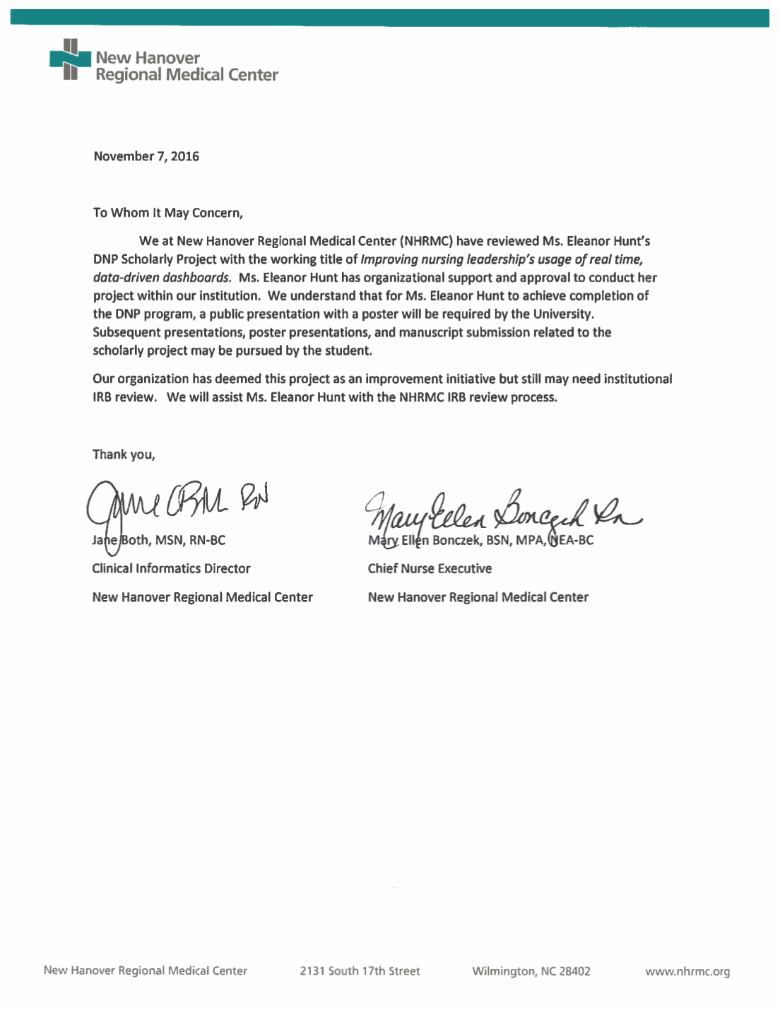

Appendix B

Educational Session Objectives
- Define dashboard, key performance indicators, and quality metrics.
- Examine why the dashboard workflow process is used to mitigate hospital-acquired conditions.
- Discuss the steps involved in using the nursing dashboard and incorporating into daily workflow.

Appendix C

PDSA Cycle
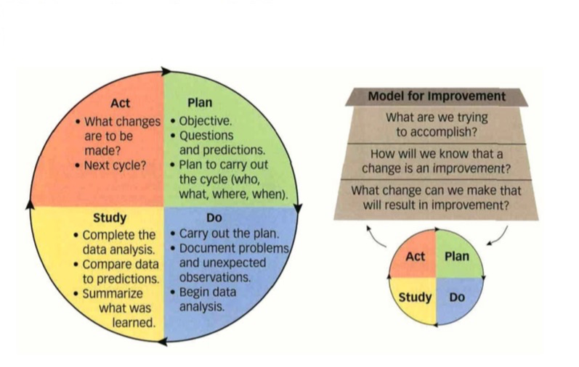
- Figure 1. PDSA cycle and model for improvement. Adapted from “Circling Back” by R.D. Moen & C. L. Norman, 2010, Quality Progress, 43(11), 27. Reprinted with permission from Quality Progress ©2010 ASQ, www.asq.org.

Appendix D

Sociotechnical Model

- Figure 2. Illustration of the relationships between the eight dimensions of the sociotechnical model. Adapted from “A new sociotechnical model for studying health information technology in complex adaptive healthcare systems.” By D. F. Sittig & H. Singh, 2010, Quality & Safety in Health Care, 19(Suppl 3), i68-i74. Reprinted with permission. ©2010. BMJ. All rights reserved.

Appendix E

PDSA and Sociotechnical Model

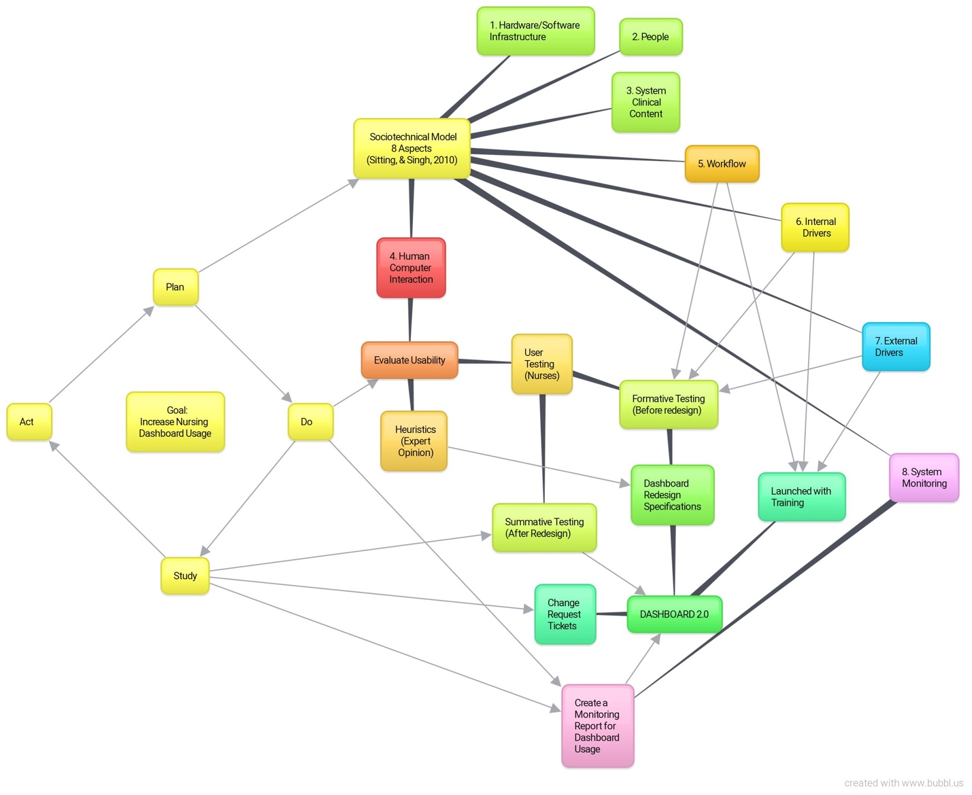
- Figure 3. Illustration of the relationships between the PDSA cycle and the eight dimensions of the sociotechnical model for the DNP project to improve dashboard use. Adapted from “Circling Back” by R.D. Moen & C. L. Norman, 2010, Quality progress, 43(11), 27. Copyright 2010 by Quality Progress and “A new sociotechnical model for studying health information technology in complex adaptive healthcare systems.” By D. F. Sittig & H. Singh, 2010, Quality & Safety in Health Care, 19(Suppl 3), i68-i74.

Appendix F

Relationship of the Theoretical Framework to Project Task
Table 1

Sociotechnical Model Key Area and associated Project Task
Key Area | Project Task
- Improve the human-computer interaction | A user centered design approach will be taken to conduct an analysis of dashboard heuristics
- Workflow and Communication  - Clinical input from nursing dept.  - Compliance input from compliance dept.  - Quality input from quality dept. | A user centered design approach will be taken to involve end-users by conducting a:  - formative analysis of Dashboard 1.0  - summative analysis of Dashboard 2.0
- Align nursing dashboard use with internal organizational policies and culture  - Align nursing dashboard functionality with external rules & regulations | Dashboard 2.0 will be launched with an education session given to nursing leadership.  A user centered design approach will be taken to involve end-users by asking end users how the external rules impact usage
- System measurement of dashboard usage | Report created to monitor dashboard usage.

Note. Specific project tasks were identified to correct the deficit highlighted by the sociotechnical model. This is adapted from “A new sociotechnical model for studying health information technology in complex adaptive healthcare systems” by D.F. Sittig and H. Singh, 2010, Quality and Safety in Health Care, 19(Suppl 3), i68-i74.

Appendix G

System Usability Scale (SUS)
Table 2

System Usability Scale used in Formative and Summative Usability Testing

 | Strongly Disagree |  |  |  | Strongly Agree
- I think that I would like to use this product frequently. | 1 | 2 | 3 | 4 | 5
- I found the product unnecessarily complex. | 1 | 2 | 3 | 4 | 5
- I thought the product was easy to use. | 1 | 2 | 3 | 4 | 5
- I think that I would need the support of a technical person to be able to use this product. | 1 | 2 | 3 | 4 | 5
- I found the various functions in this product were well integrated. | 1 | 2 | 3 | 4 | 5
- I thought there was too much inconsistency in this product. | 1 | 2 | 3 | 4 | 5
- I would imagine that most people would learn to use this product very quickly. | 1 | 2 | 3 | 4 | 5
- I found the product very awkward to use. | 1 | 2 | 3 | 4 | 5
- I felt very confident using the product. | 1 | 2 | 3 | 4 | 5
- I needed to learn a lot of things before I could get going with this product. | 1 | 2 | 3 | 4 | 5
- Overall, I would rate the user-friendliness of this product as:

Worst Imaginable | Awful | Poor | OK | Good | Excellent | Best Imaginable

Note. The SUS was developed as part of the usability engineering program in integrated office systems development at Digital Equipment Co Ltd., Reading, United Kingdom. This SUS is adapted from “Determining What Individual SUS Scores Mean: Adding an adjective rating scale” by A. Bangor, P. Kortum, and J. Miller, 2009, Journal of Usability Studies, 4(3), 116. SUS has been made freely available for use in usability assessment, and has been used for a variety of research projects and industrial evaluations; the only prerequisite for its use is that any published report should acknowledge the source of the measure. © Digital Equipment Corporation, 1986. Retrieved from https://www.usability.gov/how-to-and-tools/resources/templates/system-usability-scale-sus.html. Reprinted with permission.

Appendix H

Nielsen’s Usability Heuristics
Table 3
Nielsen’s Usability Heuristics

Usability heuristic | Description
1. Visibility of system status | The system should always keep users informed about what is going on, through appropriate feedback within reasonable time
2. Match between system and the real world | The system should speak the users’ language, with words, phrases and concepts familiar to the user, rather than system-oriented terms. Follow real-world conventions, making information appear in a natural and logical order
3. User control and freedom | Users often choose system functions by mistake and will need a clearly marked “emergency exit” to leave the unwanted state without having to go through an extended dialogue. Support undo and redo
4. Consistency and standards | Users should not have to wonder whether different words, situations, or actions mean the same thing. Follow platform conventions
5. Error prevention | Even better than good error messages is a careful design which prevents a problem from occurring in the first place. Either eliminate error-prone conditions or check for them and present users with a confirmation option before they commit to the action
6. Recognition rather than recall | Minimize the user’s memory load by making objects, actions, and options visible. The user should not have to remember information from one part of the dialogue to another. Instructions for use of the system should be visible or easily retrievable whenever appropriate
7. Flexibility and efficiency of use | Accelerators—unseen by the novice user—may often speed up the interaction for the expert user such that the system can cater to both inexperienced and experienced users. Allow users to tailor frequent actions
8. Aesthetic and minimalist design | Dialogues should not contain information which is irrelevant or rarely needed. Every extra unit of information in a dialogue competes with the relevant units of information and diminishes their relative visibility
9. Help users recognize, diagnose, and recover from errors | Error messages should be expressed in plain language [no codes], precisely indicate the problem, and constructively suggest a solution
10. Help and documentation | Even though it is better if the system can be used without documentation, it may be necessary to provide help and documentation. Any such information should be easy to search, focused on the user’s task, list concrete steps to be carried out, and not be too large
Note. Adapted from "10 Usability heuristics for user interface design" by J. Nielsen, 1995, Available from https://www.nngroup.com/articles/ten-usability-heuristics/ Copyright 2005 by Jakob Nielsen. Reprinted with permission.

Appendix I

Nielsen’s Usability Severity Rating Scale
Table 4
Nielsen's Severity Rating Scale used in Usability Testing
Problem | Severity | Description
No problem | 0 | I don’t agree that this is a usability problem at all
Cosmetic | 1 | Need not be fixed unless extra time is available
Minor | 2 | Fixing this should be given low priority
Major | 3 | Important to fix, so should be given high priority
Catastrophic | 4 | Imperative to fix this before product can be released
Note. Adapted from "Severity ratings for usability problems" by J. Nielsen, 1995, Available from https://www.nngroup.com/articles/how-to-rate-the-severity-of-usability-problems/ Copyright 2005 by Jakob Nielsen. Reprinted with permission.

Appendix J

Literature Matrix

Appendix K

Changes Made to Dashboard
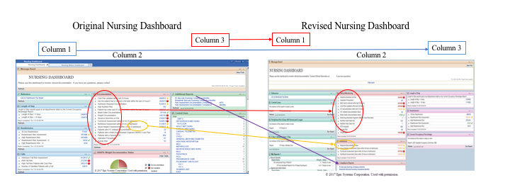
- Figure 4. Annotated screenshots of the changes made between the original dashboard and the revised dashboard. Copyright 2017 by EPIC corporation, used with permission (see Appendix N).

Appendix L

Organization Internal Review Board (IRB) Exemption

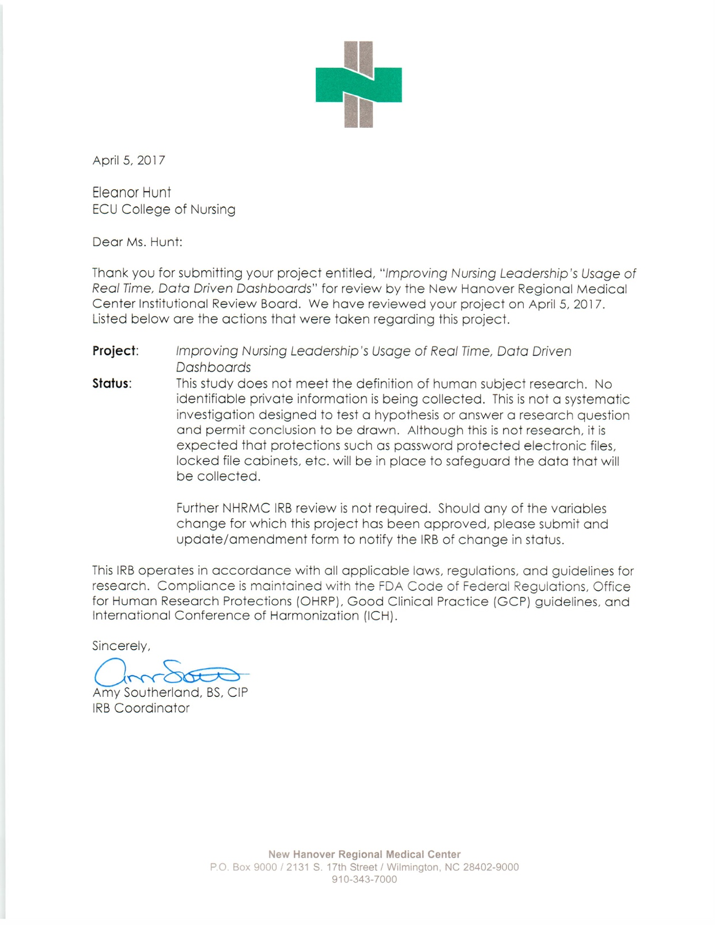

Appendix M

East Carolina University Internal Review Board (IRB) Exemption
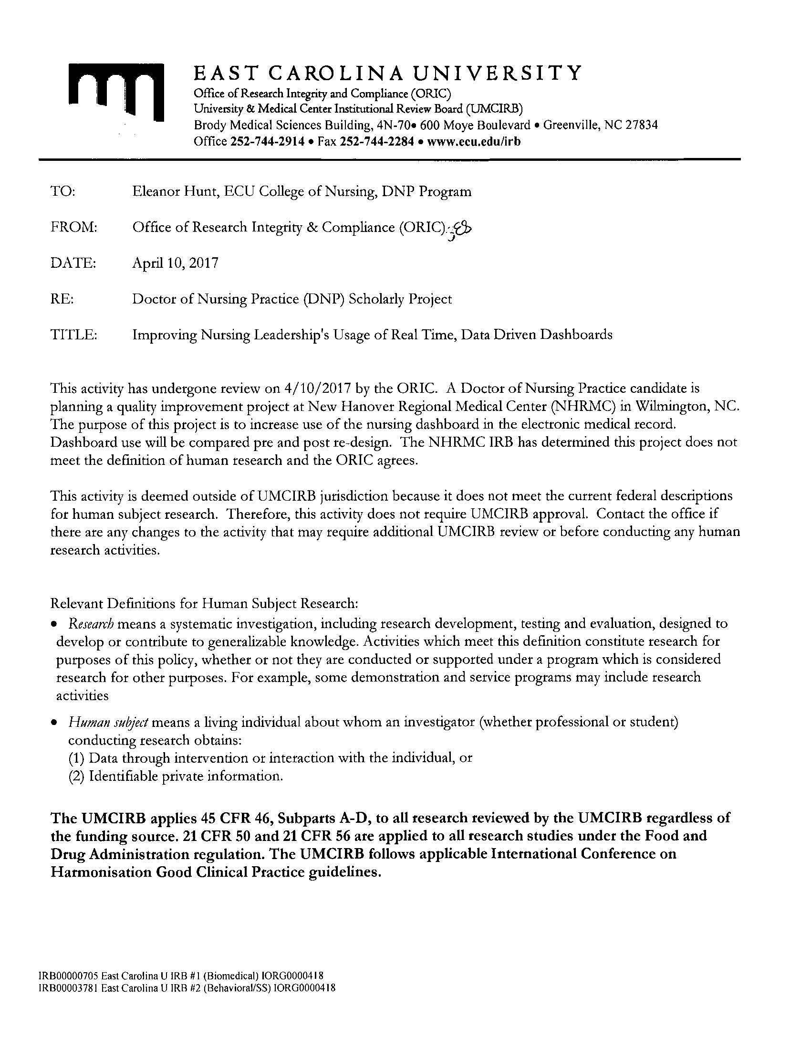

Appendix N

Permission to use Dashboard Screenshots

