Medication Cost Savings in Hospice and Palliative Care Through Implementation of a Quick-Reference Medication Guide

Brittney M. Sabol
College of Nursing, East Carolina University
Doctor of Nursing Practice Program
Dr. Krystle Vinson
April 21, 2022
Abstract
Symptom management is an integral component of end-of-life care provided by hospice services. This project employed a list of alternative low-cost medication options for symptom management to decrease medication costs to the hospice organization. This project applied a multifaceted educational approach to lower the average overall medication cost and the average nonformulary medication cost per patient per day. A quick-reference guide was created and comprised of a target medication list of high-cost, high-use medications, and medications proposed by the nursing and pharmacy staff. In collaboration with the organization’s pharmacy team, a list of low-cost alternative and formulary options with cost comparisons was defined for each target medication and included in the guide. All nursing staff was educated regarding the quick-reference guide and its use. The tools were disseminated physically and digitally to all home care and hospice house nurses and providers. Post-implementation data showed an average of $2.92 cost reduction in overall medication cost and $0.35 cost reduction in nonformulary medication cost per patient per day. These findings compute to a projected estimated annual savings of $149,212 to $159,870 for overall medication cost and $17,885 to $19,162 for nonformulary medication cost, dependent upon patient census. These findings support the use of a multifaceted educational approach to medication cost reduction in the hospice setting. However, further investigation of other methods is warranted, and more robust studies are needed to fully estimate the long-term impact of a project like this.
Keywords cost savings, medication cost, educational intervention, formulary, hospice

Table of Contents
Abstract …………………………………………………………………………………………. 2
Section I: Introduction.……………………………………………………………………………5
Background……………………………………………………………………………….5
Organizational Needs Statement………………………………………………………….5
Problem Statement………………………………………………………………………...7
Purpose Statement…………………………………………………………………………7
Section II: Evidence……………………………………………………………………………….9
Literature Review………………………………………………………………………….9
Evidence-Based Practice Framework……………………………………………………14
Ethical Consideration and Protection of Human Subjects……………………………….16
Section III: Project Design……………………………………………………………………….18
Project Site and Population………………………………………………………………18
Project Team…………………………………………………………………………….19
Project Goals and Outcomes Measures………………………………………………….19
Implementation Plan…………………………………………………………………….21
Timeline………………………………………………………………………………….21
Section IV: Results and Findings………………………………………………………………...23
Results……………………………………………………………………………………23
Discussion of Major Findings……………………………………………………………24
Section V: Interpretation and Implications………………………………………………………26
Costs and Resource Management……………………………………………………….26
Implications of the Findings…………………………………………………………….27
Sustainability ……………………………………………………………………………29
Dissemination Plan ……………………………………………………………………...30
Section VI: Conclusion……………………………………………………………………….….31
Limitations and Facilitators………….…………………………………………….…….31
Recommendations for Others……………………………………………………………32
Recommendations for Further Study…………………………………………………….32 Final Thoughts…………………………………………………………………………...32
References……………………………………………………………………………………….34
Appendices……………………………………………………………………………………….37
Appendix A: Literature Matrix.………………………………………………………….37
Appendix B: Plan Do Study Act (PDSA) Framework. ………………………………….41
Appendix C: Driver Diagram………………………………………………….…………42
Appendix D: Quick-reference Tool………………………………………………………43
Appendix E: Project Timeline……………………………………………………………45
Appendix F: Project Results Data…………………………………………………….….46
Appendix G: Year-to-Year Savings Comparison…………………………………...…...47
Appendix H: Pre-implementation Nurse Survey ………………………………….…….48
Appendix I: Post-implementation Nurse Survey ……………………………….……….49
Appendix J: Project Budget Analysis …………………………………………………...50
Appendix K: Project Management Report I …………………………….……………....51
Appendix L: Project Management Report II ……………………………………………52
Appendix M: Project Management Report III ………………………………………......53
Appendix N: Project Management Report IV ………………….……………………….54
Appendix O: Doctor of Nursing Practice Essentials Table………………….………….55
Appendix P: DNP Project Poster…………………………………………….…………56

Section I. Introduction
Background
Hospice is a community-based, non-profit organization that strives to provide excellent, proficient, compassionate care and support for individuals with terminal illnesses. Hospice works to support individuals, their families, and the community, regardless of their ability to pay. Their vision is for a future with increased access to hospice care at home or in a facility setting for everyone with a life-limiting illness. Funding for such services is determined by the Centers for Medicare & Medicaid Services (CMS) annually and established on a per diem basis. Meaning, each day that a patient is enrolled in hospice, the per diem rate is disbursed to that hospice regardless of the number of services utilized (Brock et al., 2017). Therefore, if the organization can provide more efficacious care at a reduced cost, the monies saved may be reallocated to ensure adequate staffing and resources that could propel the hospice organization closer to realizing its vision of increasing access to hospice services for all who need it.
Organizational Needs Statement
According to the organization, medication costs remain a significant expenditure within the hospice and palliative care community. Savings initiatives have already been set in motion with the change to the Enclara Pharmacia fee-for-service program, which has produced savings of approximately $10,000/month. However, another opportunity for improvement identified by the organization is assessing the new drug formulary with comparisons between cost and efficacy. Such assessments may be utilized to create a quick reference guide to equip nurses and providers with a list of the most cost-effective and efficacious medications within the most commonly prescribed drug categories.
Additionally, after discussion with the organization's nursing staff, another potential solution may include the visual differentiation between formulary versus non-formulary medications within the new medication ordering platform. Reducing non-formulary medication orders will reduce medication costs and increase nurse efficiency. Per the organization, if able to reduce the cost of the most frequently prescribed medications, the overall dollar savings will translate to increased funding to staff more providers, nurses, and aids. Increased healthcare providers will, in turn, result in increased access to hospice services within the community, advancing the organization one step closer to realizing its vision.
The Centers for Medicare and Medicaid Services have delineated quality care measures in the Hospice Quality Reporting Program directly related to medication management, such as pain, bowel regimen, and dyspnea treatment (CMS, 2021). Healthy North Carolina 2030 overreaching goals relevant to this need include eliminating health disparities, achieving health equity, and engaging leadership and key constituents to take action (North Carolinas Department of Health and Human Services, 2020). According to the United States Department of Health and Human Services (2020), the leading Healthy People 2030 indicator applicable to this need include increased access to comprehensive, high-quality healthcare services. Additionally, the need to reduce the cost of frequently prescribed medications intersects with all three of the Triple Aim goals of lowering healthcare costs, improving patient experiences, and improving health outcomes of the hospice population (Berwick et al., 2008).
Suppose patients are more readily able to afford the necessary medications prescribed to them. In that case, they are more likely to fill their prescription and reap the benefits of that medication, thus increasing the potential for improving their overall health status, outcomes, and experience. Conversely, if patients cannot afford their medications, they may never fill their prescriptions, further delaying treatment and symptom relief. Per the Hospice organization, some patients may feel ashamed or embarrassed of their inability to afford their medications and refrain from communicating their financial distress to their providers during follow-up visits. This negatively affects the patient's overall experience and quality of life which is especially important among the hospice and palliative care patient populations.
Problem Statement
Following the Enclara Pharmacia fee-for-service model transition, a need was identified within the Hospice organization to reduce nonformulary medication or high-dollar formulary medication orders. Upon switching to the new pharmacy model, providers and nurses were unfamiliar with new formulary medications and how each medication compares based on cost and efficacy. Furthermore, nursing staff were unable to discern formulary versus nonformulary medication when inputting provider orders into the online ordering platform. According to the CMS updates (2021), hospice patients paid $58,509,601 for medications for the 2019 fiscal year, and approximately $499 million was paid by Medicare part D.
Purpose Statement
This project aimed to reduce the amount of non-formulary and high-dollar formulary medications prescribed to reduce the overall cost of medications by 10%. This aim was accomplished by assessing and comparing the new drug formulary to create a quick-reference prescriber's guide. Alternatively, developing a way to differentiate formulary versus nonformulary medications within the online ordering platform could also reduce the amount of nonformulary medications prescribed. The solutions above will increase efficiency, simplify medication decision-making, and clearly delineate the most cost-effective, efficacious treatment options available when inputting medication orders.
Section II. Evidence
Literature Review
The search strategies employed related to the project purpose included solution-focused interventions to confront the issue of non-formulary and high-cost medications ordered under the new Enclara drug formulary. The databases explored were Cumulative Index of Nursing and Allied Health Literature (CINAHL), Google Scholar, and East Carolina One Search via Laupus Library. The search terms used were clinical decision support, drug formulary, compliance, and medication cost, with Boolean operator ‘and’, which generated 3,237 results initially. Stratification of results ensued with the following filters: published within the last five years, English language, scholarly articles, and peer-reviewed, which yielded 2,808 articles for review. The search was further narrowed to include specific disciplines of medicine, nursing, public health, pharmacy, therapeutics, and pharmacology. Articles excluded were conducted in specific hospital units, included pharmacy formulary decision-making, or addressed non-medication formulary concerns. After applying these exclusion criteria, eight articles were kept, read in their entirety, and included in the literature review. All levels of evidence were accepted in this review, given the shortage of solution-based evidence to support this project, including one level I systematic review, one level II prospective comparative study, two level III retrospective analyses, one level III quasi-experimental longitudinal study, one level IV cohort study, one level V qualitative analysis, and one level V expert opinion.
A subsequent literature search was conducted to include the use of educational interventions specifically to reduce medication costs. The same search strategies applied in the original search were employed and the database explored was the East Carolina One Search via Laupus Library. The search terms used were educational intervention, drug formulary, prescribing practices, outpatient, and cost reduction with Boolean operator ‘and’, which yielded 1,774 articles for review. Inclusion criteria included: published within the last five years, English language, scholarly articles, and peer-reviewed, within the disciplines of economics, medicine, nursing, pharmacy, therapeutics, and pharmacology, public health, which generated 287 articles for review. The same exclusion criteria were applied, and article titles and abstracts were skimmed for those directly related to educational interventions. Of these articles, an additional three were kept for literature review and read in their entirety. Included in these articles was one level I systematic review, one level V quality improvement project, and one level III qualitative analysis. A literature matrix was utilized for literature resource management (see Appendix A). Ongoing, iterative research efforts continued and included frequent literature searches and exploration of the databases to remain up to date with latest evidence and throughout project development.
Current State of Knowledge
Little literature exists regarding solution-based best practice guidelines promoting drug formulary compliance to reduce medication costs, especially in hospice and palliative care populations. However, of the current existing literature, three main avenues of cost savings through formulary compliance were revealed: electronic alert systems, therapeutic drug substitutions, and educational interventions.
Clinical decision-making support via electronic alerts has been shown to improve prescriber efficiency, reduce errors, and manage formulary compliance, according to Melton (2017). Innovative clinical decision support systems have been shown to decrease medication ordering errors, increase patient safety, and produce financial savings for patients and organizations (Lord-Adem & Brandt, 2017). Furthermore, active clinical decision support via best-practice alerts can aid in formulary adherence and cost reduction by alerting the prescriber of formulary alternatives while inputting medication orders (Johnson et al., 2021). However, limitations such as the initial cost of implementation, provider buy-in, and potential alert fatigue may limit their use (Lord-Adem & Brandt, 2017).
Therapeutic substitutions present another avenue that has shown promise in reducing the cost of medications to both patients and organizations. One study by Stenner et al. demonstrated annual savings in drug costs of approximately $800,000 by implementing an in-class therapeutic replacement of four medication classes at the point of prescribing (2016). Another study exhibited an annual cost savings of $397,436 upon implementing the automatic substitution of ipratropium-albuterol nebulization solution for metered-dose inhalers (Loborec et al., 2017). This automatic formulary substitution resulted in 100% formulary compliance and reduced non-formulary orders for metered-dose inhalers. Additionally, another study investigated the effectiveness of pharmacist-driven formulary exchange amongst the employees and employee family members insured by an extensive healthcare system. It produced a prospective annual cost savings of $85,654 to the health system and $48,664 to employees (Keedy et al., 2018).
Educational interventions may also support formulary compliance by persuading prescribers based on medication safety, efficacy, and actual cost. Brock et al. (2017) implemented an education intervention targeting transdermal scopolamine to treat terminal secretions in the hospice setting. Prescribers were educated regarding each available treatment's efficacy, safety, and actual cost for terminal secretions. Post-intervention data demonstrated a 28.5% monthly cost reduction in treating terminal secretions (Brock et al., 2017). Additionally, a longitudinal non-randomized study further suggested that increasing the prescriber's awareness of drug formularies and medication costs could potentially result in overall medication cost savings (Tseng et al., 2016).
Current Approaches to Solving Population Problem
The current approaches presented in the literature addressing formulary adherence and medication cost reduction include educational interventions, therapeutic interchange of medications, and clinical decision support via electronic alerts within the online medication ordering platform. Of the three approaches mentioned above, the implementation of clinical decision support at the point of medication ordering appears to be the most efficient, effective intervention with the most substantial supporting evidence.
The clinical decision-making support approach was initially selected as the intervention for this project following careful consideration and approval from the project site partners. However, failure to connect with a representative from the organization’s online ordering platform presented an insurmountable barrier to the progression of this intervention for implementation. Additionally, the organization was amid merging with a larger neighboring hospice organization and transitioning to a new online ordering and charting system. This transitional period for the organization presented an added barrier to the implementation of a clinical decision-making support approach to reducing nonformulary medication orders and overall drug costs. Therefore, upon consideration of the identified barriers, discussion of the current state of evidence, and further deliberation with all project site partners, all agreed that implementing an educational intervention would prove to be the most feasible and beneficial to staff, patients, and the organization to reduce medication cost.

Evidence to Support the Intervention
Although the alternative methods of electronic clinical decision-making support and therapeutic substitution to promote formulary compliance were compelling, the project team believed that a multifaceted educational intervention would prove to be more beneficial and well-received amongst the target population. Utilizing a quick-reference guide will help to reduce the burden of decision-making when choosing medications according to formulary and simplify the ordering process. Verbal or telephone medication orders are frequently given to nurses, who are then responsible for inputting those orders and selecting the correct drug formulation within the ordering system. Nurses and providers have voiced increased difficulty in differentiating between formulary versus nonformulary medications under the new pharmacy model. By implementing a multimodal educational intervention and creating a quick-reference guide for nurses and providers, they will be able to quickly discern which medications are most appropriate for the patient based on cost and efficacy. By including cost comparisons on the quick-reference guide, nurses and providers can remain cognizant of the cost of the medications they are ordering.
A Qualtrics survey was distributed to all nursing staff to gauge their perspectives and assess their most problematic medications to enter and give them the opportunity to voice any other concerns with inputting medication orders according to the new drug formulary. The survey was sent via email to all 41 nurses, including hospices house and home care nursing staff, with 19 completed surveys returned.
In addition to receiving endorsement from the nursing staff, the literature also supports the use of educational interventions to serve as change agents. One systematic review regarding the effectiveness of educational interventions supports a multifaceted approach that directly engages healthcare professionals as this was shown to be the most effective with thirteen of the sixteen studies included in the review reporting positive results (Bourcier et al., 2018). Platt et al. (2020) revealed an 80% reduction in the rate of benzodiazepine prescriptions in an urban outpatient clinic following the implementation of a multifaceted educational intervention that included in-person education and posters displayed in the provider work areas. Another study showed an increase in value-conscious prescribing and a decrease in the prescription of proton pump inhibitors with the employment of an in-person education intervention combined with the use of a decision aid tool, producing an annual savings of $13,067 (Arao et al., 2017).
Additionally, the utilization of an educational intervention such as a quick-reference guide can be further personalized by the institution to further their cost savings, creating the potential to expand upon the current project in the future. For example, the organization may identify additional, costly medications that need to be added to the quick-reference guide to further reduce medication cost. The customizability of the guide enables the tool to be able to grow and change with the organization. This presents an opportunity for future projects and further advancements in patient safety, outcomes, and overall cost reduction.
Evidence-Based Practice Framework
This project was executed utilizing the Plan-Do-Study-Act (PDSA) operational framework for rapid cycle change (see Appendix B). The PDSA model was coined by Dr. Edward Deming, who suggested this systematic approach to conflict resolution with ongoing cyclical reevaluations and improvements (1991). This framework for change has been catalytic in the evolution of quality improvement (QI) and the application of evidence-based practice (Crowfoot & Prasad, 2017). The PDSA model has resulted in the empowerment of healthcare providers in advocating for and implementing real change to improve the outcomes of their patients. The iterative nature of the PDSA model allows for continual appraisal and improvements upon new or current practices and is widely accepted in the arena of healthcare (Crowfoot & Prasad, 2017).
The first step in the PDSA framework for rapid-cycle change is the planning phase in which the need for change is identified, data is collected, and goals are formed. The 'do' stage is where the plan is set into motion and implementation occurs. The study phase is where the intervention outcomes are considered, and the change is then further adapted and improved upon. The cyclical reevaluation of implementation actions, lessons learned, and barriers identified may be applied during the 'act' phase to further perfect the plan to produce the desired change (Crowfoot & Prasad, 2017). One of the significant benefits of this rapid cycle change framework is that it allows for minor changes to be promptly applied simultaneously, reducing the amount of resistance from staff members (Crowfoot & Prasad, 2017).
For this project, the planning phase consisted of identifying the issue of increased medication costs and non-formulary medication orders as related by the organization. After identifying the problem, a rigorous literature review was conducted to explore the current body of knowledge and evidence to support possible solutions. Collaboration with the project site partners, pharmacists, providers, and nursing staff revealed possible solutions to remedy the issue. The intervention of visually differentiating formulary drug options from the non-formulary alternatives was initially agreed upon as an acceptable intervention, and implementation was attempted with the collaboration of the pharmacy and information technology teams. However, given the inability to coordinate with the information technology team with the new online ordering system, the decision to switch to an educational intervention was agreed upon by all project partners. Thereafter, the study phase ensued and consisted of the recurrent, biweekly reevaluation of the effects of the intervention on decreasing the number of non-formulary medications ordered and overall medication cost. The act phase considered the outcomes of the intervention and lessons learned during implementation.
Adjustments to the plan and implementation were made on an iterative basis to promote drug formulary compliance and achieve the best outcomes to meet our goal. The benefits of utilizing the PDSA model for rapid-cycle change are that it allows for flexibility and frequent, minor adjustments to fine-tune the intervention to promote adaptation to the change and improve the outcome goal. This project saw two PDSA cycles during project implementation with the pivot to an educational intervention from a clinical decision support intervention and with the addition of suggested medications from the nursing, provider, and pharmacy staff to the target medication list. Upon evaluation, this project underwent an additional cycle to address the identified barriers.
Ethical Consideration & Protection of Human Subjects
There were no ethical considerations with implementing this project as it did not directly involve any patients. This project aimed to reduce medication costs to the organization by increasing formulary compliance with the application of a quick-reference medication guide. This project does not affect the care or treatment provided to the patients as the existing drug formulary is a well-established, well-studied, carefully selected formulation of designated medications managed by the EnClara pharmacy department. The target population for this project was the nursing staff responsible for inputting medication orders into the computerized ordering system. This intervention is impartial to everyone in the target population. The quick-reference guide was provided to all nursing staff physically and digitally, making it accessible to anyone who may be inputting medication orders.
Project approval was received from the Vice President of inpatient services with the Hospice organization during the planning phase of this project. Completion of the Collaborative Institute Training Initiative (CITI) training modules, focusing on social and behavioral research for investigators and key personnel, was integral in preparing for this project. In compliance with East Carolina University's project approval process, the Doctor of Nursing Practice Project Compliance Form, Project Assessment Form, and Quality Self-Certification Tools were completed and submitted for approval before project implementation. This project did not require Institutional Review Board approval, as this project does not involve the participation of patients or human subjects. The organization required no further formal approval processes prior to moving forward with this project's realization.
Section III. Project Design
Project Site and Population
A local Hospice and Palliative Care organization served as the site for this project's implementation. This organization consists of two inpatient Hospice House units and a Home Care sector. Two nurse practitioners manage these three sectors with one collaborating physician and 41 nursing staff, including registered nurses and licensed practical nurses. The nursing staff is responsible for inputting medication orders into the online ordering platform; therefore, the 41 registered nurses and licensed practical nurses served as this project's target population. Potential barriers to targeting this population included the availability of staff to attend educational sessions and heavy patient loads. Potential facilitators to this population were the Vice President of Inpatient Unit Services and the Nursing Supervisors, who helped facilitate and coordinate staff education for project implementation and the nurses' willingness to participate.
Description of the Setting
The participating Hospice organization is a predominantly Medicare-funded, not-for-profit organization specializing in hospice and palliative care services. These specialty services are available for those living with life-limiting illnesses or approaching the end of life within the community and surrounding areas. On average, the participating Hospice organization serves approximately 140 to 150 patients at any given time.
Description of the Population
This project's population will consist of 41 registered nurses and licensed practical nurses responsible for entering the medication orders received from Hospice providers. The 41 nurses include admissions nurses, after-hours nurses, home care nurses, and hospice house nurses. The Hospice organization's nurse practitioners and nurses work closely together to provide care to patients within the community. However, the nurses are mainly responsible for inputting orders received from providers and thus served as this project's population.
Project Team
The Hospice home care nurse practitioner and Vice President of Inpatient Unit Services served as the site champions for this project. Additional collaborating project partners included the Director of Pharmacy and Clinical Manager for Enclara Pharmacia.
Project Goals and Outcome Measures
The primary goal of this project was to reduce overall medication costs, as identified by pharmacy statistical data, by 10% (see driver diagram in Appendix C). Baseline pre-intervention data was collected utilizing pharmacy databases from Enclara Pharmacia's online dashboard to include the average overall medication cost per patient per day (PPD) and average non-formulary medication costs PPD in the three months preceding project implementation; May, June, and July 2021. Following the successful implementation of this project, post-intervention data was collected, utilizing the same methods, for the months of October, November, and December 2021.
Description of the Methods and Measurement
Before implementation, a thorough investigation of the key medications driving high medication costs was conducted in collaboration with Hospice's Enclara Pharmacia team. The organization's top medications by utilization were cross-referenced with their top medications by cost for May, June, and July 2021. Additionally, the medications identified explicitly by nursing staff via Qualtrics survey as challenging to order and frequently prescribed were combined with the cross-reference list to create a target medication list. Furthermore, the providers and pharmacy team suggested the inclusion of additional high-cost, problematic medications. Finally, a target medication list comprised of 18 total medications was cultivated and approved by the pharmacy team.
Each target medication was listed, along with formulary or lower-cost alternatives, complete with a cost comparison for each medication by utilizing Enclara Pharmacia's online cost estimator tool. This information was organized in a table and formatted to fit a 4x6 card for convenience (see Appendix D). Non-formulary, high-cost medications were color-coded in red with the lower-costing, formulary alternatives color-coded in green to emphasize the comparison visually. The table was then printed on 4x6 card stock, front and back, and placed in a resealable plastic cardholder, complete with a colorful carabiner. The plastic card holder enables the nurse to sanitize in between patients, and the resealable feature allows for future customization of the tool as needs arise. The colorful carabiner is esthetically pleasing and promotes user buy-in and ease of use by being able to clip the tool wherever it will most likely be needed. Additionally, a digital version of the instrument was emailed to all nurses and providers as a digital reference.
Implementation of this project included an in-person education session with the home care nursing staff where the quick-reference tool was distributed, presented, and explained in detail. Open discussion regarding the tool's potential uses and goal of the project occurred, and all questions were answered. A recorded presentation of the quick-reference tool was created via Microsoft Teams and assigned as mandatory education for the hospice house nursing staff. The tools were then supplied to the hospice house leadership team for subsequent distribution.
Discussion of the Data Collection Process
Enclara Pharmacia offers its customers numerous ways to access information via their online databases on their website's dashboard. The databases were searched for pre-intervention data collection from May 2021 through July 2021. Databases were further sorted to include the average cost of non-formulary medication orders and the average overall medication cost per patient per day. Post-intervention data was collected from October through December 2021 and evaluated for effectiveness following project implementation.
Implementation Plan
The implementation of this project was highly dependent on interprofessional and interdisciplinary collaboration. Pre- and post-intervention data collection was extrapolated utilizing the Enclara Pharmacia databases via an online dashboard. Educational sessions were conducted both in-person and online via Microsoft teams to inform all nursing staff of the new quick-reference guide to aid in medication order decision-making and cost reduction.
Timeline
Pre-intervention data was collected for May, June, and July 2021, as delineated in this project's timeline (see Appendix E). A target medications list consisting of 18 medications was cultivated in partnership with this project's site champions and pharmacy team by August 1, 2021. Development and assembly of this project's quick-reference guide with cost comparisons took place from August to September 2021 in collaboration with Enclara's pharmacy team. Educational sessions with home care nursing staff to launch this project's quick-reference tool took place on September 17, 2021. A mandatory online educational in-service was assigned to all hospice house nursing staff with quick-reference tools provided to hospice house leadership for distribution on September 17, 2021. Post-intervention data was collected for October, November, and December of 2021. After analyzing the data, the project findings were disseminated to both the Hospice organization and the East Carolina University College of Nursing in the spring of 2022.
Section IV. Results and Findings
Results
Three data points were chosen to demonstrate a trend both before and after this project was implemented. Pre-intervention data included an average medication cost PPD of $9.41 for May, $11.46 for June, and $9.32 for July, and an average non-formulary medication cost PPD of $2.24 for May, $2.36 for June, and $2.12 for July 2021. Post-intervention data included an average medication cost PPD of $6.33 for October, $7.77 for November, and $7.33 for December, and an average non-formulary medication cost PPD of $1.50 for October, $2.14 for November, and $2.03 for December 2021 (see Appendix F). Post-implementation data demonstrate an average of $2.92 cost reduction in overall medication cost and $0.35 cost reduction in nonformulary medication cost per patient per day. This data represents a 29% reduction of the overall average medication cost PPD and a 16% reduction of average non-formulary medication cost PPD, exceeding our goal of a 10% reduction. These findings compute to a projected estimated annual savings of $149,212 to $159,870 for overall medication costs and $17,885 to $19,162 for non-formulary medication costs, based on an average census of 140 to 150 patients. Furthermore, a year-to-year comparison demonstrated an average reduction of 34% for all medication costs and 41.3% for non-formulary medication costs when comparing the post-implementation months of October, November, and December 2020 to 2021 (see Appendix G).
Additionally, of the 19 responses received from the pre-implementation nurse survey (see Appendix H), 38.89% selected strongly agree and 27.78% chose somewhat agree when asked, “to what extent would you agree that you spend too much time trying to locate the correct medication to order, according to the new formulary?”. When asked, “to what extent would you agree that you sometimes feel overwhelmed by the number of available options for a specific medication when inputting medication orders?” 33.33% selected strongly agree and 38.89% selected somewhat agree. When questioned, “how well do you feel that having a quick-reference guide for the most commonly prescribed medications would help you make the right formulary choice when inputting medication orders?” 72.22% selected extremely well, 16.67% selected very well, and 11.11% selected moderately well.
Of the three post-implementation nurse survey responses (see Appendix I) received, 100% selected not in the past week but in the past month when asked, “when was the last time you used the quick-reference medication tool?”. Additionally, when asked, “how well would you say that the quick-reference tool has assisted you in choosing the correct formulary medication?”, 100% of respondents selected very well. When asked, “to what extent would you agree that the quick-reference tool enabled you to save time when inputting certain medication orders?” 66.67% responded strongly agree, and 33.33% responded somewhat agree.
Discussion of Major Findings
The notable downtrend in the average medication cost PPD for the post-intervention months of October, November, and December compared to the pre-intervention months of May, June, and July demonstrates the effectiveness of the quick-reference tool in reducing medication cost. Although the average cost of non-formulary medications showed modest savings, it is essential to note that the quick-reference tool focused on the most cost-effective alternative medications, which may or may not be formulary. The most substantial cost savings for both overall medication and non-formulary costs occurred in October, immediately following staff education and project implementation, indicating that the utilization of the tool was likely higher while the information was fresh in the minds of nursing staff. Although the organization continued to see considerable cost savings for November and December, staff may need additional prompting to reference the tool when inputting medication orders. However, when reassessed six months following project implementation, the organization continued to maintain cost savings greater than $1.24 per patient per day for overall medication cost. This demonstrates this project’s endurance and supports utilizing the quick-reference medication guide to reduce medication costs to the organization on a long-term basis.
The substantial estimated annual cost savings would equate to a sizeable income to hire another provider and additional nursing staff, which would better equip the organization to care for many patients, broadening their reach and increasing access to hospice services within our community. Furthermore, the positive feedback received from the post-intervention nurse survey, though limited, endorses the use of the quick-reference guide as both a convenient and valuable tool that was well-received by the nurses.
The quick-reference tool was created to guide users to choose the most appropriate and cost-effective medication when inputting frequently prescribed medicines for the hospice patient population. The tool is also meant to aid nurses in differentiating formulary and non-formulary medications, saving the nurses time and lessening the decision burden. The findings of this project support the use of this tool to reduce medication costs for the organization. Additionally, this tool also increases staff awareness of medication costs and promotes value-based prescribing that will continue to aid in the reduction of overall medication costs. Furthermore, this tool enables collaborative conversations between the nursing staff and prescribing providers and encourages a cost-conscious climate where everyone works together to provide cost-effective, excellent, end of life care.

Section V. Interpretation and Implications
Cost and Resource Management
As noted in Appendix J, the budget for this project totaled $181.06, although monies could be saved by opting for cheaper snacks and refreshments for the educational session. However, considering the surge in COVID-19 cases within the community at the time of implementation, opting for individually packaged cakes enabled contactless distribution. Additionally, the supplies chosen to assemble the quick-reference guide were selected with longevity in mind, resulting in a slightly higher upfront cost but will likely save money over time. Investing in durable supplies initially will hopefully minimize the cost of its continuation, as updates to the tool should only incur the fee of printing a new insert. Instead of simply laminating the instrument, a sturdy, clear, plastic, resealable cover was chosen to enable staff to sanitize in between patients, as well as increase customizability by being able to change out the insert as new medication cost-saving needs are identified. The colorful heart-shaped carabiners help make the tool visually appealing, increasing nurse buy-in with increased versatility and convenience with the capability of clipping the tool wherever needed.
Approximately 100 hours were spent working directly on this project during the implementation phase. These hours included time spent reviewing the literature, collaborating with the project site and nursing staff, consulting with the pharmacy team, comprising the target medication list, conducting cost comparisons within Enclara's dashboard, creating and formatting the quick-reference guide, shopping for and assembling the physical tool for distribution, and educating staff. If implemented on a larger scale, more time would be needed to construct more tools for distribution. Furthermore, more time would likely be necessary to conduct additional educational sessions for a larger group of nurses. Enough supplies were purchased from Amazon.com to build 100 quick-reference tools. Each tool took approximately one minute to assemble after the insert was formatted correctly and ready to print. If implemented on a larger scale, most of the time would be spent printing and filling each quick-reference guide as the insert template has already been created.
Enclara's online dashboard was the primary resource utilized in this project, which the organization's Enclara account manager granted. This dashboard was instrumental in creating the quick-reference tool, conducting cost comparisons, and pre-and post-intervention data collection. Data collected from Enclara's dashboard was organized in an excel spreadsheet and presented in graphical format in Appendices F and G. Literature resources to support the educational intervention for this project were managed via literature matrix. The literature matrix was initially created as an excel spreadsheet, then translated into a Microsoft Word table for improved readability. Pre- and post-intervention nurse survey responses were designed with online Qualtrics software (see Appendices H and I, respectively). The project site champion emailed an anonymous link to all hospice nursing staff for each survey. All survey response data was managed via the online Qualtrics software.
Implications of the Findings
The favorable findings of this project implicate the effectiveness of a quick-reference guide to reduce the cost of medications by targeting the most prescribed high-dollar and nonformulary medications that are ordered. Additionally, this project suggests that increasing staff awareness of medication cost, with a clear cost comparison at the point of order entry, can result in more value-conscious prescribing and reduce overall medication costs for organizations. However, upon the continuation of this project and subsequent PDSA cycles, staff would need re-education and reminding to continue to apply the quick-reference tool when inputting medication orders to optimize cost savings to the organization.
Implications for Patients
This project produced a significant cost reduction in medication costs. Lower medication costs lessen the financial burden during the end of life and improve the overall quality of life by appropriately providing affordable medications that offer symptom relief. Indirectly, patients in the community could potentially be affected by increasing access to quality hospice and palliative care services. Improved access can be established by saving the organization monies on high-dollar medications that could otherwise be spent hiring more staff to further reach those in need of hospice services. When we can manage our patient’s symptoms effectively with low-cost medications, we can then redirect funds to ensure adequate staffing and resources that, in turn, result in improved care and increased access for patients.
Implications for nursing practice.
One significant implication for nursing practice associated with this project is the potential improvement in overall job satisfaction by providing adequate staffing and resources for nurses to better care for their patients. Also, utilizing the quick-reference guide can save the nurses time, improve their efficiency, and reduce their decision burden when inputting medication orders, further enhancing their overall satisfaction. Furthermore, this project encourages professional collaboration between nurses and providers when deciding upon appropriate treatment plans, creating a climate of trust and partnership. Nurses are empowered to create a dialogue with their providers when utilizing the quick-reference tool, which allows them to advocate for their patients and provide high-quality, cost-effective end-of-life care, further improving job satisfaction.
Impact for Healthcare System(s)
With the cost of healthcare rising and the cost of medications, we must remain vigilant in finding creative solutions to combat this inflation for the sake of the patients and communities we serve. Nurses at the front lines should be empowered to identify areas of improvement, then work to remedy these areas with innovative, evidence-based interventions. This kind of innovation improves the healthcare system and propels the nursing profession forward. This project and the development and application of a quick-reference guide aim to provide a simple solution to cost reduction while empowering the nurses and providers to be a part of the solution. The success of this project paves the way for similar projects to be implemented on a much larger scale and translated to other healthcare settings beyond hospice, which would offer substantial cost savings to other organizations and increase access to healthcare services.
Sustainability
Although this project required a small amount of monetary support to create, the supplies utilized were chosen with longevity in mind. This project's quick-reference tool was mindfully assembled to be editable and customizable as the organization's needs change and grow. This project can be easily maintained if someone assumes the responsibility of monitoring medication costs, changes in the formulary, and maintaining the target medication list with cost comparisons. Although this person has not yet been appointed, the hospice organization is amendable to allow future doctoral students to build and expand upon this project, adding to its sustainability. As evidenced by the slow decline in savings with each passing month, nursing staff must be consistently reminded to employ the quick-reference tool to maintain considerable cost reduction.

Dissemination Plan
Findings from this project were presented to the project partners, pharmacy team, nursing staff, providers, and senior leadership on March 28, 2022, via Microsoft Teams meeting in consideration of the recent surge in COVID-19 cases. Further project dissemination took place via professional poster presentation (see Appendix P) to the East Carolina College of Nursing Faculty and Doctor of Nursing Practice cohorts on April 5, 2022, followed by publishing this project paper to the online East Carolina University ScholarSHIP archives on April 25, 2022.

Section VI. Conclusion
Limitations and Facilitators
The primary limitation of this project was the timing of its implementation. Immediately following the project rollout, the organization began transitioning to a new online charting platform as part of its merger with a larger surrounding hospice organization. This transition presented a significant barrier to the project as nursing staff were experiencing information overload and increased stress levels related to the change.
Another limitation of this project was its short duration. Subsequent PDSA cycles would need to be executed and data reassessed over time to assess the true, long-term impact of the quick-reference tool. In addition to this, the success of this project was entirely dependent on the nurse's acceptance and application of the instrument when inputting medication orders. This limitation could have been lessened had this project utilized electronic decision support as its intervention. However, this was not possible given the inability to effectively coordinate with the representative from the online ordering platform.
Thankfully, this project had ample nurse buy-in and provider support to facilitate its success. This project's site champion is one of the primary home care hospice providers. They collaborated closely with the nursing staff and advocated for the tool's application when discussing symptom management and inputting medication orders. Having an advocate working on the front lines during this project's implementation was instrumental to promoting its application and, thus, its success. Further facilitators include the incredibly receptive and supportive hospice organization and the insightful Enclara Pharmacia team, who were so helpful and eager to aid in realizing this project.
Recommendations for Others
While this project's methods of utilizing a quick-reference tool produced a moderate decrease in overall medication cost, its continuation would require a diligent project leader to maintain. Nursing staff would also need re-education and consistent queuing to apply the tool when necessary, automated email reminders could potentially remedy this. It would also be beneficial to include the providers in future educational sessions to ensure adequate tool application to continue with cost savings as part of future PDSA cycles. Also, a quick-reference guide was more feasible to implement given the smaller size and close-knit nursing staff. Implementing a tool of this kind may prove to be more difficult in more extensive, busier hospice organizations and would likely require a team of champions to manage. Additionally, upholding a close, interprofessional alliance with the pharmacy team is essential to maintaining the tool's relevance and keeping medication costs as low as possible while providing adequate symptom management at the end of life.
Recommendations Further Study
Further study of educational interventions to reduce overall medication costs would be helpful moving forward. Implementing a quick-reference guide within a larger organization may prove difficult; however, it would be interesting to evaluate the tool's effectiveness on a larger scale and over a prolonged period. Furthermore, comparing a physical tool versus an electronic decision support alert would also prove beneficial when deciding which method is more feasible and applicable to various organizations looking to address the number of high-cost medications being ordered.

Final Thoughts
Finding creative solutions to reduce cost is more important now than ever before. This project was designed to address the rising cost of medications by developing and applying a quick-reference medication guide. This project hopes that by saving the organization money on medication costs, a reallocation of funds could eventually increase access to hospice services and resources within our rural community. The quick-reference medication guide enables the home care nurse to quickly identify the most affordable medication to effectively manage a patient's symptoms when discussing treatment plans with the provider and inputting medication orders. The tool was developed with the organization's pharmacy team to address a target list of high-cost, frequently ordered medications. The cost savings achieved with the employment of this tool demonstrates its effectiveness and paves the way to improving patient outcomes at the end of life.

References
American Association of Colleges of Nursing (2006). The Essentials of Doctoral Education for
Advanced Nursing Practice. https://tinyurl.com/2jb6xknn
Arao, R. K., O‘Connor, M. Y., Barrett, T., Chockalingam, L., Khan, F., Kumar, A., Leader, A., Leven, E., Power, J. R., Shuham, B., Rifkin, R., Thomas, D., Meah, Y., & Shah, B. J. (2017). Strengthening value-based medication management in a free clinic for the uninsured: Quality interventions aimed at reducing costs and enhancing adherence. BMJ Open Quality, 6(2), e000069-e000069. https://tinyurl.com/ys43tdhn
Berwick, D. M., Nolan, T. W., & Whittington, J. (2008). The triple aim: Care, health, and cost. Health Affairs, 27(3), 759-69. https://tinyurl.com/yckhkev8
Bourcier, E., Korb-Savoldelli, V., Hejblum, G., Fernandez, C., & Hindlet, P. (2018). A systematic review of regulatory and educational interventions to reduce the burden associated with the prescriptions of sedative-hypnotics in adults treated for sleep disorders. PloS One, 13(1), e0191211-e0191211. https://tinyurl.com/yc77w47h
Brock, C., Cooper, S., & Herndon, C. M. (2017). An educational intervention to decrease drug costs related to terminal secretions in a hospice organization. Journal of Pain & Palliative Care Pharmacotherapy, 31(1), 66–70. https://tinyurl.com/2jt22snb
Centers for Medicare & Medicaid Services (2020). Provider enrollment and certification QAPI. Retrieved from PDSA Cycle Template: https://tinyurl.com/2p85t3ut
Centers for Medicare & Medicaid Services, Department of Health and Human Services (2021). Medicare program; FY 2022 hospice wage index and payment rate update, hospice conditions of participation updates, hospice and home health quality reporting program requirements. Federal Register. 86 (70). 19715-19717. https://tinyurl.com/2p95h68t
Crowfoot, D., & Prasad, V. (2017). Using the plan–do–study–act (PDSA) cycle to make change in general practice. InnovAiT: Education and Inspiration for General Practice, 10(7), 425-430. https://tinyurl.com/88e2b4f3
Deming, W. E. (1991). Out of the Crisis, 1986. Cambridge, MA: Massachusetts Institute of Technology Center for Advanced Engineering Study, 13, 507.
Johnson, S. T., Gosser, R. A., Kier, K. L., Anderson, K. C., Douglas, J. S., Heindel, G. A., Majerczyk, D., Manian, R., & Thornby, K. (2021). Formulary management challenges and opportunities: 2020 and beyond ‐ an opinion paper of the drug information practice and research network of the American College of Clinical Pharmacy. Journal of the American College of Clinical Pharmacy, 4(1), 81-91. https://tinyurl.com/36ej56zs
Keedy, C. A., Schnibben, A. P., Crosby, J. F., McGlasson, A. C. L., & Misher, A. (2018). Implementation of a pharmacist-driven formulary management service within a community health-system insurance plan. American Journal of Health-System Pharmacy, 75(23), 1854-1856. https://tinyurl.com/yz3urp5n
Loborec, S. M., Johnson, S. E., & Keating, E. A. (2016). Financial effect of converting ipratropium-albuterol therapy from inhalers to nebulizer treatments at an academic health system. American Journal of Health-System Pharmacy, 73(3), 121–125. https://tinyurl.com/2p9xdw8p
Lord-Adem, W., & Brandt, N. J. (2017). Clinical alerts to decrease high-risk medication use in older adults. Journal of Gerontological Nursing, 43(7), 7-12. https://tinyurl.com/2p9yjbry
Melton, B. L. (2017). Systematic review of medical informatics–supported medication decision making. Biomedical Informatics Insights. https://tinyurl.com/bp8etm8z
North Carolina Department of Health and Human Services (2020). Healthy North Carolina 2030. https://tinyurl.com/2p8336xs
Platt, L., Savage, T. A., & Rajagopal, N. (2020). An intervention to decrease benzodiazepine prescribing by providers in an urban clinic. Journal of Psychosocial Nursing and Mental Health Services, 58(1), 39-45. https://tinyurl.com/mryw9eds
Stenner, S. P., Chakravarthy, R., Johnson, K. B., Miller, W. L., Olson, J., Wickizer, M., Johnson, N. N., Ohmer, R., Uskavitch, D. R., Bernard, G. R., Neal, E. B., & Lehmann, C. U. (2016). Eprescribing: Reducing costs through in-class therapeutic interchange. Applied Clinical Informatics, 7(4), 1168-1181. https://tinyurl.com/ycks2dhc
Tseng, C., Lin, G. A., Davis, J., Taira, D. A., Yazdany, J., He, Q., Chen, R., Imamura, A., & Dudley, R. A. (2016). Giving formulary and drug cost information to providers and impact on medication cost and use: A longitudinal non-randomized study. BMC Health Services Research, 16(1), 499-499. https://tinyurl.com/46n7kbaz
U.S. Department of Health and Human Services. (2020). Healthy People 2030. https://tinyurl.com/bde9zund

Appendix A
Literature Matrix
Article  (APA citation) | Level of Evidence | Data/  Evidence Findings | Conclusion/  Summary | Utilization of Evidence
Arao, R. K., O‘Connor, M. Y., Barrett, T., Chockalingam, L., Khan, F., Kumar, A., Leader, A., Leven, E., Power, J. R., Shuham, B., Rifkin, R., Thomas, D., Meah, Y., & Shah, B. J. (2017). Strengthening value-based medication management in a free clinic for the uninsured: Quality interventions aimed at reducing costs and enhancing adherence. BMJ Open Quality, 6(2), e000069-e000069. https://tinyurl.com/ys43tdhn | Level III | Promoting value-conscious prescribing in a free clinic resulted in a 7.3%, or $3768 reduction in annual pharmacy costs. | The goal of this qualitative analysis was to reduce medication expenditures through value-conscious prescribing. To promote this, costly drugs on the clinic’s formulary were prohibited and a decision support within the mobile clinician reference application was added. | This analysis supports the promotion of value-based prescribing and reference tools to reduce medication costs.
Bourcier, E., Korb-Savoldelli, V., Hejblum, G., Fernandez, C., & Hindlet, P. (2018). A systematic review of regulatory and educational interventions to reduce the burden associated with the prescriptions of sedative-hypnotics in adults treated for sleep disorders. PloS One, 13(1), e0191211-e0191211. https://tinyurl.com/yc77w47h | Level I | Of the 31 studies reviewed, 23 assessed educational interventions and 8 assessed regulatory interventions. Among educational interventions, 13 out of the 16 multi-faceted interventions were reported as efficient; especially when the patients and providers were actively involved. | This systematic literature review included 31 studies to assess for the best interventions to reduce the inappropriate use of sedative-hypnotics in the treatment of sleep disorders. This review concluded that multifaceted, educational interventions were the most efficient. | This review supports the use of educational sessions as well as providing both a hard copy and digital copy of the quick-reference guide as. A multifaceted approach lowering medication cost. This review also supports the active participation of the providers.
Brock, C., Cooper, S., & Herndon, C. M. (2017). An educational intervention to decrease drug costs related to terminal secretions in a hospice organization. Journal of Pain & Palliative Care Pharmacotherapy, 31(1), 66–70. https://tinyurl.com/2jt22snb | Level IV | Following an educational intervention, monthly drug costs decreased 22.5%, average daily patient drug costs decreased 11.1%, and total anti-secretion costs decreased 28.5% after adjusting for difference in census. | This cohort study aimed to reduce medication cost for a hospice organization by targeting the frequently ordered, costly transdermal scopolamine. An educational intervention focusing of efficacy, safety, and cost for each medication used in the treatment of terminal secretions. | This study supports targeting high-cost, commonly prescribed medication, and cost comparisons in the effort to reduce overall medication costs.
Johnson, S. T., Gosser, R. A., Kier, K. L., Anderson, K. C., Douglas, J. S., Heindel, G. A., Majerczyk, D., Manian, R., & Thornby, K. (2021). Formulary management challenges and opportunities: 2020 and beyond ‐ an opinion paper of the drug information practice and research network of the American College of Clinical Pharmacy. Journal of the American College of Clinical Pharmacy, 4(1), 81-91. https://tinyurl.com/36ej56zs | Level V | This article recommends a periodic review of the literature to detect, revise, and employ inventive formulary management techniques to address high-cost medications. | This article discusses the expert opinions of pharmacists regarding formulary management strategies. | This opinion paper supports the utilization of clinical decision support systems to aid in formulary management and cost control.
Keedy, C. A., Schnibben, A. P., Crosby, J. F., McGlasson, A. C. L., & Misher, A. (2018). Implementation of a pharmacist-driven formulary management service within a community health-system insurance plan. American Journal of Health-System Pharmacy, 75(23), 1854-1856. https://tinyurl.com/yz3urp5n | Level III | The authors found that the implementation of a formulary management service produced a potential annual cost savings of $85,654 to the health system and $48,664 to employees and their spouses. | The aim of this retrospective chart review was to assess whether implementing a pharmacist-driven formulary management service would aid in medication cost reduction. Savings on medications for the health system was evaluated before and after pharmacist intervention and supported the use of a formulary management service. | Supports the potential cost savings associated with appropriate formulary management.
Loborec, S. M., Johnson, S. E., & Keating, E. A. (2016). Financial effect of converting ipratropium-albuterol therapy from inhalers to nebulizer treatments at an academic health system. American Journal of Health-System Pharmacy, 73(3), 121–125. https://tinyurl.com/2p9xdw8p | Level III | The authors found that the utilization of automatic formulary substitution to ipratropium-albuterol nebulization solution from MDIs resulted in an overall savings of $146,806 during the implementation year and a projected savings of $257,936 for each following year. | The purpose of this retrospective analysis study was to assess the cost-effectiveness of an automated formulary substitution of formulary ipratropium-albuterol nebulization solution for ipratropium-albuterol metered-dose inhalers (MDIs) at an academic health system. | Automatic formulary substitutions present an efficacious opportunity to save money and demonstrates the impact of formulary compliance on cost reduction.
Lord-Adem, W., & Brandt, N. J. (2017). Clinical alerts to decrease high-risk medication use in older adults. Journal of Gerontological Nursing, 43(7), 7-12. https://tinyurl.com/2p9yjbry | Level V | Further studies are needed to explore ways to overcome barriers to the incorporation of clinical alert systems and electronic decision support within healthcare systems. | This qualitative analysis explores the use of electronic decision support in the prevention of a high-risk-medication adverse events in older adults. While many studies have demonstrated the benefits of clinical alert systems, there are many obstacles that inhibit their use. | This analysis supports the utilization of clinical alerts to lower ordering errors, improve patient safety, and generate cost savings for patients and organizations.
Melton, B. L. (2017). Systematic review of medical informatics–supported medication decision making. Biomedical Informatics Insights. https://tinyurl.com/bp8etm8z | Level I | This systematic review included 39 articles from PubMed in the English language between 2006 and 2016 regarding decision support systems related to medications. | This review found that the employment of a well-designed electronic clinical decision support system improves patient outcomes and safety, as well as efficiency. | This review supports the utilization of clinical support systems to improve efficiency.
Platt, L., Savage, T. A., & Rajagopal, N. (2020). An intervention to decrease benzodiazepine prescribing by providers in an urban clinic. Journal of Psychosocial Nursing and Mental Health Services, 58(1), 39-45. https://tinyurl.com/mryw9eds | Level V  QI Project | This project compared the monthly average of benzodiazepine prescriptions written in 2017, prior to its intervention, to the number written 30 days following the intervention. The project results reported an 80% reduction in prescribed benzodiazepines. | This quality improvement project aimed to reduce the number of benzodiazepines ordered by implementing an educational intervention with academic and pharmaceutical detailing. | This report supports the use of quality improvement project and educational interventions to reduce specific medication orders.
Stenner, S. P., Chakravarthy, R., Johnson, K. B., Miller, W. L., Olson, J., Wickizer, M., Johnson, N. N., Ohmer, R., Uskavitch, D. R., Bernard, G. R., Neal, E. B., & Lehmann, C. U. (2016). Eprescribing: Reducing costs through in-class therapeutic interchange. Applied Clinical Informatics, 7(4), 1168-1181. https://tinyurl.com/ycks2dhc | Level II | This study employed four therapeutic interchange interventions that produced a quarterly savings that exceeded $200,000 with an estimated annual savings of $800,000, or more than $17 per member. | This prospective comparative study analyzed the monetary effects of implementing a therapeutic interchange for four specific drug classes using clinical decision support tool. | This study supports the use of a therapeutic interchange clinical decision support tool upon order entry to improve compliance with recommendations and reduce cost.
Tseng, C., Lin, G. A., Davis, J., Taira, D. A., Yazdany, J., He, Q., Chen, R., Imamura, A., & Dudley, R. A. (2016). Giving formulary and drug cost information to providers and impact on medication cost and use: A longitudinal non-randomized study. BMC Health Services Research, 16(1), 499-499. https://tinyurl.com/46n7kbaz | Level III | Giving prescribers information regarding drug formularies and costs at the point of care resulted in less increases in annual medication costs without affecting out-of-pocket costs or medication use for patients. | The purpose of this quasi-experimental longitudinal non-randomized study was to determine whether providing prescribers with formulary and medication cost information was associated with changes in their diabetic patients’ medication costs and use. | The findings of this study support the cost comparison provided on the quick-reference medication tool in an effort to promote formulary compliance and reduce medication cost.

Appendix B
Plan Do Study Act (PDSA) Framework

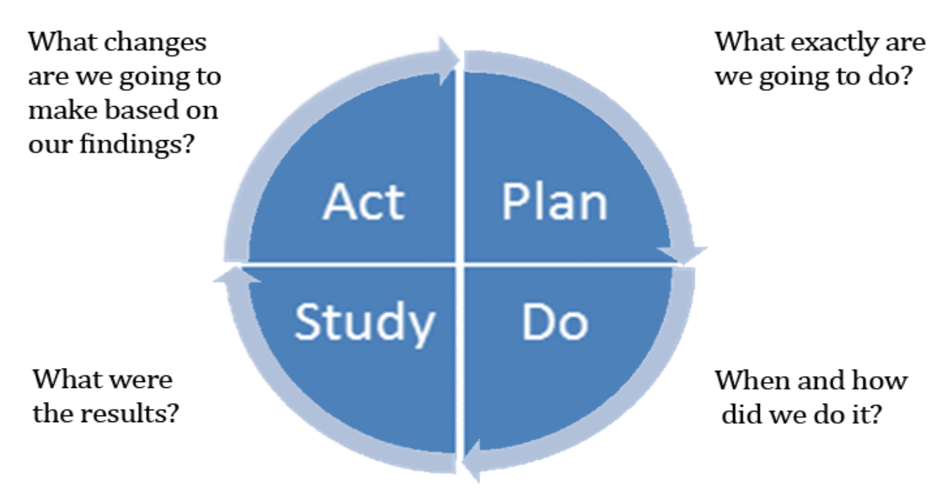
Appendix B. Plan, Do, Study, Act Model. (Centers for Medicare and Medicaid Services, 2020).

Appendix C
Driver Diagram
Specific ideas, actions, processes, or concepts to be changed

Secondary
Drivers

Aim

Primary
Drivers

Appendix D
Quick-reference Tool
Target Medication List | Desired Formulary/Alternative Medication/Dose | Estimated $ SAVINGS/15-day RX
Albuterol Sulfate 90 mcg aerosol inhaler HFA (Proventil®, Ventolin®) ($60.26)  Albuterol Sulfate 2 mg tablets ($248.41) | - Albuterol Sulfate 2.5 mg/3 ml (0.083 %) solution for nebulization (Proventil®), 30 vials ($9.68)  - Albuterol Sulfate 2 mg/5 ml syrup ($58.90) | $50.58  $189.51
Cephalexin (Keflex®) | - Cephalexin (Keflex®) Capsule: 250mg, 500mg.  - Suspension: 125mg/5mL | ---
Dexamethasone 6mg tablets ($60.00) | - Dexamethasone 2mg TAB ($23.00) | $37.00
Divalproex sprinkles 125 mg ($113.86) | - Divalproex 125 mg TAB (DR/EC) (Depakote®) ($14.83)  - Valproic Acid (Depakene®) Capsules 250mg ($19.50)  - Valproic Acid (Depakene®) Solution 250mg/5mL ($21.46) | $99.03  $94.36  $92.43
Ipratropium-albuterol 20 mcg-100 mcg/act HFA (Combivent® Respimat®) ($462.45) | - Ipratropium-albuterol 0.5 mg-3 mg (2.5 mg base)/3 mL solution (DuoNeb®), QID ($46.00) | $416.45
Guaifenesin  100mg/5mL  ($61.73) | - Mucinex ER 1200mg QD ($15.19)  - Mucinex ER 600mg BID ($18.25)  - Guaifenesin 400mg QID ($9.01) | $46.54  $43.48  $52.72
Haldol | - Haloperidol TAB: 0.5mg, 1mg, 2mg, 20mg  - ORAL CONC: 2mg/mL | ---
Hydrocodone-chlorpheniramine 10 mg-8 mg/5 ml (Tussionex®) ($163.99) | - Hydrocodone-homatropine (Hycodan®) 5 mg-1.5 mg/5 mL Syrup ($60)  - Promethazine-codeine (Phenergan® with Codeine) SYRP: 10mg-6.25mg/5mL ($30)  - Promethazine-dextromethorphan (Phenergan® DM) SYRP: 15mg-6.25mg/5mL ($25.50) | $103.99  $133.00  $138.49
Hyoscyamine | - Hyoscyamine SL TAB: 0.125mg ($51.47)  - ELIX: 125mcg/5mL ($54.34)  - COMPOUNDED Atropine (via Enclara mail order only) 1% suspension ($8.99) | ---  $42.48
Ketoprofen gel 5% Topical ($25.39) | - Diclofenac gel 1% ($10.92)  - OTC Voltaren® gel 1% | $14.47
Lidocaine Patch 5%  ($110.30) | - Lidocaine 4% cream ($16.34)  - Lidocaine 5% cream ($21.40)  - Aspercreme Lidocaine 4% patch ($29.50) | $93.96  $88.90  $80.80
Lorazepam | - Lorazepam 0.5mg tab, 1mg, 2mg  - ORAL CONC. 1mg/mL or 2mg/ml | ---
Morphine  For extended-release options, see “Oxycodone” | - Morphine CONC. (Roxanol®) 100 mg/5 mL (20 mg/mL), 30 mL bottle ($28.91)  - Morphine (MSIR®) TAB: 15mg ($28.08), 30mg ($24.60)  - Morphine CONC. 40mg/mL, 30 mL bottle ($20.08) | ---
Oxycodone 20mg ER 12H (Oxycontin®) ($186.24) | - Morphine (MS Contin®) 15mg TAB ($53.24)  - Fentanyl transdermal 25mcg/hr patch (Duragesic®) ($30.00) | $133.00  $156.24
Potassium chloride 20 mEq/15mL  ($214.44) | - Potassium 10 mEq capsule, ER (Micro-K) *NO GTube* ($33.16)  - Klor-con 10mEq ER tablet *OK w/ GTube* ($19.18) | $181.28  $195.26
Pyridium 200mg TID x2days (24.06) | - Uristat® 95mg PO, 2 tabs TID x2 days ($7.63) | $16.43
Rifaximin (Xifaxan®) 550mg  ($1427.61) | - neomycin 500 mg tablet (tablet) ($183.00) | $1244.61
Sulfamethoxazole-Trimethoprim (Bactrim®) | - Sulfamethoxazole-Trimethoprim (Bactrim®): 400mg-80mg tab  - Sulfamethoxazole-Trimethoprim (Bactrim DS®) 800mg-160mg tab  - Suspension: 200 mg-40 mg/5 mL | ---

Appendix E
Project Timeline

Appendix F
Project Results Data

Figure F. Pre-intervention data was collected for the months of May, June, and June of 2021. Research, staff education, and project implementation took place during the months of August and September. Data from October, November, and December of 2021 represent the post-intervention project data which demonstrates a desired decline in overall medication cost.

Appendix G
Project Results Comparisons

Figure G1. Post-intervention year to year comparison demonstrates an average of 34% cost reduction in overall medication costs from 2020 to 2021.

Figure G2. Post-intervention year-to-year comparison demonstrated an average of 41.3% reduction in the non-formulary medication costs from 2020 to 2021.

Appendix H
Pre-implementation Nurse Survey
1.) To what extent would you agree that it is sometimes difficult to locate the correct medication, according to formulary?
 Strong agree Somewhat agree Neither agree nor disagree Somewhat disagree Strongly disagree
2.) To what extent would you agree that you spend too much time trying to locate the correct medication to order, according to the new formulary?
Strong agree Somewhat agree Neither agree nor disagree Somewhat disagree Strongly disagree
3.) To what extent would you agree that you sometimes feel overwhelmed by the amount of available options for a specific medication when inputting medication orders?
Strong agree Somewhat agree Neither agree nor disagree Somewhat disagree Strongly disagree
4.) Please list 3-5 medications that you feel are the most difficult to order, according to the new formulary. ____________________________________________________________
5.) Please list any other concerns you may have regarding the new formulary.
_________________________________________________________________________
6.) How well do you feel that having a quick-reference guide for the most commonly prescribed medications would help you make the right formulary choice when inputting medication orders?
Extremely well Very well Moderately well Slightly well Not well at all

Appendix I
Post-implementation Nurse Survey
1.) When was the last time you used the quick-reference medication tool?
In the past week Not in the past week, but in the past month Not in the past month, but in the past 3 months Never used
2.) How often do you use the quick-reference medication tool?
Daily Weekly Monthly Rarely Never
3.) How easy or difficult is it to use the quick-reference medication tool?
Extremely easy Moderately easy Slightly easy Neither easy nor difficult
Slightly difficult Moderately difficult Extremely difficult
4.) How well would you say that the quick-reference tool has assisted you in choosing the correct formulary medication?
Extremely well Very well Moderately well Slightly well Not well at all
5.) To what extent would you agree that the quick-reference tool enabled you to save time when inputting certain medication orders?
Strong agree Somewhat agree Neither agree nor disagree Somewhat disagree Strongly disagree
6.) Overall, how satisfied or dissatisfied are you with the quick-reference medication tool?
Extremely satisfied Somewhat satisfied Neither satisfied nor dissatisfied
Somewhat dissatisfied Extremely dissatisfied
What would you change or improve about the quick-reference medication tool? _________________________________________________________________________
Appendix J
Project Budget Analysis
Item Description | Cost per Unit | Number of Units | Total Cost
Heart-shaped carabiner keychains (pack of 20) | $8.99 | 3 | $26.97
Avery perforated cardstock inserts (pack of 100) | $15.80 | 1 | $15.80
Resealable, clear, 4x6 passport holders (pack of 100) | $27.99 | 1 | $27.99
Flat key rings (pack of 50) | $4.99 | 1 | $4.99
Nothing Bundt Cakes individually wrapped bundtlet cakes (pack of 12) | $50.00 | 2 | $100.00

Appendix K

Project Management Report I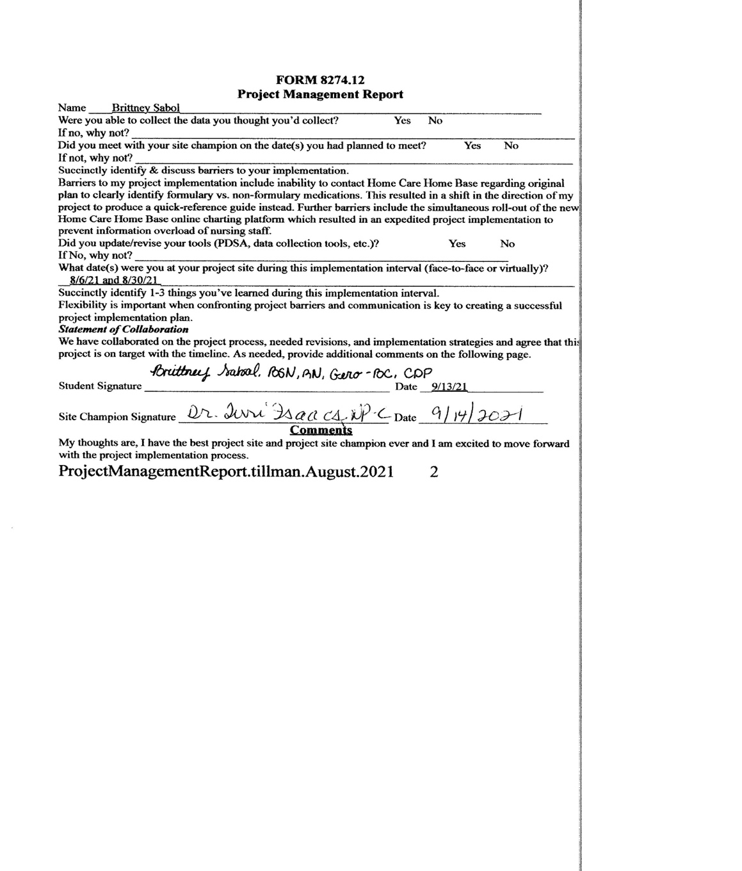
Appendix L
Project Management Report II

Appendix M
Project Management Report III
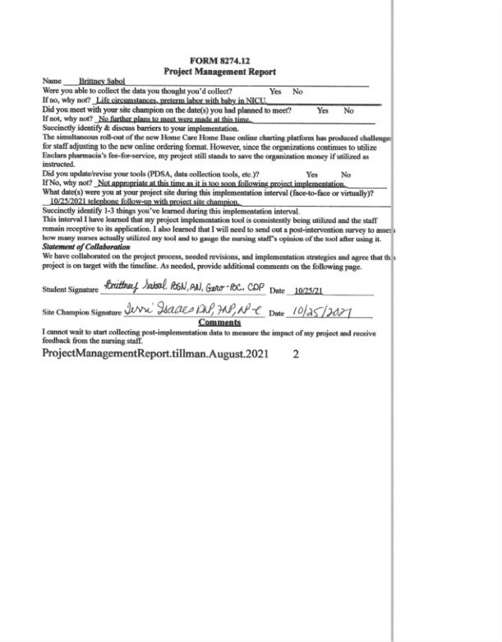
Appendix N
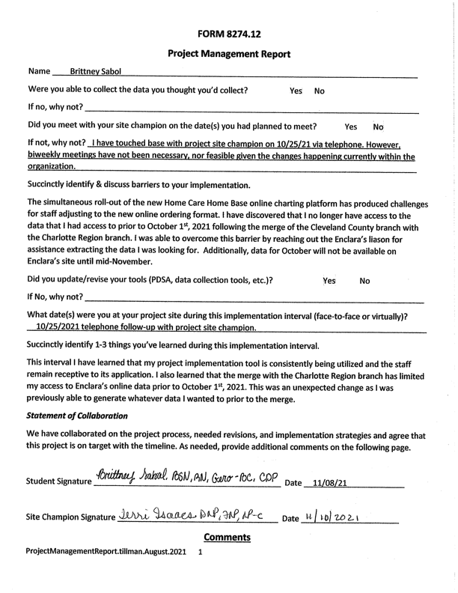
Project Management Report IV

Appendix O
Doctor of Nursing Practice Essentials Table

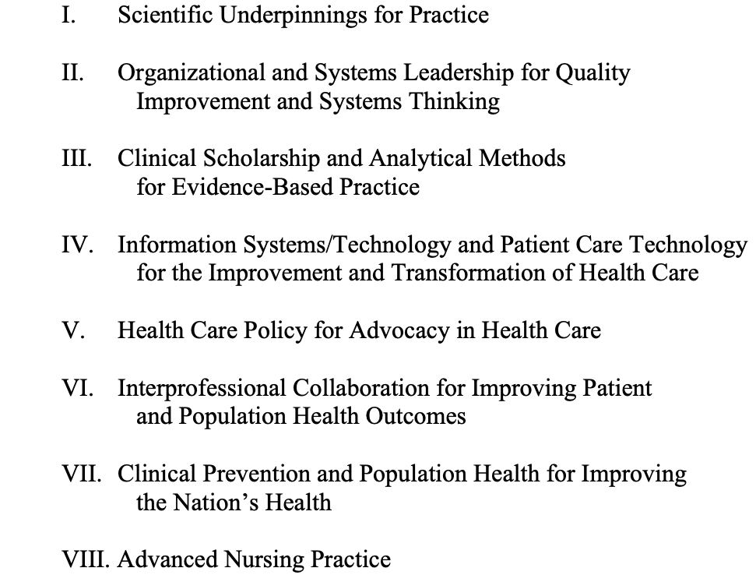
Figure O. Doctor of Nursing Practice Essentials Table (American Association of Colleges of Nursing, 2006).

Appendix P
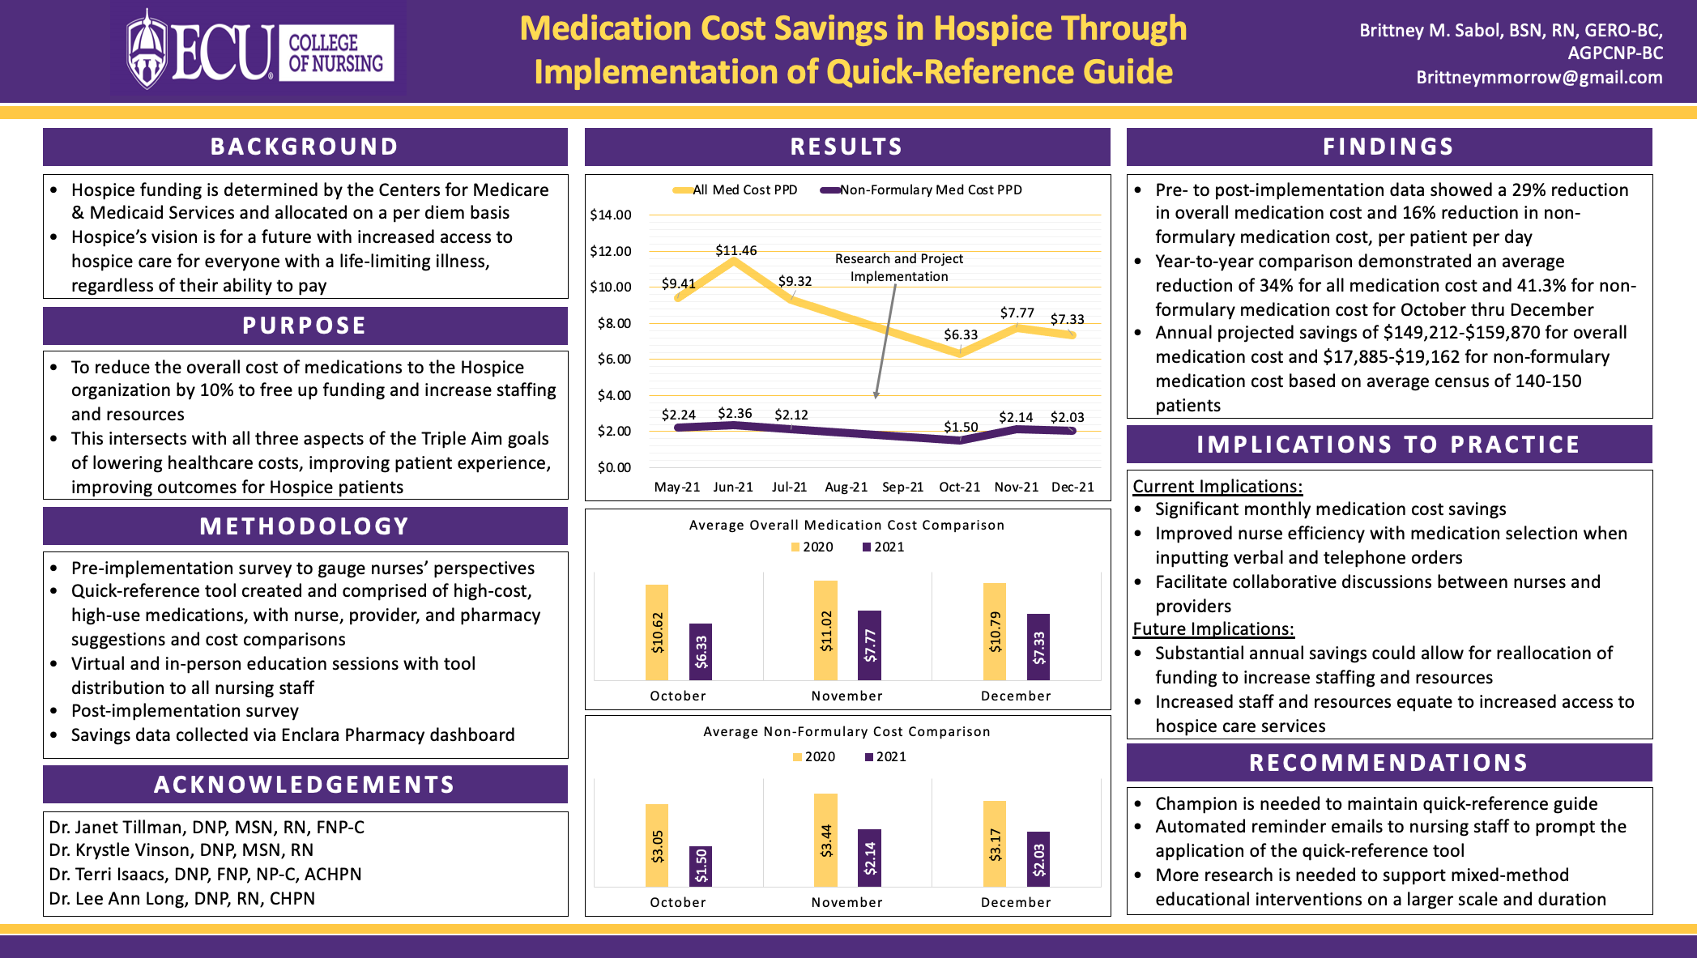
DNP Project Poster

