Optimizing Procedural Room Utilization

Dawn E Clasey
College of Nursing, East Carolina University
Doctor of Nursing Practice Program
Dr. Bradley Sherrod
July 15, 2024

Abstract
Surgical services depend on the efficiency and optimization of each of their surgical suites. Case delays and cases that run-over play a big part in disrupting the scheduling process. The Special Procedure Unit (SPU) services pediatric patients, and it is vital that their procedures are completed on time. Cases must start and end on time to treat the maximum number of patients possible. The SPU must partner with the preoperative unit to identify barriers to patients arriving at the SPU on time for their procedure. A surgical readiness checklist allows the SPU and preoperative unit to identify barriers to patients arriving at the SPU on time. In the electronic medical record (EMR) documentation through EPIC, there are lists of barriers the perioperative unit can fill out that can be captured in reports. Case runover can also create delays in the following cases. Case run-over is an inappropriately scheduled case; with the help of preference cards, EPIC can calculate a provider's last five specific cases and give an accurate posting time for the case to get scheduled. By using the surgical checklist and the preference cards, it was the intention of this project to improve the efficiency of the procedure suites and optimize the scheduled block time to see the maximum number of patients per surgical day. Results from the project showed a reduction in delays by 164 minutes, which was a 23% improvement. There was also a reduction in run-over time by 249 minutes, noting a 57% improvement.

Keywords: run-over, delays, surgical readiness checklist, preference cards, block time

Table of Contents
Abstract …………………………………………………………………………………………...2
Section I: Introduction...…………………………………………………………………..………5
Background…………………………………………………………………….………….5
Organizational Needs Statement……………………………………………….….………5
Problem Statement………………………………………………………………...………7
Purpose Statement…………………………………………………….………….......……7
Section II: Evidence………………………………………………………………………..…..….9
Literature Review……………………………………………………………….…...….…9
Evidence-based Practice Framework…………………………………………………….12
Ethical Consideration and Protection of Human Subjects……………………………….13
Section III: Project Design……………………………………………………………….………15
Project Site and Population………………………………………………………………15
Project Team 16
Project Goals and Outcomes Measures…………………………………………….….…16
Implementation Plan 18
Section IV: Results and Findings…………………………………………….……….…….……20
Results……………………………………………………………….……….….……….20
Discussion of Major Findings………………………………………...…….……………21
Section V: Interpretation and Implications……………………………………...….……………23
Costs and Resource Management………………………………………………………..23
Implications of the Findings……………………………………………………………..24
Sustainability ……………………………………………………………………………26
Dissemination Plan ………………………………………………………………...……27
Section VI: Conclusion……………………………………… ……………………….…………28
Limitations and Facilitators………….…………………………………………..………28
Recommendations for Others……………………………………….…..………….……29
Recommendations for Further Study………………………………………………….…29
Final Thoughts………………………………………………...…………………………30
References……………………………………………………………………………….……….31
Appendices
Appendix A: The Preference Card……………………………………………….………34
Appendix B: Duke IRB Approval……………………………………………….….……35
Appendix C: Project Timeline 36
Appendix D: The Surgical Checklist 37
Appendix E: Driver Diagram 38
Appendix F: Project Budget……………………………………………………………...39

Section I. Introduction
Background
The literature identifies several trends among operating rooms and procedure rooms in efficiency and optimizing room utilization. Efficiency in surgical environments is invaluable, especially in health systems where patients’ health is being impacted by heavy wait times to get scheduled for surgery and first-case delays play a big role in how many cases are done in a day (Morel & Gomez, 2021). The surgical areas produce the majority of income for organizations, delays can reach about $800,000/year. Morel and Gomez (2021) point out the initiative of the Institute of Medicine (IOM), in the 2018 Crossing the Quality Chasm, where efficiency was identified for improvement in U. S. Hospitals. Most surgeries are elective which are known in advance by the team by means of the schedule. The schedule consists of blocks of time belonging to specific specialties or providers and holds the resources needed to perform those specific surgeries. It allows the patient and surgical team a specific standard of expectations when cases are scheduled (Lin & Yen, 2023). Efficiency and optimization are critically impacted when cases are not accurately posted, do not start on time, or run over. This puts strains on the resources needed for the scheduled cases and is impactful on our patients in the form of delays to their scheduled surgery or cancelation.
Organizational Needs Statement
It was identified that the Special Procedure Unit (SPU) had a high number of cases that did not start on time causing downstream delays for patients and providers. The project focused on redesigning the SPU to increase case accuracy by 10%, which aligns with the organization’s commitment to actively seeking solutions to healthcare challenges and moves toward the national benchmark. Benchmarks are vital in understanding the effectiveness of an organization’s efforts compared to similar organizations measuring similar initiatives (Ettorchi-Tardy et al., 2012). Benchmarks in this case allow the project site to see how successful they are compared to other organizations. The national benchmark for annual surgical operating revenue growth rate is 3% (Plescia et al., 2022), and the procedural room currently according to performance review reports is -0.3%. Hospitals nationwide benchmark both efficiency and first-case on-time starts (FCOTS) in surgical settings (Morel & Gomez, 2021), currently the SPU misses this expectation with 852 delayed cases in total (FCOTS and other cases that missed starting on time) in 2022.
Quadruple Aim as Arnetz et al. (2020) explain, this a framework to optimize performance that health systems can use to improve patient experience, population health, healthcare well-being, and reducing costs. Utilizing this framework can improve a healthcare system but it also optimizes reimbursement as value-based care becomes the standard set by the Centers for Medicare and Medicaid Services (CMS). The SPU realizes that they are not utilizing their procedure rooms efficiently nor effectively, often providers are late to start their first cases, and this impacts every case following. The SPU also has extended gaps between cases, often related to combination cases involving radiology. In these combination cases, the first part of the patient’s case is in radiology, then the patient would come to the SPU for the second portion of their case. Anesthesia has partnered with radiology to place a child under anesthesia only once instead of twice, this eliminates sending the child to the Post Anesthesia Care Unit (PACU) between cases. This is the best process for the patient; however, this impacts SPU by delaying their cases a few hours at a time due to delays in radiology.
In 2022 there were 852 cases delayed, one colonoscopy case can cost $4,800/case (Vanvuren, 2018). The total number of minutes in delays can be up to a few hours. If the first case is delayed, they all are delayed. This impacts not only the patient but also the family who have taken off work to support their child in their procedure.
When the cases are delayed or run over, the SPU team has downtime and then is held at the hospital past their scheduled shift to finish the cases that are now starting late. This impacts the work-life balance of the procedure team. The SPU starts at 7:30 and runs until 16:30; however, currently, the team does not leave until past 18:00. The project site’s goal is to utilize procedure rooms at 80%. Project site data currently pulled by performance services, from the software that contains the SPU schedule called Maestro, shows the organization is using one room at 60% and the other room at 30-40%. Incorporating Quadruple Aim concepts will allow the organization to be good stewards of their resources, improve relationships with their patients and families, and allow the project site to see more patients in a day with an efficient schedule.
Problem Statement
The SPU case accuracy impacts unit flow and the ability to schedule patients. Delays affect patients, staff, providers, and the organization negatively. There is currently no process in place to mitigate delays. Cases are delayed 30 – 89 minutes approximately if these are not improved it will impact the ability to provide care to more children needing diagnosis of new disease or maintenance of current disease processes. Gaining 30 minutes adds one more case a day for a patient to receive healthcare. The aim of this project is to improve all case starts by 10%, which will allow SPU the ability to service more patients each day.
Purpose Statement
The purpose of this project was to optimize procedure room time by improving case accuracy and minimizing case gaps by 10% (3 – 10 minutes per delay, per case) which produces improved room utilization, and this gives the SPU the ability to provide care to more patients. Organizational metrics focus on case delays and case run-overs. This project will improve organizational metrics by identifying and correcting the root cause of these metric delays.

Section II. Evidence
Literature Review
Efficient use of a surgical unit organically optimizes the surgical rooms, allowing for the maximum number of cases to be done in one day. In order to achieve this, the SPU needs to reduce the number of minutes each case is delayed from preop to the procedure room. The use of a preoperative readiness checklist can serve as the intervention. The checklist can serve as a visual tool to help organize and maintain workflow. Delays can also come in the form of case run-over which is associated with case posting accuracy. The strategy in searching the following databases was to identify the validity of case delay and accurate case scheduling, as well as an evidenced-based intervention to help optimize the SPU rooms. The databases of CINAHL, Medline, PubMed as well as physical AORN Journals produced 12,379 results on preoperative checklists, and 712 results for improving operating room delays, scheduling cases, or national benchmarks. The level of evidence criteria was level one to level three. The inclusion criteria for this project were whether the literature provided information on preoperative surgical checklists, surgical case delay, and accurate case scheduling. Exclusion criteria were intraoperative checklists, all other checklists, and literature five years or older. All literature kept was appropriate for direct evidence on preoperative checklists, case postings or scheduling, and surgical case delays.
Current State of Knowledge
The literature had little on preoperative checklists and had a moderate amount on both case scheduling and case delays. The literature identified that checklist tools are utilized to establish a standardized process, nurses especially use them as visual indicators that all criteria are met before proceeding on with the established plan for the patient (Mamaril, 2022). The literature also states to achieve optimal patient outcomes, checklists help to improve the surgical processes (Daodu et al., 2023). Literature on surgical scheduling identifies medical technology as a solution to improving accurate case postings, this coincides with using preference cards as an intervention to improve case postings (Lin & Yen, 2023). Preference cards (see Appendix A) are embedded in the case posting and link the provider to this specific case. Lastly, the literature on improving case starts, especially FCOTS. This is identified as a common metric that is benchmarked as a key indicator to improve efficiency among hospitals (Morel & Gomez, 2021).
Current Approaches to Solving Population Problem(s)
The approaches identified in the literature for on-time case starts are checklists and a system called red hat, and blue hat (UNC School of Medicine, 2019). The red hat and blue hat are currently being used currently at the project site; however, it is a modified version of this initiative. The patient wears the blue hat under the red hat, the red hat is a visual cue the patient still has required items before they roll to their surgical case. The blue hat is a visual indicator that the patient is ready. The red hat is removed leaving the blue remaining when the patient is ready to progress to surgery. The population being served at this site is pediatrics, and it is difficult to ensure they wear the hats.
The checklist is currently not implemented at this project site, because this does not require pediatric participation, it would allow the nurse to visually identify the patient’s unmet needs for surgery, which in turn will improve first-case on-time starts (Daodu et al., 2023; Mamaril, 2022). It will be vital to partner with preoperative nurses to help identify any concerns during the project and to create a well-working tool that meets the needs of the SPU and preop. Cases that start on time and are accurate allow for the maximum number of patients to receive care in one day.
The approaches identified for case accuracy were technology-based. Preference cards link the provider to the case posting, using this criterion the scheduling software can identify the last five of these cases and calculate an average of those cases (Lin & Yen, 2023). This average becomes the accurate time the case can be done for this specific provider. This will decrease the time cases run over by posting them with the correct time it takes to complete by this specific provider. No preference cards are used for specific providers currently in the SPU, this gives every provider an established 60 minutes per case when it can take much longer if a provider consistently teaches new residents or uses the same surgical approach.
Evidence to Support the Intervention
Daodu et al. (2023) and Mamaril (2022) explain that checklists are nursing tools that have been utilized to standardize processes. This tool is common in nursing and provides a foundation for busy nurses to ensure all elements that are required for the next phase of care have been met. Pediatric patients are unique because they are unable to provide accurate information on their own. Checklists provide a tool that gives visual confirmation of where the patient is in the process of surgical readiness. Traditionally patients are in their preoperative care an hour to two hours before they have surgery, this time is a busy time especially if it is a first case. There may only be a few patients needing attention at the same time during the day; however, there could be a patient for each operating room during the first cases in any preoperative unit. This project site has over 35 operating rooms, with eight of these being pediatric operating rooms. Checklists are a way to deliver systematic delivery of care, reduce variability or risks, and improve quality (Mamaril, 2022). Evidenced-based checklists communicate information that is reliable and readily available to all of the healthcare teams that utilize it. Gaps in training due to short staffing or nurses that float from other floors benefit from checklists to help ensure all aspects of care are delivered (Dowd et al., 2022). Pediatric patients specifically value repetition, those patients who come to the SPU due to disease progress, feel most comfortable with an established and predictable process, which makes them feel safer when the information delivered is similar to previous visits (Daodu et. al., 2023). The checklist helps organize and direct the care of the patient, it helps the nurse navigate the patient through the preoperative phase into the interoperative phase in a timely and efficient manner (Daodu et. al., 2023).
Scheduling cases accurately makes the best use of the time in SPU, it maximizes the number of patients that can receive the care they need on time. Cases that ultimately run over their scheduled time are a misuse of SPU resources and create a gap in care for the pediatric population that this project site serves. An algorithm is often referred to in surgical scheduling as Lin and Yen (2023) discuss and is often identified with technology. The perioperative platform allows surgery for SPU to get placed into the schedule. How much time associated with this surgery is done through the preference card. If a generic card is used, it establishes a predetermined amount of time. However, not everyone can do the cases in the same timeframe. Often providers teach or allow residents to participate, while others do not. In conversations with the site preference card champion, removing this predetermined time and personalizing the case to the provider through the preference card allows the perioperative platform software to calculate the last five cases and determine an accurate case posting time (P. Brantley, personal communication, August 18, 2022). Currently, this is not used in the project site and will allow accurate scheduling which will allow optimization of the SPU.
Evidence-based Practice Framework
This project will be executed using the theoretical framework of the Stakeholders Theory developed by R. Edward Freeman (Bridoux & Stoelhorst, 2022). It was originally designed for
strategic management. This theory adopts the stakeholder’s perspective and strategy. R. Edward Freeman wrote Strategic Management: A Stakeholder Approach, in 1984, since then there have been several versions of this theory which include areas of corporate governance (Freeman, 1984; Keremidchiev, 2021). This theory emphasizes the concern and making decisions that create value for the organization (Bridoux & Stoelhorst, 2022). This theory helps those who wish to improve healthcare in their organizations by engaging those who have influence in doing so, this helps redesign old or outdated policy and develop standard work through evidence-based practices. This project focused on partnering with all stakeholders to identify targeted areas in their departments to help improve on-time starts.
This project identifies the stakeholder’s individual goals and incorporates them into the intervention. This project can be expanded to meet a greater need in preoperative surgical care. The goal for this project site was to improve SPU case starts, but the intervention can be used for all preoperative cases if it is adopted into their practice. The stakeholders in the preoperative unit are the manager, assistant manager, and preoperative charge nurse. Working with this team and anesthesia to design a preoperative readiness checklist that is specific to this project but fits the overall needs would be valuable to the preoperative unit.
Ethical Consideration & Protection of Human Subjects
There are no ethical considerations for this project, it does serve to impact the pediatric population that is seen in SPU. The intervention is designed to create a more concise workflow for staff that identifies needs that have not been met in a timely fashion to allow all patients to arrive at their scheduled case on time. There is no direct patient care for this project, it is addressing the workflow of the nurse caring for the patient. This is for every patient that SPU has scheduled each day. This would not be for any pediatric patients going to the operating room that share the same preoperative area even though the needs are similar to the SPU patients. The checklist intervention may need minor additions to help meet all those patients' needs. The goal was to use this as a visual tool to optimize the preoperative time to successfully move to the interoperative phase on time. There is not any potential harm or ability for this population to be taken advantage of it is in the patient’s best interest to arrive on time for their procedure. Undue stress can be avoided by improving delays for pediatric patients and their families to their scheduled case on time. The checklist will have a patient demographic label on it; the purpose of this patient health information (PHI) is to ensure every patient receives a checklist. All checklists are shredded before leaving the preoperative unit at the end of the day. These patients have not eaten for a few hours, delays only exacerbate this and create an unpleasant patient and family experience.
In order to prepare for the formal approval, several modules from Collaborative Institutional Training Initiative (CITI) were taken. These modules focused on research pertaining to conduct in public training and human research, both of which had several submodules of training. The project site has its own CITI modules that were required to involve vulnerable subjects (such as pediatric patients) and biomedical research. The project site has its own Institutional Review Board (IRB), to apply the director of nursing research was contacted. They have provided directions on applying to and approval of the project site’s IRB. Submission of a nursing organizational feasibility form and exempt protocol template is required for approval. Official approval was obtained on December 8, 2023, from the project site IRB, please see Appendix B.

Section III. Project Design
Project Site and Population
The facilitators in this project are the staff in the charge nurses in the SPU and preoperative unit and the assistant nurse manager over the preoperative unit. These specific facilitators are the driving team in this project. The medical director is another facilitator; however, he is not as directly involved as the SPU and preoperative team. The medical director is key to understanding key barriers and helps give direction or is critical to help find solutions that work between departments. One barrier to this project is total buy-in from the preoperative team. These come in the form of getting the team to document delays in EPIC, and agreement on why there needs to be a checklist and what should be on the checklist. Part of this is because this unit does not seem to see the impact of delayed cases as it impacts SPU, nor are they willing to adjust their workflow willingly. SPU has been filling in for the preoperative unit by doing tasks that should be done by the preoperative unit. The SPU will no longer be able to help facilitate by filling in as the SPU procedure rooms are optimized. This is a long-standing disconnect that has gone unaddressed and is now becoming disruptive to both units. Another barrier is scheduling, it is becoming more evident that providers do not schedule cases accurately. Part of this is educating the provider, and part of this is helping the provider understand their specific posting times. Most providers do not realize how impactful it is to SPU when cases run over time.
Description of the Setting
The SPU is a procedure unit that has two procedure rooms where general anesthesia (GA) cases are performed. There are two glass-door procedure rooms where non-GA cases are done, usually with a local anesthetic. The GA cases come from the preoperative unit to the SPU and can be both in-patients (already at the hospital receiving care) or out-patients, which come from the patient’s home. If there are non-GA cases, they come directly to the SPU, usually an out-patient but they can be in-patients. If the SPU is caring for in-patients, this would also involve patient transport. Often our patients have multiple procedures which also involve radiology or interventional radiology. Lastly, the SPU has a mobile unit called the travel cart which supports cases in the operating room.
Description of the Population
The population at the project site was the staff in the preoperative unit and SPU. Anesthesia, the medical director, and gastrointestinal (GI) providers are also part of the team. The team services children with a wide range of needs, they must be placed under GA to get the care they need, which creates the specific population for this project.
Project Team
The project team consists of the charge nurses in the SPU and in the preoperative unit. It also consists of the medical secretary in the SPU. The project team also consists of the GI providers and the medical director. Lastly, the project team consists two of the SPU preference card champions, the operating room preference card champion helped train and set up the cards for the SPU champions.
Project Goals and Outcome Measures
The goal of this project was to optimize the procedure rooms. To do this a surgical readiness checklist was used in the preoperative unit to help improve workflow and keep it moving through as a communication tool. With the checklist, anesthesia and the providers were able to see where the patient was in the preoperative process. The checklist was able to help keep the preoperative team on target. There was a target time listed at the top with a targeted roll time to SPU (seven minutes before case start). Some vital phone numbers were added on the bottom of this checklist as references, often the preoperative team were confused about whom to call, so providing them with some on-hand direction was helpful. The preference card helped schedule cases into the procedure unit with accurate times based on the historical data from those cases. This has allowed the schedulers to better anticipate and schedule within the working hours of the unit. Data analysis came pre-data and post-data reports provided by performance services.
Description of the Methods and Measurement
Performance services created a dashboard for the SPU which allows leadership to visually see performance measures. Data has been pulled by date and provider and filtered into a report. Cases are delayed 30 – 89 minutes currently due to scheduling inadequacy. To evaluate if the interventions improve SPU the optimization of the procedure rooms, looking at case times prior to the interventions by 90 days and then the 90 days during the interventions.
Comparing how the SPU performed before the implementation of the surgical checklist and preference cards will allow the project site to see if an improvement was made with the intervention. The data that is needed were if the cases started on time (yes/no), if they did not, next was to identify a delay reason listed by the preoperative unit nurse (yes/no). If there was a delay reason, it was important to identify the top three reasons. These barriers would lead to an adjustment to the surgical readiness checklist. Lastly, was to ensure that every patient in the preoperative unit got a readiness checklist, if not this can contribute to unreliable data. The preference cards were to accurately schedule cases that realistically can be completed in the operational hours of the SPU. This was identified if cases ran over their scheduled times, and required pre and post data, 90 days before the intervention and 90 days during the intervention.

Discussion of the Data Collection Process
The data that determines if the performance services information is accurate is if the surgical readiness checklist was used for the SPU patients. A list of all the patients during the intervention implementation period will be provided to the preoperative unit with a surgical readiness checklist for the following day. Extra surgical readiness checklists will be printed and provided for add-on cases. The preoperative unit will be asked to return these sheets to the charge nurse. If every patient scheduled that day gets a returned and filled out checklist it reinforces performance services data. Any patient missing data could show a percent error in the data for on-time starts. The reasons why the case rolled to SPU late are also important and will be kept track of this is standard work that has not been used previously by the preoperative unit. The preference cards will be tracked in a similar way, cards will be made for each provider and for each of their cases. The EPIC preference card team will help establish they are correctly implemented to adjust with historical case data. The medical secretary will help identify as they schedule cases the time changes in EPIC and it is not adjusted manually. This creates case accuracy through EPIC. Communication will be given to off-site schedulers if they place case requests in place of the provider. This would also include any residents or fellows.
Implementation Plan
November 2023 will consist of the preference card champions’ training, modules, and meeting with the charge nurse on the preoperative unit. Access to the preference cards and their creation was in December 2024, as well as the meeting with EPIC and the medical secretary. Prior to implementation, a meeting was held with the EPIC team and the medical secretary will allow her to understand the changes to expect during the scheduling process and ask any questions, the project timeline is indicated in Appendix C.
Meetings with the preoperative team, charge nurse, and assistant nurse manager were held in December 2024. On January 2nd, 2024, both the preference cards and the checklist went live. The checklists were placed in a specified folder for evaluation after 17:00 every evening. The checklists were collected and checked for accuracy. Accuracy means that every SPU patient received the intervention. Feedback was given to the charge nurse if any patients were missing from the previous day. Regular rounding of the preoperative unit and the SPU to answer any questions and receive feedback. Adjustments were made as they were identified or needed. February 26 – 29, 2024, a meeting with performance services to evaluate the data being generated by EPIC and adjust the dashboard as needed. April 19th, 2024, ended data collection and collection of any final checklists, see Appendix D. Performance services meetings took place the week of April 22 to 26, 2024 to review the data collected through EPIC. May through July the data was evaluated and the results of the effectiveness of the interventions were established. An overall evaluation of the project, including what could improve on the work already done. Documenting where errors occurred during the project and any major findings. Evaluating the cost associated with the project, sustainability, and dissemination. The driver diagram clearly identifies the project AIM, drivers and stakeholders, see Appendix E.

Section IV. Results and Findings
The project identified several inefficiencies that cumulatively contributed to case delays and runovers. Data was collected between 1/22/24 – 3/22/24 to identify how many cases were delayed and ran over in minutes. Data was collected on delay reasons, how many cases were done, how many surgical checklists were missed, which rooms were delayed, and which cases were in each room. The delay reasons that were documented were also collected. Lastly, during SPU team huddles, some discussion of the GI-related run-overs helped solve some run-over reasons related to preparation follow-through in these pediatric patients.
Results
During the implementation of the surgical readiness checklist, 366 cases/patients were included between 1/22/24 – 3/22/24. During this time the preference cards were being built, posted to cases, and went live at the end of business day on 3/15/24. Out of the 366 cases/patients 243 surgical readiness checklists were returned and confirmed to be used on SPU patients. During this time 188 cases were delayed, and 179 cases ran over. The delay case minutes average totaled 4,336 and the runover minutes average totaled 3,895. Delays per room noted: room one had 39 cases, room two had 138 cases, room three had 18, and room four had none. The top five documented delay reasons were prior case run-over with 58, provider consent with 19, history & physical examination (H & P) with nine, anesthesia consent with seven, and SPU changed case without notifying the preoperative unit with five. Since the activation of the preference cards, the delays have decreased by an average of 164 case minutes for a 23% improvement, and the run-over cases decreased by an average of 249 case minutes for a 57% improvement. By allowing the preference card to help determine the correct time a case should be posted by using historical data when those specific types of cases have been completed allows future cases to get scheduled with accurate times.
Discussion of Major Findings
During this time the project manager (PM) discovered several delay reasons that none of us planned on such as patients who came to get a procedure had other appointments before coming to the preoperative unit on the fourth floor which delayed them. Most of the delays almost mirror the run-over in occurrences. During the huddle, the SPU staff had an open discussion around GI relayed runovers. It was discovered that when GI cases ran over that it was a direct correlation to whether the patient was compliant with the colon cleanse preparation instructions. If the patient is not compliant with the GI preparation instructions, during scoping the provider would have to clean out the patient’s bowels to see the intestines to identify the disease process and to take pictures or films. This is extremely time-consuming which often leads to case run over. Once the patient is under anesthesia, the provider starts the case they are then committed to case completion whether or not they did good case preparation. This patient population is pediatrics, which may not be willing to follow the instructions of the colon preparation. Other findings were the different types of delay reasons. Some were not anticipated and due to this project were discovered. One of these barriers was delays from fourth-floor appointments, this could mean the patient was having an infusion or was being treated for cancer. These are time-consuming clinic visits and may need their times adjusted to create accurate clinic visits in the future.
The literature did support the PM’s findings, checklists in this case did provide reliable information which was not being charted in EPIC (Dowd et al., 2022). Had the preoperative unit been charting the barriers in EPIC, reports could have helped discover some of these barriers. This project allowed nurses to indicate delay reasons and because the reasons were documented on the checklist these barriers can be addressed. The checklists delivered a systematic way of capturing this data which reduced variability to improve quality by capturing delay reasons (Mamaril, 2022). Lin and Yen (2023) discussed an algorithm to establish truth in posting by using technology. This is exactly what the PM did by using EPIC, the perioperative scheduling platform uses the historical times from specific providers doing specific cases. EPIC will take the last ten cases and discard the five cases that have the most variability. It then takes the remaining five and takes the median time. It will start to schedule the future cases with the new calculated time. If EPIC cannot find the case time through this method, it will run through methods of similar requirements, and lastly, if it fails to locate a time still it will then resort back to the original standard time to ensure the case is posted. Usually, this happens if there is vital information missing from the case posting which would prompt a scheduler to review the case.

Section V. Interpretation and Implications
Costs and Resource Management
This project happened at an opportune time; the SPU was slightly overstaffed in anticipation of new services being added to the schedule. One new service was added and an additional day of another was added. The SPU was anticipating several new services and more block time filled by current services. This has not happened due to losing two providers to retirement, two providers to other opportunities at different organizations, and the medical director to another organization. Anesthesia also lost several staff members and without anesthesia, we are unable to open rooms as was originally planned. The time spent by the SPU team and the preoperative unit was easily met during downtime and between cases. The supplies used were printer ink and paper for the surgical readiness checklists. The time spent calculating the data was most extensive, this was a manual process and took three to four hours every week. The SPU and the preoperative unit did not suffer unfinished work or delays due to this project.
The printer toner is about $117.00 for all colors, and one ream of paper with 500 sheets is approximately $10.00, the printer would be something to consider in purchasing if the project site did not permit to use it for the project as well as two computer laptops. Internet access would have also been something to think about to obtain all the data if the project site did not already provide this. The EPIC program did not need purchasing, and the platform was already in place. The real cost is in the staff that helped, five nurses (three preference card champions, one with access and two for SPU) one preoperative charge nurse and one student nurse, one medical secretary, and one nursing assistant. The cost of the nurses is approximately $36.41 per nurse according to Indeed, (2024a,b,c), a medical secretary is approximately $18.82, and a nursing assistant is $16.94. To employ each for one hour a day for forty-five days would amount to $8,192.25 for the nurses, $846.90 for the medical secretary, and the nursing assistant would have cost $762.30, for a total of $9,801.45. The time it took one nurse to calculate the data alone is an additional $546.15. If this project had to take into consideration facility charges or leasing of equipment/tools this would have increased the budget significantly, the project budget is in Appendix F.
Implications of the Findings
The SPU redesign project is in the process of optimizing the procedure rooms. The more data provided to EPIC to work with for each case, the more accurate the case postings will be. If a provider starts teaching fellows and allows them to scope instead of the primary provider and it takes longer, this will start to make the case run over. As this happens, EPIC will readjust the case postings to reflect the longer running case time. Why the case is taking longer does not matter, having the case postings adjusted to accommodate why does matter. This would be the same if a provider stopped teaching and his cases ended earlier, EPIC would adjust for the new times.
The providers may not like this initially because it would mean they may not be able to schedule as many cases. Often the provider puts the number of cases they know they can do in an amount of time. This does not consider set-up time or clean-up time (case turnover). It also will not consider any teaching or service-related delays such as GI clean-out preparation that the patient must do for the provider to visualize the surgical field. Inappropriate clean-out may still happen and must be considered to schedule the case accurately. The SPU has morning block times and afternoon block times. The providers operate in their block time, morning times are preferred over afternoon times. The reason for this is truth in posting, none of the providers want to operate behind a provider that continually goes over their times (run over). This then delays all of their patients and makes the provider late for what they have planned after cases. This prevents the SPU from filling in the afternoon block times with willing services to risk leaving later than anticipated. Due to this, it would prevent the procedure rooms from reaching the goal of utilizing the entire day in both procedure rooms. To make the afternoon times more marketable to other providers with additional services, the SPU must accurately post their cases. This project will continue to make progress in the future due to EPIC calculating accurate case times. This will continue to optimize the procedure rooms and utilize all of the procedure time available for patient care.
Implications for Patients
The implications for patients will significantly impact the ability to be seen, diagnosed and treated in a timely manner. Currently, patients wait a month or more; by optimizing the SPU surgical suites, this would reduce the wait time by weeks. The implication for patients is that more patients can be seen a day, which will allow more flexibility in patients being seen each day and earlier than in the SPU’s current schedule. The SPU will be able to provide new services in an efficiently run room.
Implications for Nursing Practice
During project implementation the SPU was fully staffed and often flexed off due to a procedure room being down. This happens when there are no providers that have agreed to block time. Part of this is due to the inefficiency in posting cases, and part of this is circumstantial due to anesthesia staffing and providers leaving the organization. The nursing team has commented in the past regarding not enough cases and too many nurses. Since the project began SPU added additional block time to a service they already have and new services. This increased the schedule by three additional days a week. The nursing team is looking forward to a busy unit, within a couple of weeks one more service will be added to the SPU’s non-anesthesia procedure rooms.
Impact for Healthcare System(s)
As the SPU increases volume, it will show a positive increase compared to projected volumes in the productivity reports. This report is how leadership determines how well the unit is doing. Currently, SPU has variants noted in their staffing versus projected cases. The SPU leadership can speak to these variants and can explain why they are there. However, it will take the completion of optimizing the SPU rooms and onboarding of new services, as well as providers to create the growth the SPU needs. Once this happens, the variants in the reports will show how SPU is preforming for the health system. If a unit is performing below projected cases, the organization is losing money per case. If the unit is performing at or above the projected cases it is breaking even or making money. Following the recent COVID pandemic, the health systems are still trying to recover finically. A unit that is not covering the cost of its cases or making a profit significantly impacts the organizations’ ability to rebound from the previous finical impact of the pandemic (American Hospital Association [AHA], 2021).
Sustainability
The sustainability is in the EPIC preference cards and to continue to identify case delays. Once all the preference cards are activated for every provider and each of their cases, there will be minor edits to update the cards information, but it will not change the functionality of EPIC to create truth in posting. The preference card champions must continue to update them every year and add any new cards for new providers or cases. If this continues, the attention on delays will mainly concern first case on-time starts which is a metric most surgical units have. This will continue to be addressed as a metric for the SPU, barriers need to be identified and standard work created or adjusted. Partnering with other teams to help solve any barriers to the root of the cause is vital since most surgical services depend on many other areas to keep it on track and operational.
Dissemination Plan
This project can be disseminated in other parts of the organization. In pediatrics, the project can work for the current north operating rooms. It can also work in the adult GI units and other procedure units. It would be beneficial in surgery centers and sedation units. In this project site, it would also be beneficial in the eye center. In discussions with the project site, the next step would be to utilize the surgical readiness checklists for the pediatric operating rooms. Once the project was completed, July 8th, 2024, a presentation at East Carolina University was given reviewing the project with its outcomes, and July 24th, 2024, a presentation to the SPU team.

Section VI. Conclusion
Limitations and Facilitators
Limitations found in this project began with the project site champion where time was very limited and needed advance scheduling. The medical director was a limiting factor as they played a big part in directing and partnering with anesthesia to help schedule them into open block time. Often the SPU needs to schedule into a room for weeks with the current availability and often anesthesia requires over half the block time utilized before guaranteeing services. This is not something the SPU can do, as they need the coverage first before can start to schedule into a room. The medical director was out for several months and then took a position at another organization. The preoperative unit team did not have direct leadership during part of the project and the assistant nurse manager retired, which posed several barriers in directing the preoperative team in documenting delays in EPIC and consistently using the surgical readiness checklist. Limitations on time were a factor as the project required manual documentation of the data. The preference card champions needed access to implement the cards, after they are trained, this access would have been given. However, it was discovered that if they were given access, they would have the ability to manipulate the OR’s cards. Limited access was not possible because it would remove access they needed to their current processes. An outside preference card champion with complete access stepped in to help. Lastly, IT had to build the section in EPIC to activate the ability to use preference cards the way it was needed, this went live later in the project.
The facilitators that helped were the preference card champions in the SPU, they helped build the cards and implemented the cards. The SPU medical secretary schedules for the SPU and often lets the preoperative unit know of add-on patients for the surgical readiness checklists. The preoperative unit charge nurse with the help of the NA I, got the surgical readiness checklists ready for each day and distributed them to the nurses with the patient's chart.
Recommendations for Others
The recommendation for others to duplicate this project is to start planning early and if there is an IT portion to try and implement this as soon as possible even if you do not use it right away to identify any technical barriers. Moran et al. (2024), explained in coordinating with the organization, including IT solutions it is best practice to plan ahead to avoid barriers that may delay parts of the project. Partner with your site champion to identify times to meet early and get those meetings on the schedule ahead of time. Identify early how the project can sustain itself and prepare for that by partnering with those who can keep it going. Often the clinical ladder will have projects for the nurses who want to move up and part of this is to work on those projects all year long. This can be a talking point to help identify those who would like to participate in the project's sustainability.
Recommendations Further Study
Recommendations for further study are to extend the surgical checklist to the pediatric OR. The preference cards are currently being used in the OR; however, the preoperative unit felt the surgical checklist worked well for the SPU and would like to extend its use to the OR. Paterson et al. (2023) and Harris et al. (2022), both state in their studies that it is vital the checklist is developed by multi-disciplinary healthcare team and decreased barriers leading to desired patient outcomes. This checklist was developed by SPU, anesthesia, providers and the preoperative unit creating a multi-disciplinary checklist. This could help improve the OR’s first case on-time starts. It could also help them identify barriers to those delays in their first cases. It would also be recommended that other procedural areas implement preference cards to help them optimize their rooms. Schedules that do not optimize their rooms create waste in utilizing their resources and not utilizing the procedure time to help as many patients as possible per day. This can also get extended to the adult GI procedure units.
Final Thoughts
In evaluating this project, any healthcare organization can benefit from using its resources fully and efficiently. Looking at how the organization can help more patients per day with the time that is currently available and evaluating how the unit can change to operationalize a more efficient system. Patients wait weeks or months to be seen, diagnosed, and treated. If old and outdated practices were reevaluated, they would not have to. More patients can be helped by utilizing all of the operational hours of the procedure room, by making it more efficient, and by posting accurately. Optimizing provider block time, inviting those who would like to do cases, and limiting those who do not use their block time by 70%. Having a provider only post a few cases is also not a good use of the procedure room and its resources. The goal of the SPU is to have all the rooms running optimally, add services, and provide care with early diagnosis that leads to early treatment. The only way to do this is to see more patients each day by using our current resources responsibly.

References
American Hospital Association. (2021, March). Fact sheet: Hospitals face continued financial challenges one year into the COVID-19 pandemic: AHA. https://www.aha.org/fact-sheets/2021-03-16-hospitals-face-continued-financial-challenges-one-year-covid-19-pandemic
Arnetz, B. B., Goetz, C. M., Arnetz, J. E., Sudan, S., vanSchagen, J., Piersma, K., & Reyelts, F. (2020). Enhancing healthcare efficiency to achieve the quadruple aim: An exploratory study. BMC Research Notes, 13(1), 1-6. https://doi.org/10.1186/s13104-020-05199-8
Bridoux, F., & Stoelhorst, J. (2022). Stakeholder theory, strategy, and organization: Past, present, and future. Strategic Organization, 20(4), 797–809. https://doi.org/10.1177/14761270221127628
Daodu, O., Sunba, S., Pentz, B., McRobie, A., & Brindle, M. E. (2023). Adolescent experiences of the safe surgical checklist and surgical care processes. Pediatric Surgery International, 39(1), 107- 108. https://doi.org/10.1007/s00383-023-05396-z
Dowd, S., Thompson, J. A., Pearson, J. A., Pinero, S., & Simmons, V. C. (2023). Education for registered nurses completing preoperative anesthesia interviews: A quality improvement project. Journal of PeriAnesthesia Nursing, 38(3), 382–393. https://doi.org/10.1016/j.jopan.2022.06.003
Ettorchi-Tardy, A., Levif, M., & Michel, P. (2012). Benchmarking: A method for continuous quality improvement in health. Healthcare Policy | Politiques de Santé, 7(4), e101-e119. https://doi.org/10.12927/hcpol.2012.22872
Freeman, R. E. (1984). Strategic management: A stakeholder approach. Pitman.
Harris, K., Søfteland, E., Moi, A. L., Harthug, S., Ravnøy, M., Storesund, A., Jurmy, E., Thakkar, B., Haaverstad, R., Skeie, E., Valen, H. W., Sevdalis, N., & Haugen, A. S. (2022). Development and validation of patients’ Surgical Safety Checklist. BMC Health Services Research, 22(1). https://doi.org/10.1186/s12913-022-07470-z
Indeed. (2024a, March 4). Registered nurse salaries in Durham for duke health. https://www.indeed.com/cmp/Duke-Health-1/salaries/Registered-Nurse/Durham-NC
Indeed. (2024b). Medical secretary salary in United States. https://www.indeed.com/career/medical-secretary/salaries
Indeed. (2024c). Nursing assistant salary in Durham, NC. https://www.indeed.com/career/nursing-assistant/salaries/Durham--NC
Keremidchiev, S. (2021). Theoretical foundations of stakeholder theory. Bulgarian Academy of Science, 30(1), 70–88. https://tinyurl.com/jhk76vzd
Lin, Y. K., & Yen, C. H. (2023). Genetic algorithm for solving the no-wait three-stage surgery scheduling problem. Healthcare, 11(5), 739. https://doi.org/10.3390/healthcare11050739
Malley, A., Kenner, C., Kim, T., & Blakeney, B. (2015). The role of the nurse and the preoperative assessment in patient transitions. AORN Journal, 102(2), 181. https://doi.org/10.1016/j.aorn.2015.06.004
Mamaril, M. (2022). Development of an evidence-based pediatric preoperative risk assessment checklist. Journal of PeriAnesthesia Nursing, 37(5), 589-594. https://doi.org/10.1016/j.jopan.2020.12.004
Moran, K. J., Burson, R., & Conrad, D. (2024). The doctor of nursing practice project: A framework for success (4th ed.). Jones & Bartlett Learning.
Morel, S. D., & Gomez, N. A. G. (2021). Improving on-time first case starts: An integrative review and quality improvement project plan. Journal of PeriAnesthesia Nursing, 36(6), 717–723. https://doi.org/10.1016/j.jopan.2021.02.002
Paterson, C., Mckie, A., Turner, M., & Kaak, V. (2023). Barriers and facilitators associated with the implementation of surgical safety checklists: A qualitative systematic review. Journal of Advanced Nursing, 80(2), 465–483. https://doi.org/10.1111/jan.15841
Plescia, M., Diaz, N., & Masson, G. (2022, August 8). 83 hospital benchmarks: 2022. https://tinyurl.com/rececd4m
UNC School of Medicine. (2019, June 7). Perioperative Care Coordination . https://www.med.unc.edu/anesthesiology/enhancedrecovery/wp-content/uploads/sites/492/2019/02/PerioperativeCareCoordinationToolkit.pdf
Vanvuren, C. (2018, July 12). Cost of a colonoscopy in the U.S.: What you need to know. https://www.newchoicehealth.com/colonoscopy/cost

Appendix A
The Preference Card
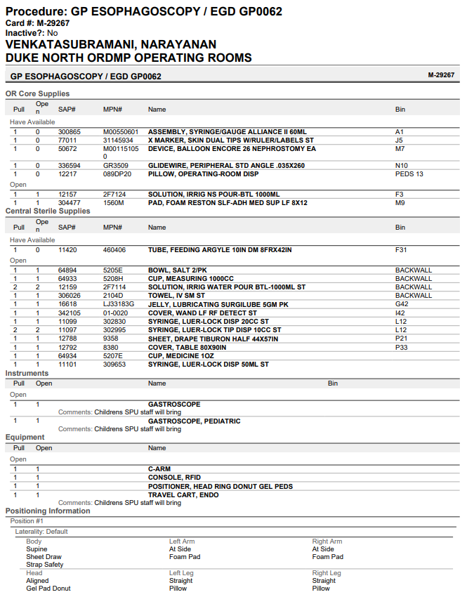

Appendix B
IRB Approval
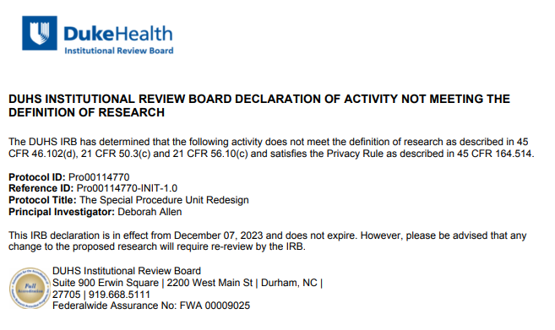

Appendix C
Project Timeline
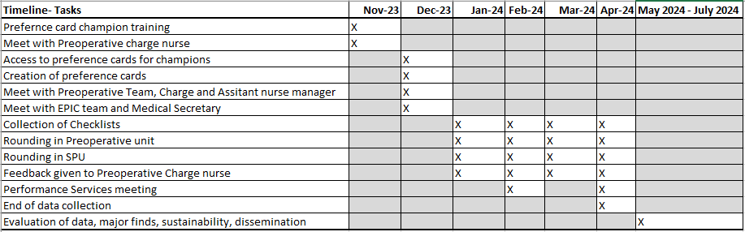

Appendix D
The Surgical Checklist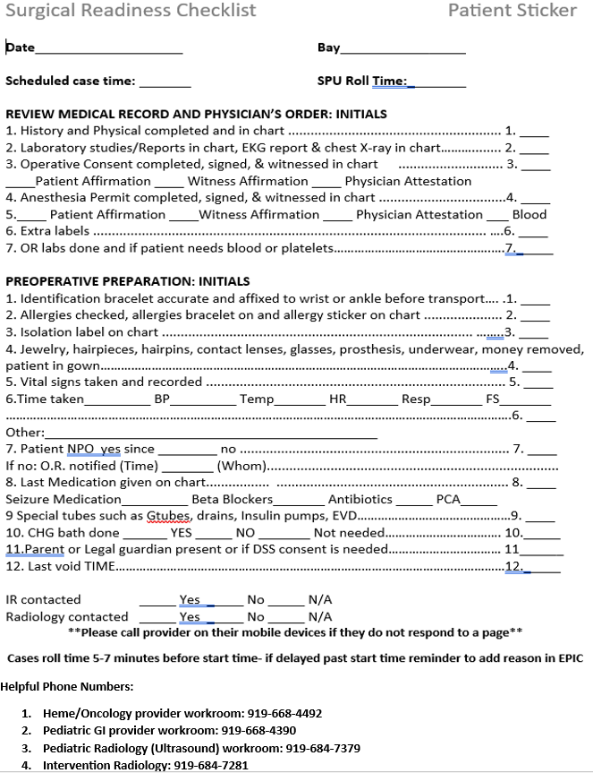
Appendix E
Driver Diagram
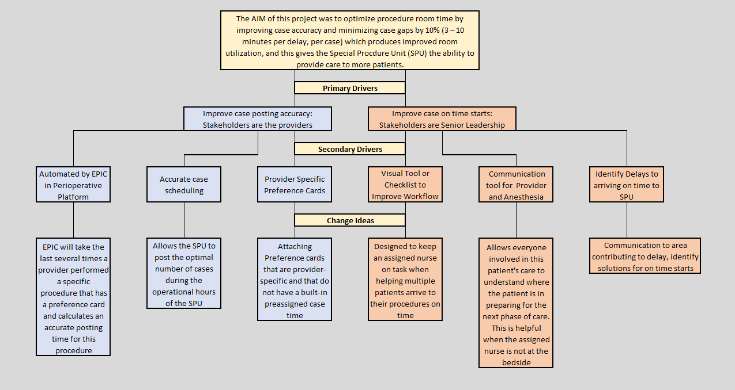

Appendix F
Project Budget
