DNP Paper

Amanda Laughlin
College of Nursing, East Carolina University
Doctor of Nursing Practice Program
Dr. Margaret Dillon
July 18, 2022

Notes from the Author
This project would not have been possible without the support, encouragement, and love from my husband, Seth Laughlin, and two children, Anabelle and Evan. A special thanks to my friend Heather Thienpont for her creativity and assistance with my advertising material and excel graphics. Additionally, I appreciate my mother, Nel McLawhorn being my cheerleader and realizing when I needed a helping hand with my children due to various project deadlines. I would like to express my gratitude to Dr. Dillon for your support, guidance, and encouragement throughout the length of this project. Lastly, thank you to my project site for supporting me during this endeavor and valuing the importance of supporting breastfeeding women in our rural community.
Abstract
Breastfeeding provides numerous health benefits to women and their infants. Even with knowledge of the protective benefits of breast milk, there continues to be early breastfeeding discontinuation. The state and national breastfeeding rates fall below Healthy People 2030 goals. There are various reasons for breastfeeding cessation, including concerns about supply, low socioeconomic status, lack of maternal confidence, and inadequate social support. Social support for breastfeeding women has been shown to be one of the most critical factors influencing breastfeeding exclusivity and duration. Social media support groups are among the most frequently cited approaches in the literature for supporting breastfeeding mothers during the postpartum period. Social media support groups are easily accessible, allowing support to be provided to a larger group of individuals. This paper discusses the implementation of a Facebook breastfeeding support group with the aim of increasing breastfeeding duration for mothers in a rural community. This project demonstrated that providing breastfeeding support through Facebook improves breastfeeding duration.
Keywords: breast milk, breastfeeding, breastfeeding duration, breastfeeding support group, Facebook

Table of Contents
Notes from the Author……………………………………………………………………………2
Abstract …………………………………………………………………………………………..3
Section I: Introduction ..………………………………………………………………………… 6
Background……………………………………………………………………………….6
Organizational Needs Statement………………………………………………………….7
Problem Statement………………………………………………………………………..7
Purpose Statement………………………………………………………………………...8
Section II: Evidence………………………………………………………………………………8
Literature Review…………………………………………………………………………8
Evidence-Based Practice Framework……………………………………………………12
Ethical Consideration and Protection of Human Subjects……………………………….13
Section III: Project Design……………………………………………………………………….14
Project Site and Population………………………………………………………………14
Project Team……………………………………………………………………………..16
Project Goals and Outcomes Measures………………………………………………….17
Implementation Plan…………………………………………………………………….18
Timeline…………………………………………………………………………………19
Section IV: Results and Findings……………………………………………………………….20
Results…………………………………………………………………………………..20
Discussion of Major Findings…………………………………………………………..21
Section V: Interpretation and Implications……………………………………………………..22
Costs and Resource Management………………………………………………………22
Implications of the Findings…………………………………………………………...23
Sustainability ………………………………………………………………………….26
Dissemination Plan …………………………………………………………………....26
Section VI: Conclusion………………………………………………………………………...27
Limitations and Facilitators…………..………………………………………………..27
Recommendations for Others………………………………………………………….27
Recommendations for Further Study………………………………………………….28
References……………………………………………………………………………………..30
Appendices………………………………………………………………………………….....34
Appendix A: Literature Matrix………………………………………………………..34
Appendix B: Survey…………………………………………………………………...35
Appendix C: Poster……….…………………………………………………………...37
Appendix D: Project Timeline………………………………………………………..38
Appendix E: Figure 1…………………………………………………………………39
Appendix F: Figure 2…………………………………………………………………40
Appendix G: Table 1………………………………………………………………....41

Section I. Introduction
Background
Breastfeeding provides the optimal standard of infant nutrition with numerous health benefits and reduces the long-term health risks for infants and mothers (Boateng et al., 2019). “The World Health Organization, Centers for Disease Control and Prevention, and the American Academy of Pediatrics all recommend early initiation of breastfeeding (within one hour of delivery), exclusive breastfeeding for the first six months of life, and continued breastfeeding for at least two years” (Boateng et al., 2019, p.2). Infants receiving breast milk have a decreased risk of long-term health conditions such as obesity, diabetes, otitis media, respiratory tract infections, and gastrointestinal infections (Centers for Disease Control and Prevention [CDC], n.d.). Additionally, breast milk has positive long-term effects on children's cognition, behavior, and mental health (Krol & Grossmann, 2018). Maternal breastfeeding benefits include decreased risk for hypertension, diabetes mellitus, ovarian cancer, and breast cancer (CDC, n.d.). Krol & Grossmann found that breastfeeding mothers reported reduced anxiety, negative mood, and stress (2018). Even with knowledge of the protective benefits of breastfeeding, there continues to be early breastfeeding discontinuation. Barriers to achieving breastfeeding goals for women include cultural views, reduced maternity leave, low socioeconomic status, and lack of breastfeeding support (Sayres & Visentin, 2018; Siraman & Kellams, 2016). Sriraman & Kellams identify that providing breastfeeding education and support at the community level can reduce barriers and improve breastfeeding exclusivity rates (2016). Implementing appropriate interventions to increase breastfeeding rates can positively impact morbidity and mortality rates, preventing an estimated 823,000 child deaths and 20,000 breast cancer deaths yearly (Boateng et al., 2019; Sriraman & Kellams, 2016).

Organizational Needs Statement
The project site, a rural health department, currently provides lactation resources during the prenatal and postpartum periods and has identified the need to improve breastfeeding support during the postpartum period for mothers in the community. Nationally, 60% of mothers stop breastfeeding sooner than expected, indicating interventions are needed to increase breastfeeding duration (Dellen et al., 2019). Low-income and minority women are even less likely to reach their breastfeeding goals, often related to inequities, including adequate breastfeeding support (Rhodes et al., 2021). Healthy People 2030 Objectives MICH-15 and MICH-16 support improving breastfeeding duration by addressing the need to increase the number of infants breastfed exclusively through six months to 42.4%, with an overall goal of 54.1% of infants breastfed at one year (Office of Disease Promotion and Health Prevention, n.d.). Currently, breastfeeding rates in the United States (US) and North Carolina (NC) fall well below the Healthy People 2030 goals. Nationally 84.1% of mothers initiated breastfeeding, with exclusive breastfeeding rates decreasing to 25.6% at six months and only 35.3% breastfeeding at one year (CDC, 2020). North Carolina has lower breastfeeding rates than the national level, with 80.3 % of mothers initiating breastfeeding, with exclusive breastfeeding rates decreasing to 23.3% at six months and only 29.2% breastfeeding at one year (CDC, 2020). These low rates at the national and state level highlight the importance of implementing interventions to improve breastfeeding exclusivity and health outcomes.
Problem Statement
Breast milk is considered the gold standard of nutrition; despite the well-established benefits, exclusive breastfeeding rates remain disproportionately lower for specific groups of women, such as minority and low-income women (Boateng et al., 2019; CDC, 2021; Rhodes et al., 2021). There are various reasons for breastfeeding cessation, with common barriers for low-income women being cultural views, reduced maternity leave, low socioeconomic status, and lack of breastfeeding support (Sayres & Visentin, 2018; Siraman & Kellams, 2016). Interventions combining education and support have positively impacted breastfeeding duration (Dellen et al., 2019).
Purpose Statement
This Doctor of Nursing Practice (DNP) project aims to increase breastfeeding duration for mothers in five rural counties in eastern North Carolina by implementing a Facebook breastfeeding support group for mothers during the postpartum period.
Section II. Evidence
Literature Review
A literature review for evidence-based research on breastfeeding support for postpartum mothers was conducted using PubMed and Cumulative Index to Nursing and Allied Health Literature (CINAHL) databases. The following Boolean phrase was utilized when searching both databases (“support group” OR “community support” OR “peer support”) AND (breastfeed* OR lactation OR “nursing mom*” OR “nursing mother*”). The PubMed search initially yielded 331 results. The first limit set included publications within the last five years which yielded 154 results. The abstract of each of these articles was reviewed using the following inclusion and exclusion criteria. The inclusion criteria included breastfeeding mothers, face-to-face or online support groups, postpartum period, full-term infants, and peer-reviewed articles. The exclusion criteria included not involving breastfeeding, prenatal period, preterm neonates, and articles that were not peer-reviewed. After applying the inclusion/exclusion criteria, 14 articles were kept. The CINAHL database search initially yielded 227 results. The first limit set included publications within the last five years which yielded 106 results. The abstract of each of these articles was reviewed using the same inclusion and exclusion criteria. Seven articles met search criteria; however, six were duplicated in both databases; therefore, one original article was kept from CINAHL. These 15 articles were read entirely and further assessed for relevance to this project, and 12 remained. Levels of evidence are rated on a hierarchy, with level I being the highest and level V the lowest. The remaining articles meet the criteria for level III evidence and above and can be reviewed in the literature matrix included in Appendix A.
Current State of Knowledge
Breastfeeding provides positive health benefits for both infants and mothers, improving health outcomes and decreasing morbidity and mortality (Alianmoghaddam et al., 2019; Black et al., 2020; Skelton et al., 2018; Wilson, 2020). Healthy People 2030 Objectives MICH-15 and MICH-16 support improving breastfeeding duration by addressing the need to increase the number of infants breastfed exclusively through six months to 42.4%, with an overall goal of 54.1% of infants breastfed at one year (Office of Disease Promotion and Health Prevention, n.d.). Breastfeeding rates in North Carolina (NC) fall well below the Healthy People 2030 goals, with exclusive breastfeeding rates for infants at six months of age being 23.3% and only 29.2% breastfeeding at one year (CDC, 2020). These low breastfeeding rates highlight the importance of implementing interventions to improve breastfeeding exclusivity and health outcomes at the state level. Given the known benefits of breastfeeding yet low rates of exclusively breastfed infants at six months, The US Surgeon General issued a Call to Action, which includes providing support at the community level (Department of Health and Human Services [DHHS], 2011). Skelton et al. discuss the importance of understanding the reasons for early breastfeeding cessation and implementing interventions to increase breastfeeding duration; this is imperative to improve the health of mother/infant dyads (2018). Reasons for breastfeeding cessation may involve numerous factors, including nipple pain, tongue-tie, concerns about supply, lack of maternal confidence, and inadequate social support (Black et al., 2020). The US Preventive Services Task Force (USPSTF) recommends interventions that support breastfeeding women beginning in pregnancy and continuing throughout the mother's breastfeeding journey, increasing breastfeeding exclusivity and duration (2016). Social support can occur in face-to-face peer support groups, from family and friends, or in online support groups via social media (Regan & Brown, 2019; Skelton et al., 2018).
Current Approaches to Solving Population Problem(s)
The literature review pointed to the importance of interventions that provide social support for breastfeeding women. It has proven to be one of the most critical factors influencing breastfeeding exclusivity and duration (Alianmoghaddam et al., 2019; Regan & Brown, 2019; Wilson et al., 2020). Interventions found within the literature to support breastfeeding women in the postpartum period included peer support programs and Facebook breastfeeding support groups. Peer support groups meet face-to-face or via telephone, with the leaders of this group being mothers who have experience breastfeeding and have undergone specific training (McLardie-Hore et al., 2020; Morse & Brown, 2021; Regan & Brown, 2019). Research has shown the positive impact of face-to-face support groups; however, currently, the COVID-19 pandemic makes in-person meetings difficult (Morse & Brown, 2021). Peer support groups require experienced breastfeeding mothers willing to lead the group and specific breastfeeding training, which is not feasible for this project site.
One of the most frequently cited approaches in the literature for supporting breastfeeding mothers during the postpartum period was using social media support groups. Facebook is the most widely used social media network, with over three billion users, making it one of the most utilized social media networks for breastfeeding support groups (Alianmoghaddam et al., 2019; Robinson et al., 2019; Tomfohrde & Reinke, 2016; Wilson et al., 2020). Tomforhrde & Reinke report that 92% of breastfeeding mothers use Facebook (2016). Social media support groups offer mothers a sense of community, social support, and education (Tomfohrde & Reinke, 2016; Wilson, 2021). Regan & Brown found the reasons women accessed Facebook for breastfeeding support included lack of healthcare provider support, feelings of isolation, difficulty accessing face-to-face groups, and the 24/7 availability of online support (2019). Women expressed the following benefits associated with Facebook breastfeeding support groups: normalization of breastfeeding, increasing confidence and empowerment, a sense of community, emotional support, and a resource for breastfeeding knowledge (Regan & Brown, 2019; Skelton et al., 2018).
Evidence to Support the Intervention
Based on the literature review, the intervention proposed is a community Facebook breastfeeding support group. Currently, in this rural community, breastfeeding support is not offered. The project site’s mission statement discusses the importance of providing care to the community that is accessible and leads to overall improved community health outcomes (Beaufort County Public Health, 2021). Due to the current COVID-19 pandemic, face-to-face breastfeeding support options are unavailable, making social media support groups even more critical (Morse & Brown, 2021). The accessibility of breastfeeding support is essential, considering the most common time for breastfeeding cessation is during the first six weeks postpartum (Black et al., 2020). Most mothers use cell phones that include a Facebook app that allows support to be readily accessible around the clock (Alianmoghaddam et al., 2019). One of the largest groups in their childbearing years is millennials, or generation y (Alianmoghaddam et al., 2019; Wilson, 2020). This specific generation is proficient in various technological forms and prefers virtual interactions and information over face-to-face communication (Alianmoghanddam et al., 2019; Wilson, 2020). Robinson et al. found that breastfeeding mothers reported the highest support from Facebook compared to healthcare professionals, spousal support, peer support, and other family members (2019). Exclusively breastfeeding mothers in this study described Facebook as vital to their success (Robinson et al., 2019). In addition to increasing breastfeeding duration, social media support groups have positively influenced breastfeeding attitudes, knowledge, and self-efficacy (Black et al., 2020; Robinson et al., 2019; Wilson, 2020). Morse & Brown found local Facebook breastfeeding support groups were beneficial to members, specifically concerning recommendations for local services, and allowed members to meet up independently face-to-face (2021). Facebook defies boundaries and allows an opportunity to support a wide range of mothers from various demographics and socioeconomic backgrounds (Alianmoghaddam et al., 2019).
Evidence-Based Practice Framework
This project will be implemented based on Breastfeeding Self-Efficacy Theory. Breastfeeding self-efficacy is a modifiable factor involving a woman’s confidence or belief in her abilities to breastfeed, influencing breastfeeding initiation and duration (Ngo et al., 2018). Breastfeeding Self-Efficacy Theory is derived from Bandura's Social Cognitive Theory. It states that four primary sources of information influence breastfeeding self-efficacy: (1) performance accomplishments, (2) vicarious experiences, (3) verbal persuasion, and (4) inference made from one's physiologic state (Dennis, n.d.; Dennis, 1999). Dennis states that successful performances increase self-efficacy, while failing can lead to diminished confidence (1999). Performance accomplishments may come from previous successful breastfeeding experiences or professional support guiding repeated breastfeeding attempts (Dennis, 1999). Dennis describes vicarious experiences as observational learning, such as watching other mothers breastfeed face-to-face, viewing a video, or seeing images of women breastfeeding (1999). Verbal persuasion involves positive feedback and consistent advice from lactation consultants, healthcare professionals, and a support network (Dennis, 1999). This project will offer women social support, which influences breastfeeding self-efficacy (Wilson, 2021). Evaluating group members breastfeeding self-efficacy will be important as this factor influences breastfeeding duration.
Ethical Consideration & Protection of Human Subjects
Information on the approval process involving the Institutional Review Board (IRB) was gained by completing Collaborative Institutional Training Initiative (CITI) modules. These modules provide details on defining research, ethical principles, the IRB's role, and informed consent. The modules also discuss the importance of protecting participants' privacy and the most vulnerable population (CITI Program, n.d.). The CITI training instills essential knowledge on protecting participants within a study. The Facebook breastfeeding support group will cause minimal harm with voluntary participation and members being able to leave the group anytime. The group will provide equitable support to all breastfeeding group members. Participants of the Facebook group will complete a survey with all health information kept confidential. The Facebook group will be private and require membership. Potential members will be required to answer a series of questions regarding (1) current breastfeeding status, (2) county of residence, (3) interest in a face-to-face group, and (4) agreeable to a set of specific ground rules. Participants must answer these questions appropriately and be approved by a moderator to join the group.
Additionally, the project was evaluated using the Quality Self-Certification Tool and Qualtrics survey to determine the project's classification as research or quality improvement (QI). QI projects are a minimal risk to participants and focus on improving a process or program. Research projects typically have more than minimal risk to participants and test an experimental drug, device, or biologic. The Facebook breastfeeding support group is classified as a quality improvement project and will not require IRB approval.
Section III. Project Design
Project Site and Population
The project site, a rural health department, currently provides immunizations, STD screening, family planning, prenatal care, and lactation resources during the prenatal and postpartum periods (Beaufort County Public Health, 2021). The rural health department has identified the need to improve breastfeeding support for mothers in the community during the postpartum period. The project site offers many programs, including Healthy Beginnings and Women, Infants, & Children (WIC). The Healthy Beginnings program supports African American and Latino women during their pregnancy and through their child's second birthday providing support through education, home visits, and referrals to reduce infant mortality (Beaufort County Public Health, 2021). WIC is a nutritional program supporting low-income prenatal and postpartum women and their infants, providing nutrition education, healthy foods, and support for breastfeeding (Beaufort County Public Health, 2021). The providers for this project site include a midwife and family nurse practitioner (Site Champion, personal communication, October 4, 2021). The health department's mission is to provide accessible care to all community members (Beaufort County Public Health, 2021).
Facilitators and Barriers
Facilitators for this project include the largest portion of the population within the childbearing years belonging to generation y, including women 26 to 41 years old (Wilson, 2020). Members of generation y are technologically savvy with a strong preference for online interaction (Wilson, 2020). This generation is comfortable accessing support and information through social networking sites via smartphones. Currently, Facebook is the most widely accessed social networking site (Tomfohrde et al., 2016). Another facilitator is the COVID-19 pandemic, limiting face-to-face interactions, thereby increasing the use of technology, including social media, for much of the population. A barrier to the project includes participants' accessibility to Facebook as this requires a computer and internet or a smartphone with internet through a mobile carrier. The project site is in a rural county, with 83.3% of households having a computer and 69.3% of residents having broadband internet (United States Census Bureau, 2019). While some participants might not have residential internet, 85% of US residents own a smartphone that offers accessibility to the internet and social media networks such as Facebook (Pew Research Center, 2021).
Description of the Setting
The setting for the DNP project is the social media platform Facebook. This setting will provide breastfeeding education, support, and resources to mothers in five regional North Carolina counties. The Facebook setting will be a private group only available to members who have answered a set of required questions and agreed to basic ground rules. The Facebook group will provide daily images, internet resources, videos, or written information regarding various breastfeeding topics. Participants can pose questions and receive responses from moderators and other breastfeeding mothers.
Description of the Population
The project population will include pregnant women planning to breastfeed and mothers currently breastfeeding during the postpartum period. The population may include women of various ages, ethnicities, and socioeconomic backgrounds. All breastfeeding women may participate regardless of parity, breastfeeding exclusively or partially, or infant status (full-term or preterm). The population will exclude participants who do not reside in one of the five regional counties in North Carolina.
Project Team
The project team comprises a DNP student, faculty, and a project site champion. The DNP student is the project leader responsible for conducting a literature review, evaluating evidence-based practice, implementing the project, analyzing data, and evaluating the project outcome measures. The DNP student is responsible for communicating and meeting with DNP faculty and project site champion, obtaining their advice and recommendations throughout the project. The DNP faculty is a doctorally prepared adult nurse practitioner providing guidance and mentoring the DNP student. The project site champion is the WIC director at the health department and is a master prepared nutritionist giving advice, support, and site-specific resources. Additional team members employed at the project site and providing project support include a WIC breastfeeding peer counselor, nutritionist, and a Healthy Beginnings social worker. These team members provide education and support to pregnant and breastfeeding women at the project site and will assist with implementing and evaluating the Facebook support group. Each project team member's individual expertise assists in guiding the overall success of the DNP project.
Project Goals and Outcome Measures
This DNP project aims to provide an intervention that supports breastfeeding women during the postpartum period. The method developed to provide this intervention is a Facebook breastfeeding support group. The outcome measure for the project is to increase breastfeeding duration for women within a rural community. The outcome, breastfeeding duration, will be evaluated using a survey tool created in Qualtrics and distributed to participants via a post to the Facebook support group. The survey will include questions regarding demographics, breastfeeding confidence, breastfeeding duration, and whether participants feel satisfied with the support provided. Any personal participant information obtained through the survey will be kept confidential.
Description of the Methods and Measurement
The project involves implementing a Facebook support group to improve breastfeeding duration for women within a rural community. A survey was distributed to participants ten weeks after implementation to collect essential data and measure the outcome of breastfeeding duration. The DNP student and site champion deemed eleven questions relevant for inclusion in the participant survey. The survey was developed in Qualtrics and distributed to participants via a post to the Facebook breastfeeding support group. Participation in this survey was voluntary and anonymous. Qualtrics offers anonymous surveys, data encryption, and password security to protect participants' personal information and privacy.
Discussion of the Data Collection Process
A survey created by the DNP student in collaboration with DNP faculty and the project site champion evaluated participant demographics, breastfeeding confidence, participants' feelings of support, and the influence of the support group on breastfeeding duration (Appendix B). The Facebook breastfeeding support group is private and only accessible to members approved by the moderators. The survey was created using Qualtrics and distributed during the implementation phase on the Facebook site at ten weeks. The survey allowed participants to remain anonymous, and the data storage is on a password-protected computer only accessible by the DNP student. The DNP student did not share the Qualtrics login ID and password with any team members. Qualtrics was selected to distribute the survey because they offer anonymity for participants, ease of use, and simplicity of incorporating the survey into the Facebook site.
Implementation Plan
The DNP project used the Plan-Do-Study-Act (PDSA) cycle during the implementation phase. The PDSA cycle involves making small changes, learning from those changes, and then implementing those changes that improve outcomes (Fineout-Overholt & Stevens, 2019). The DNP student, site champion, and other essential site personnel planned to meet every three weeks to discuss possible changes to improve the Facebook support group. The implementation process began with marketing the Facebook site via 4x6 postcards and 8.5x11 posters distributed to health departments, pediatric offices, and OBGYN offices located within the five rural counties included in this project (Appendix C). Pregnant and postpartum mothers frequent these offices, making these locations appropriate for recruiting participants. The poster and postcard contain a QR code that can be scanned, taking interested participants straight to the Facebook site. The Facebook group is private, requiring potential members to answer a series of questions and be approved by an administrator. The three questions include (1) Are you currently breastfeeding or planning to breastfeed, (2) Which one of the following counties do you reside in? (3) Would you be interested in joining a monthly face-to-face breastfeeding support group? Participants must reside in one of the five rural counties to join this support group. The DNP student posted daily on various breastfeeding topics to the Facebook breastfeeding support group, and members of the Facebook group can pose breastfeeding questions or concerns at any time to the group. The DNP student and project site team members are moderators and respond daily to various member posts. The project leader and site team members evaluated members' engagement on the support group page based on members' posts, likes, and comments. The DNP student and project site team met every three weeks to discuss participation from members and make necessary changes to improve support.
Timeline
This DNP project occurred over four semesters, beginning during the summer from May 2021 through July 2022 (Appendix D). The first semester involved identifying a problem and collaborating with a project site to develop a project plan. After several meetings with the project site champion and DNP faculty, the DNP student received project approval from the director of the rural health department and the DNP program director. After receiving approval, the DNP student continued designing the project with the project site champion and other health department team members. The second semester of the DNP project occurred from August through December 2021. During this portion of the project, information on the approval process involving the Institutional Review Board (IRB) was gained by completing Collaborative Institutional Training Initiative (CITI) modules. The project was then evaluated using the Quality Self-Certification Tool and Qualtrics survey. It was determined that this was a QI project, and a formal IRB approval was unnecessary.
Additionally, this portion of the project entailed a literature review of evidence-based research on breastfeeding support options for mothers. After evaluating the literature, it was clear that the evidence supported a Facebook breastfeeding support group. Implementation occurred during the third semester over 12 weeks from January through April 2022. On January 13, 2022, the Facebook support group Latch On was made available for membership, and the first breastfeeding post made by the DNP student. The DNP student continued to make posts on various breastfeeding topics daily. Posters and notecards advertising the Facebook support group were distributed on January 13, 2022, to the local pediatrician office, OBGYN office, and health department. The DNP student and project site team members met on January 20, 2022, to evaluate membership and engagement using the PDSA cycle and make necessary changes to improve support. The project team met at least every three weeks throughout the implementation period. The DNP student posted the Qualtrics survey to the Facebook group at ten weeks on March 25, 2022, to collect essential data and measure the outcome of breastfeeding duration. The data was then analyzed and interpreted by the DNP student. The project will be disseminated during the fourth semester on July 12, 2022.
Section IV. Results and Findings
Results
This project aimed to increase breastfeeding duration for women in rural communities by providing support through a Facebook group. There were approximately 41 Facebook members when the Qualtrics survey was distributed on March 25, 2022. The DNP student posted on the Facebook group page reminding participants to fill out the survey, which closed on April 15, 2022, with seventeen support group member responses. The results included demographic data, information on members breastfeeding confidence, feelings of support, and if breastfeeding duration improved after participating in the Facebook support group.
The demographic data results obtained from the survey were ethnicity, age, and education. Fifteen survey participants were White, and two were Hispanic or Latino, with most participants (65%) being from 25 to 34 years old. The highest level of education is high school graduate (47%) or bachelor's degree (29%). Most of these participants had been Facebook group members for two months (47%) and checked the page more than three to five times a week. There was a range in infant age; however, most participants' infants were five to nine months old (41%). Participants expressed feeling supported, with 82% responding yes, 17% responding maybe, and 0% responding no. They expressed an increase in breastfeeding confidence levels since joining the group, with 52% responding yes, 47% responding maybe, and 0% responding no. Most participants (52%) answered maybe regarding the group’s breastfeeding education and support helped them to breastfeed longer. Before joining the breastfeeding support group, 64% of participants planned to breastfeed for seven months to one year, whereas 94% planned to breastfeed for this length of time after joining the group (Appendix E & F).
Discussion of Major Findings
Providing support to breastfeeding women is a critical factor influencing breastfeeding duration (Alianmoghaddam et al., 2019: Regan & Brown, 2019; Wilson et al., 2020). The participants that completed this survey indicated feeling supported, and overall breastfeeding duration increased after joining this Facebook group. Increasing breastfeeding duration improves mothers' and infants' overall health and positively impacts morbidity and mortality rates (Boateng et al., 2019; Kellams, 2016). Reasons for breastfeeding cessation are numerous; however, two factors may include a lack of maternal breastfeeding self-efficacy or confidence and inadequate support (Black et al., 2020). Approximately 52% of participants felt more confident about breastfeeding after joining the Facebook group. Higher levels of breastfeeding confidence are associated with an increase in breastfeeding duration.
Feedback from support group members was also obtained by monitoring engagement on the Facebook group page, measured through comments and likes of daily posts. While most members were viewing the daily posts, there was low member engagement during the initial implementation stage of this project. One strategy implemented to increase engagement was to increase group membership. Additional advertising via Facebook and community sites was implemented to increase membership and overall engagement. Increase in membership correlated with an increase in member engagement. Another strategy to increase membership engagement was polling members and posts that encouraged comments. Polling members resulted in a higher level of engagement than posts that encouraged member comments.
Section V. Interpretation and Implications
Cost-Benefit Analysis and Resource Management
The total costs for the project were $170.49. The costs were kept minimal by offering the support group on Facebook, a free social media platform. Moderators of the group include the DNP student, site champion, and additional health department staff who do not charge a fee for their services. The main costs included printing, laminating posters, and printing 4x6 postcards for advertising. A Canva membership cost was incurred to assist with advertising material and creating daily postings on the support group’s various breastfeeding topics. A budget can be viewed in Appendix G. If this project was duplicated and the moderator was in a paid position, the costs would increase. The moderator would need to have experience supporting breastfeeding mothers and would likely be paid $50/hr for a part-time position of 15 hours a week; this would equate to an additional expense of $750 every week. This expense could pose a barrier to rural communities implementing this project. Keeping the cost at a minimum is essential for ease of duplication in a wide array of counties.
The DNP student posted information on a breastfeeding topic daily. Most of these posts were created via Canva, and additional resources related to the topic were included in the comment section. This project was particularly labor-intensive during the implementation stage, requiring daily check-ins and responding as needed to member questions or comments. The DNP student spent ten to fifteen hours a week creating posts and responding to member comments and questions. In the future, additional moderators could be considered to keep costs minimal and sustain the daily Facebook postings to the support group.
This project's costs are minimal compared to the long-term benefits of breastfeeding. Breastfeeding is associated with decreased morbidity and mortality, which is well worth this minimal cost. Even if only one member extended their breastfeeding duration, the benefit would easily outweigh these minimal costs when considering the long-term health benefits breastfeeding provides for mothers and infants.
Implications of the Findings
This project offers breastfeeding mothers support and education, which have been found to increase confidence levels and breastfeeding duration. The support group is provided virtually through social media, allowing participants 24/7 access to the site. Social media enables members to access support and education while removing barriers that face-to-face meetings might encounter, such as accessibility and childcare constraints. Eliminating these barriers increases the number of breastfeeding community members that can access this support group. The online platform allows moderators flexibility in providing this support from their home or workplace.
This project was limited to several counties located in rural communities. There are limited resources to support breastfeeding in this region. The minimal cost and ease of creating a support group on Facebook make this a feasible project that can be replicated in other rural communities with limited resources. It would be essential to consider intensive advertising through social media outlets and at clinic sites for the future implementation of a Facebook breastfeeding support group as an increase in membership leads to improved engagement. The implementation period is labor-intensive and could lead to moderator burnout due to the time commitment needed to support the Facebook group. In the future, recruiting experienced moderators from the various communities could reduce burnout and decrease the time commitment of each moderator involved.
Implications for Patients
Social support is a critical factor influencing breastfeeding exclusivity and duration (Alianmoghaddam et al., 2019; Regan & Brown, 2019; Wilson et al., 2020). Support and education have been found to impact breastfeeding self-confidence. Higher levels of self-confidence positively impact breastfeeding duration (Wilson, 2021). Increasing breastfeeding support, education, and confidence levels can influence breastfeeding duration. Increased breastfeeding duration leads to decreased morbidity and mortality rates and reduces long-term health risks for infants and mothers. Providing a Facebook support group provides daily education on various breastfeeding topics. It allows members to be supported by accessible qualified moderators throughout the ever-changing breastfeeding journey. Providing support online creates an opportunity to support a larger population due to ease of accessibility. This group is limited to several neighboring counties, creating a community feel and allowing participants to share resources available in their specific area. Many face-to-face groups have been suspended during the pandemic, making this resource more valuable.
Implications for nursing practice
The increasing demands placed on healthcare personnel in the office setting during the prenatal period leave limited time for educating and supporting mothers during pregnancy regarding breastfeeding. A Facebook breastfeeding support group provides additional education and support to encourage breastfeeding and assists in supplementing education provided by healthcare personnel. This support group can decrease healthcare personnel's time spent on this education component, leading to a more efficient healthcare team and overall healthcare savings. Supporting women during pregnancy and throughout the mother's breastfeeding journey increases breastfeeding duration, improving overall infant and mother health outcomes (Alianmoghaddam et al., 2019 & US Preventative Services Task Force, 2016). Breastfeeding education and support occur during the postpartum period in the hospital. This support must continue during the postpartum period, as breastfeeding cessation most often occurs during the first six weeks postpartum (Black et al., 2020).
Impact for Healthcare System(s)
Offering this Facebook support group intervention will positively impact the healthcare system by influencing all three dimensions of the Institute for Healthcare Improvement (IHI) Triple Aim: (1) improving patient care, (2) improving health outcomes, and (3) reducing healthcare costs (Institute for Healthcare Improvement [IHI], 2022). Facebook breastfeeding support has been shown to increase confidence, provide educational resources, and create a sense of community (Regan & Brown, 2019; Skelton et al., 2018). This project improves patient care by making breastfeeding support accessible in rural communities with limited resources. The accessibility of this online support group allows an opportunity to positively impact a larger patient population. Breastfeeding support has been recognized as an essential factor influencing breastfeeding rates and duration. Breastfeeding improves health outcomes for both mother and infant and decreases morbidity and mortality (Alianmoghaddam et al., 2019; Black et al., 2020; Skelton et al., 2018; Wilson, 2020). Providing the breastfeeding support group has minimal costs; however, the impact can significantly reduce long-term healthcare costs for this patient population. Increased breastfeeding duration improves the overall health of mother and infant with long-term health benefits leading to decreased hospitalization and the need for healthcare resources.
Sustainability
The project is sustainable for the future, and the project site plans to continue the Facebook support group. Maintaining an active presence on the Facebook site is labor-intensive. For future sustainability purposes, including more moderators could help decrease moderator workload. Currently, the Facebook site is limited to members living in five adjacent counties in a rural area. The project site will consider including members from other surrounding counties, hopefully increasing membership and increasing engagement.
Dissemination Plan
This project will be presented to the North Carolina Breastfeeding Coalition during one of their Fall 2022 meetings. The coalition meets monthly, and its mission is to advocate and support breastfeeding families in North Carolina. Individuals in additional counties have expressed interest in joining the group; therefore, the DNP student will plan to disseminate the project to other local rural health departments in North Carolina in Fall 2022. The project will be disseminated to the CON on July 12, 2022, and uploaded to the “The ScholarShip” database. This database is available to East Carolina University faculty, staff, and students. Disseminating the project to this database offers the possibility of expanding the project in the future.
Section VI. Conclusion
Limitations and Facilitators
There were limitations and facilitators identified during the project process. At the beginning of implementation, a limitation was an increase in COVID cases within this project's rural communities, leading to staffing shortages. It decreased communication with agencies and sites, resulting in delayed advertising of posters. A second limitation was minimal engagement from members during implementation. Engagement on Facebook can be measured through members’ comments and likes of daily posts. Lack of engagement led to the DNP student selecting various breastfeeding topics with limited members' input. Initially, the DNP student planned to discuss breastfeeding topics based on member questions and comments. The DNP student continued to make changes throughout implementation to encourage engagement among members.
There were several facilitators during the project process. One of the facilitators was the availability of the DNP student to respond promptly to members and post daily to the Facebook group. Another facilitator was frequent PDSA cycles. The frequent cycles allowed continual analysis of the support group leading to overall improvements in the project. The third facilitator is potential participants' ease of access in locating the support group via QR code made available on all advertising material.
Recommendations for Others
This project has shown the potential to increase breastfeeding duration, which has long-term positive health outcomes for mothers and infants. Recommendations for others during the planning process are to increase advertising with posters while also incorporating advertising outlets on social media platforms. Consider the counties included for breastfeeding support and reach out to those agencies, specifically those with breastfeeding training, and expand the number of moderators for the group. Expanding moderators would improve response time to participants, decrease moderator burnout, and might increase advertising by that site if that agency was invested in the project as a moderator. Many future possibilities could be considered and incorporated into the support group, including a Q&A session or a live breastfeeding support session. Lastly, this breastfeeding support group could be duplicated in other rural regions with limited resources and support. The minimal costs and ease of participant accessibility make duplication of this project feasible.
Recommendations Further Study
Recommendations for further study include promoting the Facebook support group through various outlets and increasing membership. Several mothers in an adjacent county showed interest in joining, and the site champion was able to verify a need for breastfeeding support in this county. In the long-term, this project could include other surrounding rural counties and expand the available breastfeeding support within the local communities. However, limiting membership to communities within a specific geographical location will be essential to support members with relevant recommendations on local breastfeeding resources. Moderators of the Facebook group will need to continue to implement strategies to engage members in conversations allowing moderators and fellow members to support each other. A few strategies that could be considered in the future to engage members include polling participants, Q&A, and a possible live session. Another option for the future could be considering a hybrid breastfeeding support group by offering members the Facebook portion and including some face-to-face meetings.

References
Alianmoghaddam, N., Phibbs, S., & Benn, C. (2019). “I did a lot of googling”: A qualitative study of exclusive breastfeeding support through social media. Women and Birth, 32, 147-156. https://doi.org/10.1016/j.wombi.2018.05.008
Beaufort County Public Health (2021). Beaufort County North Carolina.
https://co.beaufort.nc.us/departments/human-services/public-health
Black, R., McLaughlin, M., & Giles, M. (2020). Women’s experiences of social media breastfeeding support and its impact on extended breastfeeding success: A social cognitive perspective. British Journal of Health Psychology, 25, 754-771. https://doi.org/10.1111/bjhp.12451
Boateng, G. M., Martin, S.L., Tuthill, E.L., Collins, S.M., Dennis, C.-L., Natamba, B., & Young, S.L. (2019). Adaptation and psychometric evaluation of the breastfeeding self-efficacy scale to assess exclusive breastfeeding. BMC Pregnancy and Childbirth, 19(73), 1-14. https://doi.org/10.1186/s12884-019-2217-7
Centers for Disease Control and Prevention. (n.d.). CDC's work to support and promote breastfeeding in hospitals, worksites, and communities. https://www.cdc.gov/breastfeeding/pdf/breastfeeding-cdcs-work-508.pdf
Center for Disease Control and Prevention. (2020). Breastfeeding report card. https://www.cdc.gov/breastfeeding/data/reportcard.htm
Center for Disease Control and Prevention. (2021, February 21). Why it matters. https://www.cdc.gov/breastfeeding/about-breastfeeding/why-it-matters.html
CITI Program. (n.d.). CITI modules. https://about.citiprogram.org/
Dellen, S.A., Wisse, B., Mobach, M.P., and Dijkstra, A. (2019). The effect of a breastfeeding support programme on breastfeeding duration and exclusivity: A quasi-experiment. BMC Public Health, 19(993), 1-12. https://doi.org/10.1186/s12889-019-7331-y
Dennis, C.-L. (n.d.). Breastfeeding self-efficacy. Mothering Transitions Research. http://www.cindyleedennis.ca/research/1-breastfeeding/breastfeeding-self-efficacy/
Dennis, C.-L. (1999). Theoretical underpinnings of breastfeeding confidence: A self-efficacy framework. Journal of Human Lactation, 15(3), 195-201. https://doi.org/10.1177/089033449901500303
Department of Health & Human Services. (2011). The Surgeon General’s Call to Action to support breastfeeding. https://www.hhs.gov/sites/default/files/breastfeeding-call-to-action-executive-summary.pdf
Fineout-Overholt, E. & Stevens, K.R. (2019). Critically appraising knowledge for clinical decision making. In BM. Melnyk & E. Fineout-Overhold (Eds.), Evidenced-based practice in nursing and healthcare (4th ed., pp.109-123) Wolters Kluwer.
Institute for Healthcare Improvement. (2022). IHI Triple Aim initiviative. http://www.ihi.org/Engage/Initiatives/TripleAim/Pages/default.aspx
Krol, K. & Grossmann, T. (2018). Psychological effects of breastfeeding on children and mothers. Bundesgesundheitsblatt Gesundheitsforschung Gesundheitsschutz, 61(8), 977-985. https://doi.org/10.1077/s00103-018-2769-0
McLardie-Hore, F.E., McLachlan, H.L., Shafiei, T., & Forster, D.A. (2020). Proactive telephone-based peer support for breastfeeding: a cross-sectional survey of women’s experiences of receiving support in the RUBY randomised controlled trial. BMJ Open, 10, 1-11. https://doi.org/10.1136/bmjopen-2020-040412
Morse, H. & Brown, A. (2021). Accessing local support online: Mother’s experiences of local breastfeeding support Facebook groups. Maternal Child & Nutrition, 1-11. https://doi.org/10.1111/mcn.13227
Ngo, L.T. H., Chou, H.-F., Gau, M.-L., & Liu, C.-Y. (2018). Breastfeeding self-efficacy and related factors in postpartum Vietnamese women. Midwifery, 70, 84-91. https://doi.org/10.1016/j.midw.2018.12.014
Office of Disease Prevention and Health Promotion. (n.d.). Healthy People 2030. https://health.gov/healthypeople/objectives-and-data/browse-objectives/infants
Pew Research Center. (2021). Mobile Fact Sheet. https://www.pewresearch.org/internet/fact-sheet/mobile/
Regan, S. & Brown, A. (2019). Experiences of online breastfeeding support: Support and reassurance versus judgment and misinformation. Maternal & Child Nutrition, 4, 1-14. https://doi.org/10.1111/mcn.12874
Rhodes, E.C., Damio, G., LaPlant, H.W., Trymbulak, W., Crummett, C., Surprenant, R., & Perez-Escamilla, R. (2021). Promoting equity in breastfeeding through peer counseling: The US breastfeeding heritage and pride program. International Journal for Equity in Health, 20(128), 1-12. https://doi.org/10.1186/s12939-021-01408-3
Robinson, A., Lauckner, C., Davis, M., Hall, J., & Anderson, A.K. (2019). Facebook support for breastfeeding mothers: A comparison to offline support and associations with breastfeeding outcomes. Digital Health, 5, 1-12. https://doi.org/10.1177/2055207619853397
Sayres, S. & Visentin, L. (2018). Breastfeeding: Uncovering barriers and offering solutions. Current Opinion in Pediatrics, 30(4), 591-596. https://doi.org/10.1097/MOP.0000000000000647
Skelton, K.R., Evans, R., LaChenaye, J., Amsbary, J., Wingate, M., & Talbott, L. (2018). Exploring social media group use among breastfeeding mothers: Qualitative analysis. JMIR Pediatrics and Parenting, 1(2), 1-11. https://doi.org/10.2196/11344
Sriraman, N.K. & Kellams, A. (2016). Breastfeeding: What are the barriers? Why women struggle to achieve their goals. Journal of Women’s Health, 25(7), 714-722. https://doi.org/10.1089/jwh.2014.5059
Tomfohrde, O.J. & Reinke, J.S. (2016). Breastfeeding mothers’ use of technology while breastfeeding. Computers in Human Behavior, 64, 556-561. https://doi.org/10.1016/j.chb.2016.07.057
United States Census Bureau. (2019). Beaufort County, NC. https://www.census.gov/quickfacts/fact/dashboard/beaufortcountynorthcarolina,NC/PST045219
US Preventive Services Task Force. (2016). Primary care interventions to support breastfeeding. JAMA, 316(16), 1688-1693. https://doi.org/10.1001/jama.2016.8882
Wilson, J.C. (2020). Using social media for breastfeeding support. Nursing for Women’s Health, 24(5), 332-343. https://doi.org/10.1016/j.nwh.2020.07.003

Appendix A
Literature Matrix
Appendix B
Survey
Facebook Breastfeeding Support Group Survey
Please answer each question, only choosing one answer for each question.
- Which race/ethnicity best describes you?
- Asian or Pacific Islander
- African American
- Hispanic or Latino
- Native American or Alaskan Native
- White or Caucasian
- Race/Ethnicity not listed
- Prefer not to answer
- What is your age?
- Less than 18 years old
- 18-24 years old
- 25-34 years old
- 35-44 years old
- 45 years & older
- What is the highest level of education you have completed?
- Some High School
- High School
- Bachelor’s Degree
- Master’s Degree
- PhD
- Trade School
- How old is your infant?
- Less than 1 week old
- 1-3 weeks old
- 1-4 months old
- 5-9 months old
- 10-12 months old
- Greater than 1 year old
- How long have you been a member of this Facebook group?
- Less than 1 week
- 1-3 weeks
- 1 month
- 2 months
- More than 2 months
- How often do you check the Facebook group page?
- Once a day
- Several times a day
- 3-5 times a week
- 2 times a week
- 3-5 times a week
- Once a week
- Monthly
- Rarely
- Do you feel more confident about breastfeeding since joining this group?
- Yes
- No
- Maybe
- Do you feel supported by this group?
- Yes
- No
- Maybe
- Prior to joining this group how long did you plan to breastfeed your baby?
- Several days
- 1-3 weeks
- 1-3 months
- 4-6 months
- 7-9 months
- 10 months-1 year
- Over 1 year
- Has the breastfeeding education and support from this group helped you breastfeed longer?
- Yes
- No
- Maybe

- Since joining this group how long do you plan to breastfeed your baby?
- Several days
- 1-3 weeks
- 1-3 months
- 4-6 months
- 7-9 months
- 10 months-1 year
- Over 1 year

Appendix C
Poster
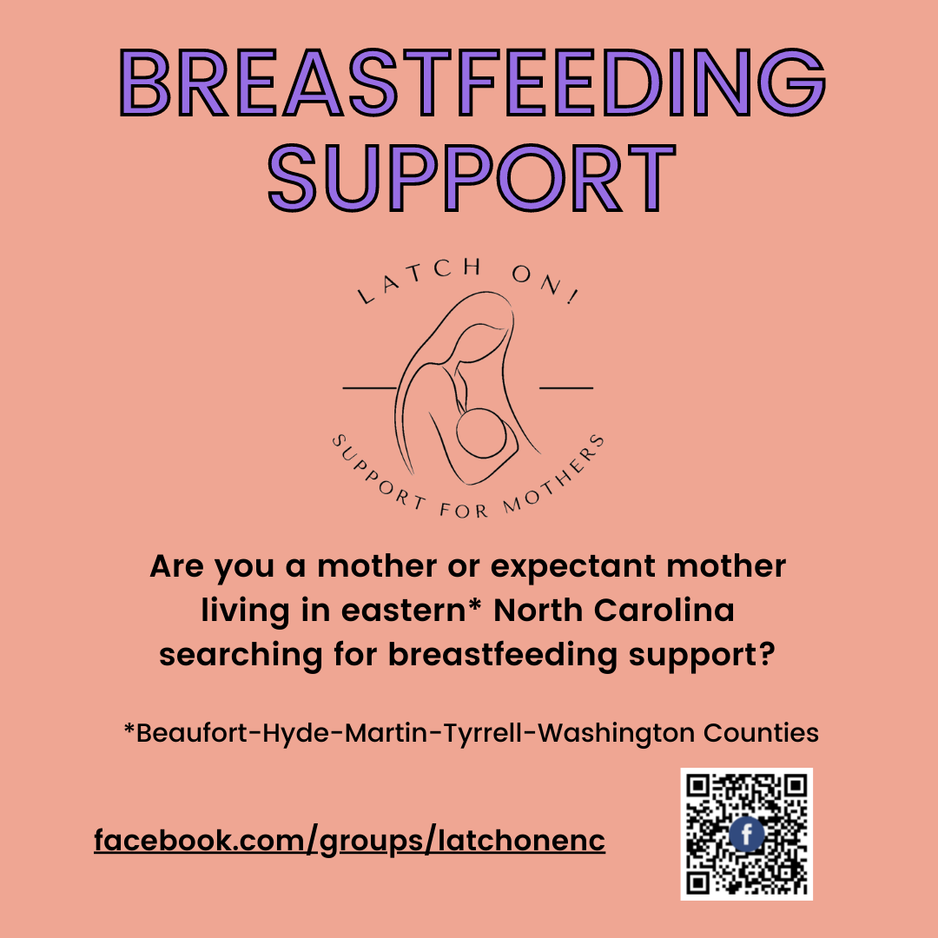

Appendix D
Project Timeline
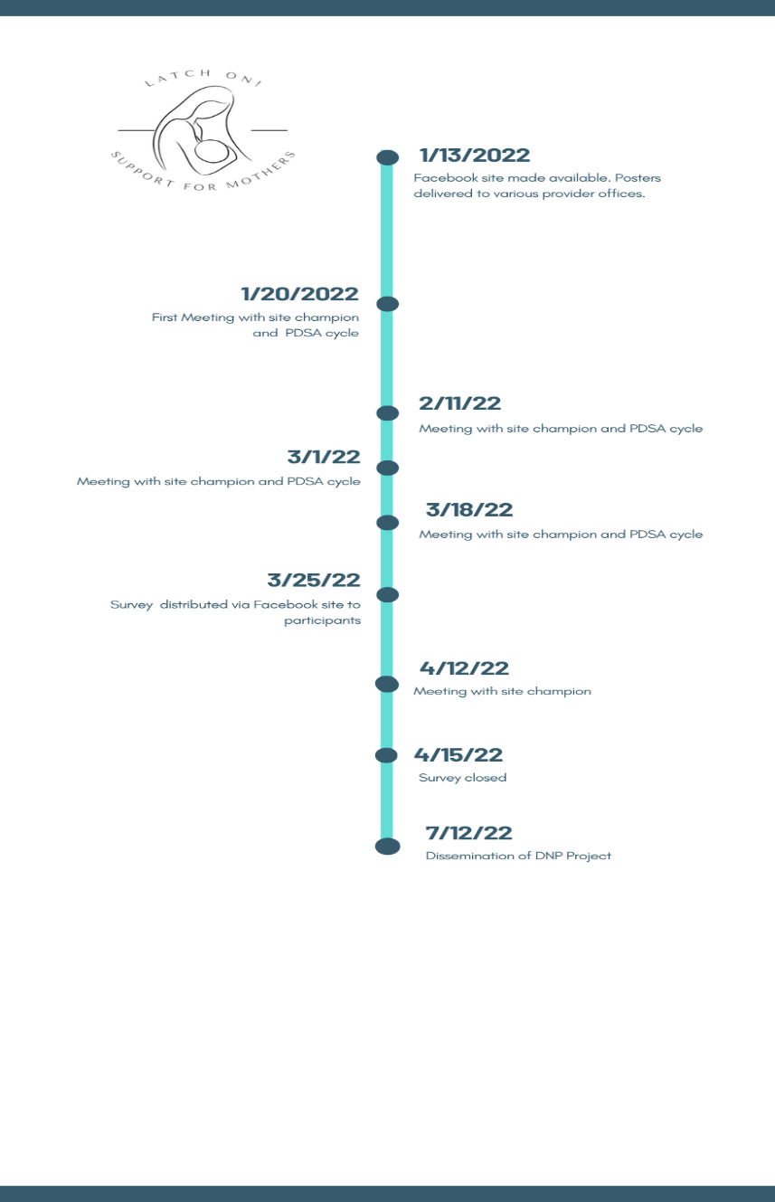

Appendix E
Figure 1
Breastfeeding Duration Prior to Joining the Facebook Support Group

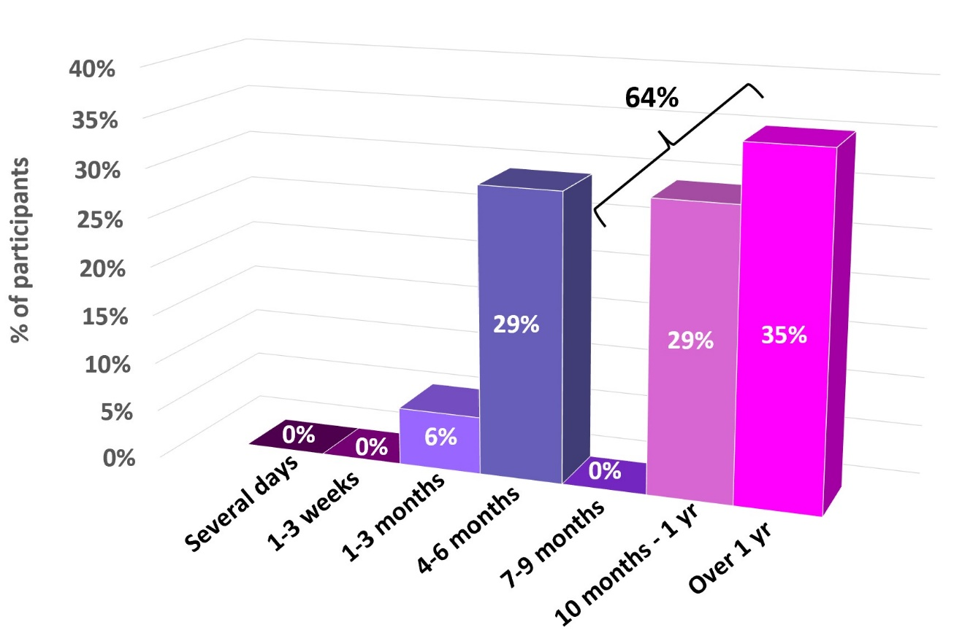
Note. This figure demonstrates participants breastfeeding duration prior to joining the Facebook support group.
Appendix F
Figure 2
Breastfeeding Duration After Joining the Facebook Support Group
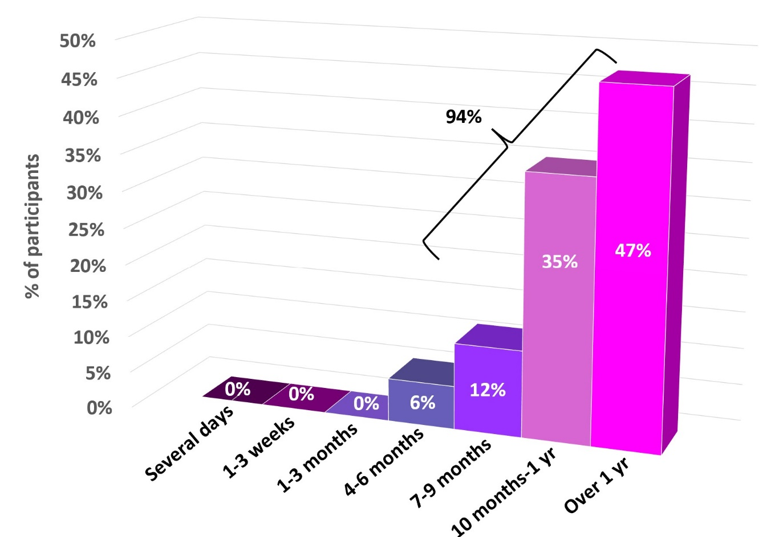
Note. This figure demonstrates participants breastfeeding duration after joining the Facebook support group.
Appendix G
Table 1
Costs of Implementing the Facebook Breastfeeding Support Group
Budget
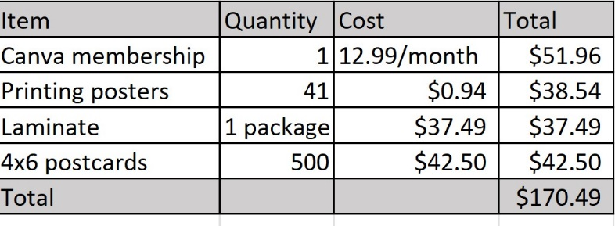
Note. This table demonstrates the cost associated with establishing a Facebook breastfeeding support group.

