Lauren McKee
Fall 2020 Senior Choreography
Working Title: reFRACtion
Costume Proposal

I want to propose the following options to be considered for costuming of my Senior Choreography piece:
- Black briefs
- Black socks
- Long, sheer black skirts
- Different colored bralettes
- Long sleeve, sheer blouses
- Tan masks (not pictured)
My concept has the dancers removing the skirts for small portions of the piece. When the skirts are removed, they will not be doing floorwork, with the exception of one moment. There is one moment where a dancer will be on the floor for one section of the piece in the briefs without her skirt. This takes place in the downstage right corner of the stage where there aren’t any other dancers. She will put her skirt back on and also lives with three of the four other dancers. I have included pictures to show the two different costume looks throughout the piece.
Option 1: Most of the piece
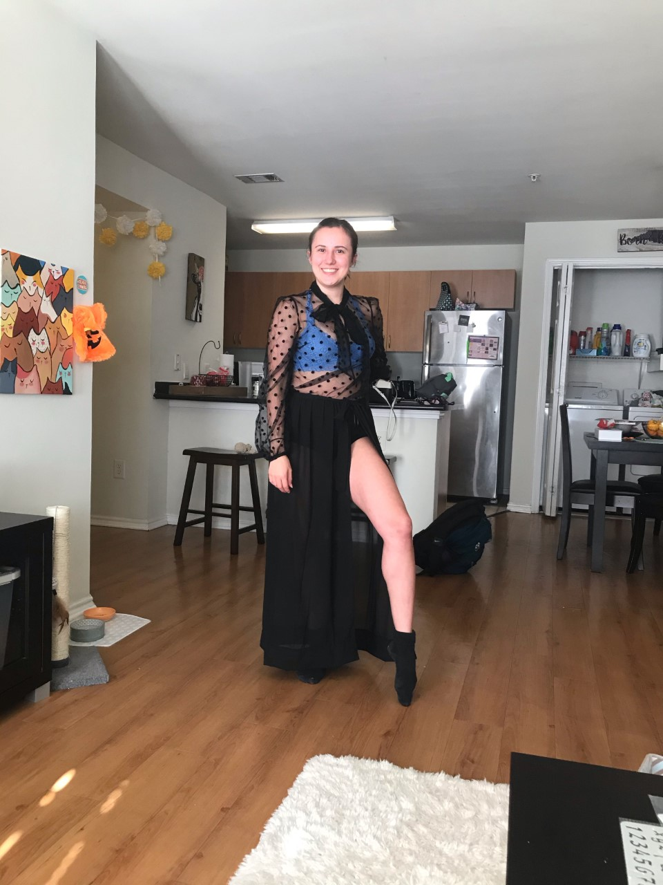

Option 2: A few sections, only once on the floor
