Utilization of Health Coaches in a Primary Care Setting
Tikia Yelverton
East Carolina University

Abstract
The patient population has grown tremendously since the implementation of the Affordable Care Act (ACA). This has led to an influx of many patients to primary care practices. The gap between an increasing patient population and physicians to care for these patients is growing immensely. This can be attributed to a decreasing primary care provider (PCP) workforce. One way to assist the PCP work force that remains is the use of health coaches in the primary care setting. Health coaches have the potential to positively impact health outcomes, patient experience, and the cost of health care. The purpose of this project was to increase the utilization of the health coach in the diabetic population at a primary care practice in eastern North Carolina amongst the providers. The American Association of Diabetes Educators’ Diabetes Self-Management Education and Support for Adults with Type 2 Diabetes: Algorithm of Care was used to implement a standardized process for referring diabetic patients to the health coach. The Plan-Do-Study-Act (PDSA) cycle was used to evaluate the process. Following implementation, the diabetic patient referral rate to the health coach increased by 9.2%. Further exploration is warranted on the use of health coaches in the primary care setting and their implication in future practice.
Key words: health coaching, diabetes, primary care, referral, health care

Table of Contents
Chapter One: Introduction……………………………………………………………………...…7
Practice Site…………………………………………………………………………….....9
Theoretical Framework…………………………………………..………………………10
Assumptions………………………………………………………………………….......11
Definitions of Key Terms……………………………………………………………..…12
Summary……………………………………………………………………………...….14
Chapter Two: Review of Literature………………………………………………………...……15
Impact of Health Coaching on Provider-Patient Relationship…………………………...16
Benefits of Health Coaching……………………………………………………………..17
Provider Education……………………………………………………………………….19
Health Coach Referrals……………………………………………………………...…...19
Barrier to the Patient…………………………………………………………………......20
The Role of PCMH in Disease Management…………………………………………….21
Gaps and Limitations…………………………………………………………………….22
Summary…………………………………………………………………………………22
Chapter Three: Methodology…………………………………………………………………….23
Design……………………………………………………………………………………23
Setting…………………………………………………………………………………....23
Sample…………………………………………………………………………………...23
Methods………………………………………………………………………………….24
Instruments………………………………………………………………………………25
Protection of Human Subjects…………………………………………………….……..27
Data Collection……………...…………………………………………………………...27
Data Analysis…………………………………………………………………………….28
Budget/Resources……………………………………………….……………………….28
Chapter Four: Results…………………………………………………………………………....29
Participant Demographics……………………………………….……………………….29
Intended Outcomes………………………………………………………………………29
Findings………………………………………………………………………………….29
Summary………………………………………………………………………………....32
Chapter Five: Implications for Nursing Practice………………………………………………...33
Introduction…………………………………………...………………………………….33
Practice Implications……………………………………………………………………..33
Essential I: Scientific underpinning for practice…………………………………………33
Essential II: Organization and system leadership for quality improvement and systems
thinkings………………………………………………………………………………….34
Essential III: Clinical scholarship and analytical methods for evidence-based practice...34
Essential IV: Information systems/technology and patient care technology for the improvement and transformation of healthcare………………………………………….35
Essential V: Healthcare policy for advocacy in healthcare……………………………...36
Essential VI: Interprofessional collaboration for improving patient and population health outcomes……………………………………………………………………….………...36
Essential VII: Clinical prevention and population health for improving the nation’s health………………………………………………………………………..……………37
Essential VIII: Advance nursing practice……………………………..………………....38
Summary………………………………………………………………………………....38
Chapter Six: Final Conclusions………………………………………………………………….39
Significance………………………………………………………………………………39
Financial Implications……………………………………………………………………40
Limitations……………………………………………………………………………….41
Strengths…………………………………………………………………………………42
Project Benefits…………………………………………………………………….…….42
Recommendations for Practice…………………………………………………….…….43
Final Summary……………………………………………………………..…………….44
References……………………………………………………………………….……………….45
Appendices
Appendix A: Quality-Caring Model: Four Relationship Essentials to Quality Caring….52
Appendix B: Pre-and Post-Survey……………………………………………………….53
Appendix C: Clinical Coach Brochure………………………………….……………….54
Appendix D: American Association of Diabetes Educators’ Diabetes Self-Management
Education and Support for Adults with Type 2 Diabetes: Algorithm of Care…………...56
Appendix E: Institute of Health QI PDSA Worksheet………………….……………….57
Appendix G: University Medical Center Institutional Review Board Waiver…….…….59
Appendix H: Data Collection Tool………………………………………………………60
Appendix I: Table 1……………………………………………………………………...61
Appendix J: Figure 1……………………………………………………………………..62
Appendix K: Table 2……………………………………………………………………..63
Appendix L: Figure 2…………………………………………………………………….64
Appendix M: Literature Matrix………………………………………………………….65

Chapter One: Introduction
Since the implementation of the Affordable Care Act (ACA), the United States has seen a growing patient population due to the increased coverage for millions of uninsured and underinsured Americans (Stults et al., 2016). More Americans may, in fact, be insured, but this does not guarantee access to primary care service with a rising shortage of primary care providers (PCP). Per the Association of American Medical Colleges (2017), a physician workforce report projected the shortage of physicians over the next decade to range between 61,700 and 94,700. Four broad categories were included in this study: primary care, medical specialties, surgical specialties, and other specialties. It is projected that by 2025 there will be a shortage of between 14,900 and 35,600 primary care physicians (Association of American Medical Colleges, 2017). With an imminent threat of a PCP shortage on the horizon, it is important to explore ways to meet the growing patient demand in America.
Seventy-five percent of health care cost of the patient population will be spent on those with chronic conditions such as heart disease, chronic lower respiratory disease, and diabetes (Ford, Croft, Posner, Goodman & Giles, 2013). More than 70% of individuals with chronic conditions will result in demise (Ford et al., 2013). Of these chronic diseases, a total of 29.1 million people (9.3% of the population) living in the U.S. have been diagnosed with diabetes (Centers for Disease Control and Prevention, 2017a). In 2012 it was estimated that 1.5 million deaths were directly caused by diabetes and another 2.2 million deaths were attributed to high blood glucose (World Health Organization, 2017). When patients with chronic diseases such as diabetes visit their primary care provider (PCP), at least 50% leave the office without understanding the information that was reviewed by their clinician (Bodenheimer & Laing, 2007). In addition, 42% of PCPs feel as if they have a limited amount of time to go in depth with their patients on the management of their chronic diseases (Bodenheimer & Laing, 2007).
With a growing patient population, increased health care cost, and an impending PCP shortage, measures must be taken to ensure that doctor’s visits are productive. PCPs have a huge responsibility to ensure that their patients understand, agree with and participate in the management of their chronic conditions (Bennett, Coleman, Parry, Bodenheimer, & Chen, 2010). One way to support these tasks is by utilizing health coaching, a way to “motivate patients to achieve a goal that enhances quality of life and improves health” (Oksman, Linna, Hörhammer, Lammintakanen & Talja, 2017, p. 2). Health coaching can prove effective in patients with chronic diseases because it teaches self-management techniques through goal setting and problem solving, which can lead to better outcomes such as decreased HgbA1c in diabetic patients as an example (Delaney et al., 2017). A randomized controlled trial conducted found when health coaching was implemented in the primary care setting for the diabetic patient it led to significant benefits (Wayne, Perez, Kaplan & Ritvo, 2015). There was a statistically significant improvement in HgbA1c of the two groups included: an intervention group that received health coaching with Smartphone interaction and a control group that received health coaching without Smartphone interaction. Health coaching also decreases burnout in PCPs and enable them to maximize the visit by referring tasks that can be taught by health coaches such as how to correctly monitor blood glucose (Kresser, 2017). In addition, health coaching can reduce health care costs by decreasing the occurrence of hospital admissions and overall health services expenditure (Jonk et al, 2015).
The purpose of this project was to develop and implement a standardized process for automatically referring diabetic patients to health coaches in a primary care setting in eastern North Carolina. Furthermore, the goal was to encourage providers to increase their referral to and utilization of health coaches.
Practice Site
This project was implemented at a primary care practice in eastern North Carolina. The practice site was a patient centered medical home that coordinated the health care needs of their patient population which included preventive check-ups, sick care, and referrals to the appropriate resources. The providers at the practice site worked with patients to develop care plans that met their specific health needs. The practice consisted of two medical doctors, one family nurse practitioner, one practice manager, two office assistants, one referral coordinator, two medical assistants, one radiologist technician, and one registered nurse who served as a health coach. There was also an endocrinologist at the practice who was in the department but was not considered a provider with the practice site. Therefore, this provider was excluded from the project.
The practice site provided services to an average of 70 diabetic patients per month. Though it was a practice that employed a health coach, the health coach was being underutilized by the PCPs. This data was based on the health coach’s monthly encounter log which tracked the number of referrals for a day per the number of patients seen by the providers at the practice. A review of the monthly log between March 1, 2017 and May 31, 2017, showed a total of four patients who were referred to the health coach with two of those patients having diabetes. During the same time period, there were a total of 248 patients seen for diabetes who had a HgbA1c collected, of whom 112 had a HgbA1c greater than 7 mg/dL and 136 had an HgbA1c less than 7 mg/dL. The utilization of the health coach could help maximize the patient visit by allowing the clinician to give better service and providing the patient with more support and, thus, a better outcome.
There was no standardized process in referring diabetic patients at the practice site to the health coach. A health coach was first introduced at the site in 2016. The PCPs were distributed a copy of the health coach job description, informed of aspects of medical home that the health coach can help to meet, informed of chronic conditions that the health coach would focus on, and educated on how to refer a patient to the health coach. The practice site previously utilized a flyer to serve as a reminder of availability of the health coach, but the flyer was no longer available. The practice at the site was that providers referred patients to the health coach at their own discretion; that is, they decided whether the patient would benefit or not from seeing a health coach. There were no specific guidelines established to guide PCPs on who may be best served to be referred and who may not. If the PCPs decided that a patient would benefit from seeing the health coach, an order was entered in the electronic health record (EHR) for a health coach consultation. Once an order was signed, it was transmitted to a referral coordinator who then routed it to an in-basket folder for the health coach. The PCPs could also walk the patient to the health coach’s office with no referral entered. In this case, the health coach entered her own referral.
Theoretical Framework
The theoretical framework that was used to guide this DNP project was Joanne R. Duffy’s Quality-Caring Model (Appendix A) which depicts how complex relationships continuously evolve in healthcare through multiple, ongoing reciprocal interactions which can change conditions (Butts & Rich, 2015). “Caring is a belief or value, an intention, a process, and a way of being human that enhances personhood” (Butts & Rich, 2015, p. 499). It is a precursor to ultimate health outcomes when it is practiced genuinely. Caring in the patient-provider relationship is not simply a series of kind acts or an attitude, but it is guided by knowledge-based actions, a collection of values, and mannerisms. Implementation of this model has shown to improve patient satisfaction and decrease adverse outcomes and their associated costs (Duffy, 2005), which aligns with the goals of the Triple Aim: to improve patient experience of care, to improve the health of the population, and to reduce the per capita cost of health care (Institute for Healthcare Improvement, 2017).
The Quality-Caring Model denotes patients as knowledgeable partners with the facilitators (clinicians, nurses, and health coaches) of positive health outcomes who share responsibility in wellness (Appendix A). For example, in helping a newly diagnosed diabetic patient learn about a prescribed medication, the facilitator and the patient together may search for information on the World Wide Web. The facilitator's role in this model would be to direct the patient to quality and credible Web sites, comprehend and explain the information that is being retrieved, and as a team come up with a plan for adherence. This mutual interaction poses benefits to both facilitator and patient through interaction by way of new knowledge obtained, potential for adherence and/or self-care, and satisfaction with the process (Duffy, 2005). Patient, facilitator, and system outcomes can be optimized by embracing the value of caring relationships as demonstrated in the Quality-Caring Model (Duffy, 2005).
Assumptions
The primary assumption of this project was that providers were not utilizing the available health coach at the primary care site. This was evidenced by the lack of referrals noted in the monthly encounter log maintained by the health coach. Implementing a standardized process of referring a subset of diabetic patients to the health coach could potentially increase the utilization of the health coaching services. The secondary assumption was that though clinicians were provided with a tool that would allow for a more efficient referral of diabetic patients to the health coach, they may not always utilize the tool. This could be due to time constraints or their perception of the usability of the tool. The final assumption was that by using the Quality-Caring Model as a guide to this DNP project, the patient, provider, and health coach would interconnect and build caring relationships that make way for better patient outcomes and satisfaction.
Definition of Key Terms
Diabetes is defined as a condition in which the body does not properly process food for use as energy (Centers for Disease Control and Prevention, 2017b). With diabetes, the body cannot make enough insulin or it cannot use its own insulin as well as it should, which cause sugar to build up in the blood stream. Hence why many people use the term “sugar” to refer to diabetes (Centers for Disease Control and Prevention, 2017b). Diagnosis of diabetes can be done by measuring certain lab values: hemoglobin A1c (HgbA1c), fasting plasma glucose (FPG), oral glucose tolerance test (OGTT), or random (casual) plasma glucose (American Diabetes Association, 2017). A HgbA1c greater than or equal to 6.5%, a FBG greater than or equal to 126 mg/dl, an OGTT greater than or equal to 200 mg/dl, and a random plasma glucose greater than or equal to 200 mg/dl denotes a diabetes diagnosis (American Diabetes Association, 2017).
A health coach assists patients to gain the knowledge, skills, and confidence to self-manage their chronic conditions (Ngo, Hammer, & Bodenheimer, 2010). The health coach is trained in behavior change theory, motivational strategies, and communication techniques, which are used to assist patients to develop intrinsic motivation and obtain skills to create sustainable change for improved health and well-being (Wolever, Jordan, Lawson & Moore, 2016). Specifically, the health coach does the following: help patients set agendas for the clinician visit, make certain patients understand what their clinician wants them to do, determine whether patients agree with their care plans, provide support to patients’ efforts in adopting healthy behaviors, assist patients to improve medication understanding and adherence, and function as a cultural bridge, point of access, and support for their patients (Ngo et al., 2010).
The patient-centered medical home (PCMH) is a model of primary care transformation designed to improve patient and staff experiences, outcomes, safety, and system efficiency while at the same time meeting the health care needs of patients. The term “medical home” was first used by the American Academy of Pediatrics in 1967 to describe the concept of a single centralized source of care and medical record for children with special health care needs (Kemper et al., 2013). The core principles of the PCMH are the following: wide-ranging, team-based care; patient-centered orientation toward the whole person; care that is coordinated across all elements of the health care system and the patient's community; enhanced access to care that uses alternative methods of communication; and a systems-based approach to quality and safety (Kemper et al., 2013).
Referral is defined as the process of directing or redirecting (as a medical case or a patient) to an appropriate specialist or agency for definitive treatment or the act of sending someone to another person or place for treatment, help, advice, et cetera (Meriam-Webster.com, 2017). Automatic is defined as given or imposed as a necessary and inevitable result of a fixed rule or particular set of circumstances (OxfordDictionaries.com, 2017). In the case of diabetic patients, if they meet particular circumstances of the DSME algorithm, this will call for automatic referral by the provider to the health coach. The DSME algorithm, list four categories when referrals should be made for diabetic patients: (1) at diagnosis, (2) during annual assessment, (3) when new complicating factors influence self-management, and (4) when transitions in care occur. Each category contains sub-categories that further denote a need for referral. For example, the transitions in care category includes a change in (1) the living situation, (2) the medical care team, (3) insurance coverage that results in treatment change, and (4) age-relating changes affecting cognition or self-care (Powers et al., 2016). If any one of these circumstances is chosen, the diabetic patient will automatically be referred to the health coach.
Summary
Health care in the United States is being transitioned from fee-for-service to value based care while concurrently trying to meet the goals of the Triple Aim of reducing health care costs, improving population health, and improving patient experience (Sangvai, 2016). It is imperative that each member of the medical team practice at the extent of his or her license to have an impact toward decreasing health care costs. This includes utilizing all available resources, finding new ways of addressing what goes on beyond clinic walls to improve population health, and measuring the patient experience in patient perspective and outcomes (Sangvai, 2016). With ease of referral in utilization of available resources, PCPs at the project site can actively participate in meeting the goals of the triple aim. By increasing their utilization of the health coach, they can potentially reduce the number of hospital readmissions of those with chronic diseases such as diabetes. This, in turn, can reduce health care cost. The health coach can assist in the follow up with the diabetic patient and address concerns that may not have been evident during their doctor’s visit which, in turn, can improve the health of this population. PCPs and the health coach working collaboratively to provide holistic care can improve patient experience.

Chapter Two: Review of Literature
A literature review was conducted to explore the use of a health coach in the diabetic population and in the patient centered medical home (PCMH). Keywords were derived from the clinical question: Will implementing a standardized referral process in the diabetic population increase referral rates to the health coach at a primary care practice in eastern North Carolina? PubMed, the Cumulative Index to Nursing and Allied Health Literature (CINAHL), and Google Scholar were the databases utilized to search key terms “health coaching” and “diabetes”. The literature search in PubMed totaled 268 citations. Filters were applied to limit the search to publications within the last ten years with human subjects only and articles that were printed in English and peer-reviewed. After the application of these filter, 170 of the original citations were retained. Abstracts of the 170 were reviewed and seven articles were found to be significant to the examination of health coaching in the diabetic population.
An additional literature search in PubMed resulted in meaningful Medical Subject Headings (MeSH) terms of “primary care providers” and “health coaches”. This literature search yielded 38 articles. Filters were again applied to limit the search to publications within the last ten years and to human subjects, which resulted in 26 articles retained and abstracts reviewed for each. Two of the articles were found to be repetitive and none of the remaining articles helped to clarify the clinical question; therefore, no articles were retained from this search.
A literature search in CINAHL with MeSH terms “health coach” and “primary care provider resulted in 17 articles. Abstracts from these articles were reviewed and three were retained and focused on the provider-patient relationship with the implementation of a health coach.

Impact of Health Coaching on Provider-Patient Relationship
Three articles (Thom et al., 2014; Thom et al, 2016; Wroth 2015) explored the impact that a health coach has on the provider-patient relationship. A 12-month randomized control trial was conducted at two federally qualified health centers in San Francisco, California. This study compared trust levels of low-income patients (primarily of Hispanic and African-American descent) with poorly controlled type 2 diabetes, hypertension, and/or hyperlipidemia of primary care providers (PCPs) with those who received health coaching and those who only received usual care. Thus, 12 months after patients were assigned to health coaches, the mean level of patients’ trust in PCPs increased significantly compared to those in usual care. In addition, there was a substantial increase in patients who reported they would highly recommend their PCPs in the health coach group (Thom et al., 2014).
Thom et al. (2016) identified how the health coach bridges the gap between the patient and clinician. A qualitative study was conducted using six focus groups (three in Spanish and three in English) that included interviews with patients, family members, health coaches and clinicians. Common theme found in the study referred to health coaches working with providers to support patient decisions. Clinicians realized the role the health coach had in supporting their relationship with their patients. One clinician stated, “I think of the health coach as being almost like a liaison between me and the patients. If I haven’t explained something well or can’t do follow-up or can’t reinforce a message, I’m hoping the health coach can do that” (Thom et al., 2016, p. 514).
Dr. Wroth is an integrative health physician and an obstetrician/gynecologist (OB/GYN) who has extensive training in health coaching models for patient care. She views patients’ interaction with the health coach as an avenue to build the physician-patient relationship; as “a way to take the best of medicine that [clinicians] already provide and add in the best of behavioral science to really help [providers] more effectively and efﬁciently engage people in healthier lifestyle change” (Wroth, 2015, p.159). She explains how providers want the best outcomes for their patients and they themselves become frustrated when patients struggle and are not able to achieve these outcomes based on providers’ recommendations (Wroth, 2015).
Benefits of Health Coaching
Sharma, Willard-Grace, Hessler, Bodenheimer, & Thom (2016) conducted a pragmatic study to follow up a 12-month randomized controlled trial (RCT) to evaluate the benefits of health coaching for chronic disease management compared to usual care for patients with chronic disease. The patients who were randomized to the usual-care arm had access to resources available at their clinic site which included primary care, pharmacy, diabetes educators, chronic care nurses, and nutrition counseling. The patients who were randomized to the intervention arm had services of usual care plus they received health coaching for one year. Twenty-four months from RCT baseline, participants were followed up. Participants included patients with uncontrolled diabetes, hypertension, or hyperlipidemia who took part in the original RCT at adult-medicine primary care clinics in San Francisco, California serving mostly African-American and Latino populations. Weight, height, HgbA1c, blood pressure, and lipids were the clinical measures obtained at baseline, 12 and 24 months. Of the 441 participants, 290 participated at both 12 and 24 months. Finding from this study reported that patients who received health coaching experienced slight declines in clinical goals, except for HgbA1c, which showed a significant drop from 53.4% to 36.2%. Results support the inference that health coaching is beneficial to the diabetic population.
Delaney et al. (2017) elaborated on how chronic disease management programs (CDMPs) that include health coaching can engage patients in management decisions and thus, improve health outcomes. Patients enrolled in a face-to-face CDMP group with health coaching telephone follow-up were compared with participants in a telephone-only health coaching session during a 12-month period in 2013. Three questionnaires were administered to diabetes patients enrolled in a health coaching program at Royal North Shore Hospital in Sydney, Australia at baseline three, six, and twelve months. The Diabetes, Hypertension, and Hyperlipidemia (DHL) questionnaire was used to examine patients’ general knowledge of diabetes; the Short-Form 36 Quality of Life Instrument (SF-1) was used to assess self-reported health status; and the Diabetes Distress Scale (DDS) was used to assess diabetes distress. A total of 238 patients participated in the study: 178 attended a face-to-face CDMP session with telephone follow-up and 60 participated in telephone-only health coaching. No change in BMI was found in either group; however, there were significant changes in HgbA1c levels in patients with baseline above the recommended target of greater than 7%; diabetes knowledge improved in all patients; and diabetes distress decreased in those patients with the highest level of distress at baseline. The results of this analysis identified patients who demonstrated the most benefit in diabetes distress and glycemic control after participation in a 12-month diabetes health coaching CDMP (Delaney et al., 2017). Furthermore, providing evidence to support the positive effect health coaching has on diabetic patients with poor glycemic control or high levels of diabetes distress.

Provider Education
In 2014 a study was conducted to determine whether a provider and health coaching course for staff in Veterans Health Affairs medical facilities resulted in increased attitudes towards, intentions to use and actual use of health coaches (Collins et al., 2015). A Whole Health Coaching course was developed and implemented using a pre- and post-intervention group only design to measure changes in health coaching outcomes including health coaching skills. The sample sizes were 258 at pretest, 253 at posttest, and 163 at follow-up (Collins et al., 2015). At follow-up, preparedness and self-efficacy showed large pre- and posttest increases; attitudes toward patient-centered care and intentions to use health coaching skills showed small increases; and actual use of health coaches through pre-test and follow-up showed medium increases (Collins et al., 2015). The findings of this study support that providers and staff have an increase in health coaching skills, preparedness, and self-efficacy after participating in a health coaching course.
Health Coach Referrals
A mixed-methods hypothesis-generating study was conducted to understand how health coaches affect the work of primary care clinicians and influence their perception of patient care (Dubé et al., 2015). Post-visit surveys were administered which assessed how demanding the visit was, the clinician's experience of the visit, the clinician's perception of the patient experience, perceptions of patient understanding of the care plan, and patient satisfaction with the medical encounter (Dubé et al., 2015). In addition, interviews were conducted with 13 of the 17 PCPs who participated in the study and worked with health coaches (Dubé et al., 2015). One clinician gave the following account about diabetes management at the post-visit interview:
Diabetes is complicated ... and so there are a number of our patients for whom it's frustrating 'cause you try and you try and you feel like you just, you get nowhere.... And the health coaches were a real boom. I mean, they were really the extra factor that allowed some improvement where there had not been before. And that's because of being able to reinforce the message after, between visits ... outreach in a way that I would never have time to do (Dubé et al., 2015, p. 218).
PCPs rated visits with patients who received health coaching as less demanding and as having an adequate amount of time with patients compared to usual care patients. This investigation demonstrates that those providers who refer their patients to health coaches have better outcomes in disease management and more productive patient visits.
A pilot study was conducted at two primary medicine clinics to assess the impact of health coach referrals by PCPs as it relates to clinical outcomes (Bernhard et al., 2015). Forty patients paid out of pocket for health coaching sessions which covered topics such as exercise, weight loss, and healthy eating (Bernhard et al., 2015). Improvements in laboratory values were noted when pre- and post-intervention data were compared. Though this study was limited by a small number of participants, it still demonstrated that health coaches can improve patient outcomes. This further provided evidence of the benefit of providers referring their chronic disease patients to health coaches.
Barriers to the Patient
Identifying perceived barriers to and effective strategies for self-management for adults with diabetes in a rural setting was the goal of Nagelkerk, Reick & Meengs (2006). Focus groups were incorporated into an exploratory, descriptive design where twenty-four type 2 diabetic adults were recruited from a rural primary care practice to participate in one of three audiotaped focus groups. An expert panel and nurse researchers conducted a content analysis on each focus group to determine rankings of barriers and strengths. Findings from this study showed that the most reported barriers were discouragement from lack of glycemic control and continued disease process, not fully understanding the plan of care, and lack of knowledge of a specific diet plan. Furthermore, this study highlighted the importance of overcoming barriers, developing and implementing realistic self-management plans, and stressing collaborative relationships between patient and provider to increase good patient outcomes. Health coaches can be used as an avenue to help diabetic patients overcome barriers to self-management of their disease.
The Role of PCMH in Disease Management
A study was conducted to investigate the impact of patient-centered medical homes (PCMHs) on the quality of diabetes disease management and the adherence to oral hypoglycemic agents (OHAs) (An, 2016). A total of 3,334 adult diabetes patients were identified by using the 2009-2013 longitudinal data files from the Medical Expenditure Panel Survey. A PCMH group that contained core features such as team-based care and a systems-based approach to quality and safety was compared to a group without PCMH features. Overall, improvement in process measures of diabetes care was found in the PCMH group; however, there was no significant impact on an increased adherence to OHAs. This study revealed that more evaluation is needed on compliance with OHAs in PCMHs. The project site is a PCMH with a large diabetic population. The health coach at this site can be utilized to reinforce the education these patients may have received from the providers on OHAs.

Gaps and Limitations
From the current review of literature, there are some notable gaps. None of the articles reviewed discussed the attitudes or perceptions of providers towards health coaches as barriers to or facilitators of effective disease management in diabetic patients. Furthermore, extensive research is needed on how health coaching fits within the concept of PCMH.
Summary
Findings from this literature review support the inference that the health coach facilitates the provider-patient relationship, benefits the diabetic patient population, and poses as an integral part of the PCMH. It was discovered that the health coach serves as a link between the clinician and patient and often helps to build the physician-patient relationship by reinforcing key messages from the visit. This further supports the theoretical framework used to guide this DNP project: The Quality-Caring Model. This model highlights relationship-centered professional encounters, feeling cared for, and self-advancing systems, which are considered quality systems because they enhance well-being and growth (Butts & Rich, 2015, p. 509).
Health coaches have shown to benefit the diabetic population by demonstrating improvement in health outcomes such as a decrease in HgbA1c and by engaging patients in management decisions. Furthermore, health coaches have assisted diabetic patients to overcome barriers to self-management of their disease by individualizing self-management plans that include realistic goals. Providers who referred their diabetic patients to health coaches had more productive visits with their patients and an adequate amount of time to conduct thorough visits. Lastly, the health coach adds to PCMHs core principle of team-based care where care does not stop at the physician, but it extends to other entities in the health care system to provide comprehensive care to patients.
Chapter Three: Methodology
Design
The project consisted of a descriptive quality improvement approach. The purpose of the project was to implement a standardized process in diabetic patient referrals for health coaching. The Plan-Do-Study-Act (PDSA) cycle was used to evaluate the process of change in referral rates to the health coach at a primary care practice in eastern North Carolina. The PDSA model advocates the formation of a hypothesis for improvement (Plan), a study protocol with collection of data (Do), analysis and interpretation of the results (Study), and the iteration for what to do next (Act) (Speroff & O'Connor, 2004).
Setting
This project was conducted at a primary care practice located in eastern North Carolina that joined a large health care system in 2013. The practice was designated as a patient centered medical home and accepts most all insurances including Medicare and Medicaid. The project site currently staffs two medical doctors, one family nurse practitioner, one health coach, and auxiliary staff (one practice manager, two medical assistants, one radiologist technician, and two secretaries who register patients). It provides services to an average of 70 diabetic patients per month.
Sample
Project target sample consisted of the medical assistants, the health coach, and the providers at the practice site who provide care to the patient population: two physicians and one nurse practitioner. One of the physicians is a Caucasian female who specializes in primary care and who is board certified in family medicine. The other physician at the practice site is a Caucasian male who specializes in internal medicine and is board certified in internal medicine. The nurse practitioner is a Caucasian male who has obtained an American Academy of Nurse Practitioners board certification.
Methods
At week one of project implementation, a short survey was distributed via a paper survey to all the providers at the site (Appendix B). This survey was used to assess how clinicians view the ease of the referral process to the health coach, the importance of referring their diabetic patients to the health coach, and barriers encountered in the referral process to the health coach. Following the survey, the project lead met with each provider one-on-one. During these meetings, providers were distributed two tools and educated on the new referral process for diabetic patients. The tools included a brochure outlining the role of the health coach (Appendix C) and the Diabetes Self-Management Education and Support for Adults with Type 2 Diabetes: Algorithm of Care (DSME algorithm) (Powers et al., 2016) (Appendix D). The DSME algorithm was used as a tool to guide providers to refer diabetic patients who met criteria to the health coach at the practice site. In addition to the providers being educated on the new referral process, the medical assistants (MAs) had a one-on-one session with the project lead. During this session, the MAs were educated on the referral process and the algorithm as they were responsible for ensuring that the providers had a copy of the algorithm when they saw diabetic patients. Furthermore, the health coach was educated on the process because she was responsible for keeping track of the number of diabetic patients she saw with the DSME algorithm being utilized.
Staff were educated on the steps of the new referral process of diabetic patients to the health coach. The MA placed a DSME algorithm with the patient's medical record number (MRN) written on it in the room with the diabetic patient for provider use only. The provider reviewed and completed the algorithm during the patient visit and if any of the criteria were met, he/she placed a referral in electronic health records (EHR). What constituted criteria being met was if any of the items on the DSME algorithm were checked. If none of the criteria pertained to the patient, the provider did not utilize the algorithm. At the end of the visit, the completed algorithm was left in the room for the MA to collect and placed in a locked cabinet in the practice manager’s locked office. Every week for a total of ten weeks, the algorithms were collected and electronic health record (EHR) was reviewed to verify whether a referral was made to the health coach or not for the algorithms that were completed. Once verifications were made the algorithms were placed in the shred box at the practice site to ensure that patient health information (PHI) was protected.
The PDSA worksheet was utilized weekly to evaluate the process and review the data with the providers and the health coach. At the completion of the project, the post survey was redistributed via a paper survey to determine if there were any change in providers’ perceptions about the referral process to the health coach. In addition, data was compiled from the manual audits conducted on the number of health coach referrals in EHR during the project implementation to determine if the referral rates had increased. A retrospective and prospective clinical coach referral rate was compared to determine if an improvement in health coach referrals occurred with implementation of the project.
Instruments
Pre and post survey: The survey questions were created specifically for the practice site to address the providers’ perception of utilizing the health coach and the referral process to the health coach. The questionnaire was limited to four questions to increase the rate of completion among the providers. Two of the questions were rated on a Likert scale to determine the ease of the referral process and the importance of referring diabetic patients to the health coach. The remaining two questions focused on background information on the current referral process and barriers encountered with the process. The same survey was administered at week one and at week ten to determine if providers had changed their perception on the referral process to the utilization of the health coach.
Brochure: A brochure was created from a composition of evidence based literature from a search conducted in CINAHL. The brochure consisted of information on why a health coach is needed in the primary care setting, information on the role of the health coach, and steps of referring diabetic patients to the health coach at that practice site. The brochure was provided to the clinicians as a reference to the benefits of the health coach and a reminder of the referral process (Appendix C).
DSME Algorithm: The American Association of Diabetes Educators’ Diabetes Self-Management Education and Support for Adults with Type 2 Diabetes: Algorithm of Care was available for open-access utilization without any charge or express permission. The DSME algorithm addresses the American Diabetes Association (ADA) standards of medical care in diabetes of when patients should be assessed and referred for education. Emphasis was on four critical times when diabetic patients should be assessed, provided with additional education, or have their diabetes self-management education adjusted: (1) at diagnosis, (2) during annual assessment of education, nutrition, and emotional needs, (3) when new complicating factors influence self-management, and (4) when transitions in care occur. If any of the items were checked in any of the categories on the algorithm, then criteria were considered met and the algorithm was used as a means of referral to the health coach (Appendix D).
PDSA cycle tool: The project progress was evaluated weekly by using the Plan, Do, Study, Act (PDSA) rapid cycle of improvement to determine if implementation of a standardized process in referral of diabetic patients to the health coach had increased. The PDSA worksheet (tool) from the Institute of Healthcare Improvement was utilized to evaluate the process and to guide the PDSA cycle by providing a step-by-step structure to address a plan of action (Appendix E).
Protection of Human Subjects
Organizational approval was obtained prior to implementation of the project (Appendix F). The project was reviewed by University Medical Center Institutional Review Board and deemed as non-human subject research (Appendix G). No identifying information was collected. Paper files were secured in a locked drawer in the practice manager’s locked office. De-identified data was entered on an excel spreadsheet and stored on a password protected project lead’s computer.
Data Collection
A data collection tool was developed using an excel spreadsheet to track the referral rates and was updated weekly (Appendix H). This tool included the date the information was collected the number of diabetic patients seen that week, the number of DSME algorithms used, the number of referrals made to the health coach, and the number of referrals not made to the health coach. Data was collected over a ten-week period. The DSME algorithm was collected weekly and chart audits were conducted to track whether referrals were made based on this algorithm. Once data on track referrals was obtained, the algorithm containing the patient’s MRN were shredded.

Data Analysis
At the completion of the project, data were entered on an excel spreadsheet for analysis to determine whether referral rates to the health coach had significantly increased since the implementation of the automatic referral process. In addition, the pre and post survey data was analyzed to determine change in perception of providers’ utilization of the health coach. Descriptive statistics used in the project to evaluate for improvement included percentages and frequencies.
Budget/Resources
There were little costs or resources associated with this project. Resources utilized included ink and stationary paper to produce the algorithm and the brochure. Staples charged a price of 11 cents per page for standard color copies of the documents. One hundred DSME algorithms and 10 brochures were utilized for this project bringing the total cost to $12.10. This was a relatively inexpensive project to implement.

Chapter Four: Results
The purpose of this quality improvement project was to assess whether provider use of the DSME algorithm would increase provider referral of diabetic patients to the health coach. The goal was for the providers to use the DSME algorithm on every diabetic patient seen and to evaluate if each patient met criteria for a health coach referral. Criteria were met if any of the categories on the DSME algorithm were selected.
Participant Demographics
Clinical staff (n=3) participated in the project. The participants included three providers: two medical doctors and one family nurse practitioner. Two of the participants were male and one was female. All the participants were Caucasian. A pre and post-survey was conducted to assess providers’ perception of the referral process to the health coach and any barriers that may be encountered.
Intended Outcomes
The intended outcome was to increase the number of referrals of diabetic patients to the health coach with the implementation of a standardized referral process. Secondly, it was intended that providers would use a tool that would guide the decision in which diabetic patients should be referred to the health coach.
Findings
Pre and post survey data were compared to evaluate if there was an improvement in providers’ perception of utilizing the health coach and the referral process (Appendix I). The total number of providers who participated in both surveys were three (N = 3). There were no change in pre and post survey of the providers who used an EHR order 67% (2) and in-basket message to the health coach 33% (1) as a means of referral. However, 67% (2) providers made a verbal referral to the health coach prior to the project compared to 33% (1) provider post implementation. In the post survey, an improvement was noted in the provider responses to the following: all the providers (100%) responded to the ease of the process as excellent compared to 67% (2) in the pre-survey responses; 67% (2) providers found it extremely important for diabetic patients to see the health coach compared to only 33% (1) in the pre-survey. No changes were noted in providers’ responses to barriers encountered in the referral process to the health coach. Only one of the three providers (33%) perceived the availability of the health coach as a barrier compared to other providers who encountered no barriers.
An improvement was noted in the number of diabetic patients referred to the health coach with the implementation of a standardized process. Figure 1 depicts this improvement (Appendix J). Over a twelve-week period prior to the project, 248 diabetic patients were seen by the providers with only 2 (0.8%) referred to the health coach. During the 10-week project period, 177 diabetic patients were seen by the providers with 19 (10%) referred to the health coach. Though a smaller amount of diabetic patients were seen post implementation, it is evident from the findings that a larger number of these patients were referred to the health coach compared to pre implementation.
The PDSA Cycle. The Plan, Do, Study, Act (PDSA) rapid cycle of improvement was utilized to evaluate the weekly progress of the project. Table 2 (Appendix K) summarizes the total number of diabetic patients seen and the total number of DSME algorithms used for the referral process. During weeks one and two it was discovered that providers only utilized the DSME algorithm when referring patients to the health coach. When questioned, they made it clear that they were familiar with the American Diabetes Association (ADA) guidelines which are similar to the DSME algorithm. They opted to not use the tool if they had no intentions of referring the diabetic patient to the health coach. To get full cooperation from the providers, the project lead agreed that they would refer to the DSME algorithm as a guideline only if they had intentions of referring diabetic patients to the health coach. Though the providers were familiar with the ADA guidelines, the project lead did not want the providers to miss a chance for referral because of confidence in their knowledge of the ADA guidelines.
Additional feedback provided by one provider in the pre-survey included: “reminding [providers] of dates the health coach would be out of the office or she had limited hours in the clinic.” This same provider thought it was “much more important for newly diagnosed [diabetics], poorly controlled [diabetics] or those with other medical conditions that may affect diabetes” to see the health coach. This feedback was included in the initial PDSA cycle to evaluate how to make the referral process more effective. In addition, this information was taken directly to the health coach who agreed to give ample notification via email and verbally to the practice manager when she planned to be out of the office. The health coach also agreed that her role was important in the management of newly diagnosed diabetics, poorly controlled diabetics or diabetic patients with additional chronic conditions and she welcomed referrals from the providers.
Figure 2 (Appendix L) depicts the trend of diabetic patients referred to the health coach. The referral rate fluctuated weekly. During weeks three, six and ten no diabetic patients were referred to the health coach. By conducting a PDSA cycle, it was discovered that those were weeks when: 1) a small number of diabetic patients were seen in the practice, 2) diabetic patients were being seen for other issues besides diabetes (i.e. for a nursing visit to have the influenza vaccination administered), or 3) providers were out of the office due to sickness or other personal reasons. No change was made in the process based on this feedback.
Summary
A review of pre and post surveys found that providers used different modalities of referring diabetic patients to the health coach with the majority placing an order in EHR or notifying the health coach verbally that they were going to refer a patient. Furthermore, there was a general perception among the providers of “excellent” in ease of the referral process to the health coach and that it was extremely important for diabetic patients to see the health coach. However, one provider noted barriers in the referral process. Following implementation of a standardized approach in referrals, it was found that diabetic patients’ referrals increased to the health coach.

Chapter Five: Implications for Nursing Practice
Introduction
The American Association of Colleges of Nursing (AACN) is the national governing body for baccalaureate and graduate nursing education (AACN, 2017a). “AACN works to establish quality standards for nursing education; assists schools in implementing those standards; influences the nursing profession to improve health care; and promotes public support for professional nursing education, research, and practice” (AACN, 2017a, para. 1).
Practice Implications
AACN has developed essentials practice guidelines that outline competency expectations for graduates of baccalaureate, master’s, and Doctor of Nursing Practice (DNP) programs (AACN, 2017a). In addition, these essentials are a guide to discussing practice implications. Regardless of specialty or functional focus, there are eight DNP essentials which are foundational outcome competencies deemed vital for all graduates of a DNP program (AACN, 2017b). Each essential will be defined and implications for certain aspects of each will be discussed in relation to the project.
Essential I: Scientific underpinnings for practice. The scientific foundations of the practice doctorate in nursing reflects the intricacy of practice at the doctoral level and the rich heritage that is the conceptual foundation of nursing (AACN, 2017b). Key aspects of this essential that were important in the project included the integration of research, theory, and practice to develop new approaches towards improved practice and outcomes and the translation of research to improve practice (AACN, 2017b). For future practice, health coaches can be integrated into primary care practices to improve patient outcomes and improve the clinician and patient relationship. According to Garland & Norton (2013), health coaches do not “compromise the clinician-patient relationship”, but they “support it” (p. 1152). Unlike dialogue between the physician and patient, communication between the health coach and patient is non-directive. That is, health coaches mentor patients to help them understand their diseases, but accountability remains with the physician who has total access to the interaction of the patient and health coach (Garland & Norton, 2013).
Essential II: Organization and system leadership for quality improvement and systems thinking. Advanced nursing practice includes organizational and systems leadership components which are important for DNP graduates to improve patient and healthcare outcomes, improve practice, and ensure patient safety (AACN, 2017b). Two facets of this essential highlighted in this project was the promotion for improved quality, access, and cost of healthcare. Health care systems are seeking ways to decrease the cost of managing chronic diseases. Health coaching is effective and has the potential to lower health care expenditures for chronic disease management (Hale & Giese, 2017). It allows participants to change health care behavior and improve compliance (Hale & Giese, 2017). A study utilizing a quasiexperimental pre-post design was conducted over a 2-year period from 2009 to 2010. A total of 6940 patients participated in health coaching of which 1161 participated for at least four weeks and had a minimum of six months of claims data prior to participation and post participation (Jonk et al, 2015). It was found that an estimated outpatient savings was $286 and total cost savings $412 per person per month (Jonk et al, 2015). Health coaching is an innovative way to effect change in the quality, access and cost of healthcare.
Essential III: Clinical scholarship and analytical methods for evidence-based practice. The hallmarks for doctoral education are scholarship and research. Scholarship is embodied in the nursing practice through its position where the sciences, human caring, and human needs meet and new understandings emerge (AACN, 2017b). Research for the DNP graduate is the translation of new science, its application and evaluation (AACN, 2017b). The aspects of this essential which were utilized in this project included the analysis of literature to determine best practices, the implementation of an evaluation process to measure process outcomes, and the design and implementation of a quality improvement strategy to promote safe, timely, efficient, effective, equitable, and quality patient centered care (AACN, 2017b). A literature review was conducted to guide the project. From this literature review, it was proposed that health coaching benefits both the provider and the patient allowing for better communication and a working relationship between the two. In addition, a quality improvement project was designed and implemented that would benefit primary care practice and enhance patient outcomes. In the future, DNP students can use this method of evaluating best practices in the literature to translate practices into a quality improvement project to address a healthcare need.
Essential IV: Information systems/technology and patient care technology for the improvement and transformation of healthcare. Information systems/technology enables the DNP graduate to apply new knowledge, manage individual and aggregate level information, and assess the efficacy of patient care technology appropriate to a specialized area of practice (AACN, 2017b). In addition, it provides a mechanism to apply budget and productivity tools, practice information systems and decision supports, and web-based learning or intervention tools to support and improve patient care (AACN, 2017b). For this project, electronic health records (EHR) were utilized to track and audit the number of referrals made to the health coach. EHR is not only beneficial to the DNP graduate, but it benefits the provider making referrals as well. In fact, eReferrals were utilized by the provider during the implementation of this DNP project to refer the diabetic patient to the health coach. Electronic referral systems (eReferrals) “include secured delivery of referrals, improved efficiency, access to care, quality of care and continuity of care, better quality of documentation and communication, as well as reduced cost” (Gu, Warren & Orr, 2014). In future practice providers can use eReferrals as a means for a smoother transition to care.
Essential V: Healthcare policy for advocacy in healthcare. Healthcare policy is crucial in creating a healthcare system that meets the needs of its constituents. In addition, it influences multiple care delivery issues such as health disparities, cultural sensitivity, ethics, the internationalization of health care concerns, access to care, quality of care, health care financing, and issues of equity and social justice in the delivery of health care (AACN, 2017b). The enactment of the Affordable Care Act (ACA) in 2010 was an epic change in healthcare policy (Bauchner & Fontanarosa, 2016). The main goals of the bill were to “increase the number of individuals with health insurance; improve the quality of care; and tame the seemingly inexorable increases in the cost of care” (Bauchner & Fontanarosa, 2016, p. 1339). The aspect of this essential which was highlighted in the project was the education of others regarding nursing and patient care outcomes. By re-educating the providers on the benefits of health coaching, they took advantage of a service that aligned with several goals of ACA such as improving quality of care in the patient population and cutting health care cost. This organization could include as standard policy the use of health coaching within the practice setting. Health coaching is a service which providers at primary care practices across the United States can benefit from now and in the future.
Essential VI: Interprofessional collaboration for improving patient and population health outcomes. Healthcare professionals must function as highly collaborative teams because efficient patient care and outcomes depends on the contributions of highly skilled and knowledgeable individuals from multiple professions (AACN, 2017b). Interprofessional collaboration has been shown to improve patient outcomes such as optimizing medication dosages and decreasing morbidity and mortality rates (Bosch & Mansell, 2015). In addition, teamwork has been shown to provide benefits to health care providers such as reducing extra work and increasing job satisfaction (Bosch & Mansell, 2015). This project explored the collaborative efforts between the physician and the health coach to improve patient outcomes. Furthermore, the project lead employed communication and collaborative skills in the development and implementation of this project at the practice site. Interprofessional collaboration and communication between physicians, nurse practitioners, health coaches and the patients is important for the continuity of care. For processes to flow successfully in any practice, participants must be willing to collaborate. This holds true for current and future practice.
Essential VII: Clinical prevention and population health for improving the nation’s health. Central to achieving the national goal of improving the health status of the population of the United States is the implementation of clinical prevention and population health activities (AACN, 2017b). DNP graduates engage in leadership to integrate and institutionalize evidence-based clinical prevention and population health services for individuals, aggregates, and populations (AACN, 2017b). This project utilized the synthesis of information and cultural competency to develop and use health promotion/disease prevention strategies to address gaps in care (AACN, 2017b). There is a gap in the care of diabetic patients and vast economic costs of dealing with the consequences of diabetes. Diabetes is “chronic, expensive to treat, and tends to effect economically active people” (Wareham & Herman, 2016, p. 1). As reflected in this project, one way to fill the disproportionate gap is by utilizing health coaching amongst the diabetic population. Health coaches can help to cement the education provided by the clinicians in the diabetic population, in turn, improving the diabetic population’s health in generations to come.
Essential VIII: Advanced nursing practice. The development of advanced practice nursing roles in primary care has become eminent. This, in part, is due to “shortages of doctors in primary care as well as the need to adapt to and deal with the rising number of patients with chronic conditions” (Williams, 2016, p. 17). The increased knowledge and sophistication of healthcare has resulted in the growth of specialization in nursing to ensure competence in these highly complex areas of practice (AACN, 2017b). A DNP graduate is prepared to practice in an area of specialization within the larger domain of nursing, which is a hallmark of the DNP (AACN, 2017b). The design, implementation and evaluation of nursing interventions to promote quality was essential to this project (AACN, 2017b). It was found that once a quality improvement design was implemented and evaluated on a weekly basis, a positive change took place. These are essential for future DNP practice in translating best practices to address a need toward improving positive outcomes.
Summary
The ANCC has laid the foundation for the Doctor of Nursing Practice (DNP) with implications for future nursing practice. This foundation aids the advanced practice nurse to identify a need in primary care practice and addresses the need in collaboration with the health care team. Working with the health care team in the implementation of a standardized approach in health coach referrals can lead to improve patient care outcomes by the interprofessional team. Health coaches can be integrated into the primary care practice to assist the primary care providers (PCPs) by serving as a bridge between the communication of the PCPs and their patients. In addition, health coaches can aid in overall patient satisfaction.
Chapter Six: Final Conclusions
The implementation of the Affordable Care Act (ACA) into the United States’ health care system has brought an influx of patients seeking medical care. Though the patient population has grown, the primary care provider workforce seems to be on a decline. With the growing patient population, leaders of healthcare reform must find ways to cut costs while at the same time providing high quality care. The implementation and utilization of health coaches in the primary care setting can offer a solution to this dilemma. The purpose of this project was to examine provider’s perception of the health coach and implement a standardized process of referring the diabetic population to the health coach.
Significance
During the course of this project, it was generally easy for providers to refer diabetic patients to the health coach, however there were instances where no referrals were made. This led to further exploration as to why providers were choosing not to utilize the health coaching service. Overall, referrals to the health coach did increase over the 10-week period by 10%. By patients engaging with a health coach and learning to be healthier, it can help prevent unnecessary hospitalizations and emergency department (ED) visits, in turn, decreasing health care costs. San Francisco Health Network (SFHN) established a Complex Care Management program where interdisciplinary complex care management teams were formed to include nurse care managers, health coaches, social workers, and others in primary care health centers to provide additional “wraparound services” for patients (Davis, 2015). Health coaches were “effective at improving patient self-management and assisting with navigational issues, allowing the nurse time to focus on more complex clinical issues” (Davis, 2015, para. 14). After patients were enrolled in this program patients’ hospital days dropped 52 percent and ED visits reduced 24 percent (Davis, 2015). The use of a health coach as part of an interdisciplinary team proved effective in patient outcomes.
Findings of this project provided a foundation for exploring the role of and utilization of the health coach in a primary care setting. Further exploration can aid in the goals of Healthy People 2020:
- Attain high-quality, longer lives free of preventable disease, disability, injury, and premature death.
- Achieve health equity, eliminate disparities, and improve the health of all groups.
- Create social and physical environments that promote good health for all.
- Promote quality of life, healthy development, and healthy behaviors across all life stages (Healthypeople.gov, 2018).
Within the goals of Healthy People 2020, “health” is an ongoing theme. This project showed that health coaches promote health and they motivate individuals to make changes in achieving optimal health. In the post-survey 67% of the providers rated the importance of diabetic patients seeing the health coach as extremely important compared to 33% pre-survey. Health coaches are not only beneficial to diabetic patients, but they can support patients with various health disparities.
Financial Implications. The site where this project was conducted is both an accountable care organization (ACO) and a patient-centered medical home (PCMH). The ACO represents an integrated system of care that is set up to manage patient populations under a global payment model (Hacker & Walker, 2013). The PCMH’s focus is on better delivery of patient-centered primary care that addresses the whole patient (Hacker & Walker, 2013). An ACO will share in the savings it achieves for the Medicare program when it succeeds both in delivering high-quality care and spending health care dollars more wisely (Centers for Medicare and Medicaid Services, 2018). The health coach is an extension of high quality care and if utilized effectively, she can help this site save money. Improving diabetic care by utilizing the health coach could have a positive implication on decreasing hospital admissions, in turn, saving both the patient and this health care site money.
Limitations
Several limitations were noted within this project. This project was implemented in one primary care clinic consisting of a convenience sample of only three providers who were making referrals to the health coach. Thus, the sample size is not reflective or generalizable of the general population. A comparison of the pre and post referrals were over a different time period. Referrals made during the project was over a 10-week period compared to the pre-data findings of a 12-week period. Literature regarding the cost to implement health coaches in the primary care setting was limited. Research examining the collaborative relationships between the health coach, provider, and the patient was even more limited. Quantitative and qualitative research is needed to further examine attitudes providers have toward engaging in a collaborative relationship with the health coach.
The Plan, Do, Study, Act (PDSA) rapid cycle of improvement revealed that providers were familiar with the American Diabetes Association (ADA) guidelines which were similar to the DSME algorithm. This resulted in the providers not using the algorithm as planned, therefore patients who might have met criteria for referrals were not referred. The project lead had to be flexible in working with the providers to accomplish the goal of getting diabetic patients referred to the health coach, therefore this altered the original path of the project.

Strengths
The literature supported the utilization of a health coach. There was a noted improvement over the 10-week period in the use of the health coach. The health coach was accessible to the providers five days a week for eight hours a day unless she had planned leave. The providers had access to EHR for electronic referrals directly to the health coach which increased the ease of the referral process. With this ease of referral and health coach availability, the providers utilized the health coach in the diabetic patient population more often than they had in the past. The health coach was also accessible to the project lead weekly and provided insight to her role. Weekly follow-up with the providers helped to identify barriers to the project and changes were made based on providers’ feedback.
Project Benefits
This project encouraged interprofessional collaboration amongst various entities of the health care system which resulted in a team effort to enhance patient outcomes. It allowed for a standardized referral process to be implemented that increased the utilization of the health coach. The health coach was able to reinforce concepts the patients learned during their visit with the provider. Furthermore, it allowed for the exploration of the providers’ attitude toward the practice of health coaching. The information that was learned from the providers in the pre-survey was shared with the health coach who made changes in her practice. This led to improved responses in the post-survey, with 100% of the providers finding the ease of the referral process excellent.

Recommendations for Practice
Health coaches can fulfill a pivotal role in the primary care practice. An understanding of providers’ attitudes toward instituting health coaches in the primary care practice setting is imperative in implementation of health coaches. Awareness of the providers’ understanding can guide leaders to develop strategies to enhance the referral process. As a result of this project, one provider’s perception was that the health coach did not provide ample notification of days she would be out of the office. A recommendation for health coaches would be to identify methods in having his/her schedule readily available to the providers. This could alleviate some of the confusion on availability of the health coach during the patient visit. Another recommendation would be for the health coach to establish a collaborative relationship with the providers which could allow for a more effective patient visit and increase patient satisfaction.
Replication of this project should be conducted at local level initially and if proven to be successful, it can be conducted on statewide scale. The process and implementation strategies can be altered to allow for a larger patient population. Sustainability would be enhanced if this project includes health coach referrals for patients from various disease processes that could benefit from health coaching such as those with diabetes, heart disease, kidney disease, lung disease and obesity. In addition, sustainability can be improved at the project site if the algorithm is incorporated into EHR and the system automatically generates an alert to make a referral to the health coach based on specific data entered.

Final Summary
Though the patient population is trending up and the primary care provider workforce is trending down, there is a silver lining. Organizations can integrate best practices into their standards to improve patient care delivery outcomes. One such practice is utilizing health coaches along with standardized policies and procedures that address the referral process. Health coaches not only bridge the gap between the provider and the patient, but they provide continuity of care through reinforcing and educating patients on guidelines and practices providers have discussed with their patients. Health coaching teaching can support patient’s better understanding of their disease process and treatment plan which can lead to a decrease in health care costs to patients and the health care system. With use of health coaches in reinforcing primary care provider visits and empowering patients to take control of their health, patients potentially will have less emergency department visits and hospital admissions. Health coaches can be a valuable asset to health care and should be highly considered by primary care practices and health care institutions.

References
American Association of Colleges of Nursing. (2017a). Retrieved from
http://www.aacnnursing.org/About-AACN/Who-We-Are
American Association of Colleges of Nursing. (2017b). Retrieved from
http://www.aacnnursing.org/Portals/42/Publications/DNPEssentials.pdf
American Diabetes Association. (2017). Retrieved from http://www.diabetes.org/are-you-at-
risk/prediabetes/?loc=superfooter
An, J. (2016, November). The impact of patient-centered medical homes on quality of care and
medication adherence in patients with diabetes mellitus. Journal of Managed Care & Specialty Pharmacy, 22(11), 1274-1284. http://dx.doi.org/10.18553/jmcp.2016.22.11.1272
Association of American Medical Colleges. (2017). Retrieved from
https://www.aamc.org/newsroom/newsreleases/458074/2016_workforce_projections_04052016.html
Automatic. (2017). In OxfordDictionaries.com. Retrieved from
https://en.oxforddictionaries.com/definition/automatic
Bauchner, H., & Fontanarosa, P. B. (2016). The future of US health care policy. Jama, 315(13),
1339-1340. 10.1001/jama.2016.2447
Bennett, H. D., Coleman, E. A., Parry, C., Bodenheimer, H. D., & Chen, E. H. (2010,
September/October). Health Coaching for Patients. Family Practice Management, Retrieved from http://www.aafp.org/fpm/2010/0900/p24.pdf
Bernhard, K. A., Cichon, C. Y., Voelkers, P., Baumgardner, D. J., Kram, J. J. F., Magliocco, K.
J., & Mullen, T. A. (2015). Disease management in family medicine clinics through the addition of a health coach: A pilot study. Journal of Patient Centered Research and Reviews, 2(4), 212213. doi:10.17294/23300698.1240
Bodenheimer, T., & Laing, B. Y. (2007). The Teamlet Model of Primary Care. Annals of Family
Medicine, 5(5), 457–461. http://doi.org.jproxy.lib.ecu.edu/10.1370/afm.731

Bosch, B., & Mansell, H. (2015). Interprofessional collaboration in health care. Canadian
Pharmacists Journal, 148(4), 176. 10.1177/1715163515588106
Butts, J. B., & Rich, K. L. (2015). Philosophies and theories for advanced nursing practice (2nd
ed.). Burlington, MA: Jones & Bartlett Learning.
Centers for Disease Control and Prevention. (2017a). Retrieved from

https://www.cdc.gov/diabetes/programs/stateandlocal/index.html

Centers for Disease Control and Prevention. (2017b). Diabetes. Retrieved from

https://www.cdc.gov/media/presskits/aahd/diabetes.pdf

Centers for Medicare and Medicaid Services. (2018). Accountable care organizations. Retrieved

from https://www.cms.gov/Medicare/Medicare-Fee-for-Service-Payment/ACO/

Collins, D. A., Shamblen, S. R., Atwood, K. A., Rychener, D. L., Scarbrough, W. H., Abadi, M.
H., & Simmons, L. A. (2015). Evaluation of a health coaching course for providers and staff in veterans health affairs medical facilities. Journal of Primary Care & Community Health, 6(4), 250255. doi:10.1177/2150131915591154
Davis, Elizabeth. (2015, June 22). How to improve the health of patients with complex care
needs [Blog post]. Retrieved from http://www.ihi.org/communities/blogs/how-to-improve-the-health-of-patients-with-complex-care-needs
Delaney, G., Newlyn, N., Pamplona, E., Hocking, S. L., Glastras, S. J., McGrath, R. T., &
Fulcher, G. R. (2017, March). Identification of patients with diabetes who benefit most from a health coaching program in chronic disease management, Sydney, Australia, 2013. Preventing Chronic Disease: Public Health Research, Practice, and Policy, 14(E21), 1-8. Retrieved from https://www.cdc.gov/pcd/issues/2017/pdf/16_0504.pdf
Dubé, K., Willard-Grace, R., O'Connell, B., DeVore, D., Prado, C., Bodenheimer, T., . . . Thom,
D. H. (2015). Clinician perspectives on working with health coaches: A mixed methods approach. Families, Systems & Health: The Journal of Collaborative Family Healthcare, 33(3), 213221. doi:10.1037/fsh0000110
Duffy, J. R. (2005). Implementing the quality-care model in acute care. JONA: The Journal of
Nursing Administration, 35(1), 4-6. doi:10.1097/00005110-200501000-00002
Ford, E. S., Croft, J. P., Posner, S. F., Goodman, R. A., & Giles, W. H. (2013, April). Co-
occurrence of leading lifestyle-related chronic conditions among adults in the United States, 2002-2009. Preventing Chronic Disease: Public Health Research, Practice, and Policy, 10, 1-12. Retrieved from https://www.cdc.gov/pcd/issues/2013/pdf/12_0316.pdf
Garland, J., & Norton, W. (2013). The rise of health coaching. British Journal of Nursing,
22(20), 1152-1152. 10.12968/bjon.2013.22.20.1152
Gu, Y., Warren, J., & Orr, M. (2014). The potentials and challenges of electronic referrals in
transforming healthcare. The New Zealand Medical Journal, 127(1398), 111.
Hacker, K., & Walker, D. K. (2013). Achieving population health in accountable care
organizations. American Journal of Public Health, 103(7), 1163-1167. doi:10.2105/AJPH.2013.301254
Hale, R., & Giese, J. (2017). Cost-effectiveness of health coaching: An integrative review.
Professional Case Management, 22(5), 228-238. 10.1097/NCM.0000000000000223
Healthpeople.gov. 2018. Retrieved from https://www.healthypeople.gov/2020/About-Healthy-
People
Institute for Healthcare Improvement. (2017). Retrieved from
http://www.ihi.org/Engage/Initiatives/TripleAim/Pages/default.aspx
Jonk, Y., Lawson, K., O’Connor, H., Riise, K. S., Eisenberg, D., Dowd, B., & Kreitzer, M. J.
(2015). How effective is health coaching in reducing health services expenditures? Medical Care, 53(2), 133-140. doi:10.1097/MLR.0000000000000287
Kemper, A. R., Hasselblad, V., Dolor, R. J., Williams, J. W., Jr, Jackson, G. L., Gray, R., . . .
Heidenfelder, B. L. (2013). The patient-centered medical home: A systematic review. (IMPROVING PATIENT CARE). Annals of Internal Medicine, 158(3), 169.
Kresser, C. (2017, January 18). Why we need health coaches and nutritionists to solve the
chronic disease epidemic [Web log post]. Retrieved from https://kresserinstitute.com/need-health-coaches-nutritionists-solve-chronic-disease-epidemic/
Nagelkerk, J., Reick, K., & Meengs, L. (2006). Perceived barriers and effective strategies to
diabetes self‐management. Journal of Advanced Nursing, 54(2), 151-158. doi:10.1111/j.1365-2648.2006.03799.x
Ngo, V., Hammer, H., & Bodenheimer, T. (2010). Health coaching in the teamlet model: A case
study. Journal of General Internal Medicine, 25(12), 1375-1378. doi:10.1007/s11606-010-1508-5
Oksman, E., Linna, M., Hörhammer, I., Lammintakanen, J., & Talja, M. (2017). Cost-
effectiveness analysis for a tele-based health coaching program for chronic disease in primary care. BMC Health Services Research, 17, 138. http://doi.org.jproxy.lib.ecu.edu/10.1186/s12913-017-2088-4
Powers MA, Bardsley J, Cypress M, Duker P, Funnell MM, Fischl AH, Maryniuk MD,
Siminerio L, Vivian E. Diabetes Self-management Education and Support in Type 2 Diabetes: A Joint Position Statement of the American Diabetes Association, the American Association of Diabetes Educators, and the Academy of Nutrition and Dietetics. Diabetes Care 2015; 38:1372-1382; The Diabetes Educator 2015;41:417-430; Journal of the Academy of Nutrition and Dietetics 2015;115:1323-1334. (Adapted August 2016)
Quality-Caring Mode. [Online Image]. Retrieved from
https://www.google.com/search?q=joanne+r+duffy+quality+caring+model+images&rlz=1C1CHBD_enUS740US740&tbm=isch&tbo=u&source=univ&sa=X&ved=0ahUKEwje26apnN_XAhWCc98KHQ06DeYQ7AkIRA&biw=1280&bih=615#imgrc=w1HnpAqjBhkpTM:
Referral. (2017). In Merriam-Webster.com. Retrieved from https://www.merriam-
webster.com/dictionary/referral
Sangvai, D. G. (2016). Pivoting to value-based care in North Carolina. North Carolina Medical
Journal, 77(4), 254256. doi:10.18043/ncm.77.4.254
Sharma, A. E., Willard-Grace, R., Hessler, D. Bodenheimer, T., & Thom, D. H. (2016). What
happens after health coaching? Observational study 1 year following a randomized controlled trial. Annals of Family Medicine, 14(3), 200.
Speroff, T., & O'Connor, G. T. (2004). Study designs for PDSA quality improvement research.
Quality Management in Health Care, 13(1), 17.
Stults, C. D., Hung, D. Y., Tai-Seale, M., McCuistion, M. H., Frosch, D. L., & Cheng, P. H.
(2016). Shared Medical Appointments: A Promising Innovation to Improve Patient Engagement and Ease the Primary Care Provider Shortage. Population Health Management, 19(1), 11-16. doi:10.1089/pop.2015.0008
Thom, D. H., Hessler, D., Willard-Grace, R., Bodenheimer, T., Najmabadi, A., Araujo, C., &
Chen, E. H. (2014). Does health coaching change patients’ trust in their primary care
provider? Patient Education and Counseling, 96(1), 135-138. doi:10.1016/j.pec.2014.03.018
Thom, D. H., Wolf, J., Gardner, H., DeVore, D., Lin, M., Ma, A., . . . Saba, G. (2016). A
qualitative study of how health coaches support patients in making health-related decisions and behavioral changes. The Annals of Family Medicine, 14(6), 509-516. doi:10.1370/afm.1988
Wareham, N. J., & Herman, W. H. (2016). The clinical and public health challenges of diabetes
prevention: A search for sustainable solutions. PLoS Medicine, 13(7), e1002097. 10.1371/journal.pmed.1002097
Wayne, N., Perez, D. F., Kaplan, D. M., & Ritvo, P. (2015). Health Coaching Reduces HbA1c in
Type 2 Diabetic Patients from a Lower-Socioeconomic Status Community: A Randomized Controlled Trial. Journal of Medical Internet Research, 17(10), e224. http://doi.org.jproxy.lib.ecu.edu/10.2196/jmir.4871
Williams, S. (2016). Looking at advanced practice nursing roles: Expanded clinical roles are
becoming more popular worldwide, but there are some differences in scope. Nursing Management, 23(6), 17-17. 10.7748/nm.23.6.17.s24
Wolever, R. Q., Jordan, M., Lawson, K., & Moore, M. (2016). Advancing a new evidence-based
professional in health care: Job task analysis for health and wellness coaches. BMC Health Services Research, 16(1), 205. doi:10.1186/s12913-016-1465-8
World Health Organization. (2017). Retrieved from
http://www.who.int/mediacentre/factsheets/fs312/en/
Wroth, S. W. (2015). Health coaching bridges gaps in patient care. Alternative and
Complementary Therapies, 21(4), 157-159. doi:10.1089/act.2015.29009.sww
Appendix A

Quality-Caring Model: Four Relationship Essentials to Quality Caring

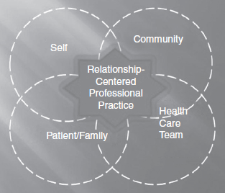

Appendix B

Pre and Post-Survey

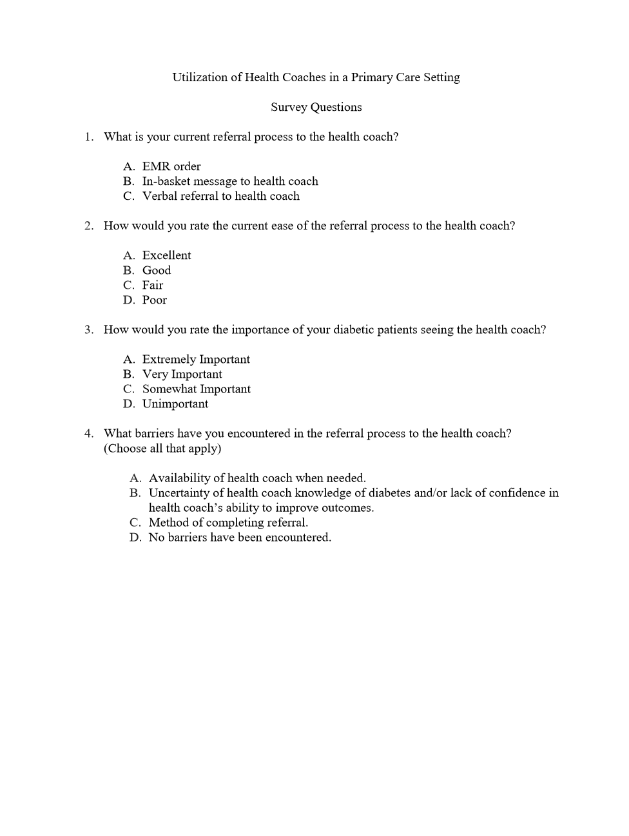

Appendix C

Clinical Coach Brochure

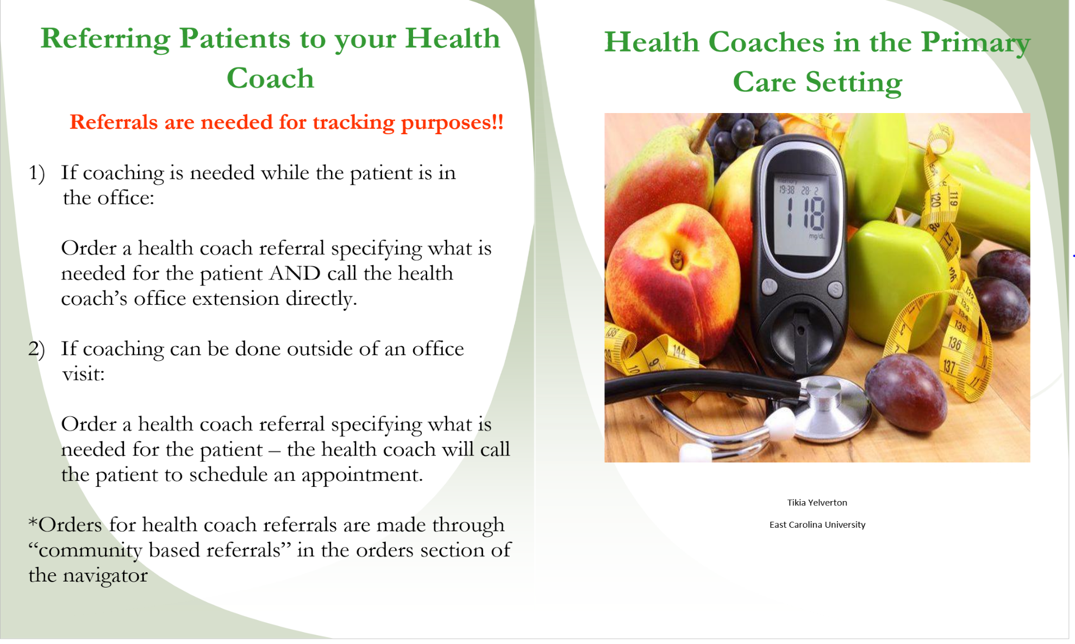

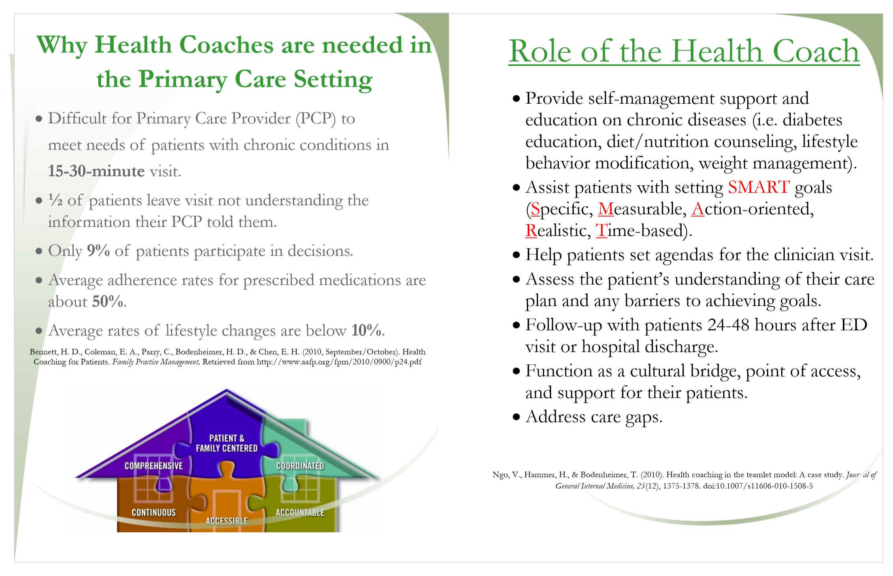

Appendix D

American Association of Diabetes Educators’ Diabetes Self-Management Education and Support for Adults with Type 2 Diabetes:

Algorithm of Care

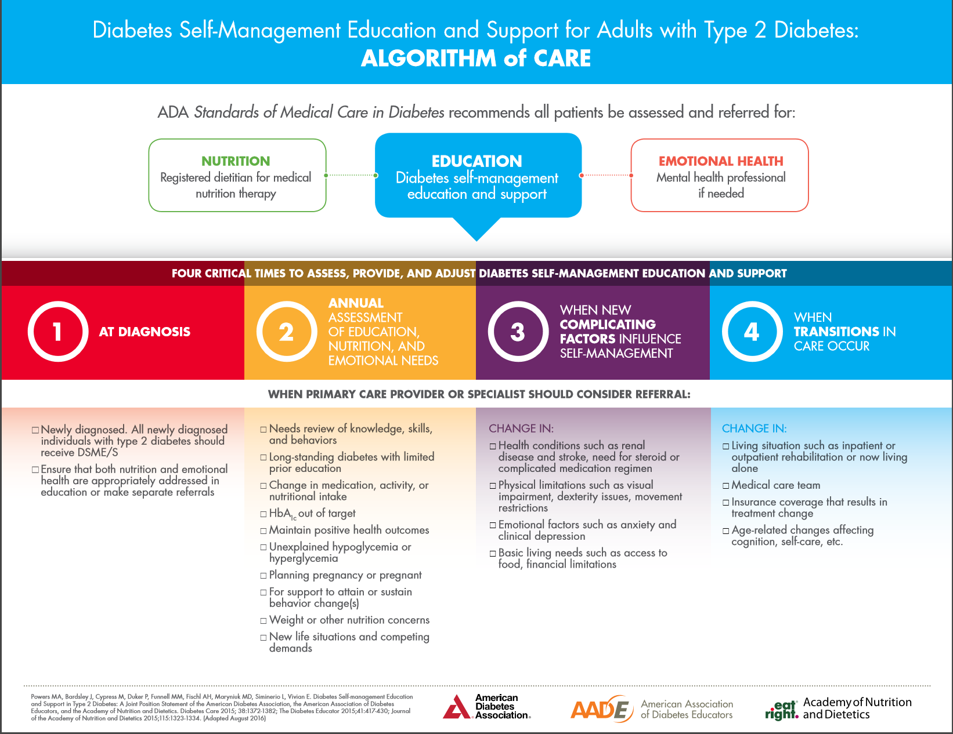
Appendix E

Institute of Health QI PDSA Worksheet

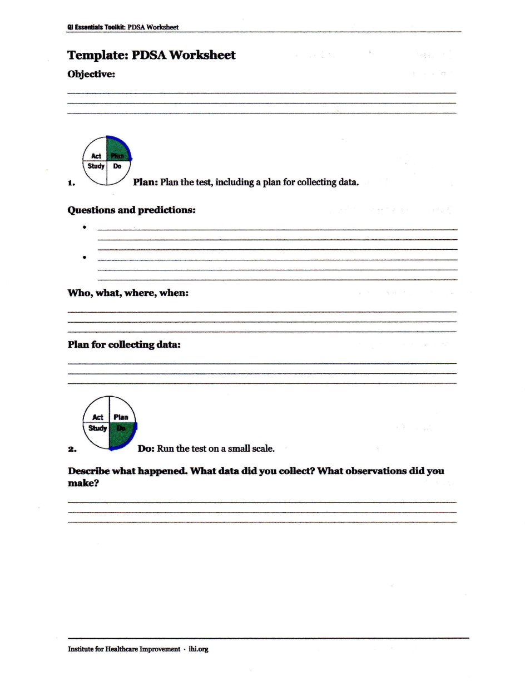
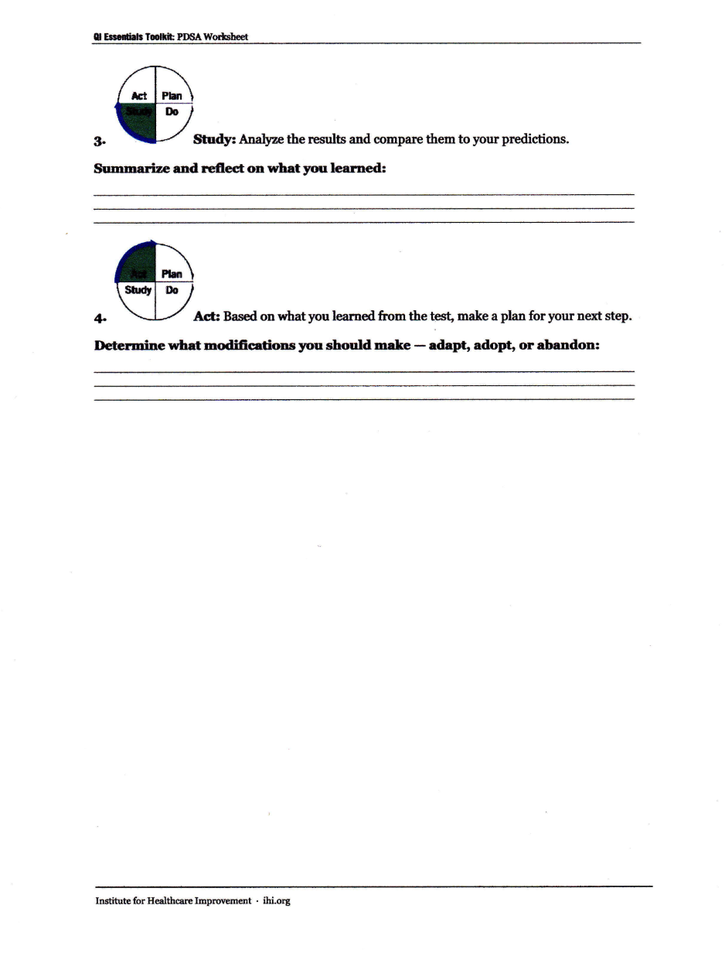

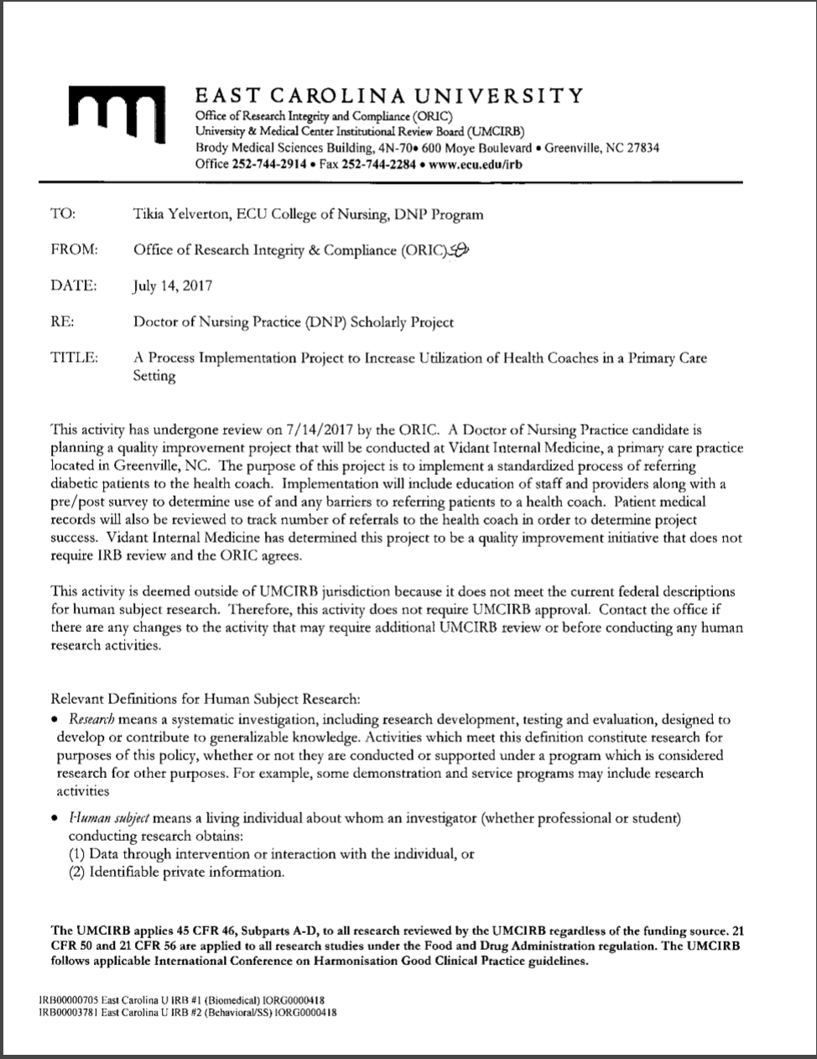

Appendix H

Data Collection Tool

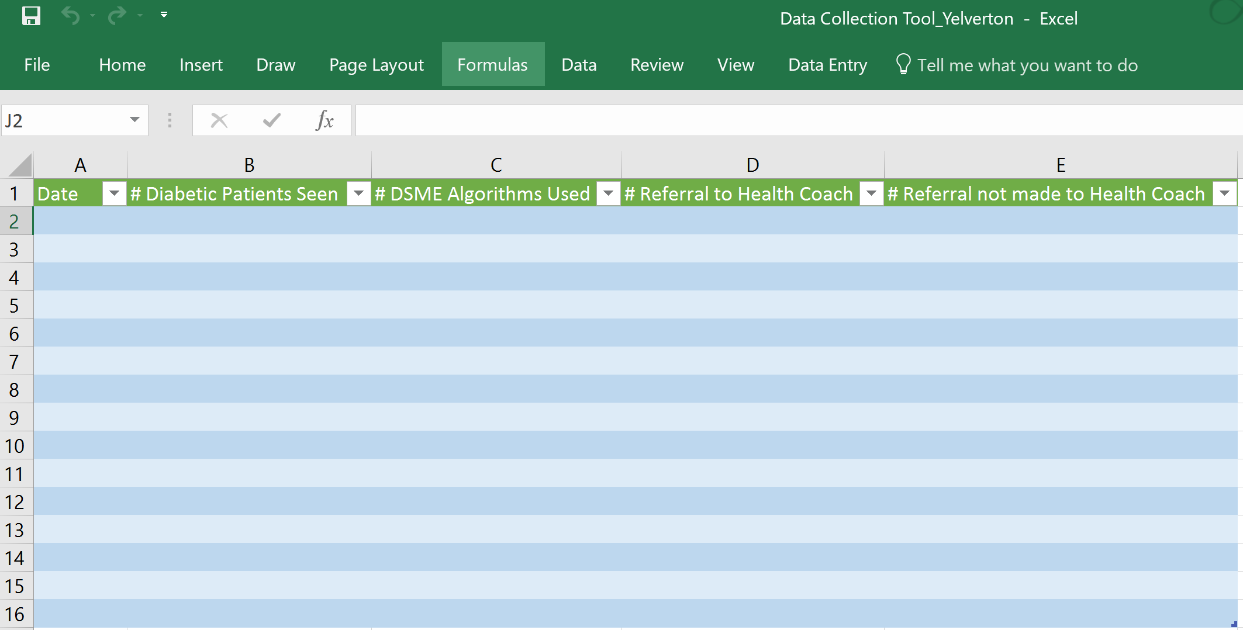

Appendix I
Table 1
Pre and post survey of providers’ perception of utilizing the health coach and the referral process, N = 3

 | Pre Data % (n) | Post Data % (n)
Q1. What is your current referral process to the health coach? (Choose all that apply)
EMR order | 67 (2) | 67 (2)
In-basket message to health coach | 33 (1) | 33 (1)
Verbal referral to health coach | 67 (2) | 33 (1)
Q2. How would you rate the current ease of the referral process
Excellent | 67 (2) | 100 (3)
Good | 33 (1) | 0 (0)
Fair | 0 (0) | 0 (0)
Poor | 0 (0) | 0 (0)
Q3. How would you rate the importance of your diabetic patients seeing the health coach
Extremely Important | 33 (1) | 67 (2)
Very Important | 67 (2) | 33 (1)
Somewhat Important | 0 (0) | 0 (0)
Unimportant | 0 (0) | 0 (0)
Q4. What barriers have you encountered in the referral process to the health coach? (Choose all that apply)
Availability of health coach when needed | 33 (1) | 33 (1)
Uncertainty of health coach knowledge of diabetes  and/or lack of confidence in health coach’s ability to  improve outcomes | 0 (0) | 0 (0)
Method of completing referral | 0 (0) | 0 (0)
No barriers have been encountered | 67 (2) | 67 (2)

Appendix J

Figure 1. Diabetic Pre and Post Referrals to Health Coach

Appendix K

Table 2
Weekly statistic of diabetic patients referred to the health coach during project implementation, N = 177 (DSME Algorithms used n = 19)

Week | Diabetic Patients Seen  % (n) | DSME Algorithms Used % (n)
1 | 13 (23) | 11 (2)
2 | 11 (20) | 21 (4)
3 | 4 (7) | 0 (0)
4 | 8 (15) | 21 (4)
5 | 11 (20) | 5 (1)
6 | 9 (16) | 0 (0)
7 | 7 (13) | 5 (1)
8 | 11 (19) | 16 (3)
9 | 16 (27) | 21 (4)
10 | 10 (17) | 0 (0)
Total | 177 | 19

Appendix L

Figure 2. Weekly Trend of Diabetic Patients Referred to Health Coach.

Appendix M: Literature Matrix

Student: Tikia Yelverton | Course: NURS 8277 | Faculty Lead: Dr. Marshburn | Date: 1/15/18 | Project: A Process Implementation Project to Increase Utilization of Health Coaches in a Primary Care Setting
Article (APA Citation) | Level of Evidence  (I to VII) | Data/ Evidence  Findings | Conclusion | Use of Evidence in EBP Project Plan  (Include your evaluation, strengths/limitations, and relevance)
An, J. (2016, November). The impact of patient-centered medical homes on quality of care and  medication adherence in patients with diabetes mellitus. Journal of Managed Care & Specialty Pharmacy, 22(11), 1274-1284. http://dx.doi.org/10.18553/jmcp.2016.22.11.1272  Study on association between PCMHs and process measures of diabetes care. | Level V | Overall, PCMH group was associated with improvement in process measures of diabetic care. PCMH was not associated with an increased adherence to OHAs. | Further investigation needed for mechanism of PCMHs in quality of care. | Include discussion of PCMH in the overall improvement of diabetes management.
Bernhard, K. A., Cichon, C. Y., Voelkers, P., Baumgardner, D. J., Kram, J. J. F., Magliocco, K.  J., & Mullen, T. A. (2015). Disease management in family medicine clinics through the addition of a health coach: A pilot study. Journal of Patient Centered Research and Reviews, 2(4), 212213. doi:10.17294/23300698.1240  A study to assess the impact of health coaches in a primary care practice as it relates to clinical outcomes. | Level VI | There was a slight improvement in lab data obtained 3 months post implementation compared to pre-implementation. Improvements weren’t statistically significant but were clinically relevant. | Patients showed mild improvements in multiple lab values after meeting with a health coach. | Include in discussion of health coaching referrals.
Collins, D. A., Shamblen, S. R., Atwood, K. A., Rychener, D. L., Scarbrough, W. H., Abadi, M.  H., & Simmons, L. A. (2015). Evaluation of a health coaching course for providers and staff in veterans health affairs medical facilities. Journal of Primary Care & Community Health, 6(4), 250255. doi:10.1177/2150131915591154  A study to determine whether a health coaching course for providers and staff in Veterans Health Affairs medical facilities resulted in increased attitudes towards, intentions to use, and actual use of health coaching. | Level II | There were large pre and post-test increase in preparedness and self-efficacy that were sustained at follow-up. | Providers increase preparedness, self-efficacy and actual use of health coaching skills after participating in a health coaching course. | Supporting evidence that a health coaching course increases provides’ health coaching skills and self-efficacy.
Delaney, G., Newlyn, N., Pamplona, E., Hocking, S. L., Glastras, S. J., McGrath, R. T., & Fulcher, G. R. (2017, March). Identification of patients with diabetes who benefit most from a health coaching program in chronic disease management, Sydney, Australia, 2013. Preventing Chronic Disease: Public Health Research, Practice, and Policy, 14(E21), 1-8. Retrieved from https://www.cdc.gov/pcd/issues/2017/pdf/16_0504.pdf  A study to assess changes in patients’ general knowledge of diabetes after enrollment in a face-to-face CDMP group health coaching session (with telephone follow-up) compared with participation in telephone-only health coaching, during a 12-month period. | Level VI | Diabetes knowledge improved in all patients and diabetes distress decreased among those with the highest levels of distress at baseline. | Diabetes health coaching programs can improve glycemic control and reduce diabetes distress in patients with high levels of these at baseline. | Include the positive effect of health coaching on the diabetic patient.
Dubé, K., Willard-Grace, R., O'Connell, B., DeVore, D., Prado, C., Bodenheimer, T., . . . Thom,  D. H. (2015). Clinician perspectives on working with health coaches: A mixed methods approach. Families, Systems & Health: The Journal of Collaborative Family Healthcare, 33(3), 213221. doi:10.1037/fsh0000110  Provides understanding on how health coaches affect the work of primary care providers and influence their perception of patient care. | Level VI | Both quantitative and qualitative findings indicated that health coaches improved providers’ work experience. | Several benefits of working with health coaches as part of the care team were identified by providers. | Supporting evidence as to how health coaches positively affect the work of primary care providers.
Ford, E. S., Croft, J. P., Posner, S. F., Goodman, R. A., & Giles, W. H. (2013, April). Co-  occurrence of leading lifestyle-related chronic conditions among adults in the United States, 2002-2009. Preventing Chronic Disease: Public Health Research, Practice, and Policy, 10, 1-12. Retrieved from https://www.cdc.gov/pcd/issues/2013/pdf/12_0316.pdf  A self-reported survey to assess prevalence and trends in the chronic conditions that are leading causes of disease and death among adults in the United States. | Level VI | From 2002 to 2009, the age-adjusted percentage with 2 or more chronic conditions increased from 12.7% to 14.7% (P < .001), and the number of adults with 2 or more conditions increased from approximately 23.4 million to 30.9 million. | If increases in chronic conditions continue, managing patients with multiple chronic conditions in the aging population will continue to challenge public health and clinical practice. | Supporting evidence that 70% of those with chronic diseases will result in demise.
Hale, R., & Giese, J. (2017). Cost-effectiveness of health coaching: An integrative review.  Professional Case Management, 22(5), 228-238. 10.1097/NCM.0000000000000223  An integrated literature review to evaluate published literature to distinguish how health coaching influences the cost of chronic disease management in insured adults with chronic conditions. | Level V | Health coaching has been found effective in chronic disease management such as hypertension, diabetes, and hyperlipidemia throughout the literature. | Health coaching has the potential to improve chronic disease management and lower health care expenditures. | Supporting evidence for Level II AACN essentials practice guidelines.
Jonk, Y., Lawson, K., O’Connor, H., Riise, K. S., Eisenberg, D., Dowd, B., & Kreitzer, M. J.  (2015). How effective is health coaching in reducing health services expenditures? Medical Care, 53(2), 133-140. doi:10.1097/MLR.0000000000000287  A study to evaluate the effect health coaching had on outpatient, inpatient, emergency room visits, and prescription drug expenses. | Level III | For health coaching participants, the probability of incurring inpatient expenditures and levels of outpatient and total costs fell significantly compared to the control group from preparticipation to post participation. | Health coaching can have a significant impact on outpatient and total expenses incurred. | Further supports theory that health coaching is beneficial to patients and should be utilized in primary care.
Kemper, A. R., Hasselblad, V., Dolor, R. J., Williams, J. W., Jr, Jackson, G. L., Gray, R., . . .  Heidenfelder, B. L. (2013). The patient-centered medical home: A systematic review. (IMPROVING PATIENT CARE). Annals of Internal Medicine, 158(3), 169.  Describes approaches for PCMH implementation and summarizes evidence for effects on patient and staff experiences, process of care, and clinical and economic outcomes. | Level V | PCMH interventions had positive effect on patient experiences and the delivery of preventive care services. There was an improvement in staff experiences and a reduction in emergency department visits, but not in hospital admissions. There was no evidence for overall cost savings. | The PCMH can potentially improve patients and staff and care processes, but no current evidence supports clinical and economic improvements. | Used to explain significance of practices switching to PCMH and their effect on patients and staff.
Nagelkerk, J., Reick, K., & Meengs, L. (2006). Perceived barriers and effective strategies to  diabetes self‐management. Journal of Advanced Nursing, 54(2), 151-158. doi:10.1111/j.1365-2648.2006.03799.x  To identify perceived barriers to and effective strategies for self-management of adults with type 2 diabetes in a rural setting. | Level VI | Barriers identified were lack of knowledge of a specific diet plan, lack of understanding of the plan of care and helplessness and frustration from lack of glycemic control and continued disease progression despite adherence. Effective strategies identified were developing a collaborative relationship with a provider, maintaining a positive attitude that prompts proactive learning and having a support person who provides encouragement and promotes accountability. | Patient and practitioner need alliances to implement realistic self-management plans | Highlights that there can be barriers to self-management of diabetes but these can be overcome.
Oksman, E., Linna, M., Hörhammer, I., Lammintakanen, J., & Talja, M. (2017). Cost-  effectiveness analysis for a tele-based health coaching program for chronic disease in primary care. BMC Health Services Research, 17, 138. http://doi.org.jproxy.lib.ecu.edu/10.1186/s12913-017-2088-4  Evaluation of the cost-effectiveness of tele-based health coaching among patients with T2D, CAD, and CHF. | Level II | The probability of health coaching being cost effective was 55% in the entire study group; 75% in the diabetic population. | Health coaching interventions should be targeted at certain chronically ill groups because it proves to be cost effective. | Demonstrates the cost effectiveness of self-management interventions as presented by health coaches.
Sharma, A. E., Willard-Grace, R., Hessler, D. Bodenheimer, T., & Thom, D. H. (2016). What  happens after health coaching? Observational study 1 year following a randomized controlled trial. Annals of Family Medicine, 14(3), 200.  Evaluation on the persistence of the benefits of health coaching after 1 year of initiation in the chronically ill. | Level II | A1C dropped from 53.4% to 36.2%. All other clinical metrics had small to non-significant changes. | One year after the completion of health coaching intervention, the most improved clinical outcome persisted (i.e. a reduction in A1C) | Further demonstrates that clinical coaching can be a benefit to the diabetic population.
Speroff, T., & O'Connor, G. T. (2004). Study designs for PDSA quality improvement research.  Quality Management in Health Care, 13(1), 17.  Discusses strengths and weaknesses of quasi-experimental designs used in health care quality improvement research; targets investigators in PDSA. | Level VII | The PDSA quality improvement study design is strengthened using replication schemes and research methodology to address extraneous factors of observational studies that weaken their validity. | The design on PDSA quality improvement research will build a stronger foundation and more convincing justification for the study and practice. | Used to explain the PDSA cycle and how implementing as a research design can be effective on a quality improvement project.
Stults, C. D., Hung, D. Y., Tai-Seale, M., McCuistion, M. H., Frosch, D. L., & Cheng, P. H.  (2016). Shared Medical Appointments: A Promising Innovation to Improve Patient Engagement and Ease the Primary Care Provider Shortage. Population Health Management, 19(1), 11-16. doi:10.1089/pop.2015.0008  Discussed how shared medical appointments (SMAs) can to overcome the challenges of physician shortages, rushed visits, and underused self-management education. | Level VI | There were 3 emergent themes among participants: enhanced learning, motivation for behavior change, and engagement with the physician and other patients. | SMAs can enhance the patient-physician relationship. | Used as demonstration on how physician and patient relationship can be enhanced.
Thom, D. H., Hessler, D., Willard-Grace, R., Bodenheimer, T., Najmabadi, A., Araujo, C., &  Chen, E. H. (2014). Does health coaching change patients’ trust in their primary care provider? Patient Education and Counseling, 96(1), 135-138.  Assessed the impact health coaching had on the provider-patient relationship. | Level II | Twelve months of health coaching was provided to 441 randomized patients. The mean trust level increased in patients who received health coaching. | Patient trust in primary care providers appears to increase after 12 months of health coaching. | Used as support that primary providers should consider utilizing health coaches.
Thom, D. H., Wolf, J., Gardner, H., DeVore, D., Lin, M., Ma, A., . . . Saba, G. (2016). A  qualitative study of how health coaches support patients in making health-related decisions and behavioral changes. The Annals of Family Medicine, 14(6), 509-516. doi:10.1370/afm.1988  A qualitative study of how health coaches support patients in making decisions and implementing changes to improve their health. | Level VI | Four themes of key coaching activities were discovered: education, personal support, practical support, and acting as a bridge between patients and clinicians. | A conceptual model was identified that supported the development of a strong relationship which provides the basis for effective coaching. | Evidence used to support health coaching and provider-patient relationship.
Wayne, N., Perez, D. F., Kaplan, D. M., & Ritvo, P. (2015). Health Coaching Reduces HbA1c in  Type 2 Diabetic Patients from a Lower-Socioeconomic Status Community: A Randomized Controlled Trial. Journal of Medical Internet Research, 17(10), e224. http://doi.org.jproxy.lib.ecu.edu/10.2196/jmir.4871  Evaluated interventions of health coaches in patients with T2D with or without a cell phone. | Level II | Control group continued to improve in A1C reduction 6 months following health coaching interventions. | Health coaching had a positive effect on glucoregulation and mental health in those groups with or without cell phones. | Demonstrates how health coaching in primary care leads to some significant benefits in the diabetic population.
Wolever, R. Q., Jordan, M., Lawson, K., & Moore, M. (2016). Advancing a new evidence-based  professional in health care: Job task analysis for health and wellness coaches. BMC Health Services Research, 16(1), 205. doi:10.1186/s12913-016-1465-8  An expert panel discussed the knowledge and skill necessary to act as a health and wellness coach (HWC). | Level VII | The expert panel identified 21 job tasks pertinent to HWC. | Provides a significant step forward in the building of a clear and consistent definition of HWC that  will allow for uniform practice standards. | Used to explain the role of a health coach.

